PROCUREMENT No. ADA/ARM/CQS-2
(Activity 3.2)

TERMS OF REFERENCE

Development of a Management Plan of Ijevan Sanctuary

- Background
The European Union (EU) funded “European Neighborhood and Partnership Instrument (ENPI) East Countries Forest Law Enforcement and Governance (FLEG) II Program” (the “Program”) is aimed to support the participating countries strengthen forest governance through enhancing their forest policy, legislation and institutional arrangements, and implementing sustainable forest management models on a pilot basis. The Program is implemented in seven countries of the EU’s European Neighborhood and Partnership Instrument (ENPI) East region: Armenia, Azerbaijan, Belarus, Georgia, Moldova, Ukraine, and the Russian Federation.
The Program builds on initiatives undertaken under the first EU funded FLEG Program. It will be carried out over a four-year period, with end on December 31, 2016. The Program is supported by the European Commission contributing to a single-donor trust fund administered by the World Bank (WB). Austrian Development Cooperation (ADC) provides additional funds for complementary measures in Armenia and Georgia. Implementation of the Program is led by the World Bank (WB), working in partnership with the International Union for Conservation of Nature (IUCN) and the World Wide Fund for Nature (WWF). The Program has three Development Objectives (PDO):
- To make progress implementing the 2005 St. Petersburg FLEG Ministerial Declaration in the participating countries and support the participating countries commit to a time-bound action plan to ensure its implementation and follow-up activities (regional level).
- To review or revise (or establish a time-bound action plan to review or revise) forest sector policies and legal and administrative structures; improve knowledge of and support for sustainable forest management and good forest governance (including the impact of related EU regulations) in the participating countries (national level).
- To test and demonstrate best practices for sustainable forest management and the feasibility of improved forest governance practices at the field-level on a pilot basis in all participating countries (sub-national level).
The Program in Armenia deals with a number of issues according to the objectives above. In particular, it is mainly focused on the works supporting legal and institutional review and reforms, building human resource capacity to address FLEG issues, public awareness and public monitoring of the forests, strengthening sustainable forest management through activities with model forest units such as forest protected areas and activities on sustainable use of forest resources with involvement of adjacent communities as well as improving the FLEG planning and monitoring at the national, regional (local) and international levels.
In the frames of ENPI-FLEG 1, the Feasibility Study on Establishment of a Forested Protected Area in Northern Armenia was implemented with the aim to assess the possibility to establish a new Protected Area (PA) to embrace 3 existing state sanctuaries (Gandzakar Sanctuary, Hazel-Nut Sanctuary and Ijevan Sanctuary with the total area of about 13000 ha) as well as other areas important in terms of biodiversity on the territories of Sevqar and Ijevan Forest Enterprises of “Hayantar” SNCO.
The feasibility study revealed rather rich biodiversity in the target area. In particular, the flora of the target area includes 755 plant species, among which 18 species are listed in the Red Book of Plants of Armenia. The fauna is represented by 1,155 invertebrate species, 16 of which are registered in the Red Book of Animals of Armenia and 5 in the IUCN Red List; and 237 vertebrate species, 42 of which are registered in the Red Book of Armenia.
According to the feasibility study the main objectives of the sanctuary are to conserve the diversity of flora and fauna, ecosystems and landscapes, support socio-economic development of adjacent communities and promote tourism development, ultimately to result in improvement of local population livelihoods.
Meanwhile, in the frames of FLEG II program the task on mapping and clarification of the boundaries of a proposed forest sanctuary was finalized, the draft map has been provided to “Hayantar” SNCO for final refinement. The sanctuary territory is assessed to be about 14,000 ha located within administrative borders of the communities Aghavnavanq, Hovq, Gandzaqar, Getahovit and Ijevan town.
The current task on development of a management plan (MP) for the sanctuary in Northern Armenia is a part of the activities aimed at strengthening the planning and management of forest sanctuaries in Armenia through implementation of pilot projects. It contributes to the PDO 3. The activity is funded by the ADC.

- Goal of the Assignment
These TORs are for consultancy services to be provided under a contract signed between the WWF-Armenia (hereinafter the Client) and a Consulting Company (the Consultant). The general goal of the assignment on development of a management plan for the proposed Ijevan Sanctuary (hereinafter the Sanctuary) is to strengthen the planning and management of the Sanctuary aimed at conservation of nature values and support to socio-economic development of adjacent communities.
The specific tasks of the assignment include:
- Task 1. Carry out inventory of biodiversity of the Sanctuary
- Task 2. Carry out inventory of forests and natural resources of the Sanctuary
- Task 3. Carry our assessment of socio-economic and cultural framework of the Sanctuary
- Task 4. Carry out tourism/recreation assessment of the Sanctuary
- Task 5. Carry out consultations with engaged communities
- Task 6. Develop draft management plan of the Sanctuary

- Scope of Services
For fulfillment of the assignment the information from the Feasibility Study on Establishment of a Forested Protected Area in Northern Armenia shall be taken into consideration (to be provided by the Client). Up-to-date satellite information should be used, minimum requirements are: spacial resolution 5-6 m, four-band, max. 10% cloud cover). It should be ensured by the Consultant. The draft map of the Sanctuary is attached to the ToRs (Attachment 1). The GIS software to be used for data entry, analysis and map production should be ArcMAP, version 9 or more.

Task 1. Carry our inventory of biodiversity of the Sanctuary
The biodiversity inventory should reveal the species diversity including those subject to conservation. The inventory should embrace plants, fungi, vertebrates and invertebrates.
The following tasks should be fulfilled: analyze existing information on distribution of species and vegetation types in the Sanctuary, carry out additional surveys to fill essential gaps in existing information, identify indicator, endemic, rare and threatened species (those registered in the Red Books of Armenia and IUCN Red List), carry out GIS mapping of collected information, identify the main threats and suggest measures on conservation and rehabilitation of concerned species.

Task 2. Carry out inventory of forests and natural resources of the Sanctuary
The following tasks should be fulfilled: analyze existing information on forests, carry out field surveys to identify tree species composition and status of forest ecosystems (preserved forest, previously logged area under natural regeneration, coppice, open area and others), carry out inventory of natural resources (timber, non-wood forest products and others) and identify the current state of their use, carry out GIS mapping of collected information, identify main threats to forests and suggest measures (rehabilitation of degraded ecosystems, conservation, sanitary-hygienic and anti-fire activities and others) for forest ecosystems.

Task 3. Carry our assessment of socio-economic and cultural framework of the Sanctuary
The following tasks should be fulfilled: review and analyze existing information on main socio-economic indicators (population, demography, economy, employment, natural resource use, education, agriculture, livestock husbandry and others) and existing regional and community development plans as well as ongoing international support programs; fill in the gaps in existing information, identify and provide key information for GIS mapping and associated overall landscape plan, make suggestions on possibilities of engagement of local population in the planning and management of the Sanctuary.

Task 4. Carry out tourism/recreation assessment of the Sanctuary
The following tasks should be fulfilled: review and analyze existing information on the current state and opportunities for tourism and recreation on the territory of the Sanctuary (includes identification of historical and cultural heritage, existing and potential tourism/recreation capacities such as eco-trails, B&Bs, camping areas, attractive areas to visit, community involvement and others), fill in the gaps in existing information through field surveys, provide key information for GIS mapping, make suggestions on development of various forms of tourism in the area (includes agro-tourism, eco-trails, respective infrastructure and others).

Task 5. Carry out consultations with engaged communities
Meetings and consultations should be organized with 5 engaged communities and stakeholders in the process of management plan development: one meeting with each community in the beginning of management planning and further meetings when having more developed draft MP. The final draft management plan should be provided to communities for review and possible comments/recommendations to be considered for incorporation in the draft MP.

Task 6. Develop draft management plan of the Sanctuary
Draft management plan should be developed based on the results of tasks 1-5. Based on GIS mapping it should delineate separate areas, for which respective regimes should be defined along with the actions required for proper functioning and management of the sanctuary within the frames stipulated by its charter.
The draft management plan should include, but not be limited to the followings: vision, aims and objectives of the sanctuary, description of the sanctuary area (biophysical framework, climate, geology, soils, geomorphology, flora, fauna, threatened species, water regime, existing infrastructure, socio-economic framework, historical monuments, land and resource use, tourism opportunities, pressures and threats to biodiversity and mitigation opportunities and others); thematic programs to include administration program, conservation program, scientific research and monitoring program, program on protection, reproduction and use of natural resources, tourism and recreation development program, public awareness raising program and others (if applicable targeted at respective areas delineated in the result of GIS mapping); delineated ranger areas and respective book-maps for ranger areas; budget and financing; operation plan for 5-year period; schemes and maps.
The management plan should correspond to the requirements of the Law on SPNAs, respective methodological instructions and other respective legal acts of the Republic of Armenia.

The main outputs of the assignment include:
- Reports on biodiversity, forests and natural resources (including description of forest assessment results of respective areas), socio-economic and cultural framework and tourism/recreation of the Sanctuary (in Armenian). Summaries of thematic reports in English.
- GIS database of key findings from tasks 1-4 (in Armenian and English).
- Draft management plan of the Sanctuary consulted with engaged communities (in Armenian and English).

- Timing and Duration
The estimated duration of the project is about 10 months (tentatively Jan – Oct 2016).
Tentative workplan
N | Activity | Months
 |  | I | II | III | IV | V | VI | VII | VIII | IX | X
1 | Task 1. Carry our inventory of biodiversity of the Sanctuary
2 | Task2. Carry out inventory of forests and natural resources of the Sanctuary
3 | Task3. Carry our assessment of socio-economic framework of the Sanctuary
4 | Task4. Carry out tourism/recreation assessment of the Sanctuary
5 | Task5. Carry out consultations with engaged communities
6 | Task6. Develop draft management plan of the Sanctuary

- Institutional Arrangements
The Client will provide to the Consultant all available information, which might be useful for the completion of this assignment, free of charge.
The Client will assist the Consultant (if needed and within the limits of its capacities) to contact all relevant stakeholders for gathering information. In case of need the Client will advise the Consultant on technical issues connected with the task implementation or any other issue within the competence of the Client.
The Consultant should keep close contact with the Client for any related issues for getting feedback and approval of any related material, event or others. The Consultant should keep close contact with “Hayantar” SNCO to get feedback on related issues linked to the forests under its management.
The Consultant may use association under the forms of: a) joint venture, in which case for the contract awarded, the Consultants shall be jointly and severally liable for the entire assignment; and b) sub-consultancy, in which case all the responsibility for performance of works lies with the main executor (the Consultant), and the subcontractor‘s qualification will not be considered in the short-listing process as an additional qualification of the main executor.

- Reporting and Approval Procedures
The Consultant should submit the following deliverables:
- The Consultant shall submit monthly progress reports with attachments (according to the agreed template) with outline of the activities implemented so far and preparations undertaken for the next steps of the assignment implementation according to the agreed workplan. The attachments should include all prepared materials (e.g. draft reports, maps, other materials, invitations, agendas, lists of participants), approved timesheets and financial supporting documents, photos and any other related materials. At the end of the assignment the Consultant shall submit final report subject to approval. Reports shall be submitted by the 5th working day of the next month.
- The required deliverables shall be submitted to the Project Coordinator (Siranush Galstyan, sgalstyan@wwfcaucasus.org) in electronic form (via e-mail above) and in one hard copy to be delivered at WWF-Armenia office, 11/1 Proshyan street, Yerevan 0019, Armenia.
The reporting language is English.
The payments will be done in the form of monthly reimbursement of expenses on the basis of supporting financial documents. The final payment will be effected only after approval of the final report.
The Contract will be considered as completed after signing the acceptance certificate.

- Qualifications Requirements
The Company to be hired for the assignment should have the following qualifications:
- Not less than three years of experience in the field of management planning (related to forests, protected areas, etc.).
- Not less than three years of experience in implementing projects in the environmental field to include field studies, inventories and assessments, communications events and team works; the experience in forest management related projects is an advantage.
- English language capacities.

The Team Leader for the assignment should have the following qualifications:
- Higher degree in biology, forestry and other environment related disciplines or other relevant field.
- Extent of experience in coordination and implementation of environmental projects related to biodiversity in general and forests in particular.
- Strong organizational, project and team management skills, report writing and communications skills.
- Knowledge of Armenian language.

The Key Personnel for the assignment should have the following qualifications:
- Higher degree in forestry, biology and other environment related disciplines or other relevant field.
- Extent of experience in biodiversity/forest studies or socio-economic surveys or communications or management planning.
- Strong communications and team-working skills.
- Knowledge of Armenian language.

Attachment 1. Map of Ijevan Sanctuary

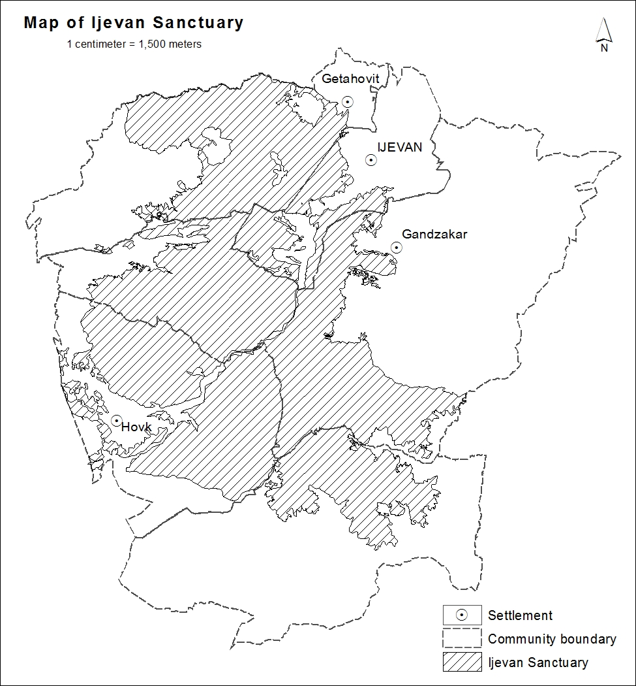

The European Neighborhood Policy (ENP) was developed in 2004, to avoid the emergence of divisions between the enlarged EU and its nearest neighbors (16 countries excluding the Russian Federation) but to instead strengthen prosperity, stability and security of all. The ENP Eastern Region includes the six countries covered by the Program. Cooperation is open to Russia whenever relevant to the objectives of the Program. The ENPI (which includes the Russian Federation) was established to support the development of an area of prosperity and good neighborliness encompassing the EU and the countries of the ENP.

