Result of the survey:

Place |  | Company
High-level

1 |  | "Terneyles" JSC  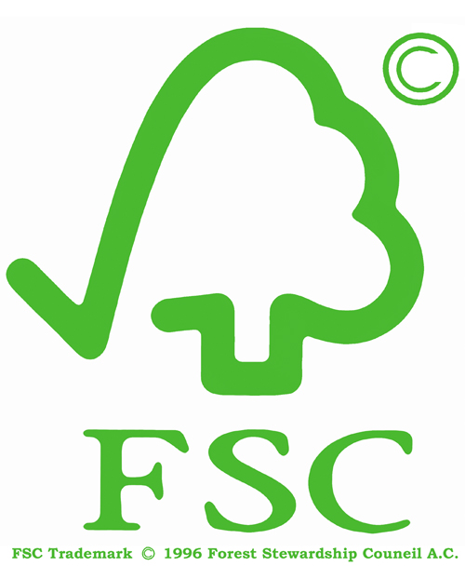 | FTN Russia
Middle level

2 |  | "Melnichnoe" JSC
3 |  | " SHelehovskij KLPH " CJSC
4 |  | " Sredneamgun'skij LPH" LLC | VLTP 
5 |  | "Primorskiy GOK" JSC | FTN Russia
6 |  | " Gorinskij KLPH " JSC
7 |  | "Suluk" LLC | VLTP
8 |  | "Primorskie lesopromishlenniki" JSC | FTN Russia
Low level

9 |  | "Roshinskiy KLPH" JSC
10 |  | "JEkstrales" LLC
11 |  | "Amgu" JSC
12 |  | "Les Export" CJSC | FTN Russia
13 |  | "Sorok perviy LPK" JSC
14 |  | "JEvoronskij LPH" JSC
15 |  | "Kirovskles" LLC
16 |  | "Forest Star" LLC
17 |  | "Dal'lesprom" JSC
18 |  | "Sihali" LLC
19 |  | "Ulikanskoe" LLC
20 |  | "Snezhnoe" LLC
21 |  | "Dalnerechinskles" LLC
22 |  | "Vostochniy" LLC
23 |  | "Vodolej" LLC
24 |  | "De-Kastriles" LLC
25 |  | "De-Kastrinskij Torgovyj Dom" JSC
26 |  | "Primsnabkontrakt" JSC
27 |  | "Kvant" LLC
28 |  | "Strojjenergoservis" LLC
29 |  | "Arka-les" LLC
Insufficient level

30 | "Aralija" LLC
31 | "Dal`wood" LLC
32 | "Chuguevskaya LPK" CJSC
33 | "JUmaks-DV" CJSC
34 | "Kavalerovskij LPH " JSC
35 | "Sergeevskij lespromhoz" JSC
36 | "Klen" LLC
37 | "El`" JSC
38 | "Voshod" LLC
38 | "Energiya" PSMK
40 | "Dalniy" LLC
41 | "Ussuri" LLC
42 | "Dal'promteh" LLC
43 | "Dal' Evro Les" LLC

Details

- The Khabarovsk Territory

- FSC certification

FTN Russia – member of Association of Environmentally Responsible Producers of Forest Products

VLTP - Verification of Legality of Timber Products (SGS in Khabarovsk)

Levels of ecological responsibility

1. High level of ecological responsibility. Wood enterprise is a sustainable forest manager. Almost all standards of sustainable forest management are observed.

2. Middle level of ecological responsibility. Wood enterprise is comparatively sustainable forest manager. Forest management is at acceptable level. Company solves problems in order to improve forest management. Company has enough resources to follow standards of sustainable forest management and has a goal to get international forest certificate.

3. Low level of ecological responsibility. Level of ecological responsibility is rather low, but company tries to improve the situation. A lot of indicators do not conform to the level of sustainable forest management. Company is ready to improve the level of forest management and ready to take steps for it.

4. Insufficient level of ecological responsibility. Level of ecological responsibility is very low. Most of indicators do not conform to the level of sustainable forest management. System of ecological management and ecological transparence does not correspond to standards of sustainable forest management.

Companies that did not agree to take part in the rating

In the Primorie Territory:
- «Tajga» JSC
- «Bikin» LLC
- «Olimp-pljus» LLC
- «Dal'nerechenskij LK» LLC
- «Evrostandart» LLC
- «Germes» LLC
- «Sihotje-Alin'» CJSC
- «Strojservis» LLC
- «Avtej» LLC
- «Uliss» LLC
- «PPK Vostok» LLC
- «JAppi» LLC
- «Tis» LLC
- «Primorskij lesokombinat» LLC
- «Pozhiga» LLC
- «Ternejlesstroj» CJSC
- «Taezhnoe» LLC
- «CHuguevskij LPH» LLC

In the Khabarovsk Territory:
- «Amgun'» CJSC
- «Amurskij DOK» LLC
- «SP Arkaim» LLC
- «Badzhal'skij LPH-2» JSC
- «Vaninolesjeksport» JSC
- «Vega» LLC
- «Vostokjeksportles» LLC
- «Dal'lesstroj» JSC
- «Duki» LLC
- «Kato» CJSC
- «Kiselevskoe» LLC
- «Komsomol'skij KLPH» JSC
- «Konstantinovskoe» LLC
- «Krona» LLC
- «Lazarevskoe» LLC
- «Lesnoj kompleks» CJSC
- «Lesstrojkompleks» CJSC
- «Litovskoe LPH» LLC
- «Magma» LLC
- «Merkurij-DV» LLC
- «Monolit» LLC
- «GP 41 LPK Morflot»
- «Muhenles» LLC
- «Nizhneamurskij LPH» CJSC
- «Nord-kompani» LLC
- «Ost» LLC
- «Rimbunan Hidzhau DV Ko» LLC
- «Ros-DV» LLC
- «Sindinskoe LPZ» LLC
- «Skider» LLC
- «Skimen-les» LLC
- «Tahtinskoe» LLC
- «Tis» LLC
- «Fart» LLC
- «Flora» CJSC
- «NO CHuin» LLC
- «CHjeatyn» JSC
- « JAsen' » LLC

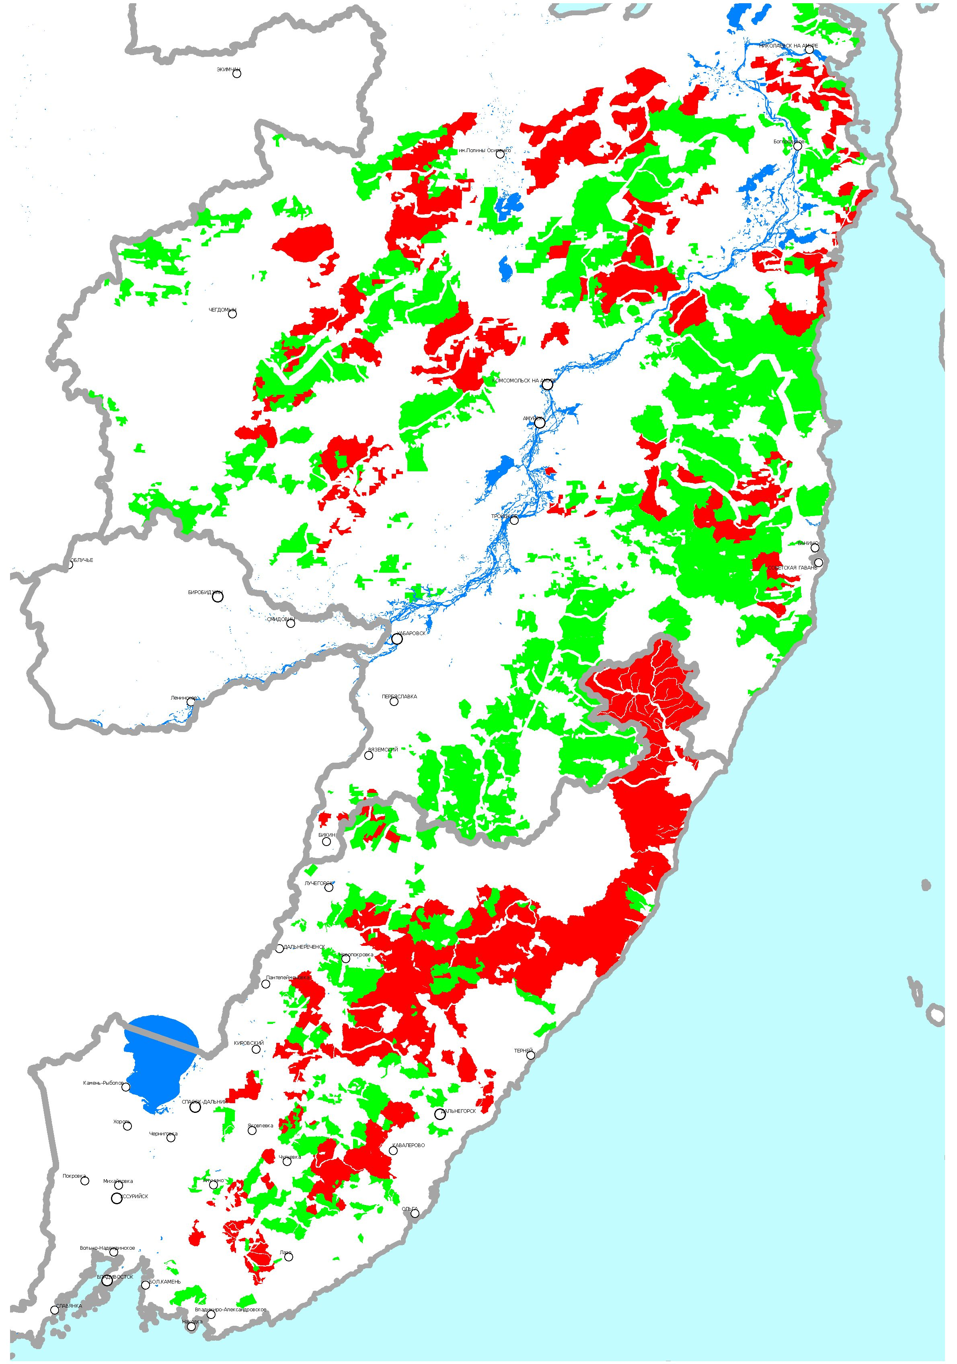
Member s of the Ecological responsibility rating among wood enterprises of the Russian Far East

- Members of the rating

- Others forests
The Khabarovsk Territory

The Primorie Territory



