World Wide Fund for Nature


WWF CLIMATE CHANGE CAMPAIGN

Key Technology Policies
to Reduce CO₂ Emissions in Japan

An Indicative Survey for 2005 and 2010

Foreword

Like similar analyses that WWF has produced for the United States and the European Union, this report indicates how Japan could make substantial early reductions in its emissions of carbon dioxide (CO₂) - the leading pollutant contributing to climate change, or global warming.

Faced by increasing physical evidence of global warming affecting human well-being and natural ecosystems in every region of the world and in most nations, WWF is convinced that industrialised nations must take important first steps against this problem by reducing their CO₂ emissions by 2005.

As well as improving the changes of survival for those ecosystems and species which are most sensitive to rapid rates of warming, the period to 2005 is also relevant to today’s political and economic decision-makers. Politicians must not shy away from acting on the clear scientific consensus that climate change poses an enormous threat to society and that reducing emissions quickly is the only responsible course of action. By enacting decisive measures now and in the next few years to start sending emissions on a downward path, they will leave their political successors more scope for managing future change. Delay will only increase the inevitable damage from global warming and force the next generation of decision-makers into implementing rushed, potentially costly and unpopular measures.

Businesses, too, will want to avoid expensive mistakes. Because targets for reducing CO₂ emissions by 2005 affect today’s investment decisions, there is an imperative for business to avoid spending on out-dated and polluting technologies. Looked at more positively, businesses that will profit will be those which are well-placed to deliver the clean and highly-efficient energy technologies that will be in increasing demand as the inevitable trend towards reducing CO₂ emissions gathers momentum.

WWF is convinced that leading governments and corporations can afford to be far more ambitious in their targets for reducing CO₂.

In WWF’s report looking at the United States, analysts from the Tellus Institute in Boston, Massachusetts, showed how a series of policies and measures appropriate to different sectors of the US economy could cut CO₂ emissions 10% below 1990 levels by 2005 and 22% by 2010. Moreover, the overall economic savings would amount to US$ 46 billion by 2005 and US$ 136 by 2010.

Investigating what a variety of proven policies and measures might produce in the European Union, experts from the Netherlands showed in detail how the EU could reduce its CO₂ emissions 14% below 1990 levels by 2005, with reductions continuing beyond this date at 2% per year.

Because these analyses are based on real experience with measures that work, they have provided WWF with valuable opportunities to discuss practical steps for cutting CO₂ with political and business decision-makers. We hope to have similar success with the present report which investigates some of the options available to Japan.
Table of contents

Foreword by WWF 3

Table of contents 4

Key Technology Policies to Reduce CO₂ Emissions in Japan

Summary 7

1. Background 8
1.1 Introduction
1.2 AIM (Asia-Pacific Integrated Model)

2. The WWF Case 9
2.1 The industry sector
2.2 The transport sector
2.3 The residential sector
2.4 The commercial sector
2.5 New and renewable energy sources

3. Simulation Results 25

4. Policies and Measures 28
4.1 The present status of CO₂ emissions in Japan
4.2 Innovative technologies for CO₂ emission reduction
4.3 How to reduce CO₂ emissions
4.4 Key technology policies
4.5 Other possibilities

5. Conclusions 31

References

Comparison of the Studies for the EU and Japan

1. Introduction 33
2. Scope and Approach in both Studies 33
3. Results 35

References

Annex: The AIM Model and Simulations

1. Introduction 39
2. The Basic Structure of AIM 39
3. Outline of the AIM/End-Use Model 41
4. The Special Features and Limitations of the AIM/End-Use Model 43
5. The Structure of the End-Use Model 43
6. Case Studies in Japan 44
7. Conclusions 48

Key Technology Policies to Reduce Co₂ Emissions
in Japan
Dr. Haruki Tsuchiya, Research Institute for Systems Technology

Summary

Key Technology Policies to Reduce CO₂ Emissions in Japan is a computer simulation of a variety of selected options for reducing carbon dioxide (CO₂) emissions in Japan between 2000 and 2010. The study calculates energy consumption and CO₂ emissions using the existing AIM model, and includes a “WWF Case” incorporating additional options for reducing emissions, which were considered feasible.

The AIM model comprises two scenarios: the “Contemporary Materialistic Nation” scenario and the “Creative/Knowledge-Intensive Nation” scenario. Economic growth of 2.3% per year is assumed in both scenarios. Under the latter scenario, the industrial structure is assumed to undergo a greater shift to a more service-based economy. Energy consumption and CO₂ emissions from the industrial, transport, household and commercial sectors are quantified for both scenarios. The two scenarios distinguish three cases: the Frozen Technology Case, the Standard Case (Market-Oriented Case), and the Intervention Case. A fourth case - the WWF Case - was added by including additional energy efficient technology options to the Intervention Case.

The results of the Creative/Knowledge-Intensive Nation scenario are as follows. If the focus is only on the market-oriented introduction of existing energy-saving technologies, and no new policy is adopted as in the AIM Standard Case, CO₂ emissions are projected to rise by 9.6% above the 1990 level in 2005 and by 12.9% in 2010. The Intervention Case shows CO₂ emissions decreasing by 2.6% in 2005 and 7.6% in 2010 based on the introduction of efficient technology. However, under the WWF Case, in which regulations and subsidies are introduced to promote energy saving, and new efficient technologies penetrate the market, CO₂ emissions could be reduced 8.6% below the 1990 level by 2005 and 14.8% in 2010.

Among the additional measures incorporated into the WWF Case are Keidanren's Voluntary Action Program, elimination of “stand-by mode” electricity consumption, the introduction of hybrid cars (which are twice as fuel-efficient as conventional cars are today), efficient refrigerators, high-performance industrial furnaces and a variety of other energy-efficient technologies.

The body of this report presents policies and measures based on the simulation results and proposes key technology policies that should be adopted in Japan.

1. Background

1.1 Introduction

Japan's energy consumption has been increasing constantly since the end of the World War II. During the strong economic growth period of the 1960s, the main energy source shifted from coal to oil, and energy consumption grew faster than gross domestic product (GDP). Energy growth was suppressed by the oil crises of 1973 and 1979 when oil prices rose dramatically. As a result, research and development into energy-saving technologies, and renewable energy sources received a considerable boost in the latter half of the 1970s. With plummeting oil prices in the 1980s, saving energy was no longer viewed as a top priority and energy consumption resumed its upward trend. This has continued into the 1990s.

In 1990, the Japanese government announced its “Action Program to Arrest Global Warming” with the goal that total or per capita CO₂ emissions in 2000 should be stabilized at 1990 levels. But by 1995, CO₂ emissions had climbed 8.3% above the 1990 level.

In this English version of the report, carbon dioxide emissions are reported as CO₂. The Japanese version reports emissions in carbon equivalents. Also yen are converted to US dollars, using an exchange rate of 120 yen per US dollar throughout the analysis.

1.2 AIM (Asia-Pacific Integrated Model)

The AIM assumes certain patterns of industrial activities and consumption in the future and a presumed trend of macro economics. It calculates energy consumption and CO₂ emissions by offsetting end-use energy demand with new efficient technologies in an integrated bottom-up approach [AIM Project Team, 1997]. The model enables the inclusion of newly-developed efficient end-use technologies with an annual gradual penetration based on a cohort model.

The macro economic framework of the AIM defines major macro economic variants such as economic growth rate, population and industrial structure and assumes two scenarios: the Contemporary Materialistic Nation and the Creative/Knowledge-Intensive Nation. Both scenarios include three cases, the Frozen Technology Case, the Market-Oriented Case and the Intervention Case. The Frozen Technology Case assumes no special regulation or other policies will be implemented and that business continues without introducing energy saving technologies or renewable energy sources. The Market-Oriented Case assumes cost-efficient technology will be introduced on a market base. The Intervention Case, on the other hand, introduces a carbon tax at a maximum rate of 30,000 yen (US$250) per ton of carbon emissions, to stimulate the introduction of energy-saving technologies and new renewable energy sources.
2. The WWF Case

The WWF Case is based on the Intervention Case of the AIM. It includes additional input from Keidanren's Voluntary Action Program, recent findings on stand-by electricity consumption and new high efficiency energy technologies. The new technologies included in the calculations are assumed to replace the capital stock by 30 - 50% by 2005, and by nearly 100% by 2010. The additional technologies that are introduced in the WWF case, are described below. Furthermore, policies that could be used to implement the described technologies are discussed.

2.1 The Industrial Sector

The most important additional options to reduce emissions in the industrial sector are the reduction of the unit energy consumption for basic material production and high-performance industrial furnaces.

1) Unit Energy Consumption in Energy-Intensive Industry

Energy-intensive industries include the steel industry, the cement industry, the paper and pulp industry and the chemical industry. These industries account for 65% of the energy used in the industrial sector. Table 1 shows the energy consumption, production and the unit energy consumption (the energy consumption per unit of production) for a number of the energy-intensive industries for 1995.

Table 1: The Unit Energy Consumption in Energy-Intensive Industry
1995 | Energy use  (PJ/year) | Production  (1000ton/year) | Unit energy consumption  (GJ/ton)
Iron & Steel | 1707 | 100,023 | 17.0
Cement | 528 | 91,644 | 5.8
Paper & Pulp | 457 | 26,634 (paper) | 17.2

In the Keidanren Voluntary Action Program energy efficiency improvement targets are mentioned for a variety of industrial sectors. Table 2 lists the program’s energy efficiency improvement targets (as a reduction of the unit energy consumption) for energy intensive industries for the year 2010 [Keidanren, 1997]. The program does not contain targets for the year 2005. We assume the reduction of the unit energy consumption for 2005 amounts to 35% of target for 2010. A target for the cement industry is not indicated in the action program.

The AIM contains a long list of energy saving technologies for each industry as shown in Table 3 from which technologies can be selected to reduce the unit energy consumption [AIM Project Team, 1997].
Table 2: Energy efficiency improvement targets for energy-intensive industries (as a reduction of the unit energy consumption) as listed in the Keidanren Voluntary Action Program [Keidanren, 1997]
Industry | Reduction of unit energy consumption in 2005 | Reduction in unit energy consumption in 2010
Iron & Steel | -3.5% | -10%
Paper & Pulp | -3.5% | -10%
Chemical | -3.5% | -10%
Cement | -- | not indicated

Table 3: Industrial Technologies Included in the AIM
Industry | Technology
Iron & Steel | Coke wet adjustment equipment, coke wet type quenching, scrap pre-heater, alternate-current electric furnace, continuous caster, direct iron ore smelting furnace, top pressure recovery turbine, combined-cycle generation, etc.
Cement | Tube mill, vertical mill, new suspension pre-heater, high-efficiency clinker cooler, fluidized bed sintering furnace, power by waste heat, etc.
Petrochemical | High-performance Naphtha cracking device, high-performance LDPE manufacturing device, gas cogeneration, combined-cycle generation, etc.
Paper & Pulp | High performance pulp washing device, oxygen delignification device, high-performance vapor drum, waste pulp manufacturing device, high-performance dry hood device, high-performance size press device, etc.

2) High Performance Industrial Furnaces

High performance industrial furnaces are being promoted by Japan’s Industrial Furnace Association and NEDO [Nikkei Mechanical, 1997; Center for Energy Conservation, 1996]. These furnaces have the following features:
- This technology is an improved type of the already commercialized “regenerative burner”, a heat-retrieving furnace, which is highly cost effective .
- It is a “heat reserve burner with short time switching”. The principle behind this burner is based on two or more inlets of fuel and air, which alternatively act as inlets and outlets, switching every 10-30 seconds.
- The heat of the exhaust gases is absorbed into a ceramic honeycomb at the outlet, and the heat is used to preheat the air when the outlet turns to be inlet again.
- The high performance industrial furnace will be developed based on this regenerative burner, and the technical target is to inject fuel into the low oxygen content and high turbulent atmosphere at high temperature (more than 1000 degrees centigrade).
- The phenomenon that occurs at this temperature is called “green flame burning”, which is a pioneer field of furnace technology. The inside temperature distribution flattens and can be used efficiently for metal melting and other industrial uses.
- The efficiency improvement is estimated to be about 30%.

Concerning the implementation of the high performance industrial furnace the following assumptions have been made:
- The development of the high performance industrial furnace technology will be accomplished by 2000. Furnaces will be commercialized and widely used by 2010.
- The energy savings of implementing the furnace are expected to amount to 18 billion liters of oil equivalent in 2010 in the industrial sectors, and 4 billion liters of oil equivalent in the commercial sectors. The total 22 billion liters of oil equivalent equals 5% of total primary energy use in 2010.
- This furnace technology can be applied in metal melting, heating, thermal processing, chemical industry furnaces, oil furnaces, industrial boiler and so on. It will be used in the iron and steel industry, the chemical industry, metal manufacturing, and the cement industry, etc.
The AIM includes the improvement of the unit energy consumption by introduction of this furnace in the industrial sector, but not in the commercial sector. In the WWF Case this technology is also included in the commercial sector.

Figure 1.
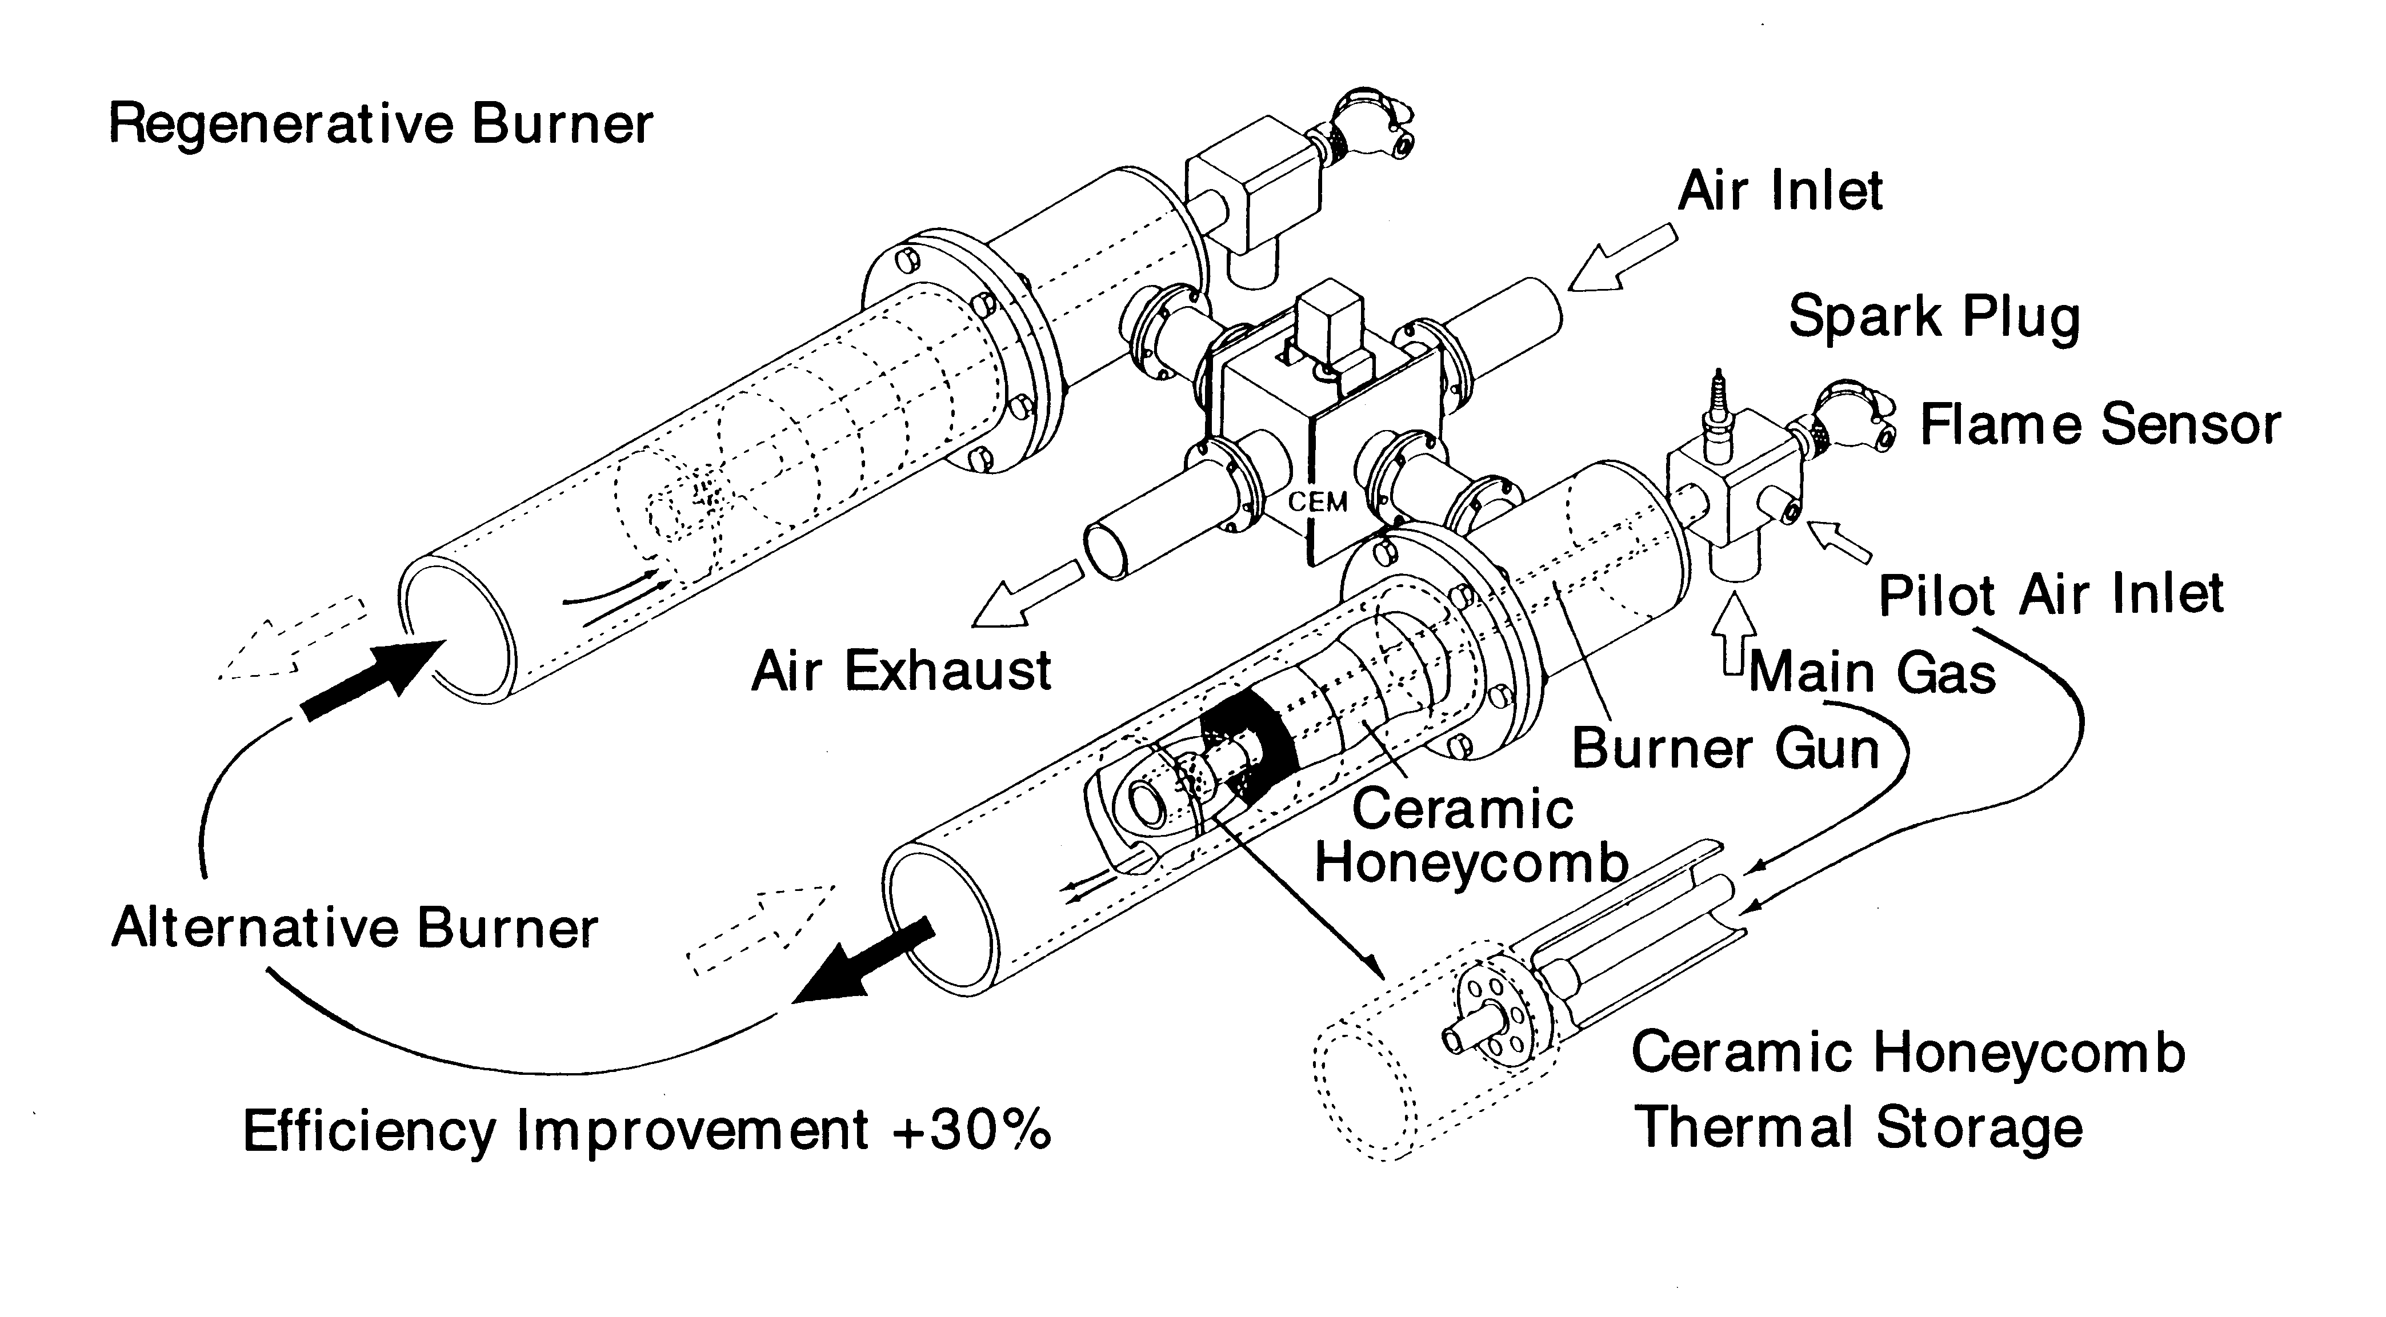
2.2 Transport Sector

Energy demand in the transport sector is rising because of the increasing use of cars and trucks. Therefore, energy efficiency improvement of vehicles is a key issue. AIM simulates the annual introduction of efficient vehicles by a cohort model based on a detailed list of a variety of cars and trucks. In 1996-1997, improving the energy efficiency of cars was high on the agenda of car manufacturers. Mitsubishi developed the GDI (Gasoline Direct Injection) engine, resulting in a 30% higher fuel economy than similar models with a conventional engine. The GDI engine can be mounted onto all type of cars, because it is easy to modify them in a short period. Vehicles using GDI technology are already included in the AIM. Another new technology improving vehicle fuel efficiency is the gasoline hybrid car, developed by Toyota. The hybrid car is included in the WWF case, and described below.

1) Gasoline Hybrid Cars

At the Hyper Car Center of the Rocky Mountain Institute, the potentials of hybrid cars have been analyzed [von Weizsäcker et al., 1997]. The hybrid car is estimated to be 5 times as efficient as conventional vehicle (or even more), if the car body is produced of fiber reinforced plastics with weight of 450-600 kg.(6)

In spite of their high efficiency, hybrid were thought to be unsuitable for small cars, because motor, battery and generator require a large amount of space. Therefore, only buses were considered for possible application. Hybrid buses are already commercialized and used in urban areas in Japan. The hybrid engine for normal-sized passenger cars is a revolution in the automobile industry.

The design of the hybrid car as developed by Toyota is a combination of a gasoline engine, a battery and a motor, achieving a fuel efficiency of 28 km per liter of gasoline (66 miles per gallon) [Toyota, 1997]. This is twice the fuel efficiency of a conventional 1500 cc car. The technology is at a commercial level, and cars equipped with it have the same appearance as normal cars. The features of the hybrid car are as follows (Figures2-1, 2-2):
- When the car is started, the engine stops and the motor drives the wheels by electricity from the battery. The car is very quiet at starting. When the car starts moving and reaches sufficiently high speed, the engine begins to run and supplies automotive power to the wheels and the generator. Excess power is converted to electricity and stored in the battery. The key characteristic of the hybrid car is that the engine runs when it can be used most efficiently: at a continuous, high speed (i.e. on highways). In urban traffic, allowing only low speed, the electric motor is used to drive the vehicle.
- Another key characteristic of Toyota’s hybrid car is regenerative braking: when the brake is applied to decelerate, the generator absorbs energy from the car’s motion and stores it in the battery. Regenerative braking is very efficient.
- When the car stops, the engine is turned off automatically.
- The power transmission mechanism is designed as a planetary gear system in order to allocate power from and to the engine, the motor, the generator and the driving shaft to the wheels. This mechanism is a continuous transmission system, located at the same place as the transmission in a conventional car.
- The battery used is a Nickel Hydrogen battery, which keeps high voltage. The engine is a type of Atkinson Cycle, which has a high thermal efficiency.
- A hybrid car weighs about 130 kg more than a conventional car of the same size.
Figure 2-1
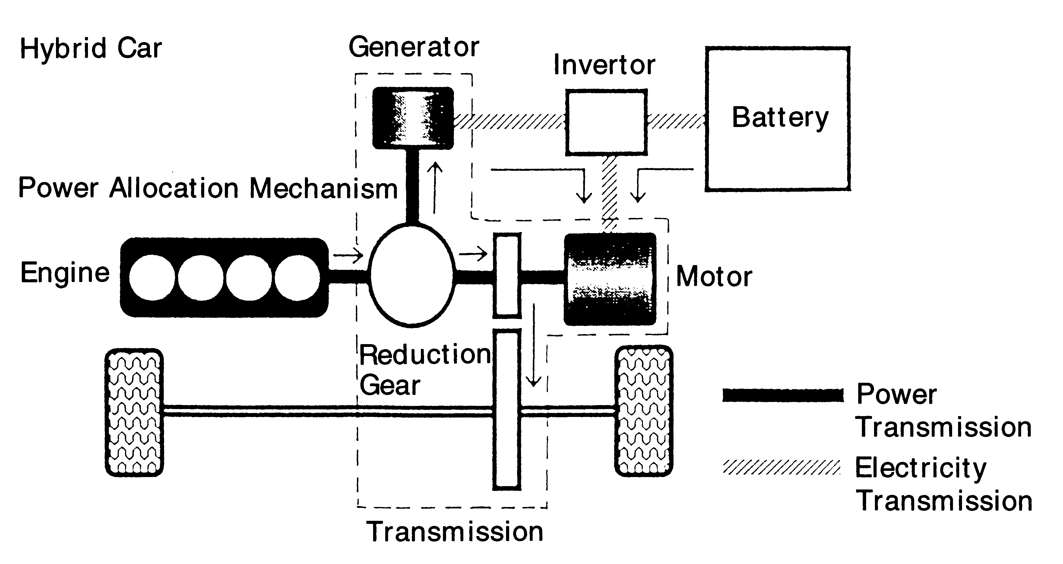
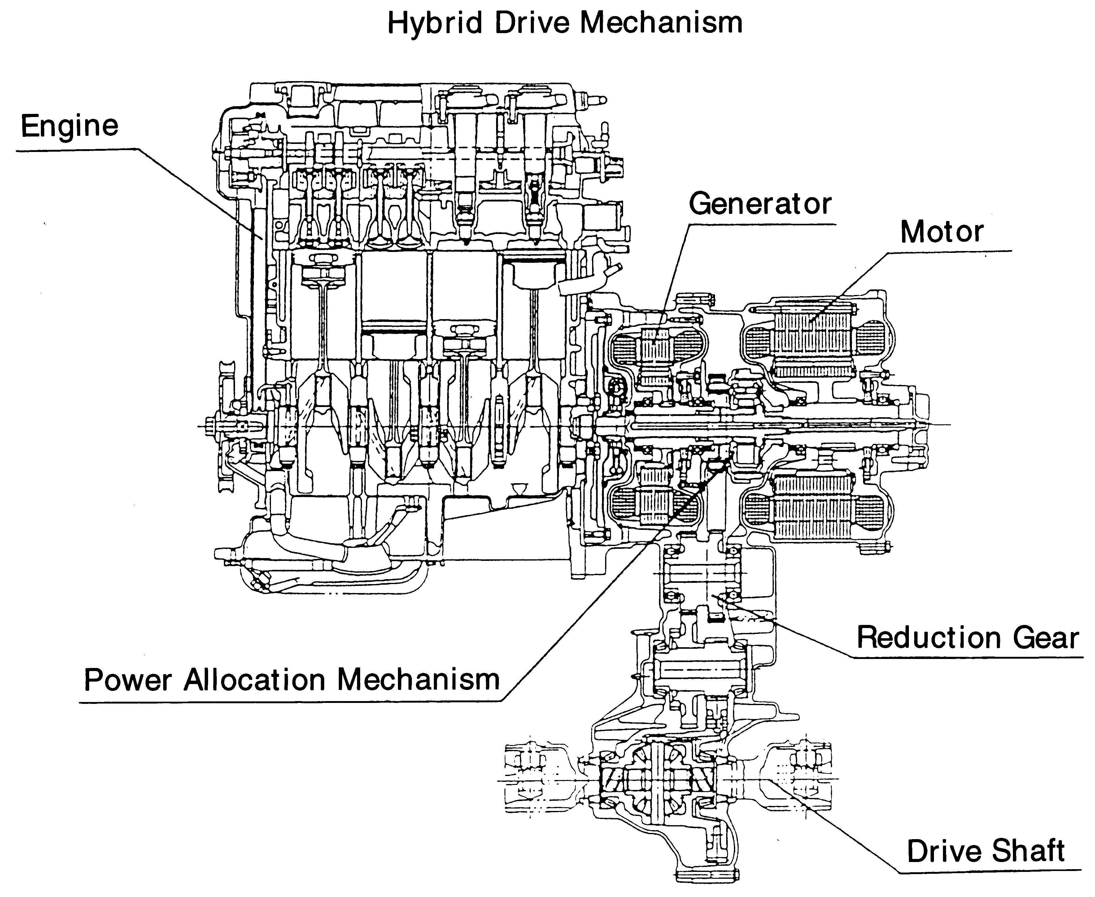Figure 2-2

Figure 3.
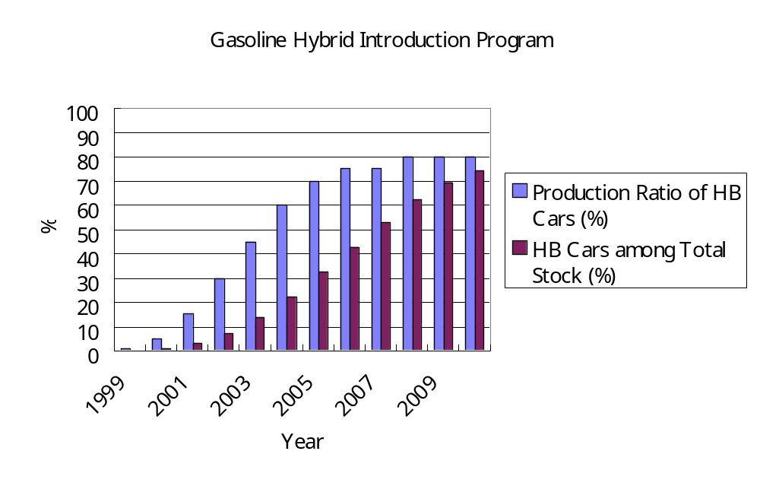
Toyota plans to manufacture 1000 cars of this type before the end of 1997. Additional costs for a hybrid car would be 0.5 million yen (US$4,200), compared to a the price of conventional 1500 cc car (about 1.6 million yen, or US$13,300). Increasing the scale of production to several 10,000 units would lower the costs to the same level as for conventional cars. Furthermore, a hybrid car saves 300,000 yen (US$2,500) on gasoline consumption over a 7 year period.

The energy efficiency of hybrid cars is expected to improve even further, up to 2.5 times (82.1 miles per gallon) in 2010. The market penetration is assumed to be accelerated as in the logistics curve. Hybrid car production is assumed to amount to 1% of total car production in the year 1999, 5% in 2000, 15% in 2001, 30% in 2002 and 70% in 2005 (see also Table 4(a) and Figure 3). These are only outlines, as the penetration is calculated in details by the cohort model for many types of cars. Accelerated introduction enables the stock of hybrid cars to increase to a share of 32% of the total vehicle fleet in 2005 and 74% in 2010.

2) Diesel Hybrid Trucks

Hybrid cars could be applied to diesel engines as well, as in any car including passenger cars, cargo trucks and buses. Diesel hybrid trucks could be very energy efficient. Currently, research & development are ongoing to overcome the air pollution caused by NO_{x} emissions from diesel engine, such as the diesel GDI engines for passenger cars. This technology has been utilized in cargo diesel trucks, but with more developments on fuel injections and burners, efficiency could be improved by 20% compared to normal diesel engines. If a hybrid engine could be used, the efficiency could be improved further. However, since trucks are mostly driven on highways at a regular high speed, the effects of hybrid car technology are not that great as for hybrid gasoline cars . It also takes time to replace trucks, and so we presumed that 38% of the stock will be replaced in 2010 for trucks (see also Table 4(b)). The energy efficiency for 2010 by diesel hybrid trucks is expected to be 1.6 times the efficiency of a convention truck.

Table 4: Hybrid Car Efficiency

Gasoline Hybrid Car Introduction Plan |  | 1999 |  | 2000 |  | 2001 |  | 2002 |  | 2003 |  |  | 2004 |  | 2005 |  | 2006 |  | 2007 |  | 2008 |  | 2009 |  | 2010
Production Ratio of HB Cars (%) |  | 1 |  | 5 |  | 15 |  | 30 |  | 45 |  |  | 60 |  | 70 |  | 75 |  | 75 |  | 80 |  | 80 |  | 80
Efficiency of HB Cars Sold |  | 2 |  | 2.1 |  | 2.2 |  | 2.25 |  | 2.3 |  |  | 2.35 |  | 2.4 |  | 2.45 |  | 2.5 |  | 2.55 |  | 2.6 |  | 2.6
HB Cars among Total Stock (%) |  | 0.14 |  | 0.86 |  | 3 |  | 7.29 |  | 13.71 |  |  | 22.29 |  | 32.29 |  | 42.86 |  | 52.86 |  | 62.14 |  | 69.29 |  | 74.29
Average Efficiency of HB Car Stock |  | 2 |  | 2.08 |  | 2.17 |  | 2.22 |  | 2.26 |  |  | 2.29 |  | 2.33 |  | 2.36 |  | 2.39 |  | 2.43 |  | 2.47 |  | 2.5
Diesel Hybrid Car Introduction Plan |  | 1999 |  | 2000 |  | 2001 |  | 2002 |  | 2003 |  |  | 2004 |  | 2005 |  | 2006 |  | 2007 |  | 2008 |  | 2009 |  | 2010
Production Ratio of HB Cars (%) |  | 0.5 |  | 2 |  | 4 |  | 8 |  | 15 |  |  | 20 |  | 25 |  | 30 |  | 40 |  | 45 |  | 50 |  | 60
Efficiency of HB Cars Sold |  | 1.2 |  | 1.25 |  | 1.3 |  | 1.35 |  | 1.4 |  |  | 1.45 |  | 1.5 |  | 1.55 |  | 1.6 |  | 1.6 |  | 1.6 |  | 1.6
HB Cars among Total Stock (%) |  | 0.07 |  | 0.36 |  | 0.93 |  | 2.07 |  | 4.21 |  |  | 7.07 |  | 10.64 |  | 14.86 |  | 20.29 |  | 26.14 |  | 32.14 |  | 38.57
Average Efficiency of HB Car Stock |  | 1.2 |  | 1.24 |  | 1.28 |  | 1.32 |  | 1.36 |  |  | 1.4 |  | 1.43 |  | 1.47 |  | 1.51 |  | 1.53 |  | 1.56 |  | 1.57

Also the efficiency of non-hybrid cars will improve, because of the implementation of GDI technology in those cars. The efficiency of the transport sector will, furthermore, result in a reduced amount of car fuels that need to be transported. The CO₂ emission reduction in 2010 caused by reducing the amount of fuel transport required, will be 350 ktons annually, which is also added to WWF case.

3) Other Possibilities

MITI studied the potential effects of a modal shift in freight transportation from trucks to railways and domestic waterways on CO₂ emissions. If the share of railways and domestic marine transports increases from 40% to 50%, CO₂ emission are reduced by 35% (770 million ton). For this purpose, an upper limit to railway tariffs railway transport should be introduced and deregulation of harbor tariff systems is necessary. The cost of rail and domestic marine freight transport should be reduced by 30% less. The use of container trains and container ships should be increased for long distance transport. For short distance transports, it is necessary to improve logistics through a more optimal planning of collection and distribution points for transports.

There are other possibilities such as changing buses to hybrid buses, and improving the energy efficiency of domestic marine transports, but we have not included such options in this study.

Table 5 summarizes the assumptions on the introduction of hybrid vehicles. In order to reach the penetrated rates indicated, the government should designate hybrid cars and trucks as Key Technology and promote market penetration by necessary subsidies, and tax systems. Feasible measures are subsidies for hybrid cars covering 50% of the price difference between hybrid cars and normal cars (in the early stage of production), decreased car taxes for the use of hybrid cars, subsidies to support car manufacturing R&D, reduced interest loans for buyers and reduced parking fees for hybrid cars. Another possibility are technology procurement programs, such as national and local government buying hybrid cars for their own use

Table 5: The Assumptions on the Introduction of Hybrid Cars
Year | Gasoline hybrid car | Diesel hybrid truck
2005 | Stock penetration 32%  Efficiency 2.32 that of conventional cars | Stock penetration 10%  Efficiency: 1.4 times that of conventional cars
2010 | Stock penetration 74%  Efficiency 2.5 times that of conventional cars | Stock penetration 38%  Efficiency 1.57 times that of conventional cars

2.3 The Residential Sector

The energy demand in the residential sector has increased steadily, partly because of low energy prices. High energy savings potentials exist. High performance insulated houses (according to new insulation standards) will save 7.3 million tons of carbon emission in 2010 compared to conventional houses if implemented nation-wide. Furthermore, compact fluorescent lighting will replace incandescent light bulbs, of which the energy demand amounts to 29% of lighting electricity demand in 2010. Table 6 shows energy saving option that are already included in AIM [Environment Agency, 1996].

Table 6: Energy saving options for the residential sector and the energy savings potential for various year (GJ) [Environment Agency, 1996]
Technology | 2000 | 2005 | 2010
Solar heat systems | 342 | 608 | 1,081
Photovoltaics | 0 | 300 | 2,396
High efficient gas water heaters | 145 | 381 | 999
TVs (Liquid crystal display) | 0 | 100 | 323
High efficient heat pumps | 761 | 1,700 | 3,798
Compact fluorescent light bulbs | 3,088 | 3,178 | 3,270

Additional measures included in the WWF case are the reduction of stand-by mode electricity consumption and efficiency improvement in refrigerators.

1) Reducing Stand-by Mode Electricity Consumption of Electrical Appliances

Many household appliances do not have a main switch, and they can only be switched off by pulling the plug. Usually these appliances are left on stand-by mode. Clock display on household electrical appliances and preheating for instant startups are on 24 hours a day, and consume large amounts of energy. According to a recent survey, stand-by mode electricity in households is constantly around 50 - 100 watts, which amounts to 10-20% of current total electricity demand in households [Center for Energy Conservation, 1997]. If electrical appliances that do not consume stand-by mode electricity are developed and promoted, this electricity consumption could be eliminated thoroughly.

Electrical appliances with stand-by mode electricity such as TVs, videos, audio visual equipment, fax machines and phones should be prohibited to be manufactured and be replaced with those that have no stand-by mode. For electrical appliances that need timer startups, ultra-small sized batteries such as used in personal computers could be an alternative, and all unnecessary clock displays could be deleted.

The costs of stand-by mode electricity consumption in an average household amount to almost 10,000 yen (US$83) annually (see also Table 7). The accumulated additional costs in 5 years are enough to buy appliances without stand-by mode electricity. Table 8 shows that some appliances consume more energy while they are in stand-by mode than during their actual use. We presume it is necessary to ban production of such appliances to improve the efficiency of social resources use as a whole.
We assume that stand-by mode electricity consumption amounts to 15% of the electricity consumption in households in the Frozen Technology Case and that the penetration rate of electrical appliances will be 40% in 2005 and 66% in 2010. This means that 6% and 10% of the electricity demand for 2005 and 2010 could be eliminated by the use of electrical appliances without stand-by mode electricity.

Table 7: Stand-by Power of Electric Appliances and Annual Electricity Costs
[Jyukankyou Research Institute, 1997]
Appliances | Stand-by mode power (W) | Annual electricity costs (US$)
TV | 1.9 | 3.4
Video recorder | 8.2 | 25.2
Audio stereo | 11.0 | 20.4
Air conditioner | 7.3 | 13.5
Telephone (parent) | 4.7 | 8.7
Telephone (child) | 2.2 | 4.1
Microwave oven | 5.5 | 12.4
Washer toilet | 6.0 | 10.8
Electric tooth brush | 4.5 | 8.1
Total | 51.3 | 88.5

Table. 8 The Typical Stand-by Mode Electricity Consumption for Audio Equipment
 | Power | Annual hours | Annual electricity consumption
During use | 120W | 365 hr (1 hr per day) | 43.8 kWh
Stand by mode | 10W | 8760-365 = 8395 hrs | 84.0 kWh

2) Efficiency Improvement of Refrigerators

Refrigerators are in operation all year long, consuming 18% of household electricity demand. Improving their energy efficiency will drastically reduce the energy demand for households. The Ministry of International Trade and Industry (MITI) decided in September 1997 to stimulate Japanese refrigerator manufacturers to reduce the electricity consumption of their products by an average of 13% by 2000. However, the latest refrigerators have become larger with many functions resulting in a higher energy consumption.

The AIM assumes a doubling of the energy efficiency by 2010. This improvement, however, is also achievable on a shorter term. Current electricity consumption for refrigerators is, on average, 60 - 70 kWh per month. The most efficient refrigerator today is commercialized by Sharp Co., a 440 liter type, which consumes 30 kWh per month [Nikkei Mechanical, 1997b]. This already represents a doubling of energy efficiency for the same size and similarly priced unit. More energy savings could be achieved technologically by more insulation within the refrigerator walls, more energy efficient compressors, and other similar steps with very little additional cost. We assumed that 40% of the refrigerator stock will be replaced in 2005 with a model having an efficiency which is 1.8 times higher than current models. In 2010, 100% is assumed to be replaced in 2010 increasing efficiency by a factor of 2.2.
Table 9: Assumptions Concerning the Reduction of Energy Consumption
in the Residential Sector
Year | Stand-by mode electricity | Efficient refrigerators
2005 | Penetration: 40 %  Energy saved: 6% of electricity in the frozen technology case | Penetration: 40%  Efficiency: 1.8 times as efficient as current models
2010 | Penetration 66 %  Energy saved: 10% of electricity in the frozen technology case | Penetration 100 %  Efficiency: 2.2 times as efficient as current models

In order to achieve the above-mentioned results, the following policies are suggested.
- Prohibit the manufacture and sales of electric appliances that consume stand-by mode electricity.
- Standardize the technology that reduces electricity consumption of refrigerators by half and promote its development and sales with subsidies.
- Designate this new technology as “Key Technology” and promote it with necessary subsidies and tax mechanisms.

2.4 Commercial Sector

The energy demand in Japan’s commercial sector has continued to increase partly because the economic structure has shifted to a service economy. Many opportunities exist to save energy and improve energy efficiency within commercial buildings.

Table 10 shows the energy saving options that are already included in the AIM [Environment Agency, 1996].

Table 10: Energy Saving Options in the Commercial Sector (GJ)
Technology | 2000 | 2005 | 2010
Insulation | 2538 | 7911 | 24768
Photovoltaics | 201 | 1285 | 8242
High frequency inverter bulb with high efficient reflector | 1653 | 5768 | 20109
High illumination light for emergency exit | 171 | 594 | 2067
Fluorescent bulb with sensor and continuous intensity control | 205 | 912 | 4077
Latent heat recovery boiler | 535 | 3214 | 19272
High efficient heat pump | 12 | 100 | 828
Cogeneration | 4709 | 9803 | 20406
Cogeneration with waste heat | 514 | 1712 | 5701
High efficient gas heat pump and other new technology | 0 | 418 | 2348

There are energy saving potentials as a result of the transition to an information based society. We further added the reduction of stand-by mode electricity consumption and efficient vending machine in the commercial sector as follows in the WWF study.

1) Electronic Paper Alternatives

The Central Research Institute for Electric Power Industries studied electronic publication as a substitute for conventional books and newspapers and calculated the energy saving from less paper production and less transport in 2010 (see Table 11) [CRIEPE, 1996]. The biggest energy saving is caused by the decrease in paper production. We added the standard case for paper alternatives from Table 11 to the WWF case, resulting in an emission reduction of 2745 ktons of carbon dioxide.

Table 11: Energy Savings from Electronic Paper Alternatives
Case | Total energy savings
Standard case | 50.6 PJ
Promotion case | 86.2 PJ

2) Satellite Office and TV Conference System

A study by the Ministry of Posts and Telecommunications showed that the satellite office and TV conference will result in less transportation and, therefore, energy saving in the beginning of the 21st century [MPT, 1993]. The results are shown in Table 12. The wide spread use of low cost TV conference systems using personal computers is expected to be an alternative to transport. We assumed 3 times the figures in Table 12 for 2010. The CO₂ reduction then amounts to 3572 kton in 2010.

Table 12: Emission Reductions Resulting from the Use of Satellite Offices and TV Conference Systems
 | Satellite office | TV conference system
Car | 1008 million person-km/year | 8942 million person-km/year
Bus | 73.8 million person-km/year
National Railways | 10,842 million person-  km/year
Private Railways |  | 437 million person-km/year
Air flights |  | 4,496 million person-km/year
CO₂ reduction  Total in 2000 | 395 kton CO₂/year | 798 kton CO₂/year
CO₂ reduction  Total in 2010 | 1186 kton CO₂/year | 2395 kton CO₂/year

The above two cases are included in the intervention case, as are the electronic paper alternatives.

The use of e-mail and facsimile would decrease the transport demand for the delivery of regular mail. The delivered number of post cards and mail was 22 billion and 11 billion respectively in 1992, using as an estimated amount of energy needed 212 J/piece of mail [Tsuchiya, 1994]. The demand for post cards and mail is expected to increase by 30% in 2010. Assuming 20% of this demand is substituted by emails and faxes, then avoided CO₂ emissions will amount to 1208 kton in 2010. However we did not include uncertain problems like junk mail and an increase in small-sized packet transport by internet shopping in the calculation.

3) Stand-by Mode Electricity

There are many machines and other equipment in offices that use a lot of stand-by mode electricity, such as fax machines, copying machines, phones, computers, printers and other office automation machinery. They use more electricity than household appliances, because the rated power is higher, the machines are operated longer periods of time, and office employees are not aware of the amount of electricity consumed. Technology to cut the stand-by mode electricity of such units in offices throughout the country could be developed along with similar technology for household appliances.

There are 11 million fax machines nationwide. Their average stand-by mode power is 25W, consuming a total of 2,409,000 MWh of electricity annually. Fax machines function 8760 hours per year, but are only used during a small part of that time to send or receive faxes. A fax machine that does not consume stand-by mode electricity has already been developed and commercialized, saving 6,000 yen (US$50) annually.

4) Reducing Excess Lighting

Electricity consumption for lighting could also be reduced drastically by regulating excess lighting in office buildings, hotels, department stores, supermarkets, and other commercial buildings. In the USA, Energy Service Companies (ESCOs) are working to find areas to save energy in public buildings. They receive a part of the money saved by the introduction of energy saving devices as their consulting fee. If policy measures are taken to encourage such energy saving consultant businesses, large amounts of energy could be saved in the commercial sector.

Here, we assume that stand-by mode electricity consumption and excess energy consumption excluding air conditioning in office buildings contribute for more than 20% to total commercial electricity demand. With appropriate regulations and incentives, we estimate that 8% and 12% of electricity demand excluding air conditioning could be saved in the commercial sector in 2005 and 2010 respectively.

5) Efficient Vending Machines

There are a variety of machines used in commercial sector. It is difficult to analyze all of them. So we focus on vending machines as a typical case to illustrate energy saving potentials.

There are 5.4 million vending machines nationwide. Of these, 2.0 million are energy-intensive machines for cold and hot beverages, and each machine consumes an average of 235 kWh per month. This means that a vending machine for beverages consumes 326 W of electricity throughout the year. Electricity costs are 71,396 yen (US$595), high enough to be an incentive for saving energy by vending machine operators.

The rated power of the vending machine is between 300-1000W. Lighting consumes 30-200W and occupies 15-40% of electricity. Some vending machines outdoors have sensors that turn the lights off during daytime, but often we see vending machines, that are fully lit at midnight in deserted streets.

There was an effort to reduce electricity demand of vending machines at afternoon peak electricity hours, especially in mid summer. In 1995, an energy-saving type vending machine called “Eco Vendor” was developed. “Eco Vendor” cools beverages only in the morning and cuts electricity supply by one-tenth during the peak hours of 13:00-16:00. Thirty thousand “Eco Vendors” have already been manufactured and used. It is reported that 70% of new vending machines will be “Eco Vendors.”

Total electricity consumption for beverage vending machines is 5.69 billion kWh annually, nearly 3.7 % of total electricity demand in the commercial sector. This could be reduced to 30% of current levels by regulations. Technologically, it is possible to increase insulation, install demand-control by purchase prediction systems, and reduce excess lighting. We assume that 50% of all the vending machines in 2005 and 90% in 2010 will be able to cut electricity consumption by 70% compared to the Frozen Technology Case. The technical aspects are as follows.

- Insulation
Insulation is the first step in energy saving. A variety of insulation materials are available, such as vacuum insulation and foam plastic insulation used in refrigerators. Increasing wall thickness sometimes raises cost, but avoids high operating costs. Therefore, the investment for insulation has a short paid-back period. The manufacturers have competed by making vending machines with less insulation in order to store more cans. Therefore, some regulations will be necessary.
- High COP (Co-efficient of Performance) and other parts
The most efficient 440 liter refrigerator for household consumes 30 kWh per month. The electricity consumption of vending machine is 8 times higher. There are many technologies in these refrigerators which could be applied to reduce energy demand in vending machines, such as high efficiency compressors, variable speed fans and others.
- Appropriate Temperature Adjustment
The difference in temperature of the outside environment should be adapted to the temperatures in the vending machines. If the target temperature is adjusted to the temperature according to season, night time and daytime, a large amount of energy could be saved.
- Demand Prediction and Partial Cooling and Heating
The demand prediction according to season, month, week, and time will enable more precise control of vending machines to reduce unnecessary cooling and heating.
- Lighting
The lighting should be controlled so that it will be minimized when there is no customer, but lights up when the machine is approached. There should be a lighting standard for vending machines to avoid excess lighting.

If the above-mentioned technological options are applied, the electricity consumption of vending machines can be reduced to less than 30 % of current electricity consumption. The most effective and economical improvement option is insulation.

Table 13: Electricity Consumption After Implementing Energy Efficiency
Improvements in Vending Machines (relative to current electricity consumption)
Technology | Electricity consumption today | Reduction | Improved electricity  consumption
Better insulation, cooling efficiency, control system, etc. | 70 | 50 | 20
Lighting | 30 | 20 | 10
Total | 100 | 70 | 30
(The total electricity consumption today is set at 100)

6) High Performance Industrial Furnace

As already explained, the amount of oil saved by introducing high performance industrial furnaces are estimated to be 4 billion liters of oil equivalent in 2010 in the commercial sector.

Table 14 summarizes the assumptions for the commercial sector used in the WWF case.

Table 14: Assumptions for Commercial Sector
Year | Appliances with no Stand-by mode  electricity consumption | Efficient vending machines | High performance  industrial furnaces
2005 | Penetration: 40%  Energy saved: 8% of FTC Electricity in the commercial sector | Penetration: 50%  Energy Saved: 1.3% of FTC Electricity in the Commercial Sector | Penetration: 40 %  Energy Saved: 1.6 billion liters oil equivalent
2010 | Penetration 60 %  Energy saved: 12 % of FTC Electricity in the commercial sector | Penetration 90 %  Energy saved: 2.4% of FTC electricity in the commercial sector | Penetration: 100%  Energy saved: 4.0 billion liters oil equivalent
(FTC = Frozen Technology Case)

In order to achieve the above-mentioned energy savings the following policy measures are suggested.
- Prohibit production and sales of electrical office equipment which consume stand-by mode electricity after the year 2000.
- Regulate vending machines to increase energy efficiency to one third of current levels after 2000.
- Regulate excess lighting and stand-by mode electricity consumption in retail shops, office buildings, and hotels.
- Establish a technology authorization standard and provide political support to encourage energy saving consulting business.
- Define as key technology for Japan such technology as electrical appliances without stand-by mode electricity consumption, energy efficient vending machines, and high performance industrial furnaces and promote their market penetration with necessary subsidies, and tax incentives.

2.5 New and Renewable Energy Sources

It is widely known that renewables is an important field to be promoted as clean energy sources. MITI's "New Energy Introduction Vision" has set targets for 2000 and 2010 for photovoltaics, heat generation from waste, cogeneration, wind power and others. We have estimated targets for 2005, listed in brackets, and added them to the WWF Case (see Table 15).

Table 15: The Assumptions for New and Renewable Energy Sources in the WWF Case
Energy source | 2000 | 2005 | 2010
Photovoltaics | 400 MW | <1000 MW> | 4600 MW
Electricity from waste | 2000 MW | <3000 MW> | 4000 MW
Cogeneration | 5420 MW | <10000 MW> | 19120 MW
Wind power | 20MW | <40 MW> | <100 MW>
Solar heat | 3 billion liters | <5 billion liters> | <8 billion liters>
Ocean thermal | 200 million liters
Heat from waste | 70 million liters
Total (share in primary energy, %) | 12.1 billion liters (2%) This shall not be realized | (Approximately 2 %) | 19.1 billion liters (3 %)
Notes: 1. The <number> are assumed for WWF case. Ocean Thermal and Heat from Waste are not included in the calculation.
2. “liters” is liter oil equivalent.

There are a variety of ways to realize the above-mentioned targets. For example, MITI began a progressive subsidizing plan in 1995 to support one third to half of the cost of introducing photovoltaics on roofs. The city of Aachen in Germany also has an innovative scheme using 1% of electricity revenues to subsidize those who wish to build photovoltaics or wind mills. The cost of photovoltaic generation is three times more expensive than normal electricity price, but the leaning curve analysis shows the cost reduction in a few years would help rapid penetration, making subsidies redundant in the near future.

3. Simulation Results

The result of the calculations using the assumptions mentioned in Chapter 2 based on the AIM is shown in Tables 16, 17, 18 and Figure 4. CO₂ emissions for each scenario are shown in Table 16. The CO₂ emissions in 1990 amounted to 1173 million ton CO₂, with Table 16 showing the relative change compared to 1990. Four cases are shown, the Frozen Technology Case, the Market Oriented Case (or the Standard Case), the Intervention Case, and the WWF case. In both scenarios, the CO₂ emission in 2005 and 2010 compared with 1990 level increase in Frozen Technology Case as well as Market Oriented Case(Standard Case), and decrease in Intervention Case and the WWF Case. In the Frozen Technology Case in the Materialistic Economic Nation scenario, CO₂ emission in 2010 increase by 26.4% compared with 1990. The WWF Case in the Creative/Knowledge Intensive scenario shows a decrease of 14.8% in CO₂ emission compared to 1990 levels. This means, that a large range of 40% of CO₂ emission reduction depends on policies.

Table 17 shows the CO₂ emission structure (by sectors) in the Creative/Knowledge-Intensive Nation scenario in 2005 and 2010. The CO₂ emission reduction in the commercial sector seems difficult in all cases. If the WWF Case is compared with Intervention Case, there is little difference in the industrial sector, but a big difference in the transport sector. This is due to accelerated introduction of efficient hybrid cars.

Figure 4

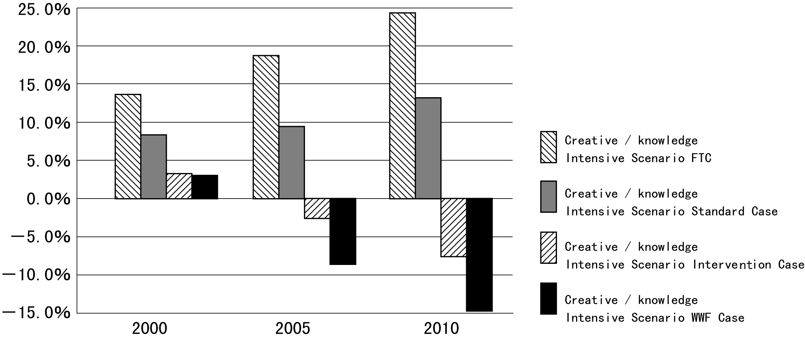

Table 16: The Calculated Change in CO₂ Emission (Ratio from 1173 Mt CO₂ in 1990)
Year | Contemporary Materialistic Nation Scenario  FTC | Contemporary Materialistic Nation Scenario  Standard Case | Contemporary Materialistic Nation Scenario  Intervention Case | Contemporary Materialistic Nation Scenario  WWF Case
2000 | +14.1% | +8.8% | +3.6% | +3.4%
2005 | +19.8% | +10.7% | -1.8% | -7.6%
2010 | +26.4% | +14.7% | -6.1% | -13.4%

Year | Creative/Knowledge Intensive Scenario  FTC | Creative/Knowledge Intensive Scenario  Standard Case | Creative/Knowledge Intensive Scenario  Intervention Case | Creative/Knowledge Intensive Scenario  WWF Case
2000 | +13.6% | +8.4% | +3.2% | +3.0%
2005 | +18.7% | +9.6% | -2.6% | -8.6%
2010 | +24.4% | +12.9% | -7.6% | -14.8%
(FTC = Frozen Technology Case)

Table 17: CO₂ Emissions in 2005 and 2010 and changes compared to 1990 levels (Creative/Knowledge Intensive Nation scenario, each sector includes CO₂ emissions related to electricity consumption)
Case | Year | Industry | Residential | Commercial | Transport | Total
Emission in  1990 (Mt CO₂) | 1990 | 564 | 139 | 123 | 214 | 1173
Frozen Technology (%) | 2005  2010 | +5.6  +7.6 | +37.7  +48.6 | +31.1  +42.2 | +36.1  +46.2 | +18.7  +24.4
Market Oriented (%) | 2005  2010 | +2.5  +2.3 | +15.2  +21.3 | +24.4  +33.2 | +15.6  +22.8 | + 9.6  +12.9
Intervention  (%) | 2005  2010 | -8.3  -14.5 | -6.0  -12.2 | +9.8  +4.4 | +7.9  +8.1 | -2.6  -7.6
WWF (%) | 2005  2010 | -10.2  -15.4 | -18.1  -21.9 | -2.1  -5.2 | -2.6  -15.4 | -8.6  -14.8

Table 18: CO₂ Emission Structure in the WWF Case (Creative/Knowledge Intensive nation Scenario, 2010)
Sector | Year | CO₂ Reduction in Intervention Case from Standard Case  (Mt CO₂) | Additional Factors for CO₂ Reduction in the WWF Case  (Mt CO₂) | CO₂ Reduction in WWF Case from Standard Case (Mt CO₂)
Industry | 2005  2010 | 61.2  94.9 | 10.3  5.1 | 71.5  100.0
Residential | 2005  2010 | 29.7  46.6 | 16.7  13.6 | 46.4  60.2
Commercial | 2005  2010 | 18.0  35.6 | 14.7  11.7 | 32.7  47.3
Transport | 2005  2010 | 16.5  31.2 | 22.4  51.0 | 38.9  82.2
Energy Conversion | 2005  2010 | 18.3  33.4 | 5.9  2.9 | 24.2  36.3
Total | 2005  2010 | 143.7  241.7 | 70.0  84.3 | 213.7  326.0

Table 18 shows CO₂ emission reductions in the WWF Case compared to the Standard Case in Creative/Knowledge Intensive Nation scenario in 2010. The biggest reduction occurs in industry and the transport sector, and the reduction in commercial sector seems to be the most difficult. In comparison with the Standard Case, the WWF Case has the largest reduction in transport sector, which implies that the introduction of hybrid car works most effectively. The CO₂ reduction in the WWF case compared to the Standard Case amounts to 326 million ton CO₂, which is 27.5% of the CO₂ emissions in 1990.
4. Policies and Measures

In the previous chapter we discussed the policies and measures that Japan should have in place in the 21st century in order to achieve emission reductions as resulting from the simulation. The short summary is as follows.

4.1 The Present Status of CO₂ Emissions in Japan

The general belief, that Japan is already very efficient, without possibilities to further reduce emissions, is far from reality. The reasons why CO₂ emissions in Japan are increasing are as follows:
- Energy price is too low, which is not an incentive to save energy.
- Industry uses very short pay back times for energy efficient investments.
- There is widespread misconception that Japan cannot improve its energy efficiency anymore.
- The social and economic structure is such that investments for energy supply systems are favored over investments for systems to save energy. This mechanism lessens incentives for industries to invest in energy efficient technologies.

4.2 Innovative Technologies for CO₂ Emission Reduction

How much possibilities exist for reducing CO₂ emissions in a short term and a long term? This study already shows some of the short term possibilities for introducing efficient technologies. These initial introduction brings forth technical innovations of more energy efficient technologies and renewables in the next decades. This will be the most important factor for Japan to establish its status as a technology innovative country in the world in the 21st century.

The IPCC’s second assessment report indicated that by accumulating energy efficient technologies, there is a possibility to maintain current standard of living with half of energy we consume today by the middle of the 21st century. Weizsäcker of the Wuppertal Institute and Amory Lovins of the Rocky Mountain Research Institute wrote a book titled “Factor Four” which persuasively shows that we can have double wealth with half of the resources we use today with many technical innovations [Weizsäcker et al., 1997]
The possible technical innovation will be caused only if we start early introduction of efficient technologies. We are now standing at a turning point to enter into a better future.

4.3 How to Reduce CO₂ Emissions

- Reduce the cost of efficient technology
If government defines efficient technology as Key Technology and declares the technology as critical for the future growth of the country, government would promote these technologies for their development and commercialization as much as possible.
- Introduction of new and renewable energy
New policies and measures are necessary to achieve the goals of the New Energy Introduction Vision.
(3) Increase the cost of energy with carbon tax and environmental tax

4.4 Key Technology Policies

Government should declare that the following technologies are key technologies to our country and promote their development and market penetration as much as possible by subsidies, tax mechanisms, regulations and other political systems.

1) Industrial Sector
- technology to reduce the unit production energy of basic materials such as steel, paper, cement, and ethylene.
- energy saving technology on a trans- industrial scale (ex. high performance industrial burners)
- cogeneration
- fuel conversion technology to a less carbon content energy

2) Transport Sector
- promote hybrid cars with a more than doubled efficiency
- modal shift technology
- better railway transport system

3) Commercial Sector
- cogeneration
- insulation in buildings
- energy efficient vending machines
- technology to reduce stand-by mode electricity

4) Residential Sector
- insulation in houses
- double efficiency refrigerators
- technology to reduce stand-by mode electricity

5) Energy Sector
- fuel conversion technology to a less carbon content fuels
- efficiency improvement in power plants
- cogeneration

6) Technical Standards to Suppress Excess Energy Consumption
The low energy price has stimulated excess energy use in commercial and household sectors. Regulation of energy efficiency will be necessary.

Following are some examples to regulate excess energy use.
- Excess lighting: regulation of lighting power density per floor space
- Excess cooling and heating: regulation of cooling and heating capacity per floor space
- Design criteria for durable goods: promotion of longer life products by product lifetime standard
- Maximum speed limit mechanism: standard to mount speed limitation for cars

4.5 Other Possibilities

The Utrecht University study evaluated CO₂ emission reduction options for the EU as a whole in 2005. It is based on technologies, but also included a description and quantification of policies required to implement the identified technological options. Among them are the following.
- changing consumption patterns (e.g. by stimulating repair of consumer goods by reduced value added tax tariffs): 15 Mt. CO₂ emission reduction
- efficient use of materials (e.g. recycle system for durable goods, reusable packaging): 30 Mt. CO₂ emission reduction
- regulation of car usage (e.g. by speed limits, modal shift): 20 Mt. CO₂ emission reduction
- shift from air transport to rail transport (e.g. by increasing railway infrastructure, imposing an aviation fuel tax): 10 Mt. CO₂ emission reduction

These options are not included in the AIM study and in this report. Another study has shown a CO₂ scenario that takes into account the transition to public transportation, enhanced material recycling, urban greening to reduce cooling demand [Tsuchiya, 1990]. These studies show that the potential for CO₂ emission reduction is even larger, depending on the policies directed at changing the social system.
We have done the calculations presented in this report, based on the AIM only and focusing on the technical potential already published. Because of difficulty of calculations we have not included other potentials, such as the ones mentioned above

This study is only to indicate, that even by focusing on just limited areas, CO₂ emissions could be reduced drastically. If all possibilities are put into consideration, emissions could be reduced much more, and Japan is well able to do that if the political will exists.
5. Conclusions

This study is a simulation of CO₂ emission reductions between 2000 and 2010 using the AIM, which assumes two scenarios; the Contemporary Materialistic Nation and the Creative/Knowledge Intensive Nation scenario. The economic growth rate is presumed to be 2.3% annually in both scenarios. The energy consumption of industrial, transport, residential and commercial sectors are calculated under these scenarios and the CO₂ emissions are quantified accordingly.

The result of the Creative/Knowledge-Intensive Nation Scenario is as follows. If the policy is focused only on introduction of existing energy saving technology and no new policy is adopted as in the AIM standard case, CO₂ emission will increase by 9.6% in 2005 and 12.9% in 2010 compared to the 1990 level. However, if effective energy saving policies, including regulations and subsidies are adopted and various new efficient technologies are introduced as in the WWF case, the level of CO₂ emissions will be reduced by 8.6% in 2005 and 14.8% in 2010 from the 1990 level. The additional options the WWF case include are Keidanren's Voluntary Action Program, reduction of stand-by mode electricity consumption, efficient vending machines, and introduction of hybrid cars that are twice as efficient as conventional cars, efficient refrigerators, high performance industrial furnaces and other energy efficient technologies.

We have considered the necessary policies and measures to achieve these results, and we have presented the Key Technology Policies to reduce CO₂ emissions effectively. The basic concept of this policy is as follows,
- Today the energy price is so low that energy saving is not stimulated.
- The social mechanism encourages people to spend much energy.
- There are many kinds of efficient energy saving technologies available.
- Lack of information is a major reason that efficient technologies are not widely used.
- The national policy can stimulate industrial aggressive innovation and reduce the cost of these efficient technologies through research and development.
- If the government defines Key Technologies and declares they are critical for the well being of the country, innovations to reduce CO₂ emissions will start to progress.
- National policies should be changed in an innovative way to reduce CO₂ emission.

References

AIM project Team, 1997, AIM interim Report, The CO₂ Emission reduction in Japan, May 1997, National Institute for Environmental Studies

Blok, K., D. van Vuuren, A. van Wijk and L. Hein, 1996, Policies and measures to reduce CO₂ emissions by efficiency and renewables; a preliminary survey for the period to 2005, Dept. of Science, Technology and Society, Utrecht University, commissioned by WWF.

Center for Energy Conservation, 1996, High performance industrial furnace, The Energy Conservation, 9, 1996, Center for Energy Conservation, Japan

Center for Energy Conservation, 1997, Field study report on life style change and energy consumption in household, Center for Energy Conservation, Japan. March, 1997

Environmental Agency, 1996, Technical evaluation report to arrest global warming, Environmental Agency, 1996

Keidanren, 1997, ‘Keidanren’s Volunteer Action Plan’, Keizai Dantai Rengo Kai, 17, June, 1997

Ministry of Post and Telecommunications, 1993, Study on Contribution to better Environment, Ministry of Post and Telecommunications, March, 1993

Nikkei Mechanical, 1997, ‘Regenerative Burner’, 31st, March, 1997, Nikkei Mechanical

Nikkei Mechanical, 1997b, ‘Energy Saving Technologies in Automobiles, Industrial machinery, and Electric Appliances’, 1st, Sept., 1997, Nikkei Mechanical

Second research group, 1996, Yuusikisha Kaigi, Books, Magzine, News paper and energy conservation, Energy saving potentials in electronic publishing, March, 1996, Central Research Institute for Electric power Industry

Toyota, 1997, Toyota Eco Project, Toyota Co., July, 1997

Tsuchiya, H., 1994, Energy Analysis of Daily Activities, Energy for Sustainable Development, International Energy Initiative, Vol.1, NO. 3, 1994, Bangalore, India

Tsuchiya, H., 1990, The CO₂ reduction Scenario for Japan, November, 1990, Nikkei Science, Nippon

Weizsacker, E. von, A. Lovins and H. Lovins, Factor Four—Doubling Wealth, Halving Resource Use, Earth Scan, 1997

Comparison of the studies for the EU and Japan
Dr. Ad van Wijk, Dian Phylipsen, Utrecht University

1. Introduction

The study on policies and measures to reduce CO₂ emissions in Japan has the same goals and backgrounds as a similar study that was carried out for the European Union in 1996 [Blok et al., 1996]. The aim of both studies is to assess the feasibility of CO₂ emission reductions by implementing ambitious policies and measures in relation to the reduction goal as required by the AOSIS (Alliance Of Small Island States). The required reduction target proposed by AOSIS, stated at COP1 in Berlin, is a 20% emission reduction in 2005 compared to 1990 levels for industrialised countries. In contrast with many other studies carried out before, the focus in both the Japan and the EU study is not on technical and economic potentials for energy efficiency improvement and renewables. Both studies concentrate on the question what part of these potentials can be implemented and by which policies and measures.

2. Scope and Approach in both Studies

Business as Usual

Both studies use as a starting point a Business-as-Usual (BaU) scenario with 1990 as the starting year for calculations. In the EU study the BaU scenario is the Conventional Wisdom scenario as presented by the EU [EC, 1996]. The WWF Japan study considers two scenarios, the Contemporary Materialistic Nation scenario and the Creative/Knowledge Intensive scenario. Both scenarios were developed by the National Institute for Environmental Studies in Japan and each distinguishes three cases: a Frozen Technology Case, a Standard Case (or Market Oriented Case) and an Intervention Case. For each scenario a WWF Japan case is studied as a case with additional efficient technologies to the Intervention Case. The Standard/Market Oriented Case of the Creative/ Knowledge Intensive Nation scenario is used as the Business-as-Usual Case for Japan.

The assumptions regarding population size, economic growth, energy use and CO₂ emissions used in the calculations are given in Table 1 for both Japan and the EU.

Table 1: Overview of the assumptions regarding population size, economic growth, energy use and CO₂ emission for Japan and the EU in 1990 and 2005 in the case of Business-as-Usual developments.
Indicator | Japan  1990 | Japan  2005 | EU  1990 | EU  2005
Population (million) | 124 | 127 | 365 | 381
GDP (billion ECU 1985) | 2219 | 2486 | 4331 | 6031
Average GDP growth per year | 2.3% |  | 2.2%
Primary Energy Consumption (EJ) | 19.4 | 22.3 | 55.5 | 63.7
Final Energy Demand (EJ) | 12.9 | 14.3 | 36.2 | 41.5
CO₂ emissions (Mt) | 1173 | 1286 | 3166 | 3388
Options

Both studies evaluate the following options for CO₂ emission reductions:
- More efficient use of energy in the end-use sectors industry, services, households and transportation
- Application of renewable energy sources
- A shift to low carbon fuels
- More efficient use of energy-intensive materials

In the EU study, broader options are evaluated including changes in consumption patterns. To some extent these options may also be included in the intervention case of the Creative/Knowledge Intensive Nation scenario of the AIM model for Japan, since this scenario assumes a shift from the current economic structure (which would persist in the Contemporary Materialistic Nation scenario) in Japan to a more knowledge-based scenario.

Policies and Measures

Both studies are taking into account policies and measures to reduce CO₂ emissions. A key assumption of the EU study is that all proposed policies and measures are fully implemented and effective from the first of January 1998. The implementation assumed in the Japan study is somewhat later, due to time constraints. The following policy measures are considered:
- Standards and regulation can play a role in improving the energy efficiency of appliances, houses, cars, etc.
- Subsidies may for example be used to improve insulation or to introduce new technologies
- Voluntary agreements can be used as an instrument to reach energy efficiency improvement in industrial sectors
- Other instruments, such as fiscal measures to stimulate the development of new technologies or to accelerate the market penetration of more efficient equipment, obligations for renewables and/or CHP, etc.

It should be noted, that for the Japan study the above-mentioned policies and measures are only considered with regard to the additional options in the WWF case. Furthermore, the effect of individual measures cannot be identified.

A more general policy instrument is a carbon tax, of which the application will certainly support other instruments in reducing CO₂ emissions.

Methodology

The methodology used in both studies is not the same.
- In the EU study the effect of the proposed policies and measures on CO₂ emissions were explicitly calculated according to a bottom-up approach, using model results as a Business-as-Usual scenario (the official EU Conventional Wisdom scenario) as an input.
- In the Japan study the effect on CO₂ emission has been calculated by updating the already existing intervention case of the Creative/Knowledge Intensive Nation scenario of the AIM model by adding new technologies. Though AIM is also a bottom-up approach, these new technologies and policies that could be used to introduce them are considered separately.
This difference in methodology means that the results cannot be compared on the same basis. In the Japan study only the results of the additional options are presented separately. This means the base simulations of the Japan study using the AIM model does not present the effects of each of the technologies separately, because the model estimates and optimizes the integrated effects of combined technology systems. In the EU study all options together with policies and measures and the effect of each of them on CO₂ emissions are presented.

3. Results

Overall CO₂ Emission Reduction

The main results with regard to the overall CO₂ emission reduction for the year 2005 are:
- In the WWF Japan study a CO₂ emission reduction of 8.6% is calculated compared to the 1990 level instead of an increase by +9.6% as predicted in the Standard Case of the Creative/Knowledge Intensive Nation scenario.
- In the WWF EU study a CO₂ emission reduction of 14% is calculated compared to the 1990 level instead of an increase by 7% as predicted in the Conventional Wisdom scenario.

Table 2: The CO₂ Emissions in the EU and Japan Studies for the Year 2005
 | Scenario | case | CO₂ emissions ‘90 (Mt. CO₂) | CO₂ emissions 2005 (Mt. CO₂) | difference  (%)
Japan | Creative/Knowledge Intensive Nation | standard case | 1173 | 1286 | +9.6
 | Creative/Knowledge Intensive Nation | WWF case | 1173 | 1072 | -8.6
EU | Conventional Wisdom |  | 3166 | 3388 | +7
 | WWF study |  | 3166 | 2720 | -14

Table 4: Contribution of Individual Sectors to the Overall CO₂ Emission Reduction in 2005
(%, compared to Business-as-usual levels) 1
Sector | Japan | EU
Industry | 33 | 25
Residential sector | 21 | 19
Commercial sector | 15 | 13
Transport | 18 | 15
Energy conversion | 11 | 21
Others² | - | 7
¹ Part of the contribution of fuel shift in the energy conversion sector to emission reduction in the EU study is classified as a contribution to emission reduction in other sectors in the Japan study
² Material efficiency improvement and changes in consumption patterns
Table 3
Comparison Japan and EU Policy and Measure
Option, policy and measure in both EU and Japan studies for the year 2005

Category | Japan |  |  | EU
 | WWF Case | Policy Measures | Effect in 2005 | Options | Policy Measures | CO₂ Effect  M ton
Industry | - KEIDANREN proposals  - Energy efficient industrial devises and machines  - High performance industrial furnace | - Voluntary agreements  - Subsidies to develop and commercialize energy efficient industrial devices and machines  - Subsidies and tax mechanism | - 3.5% reduction in specific energy consumption | - Heavy industry best practice  - Light industry 21% efficiency improvement  - More efficient motor drives  - Reduction of heating energy | - EU wide agreement  - Voluntary agreements  - Efficiency standards  - Building codes | 164
Services | - Reduce stand by electricity consumption  - Building Insulation  - Cogeneration  - Energy efficient vending machines  - High Performance Furnaces | - Prohibit office equipment with stand-by use  - Regulate vending machines energy efficiency  - Regulate excess lighting  - Establish technology authorization standard  - Promote market penetration by subsidies and tax incentives | - 8% reduction electricity  - 50% penetration,1.3%  - 1.6 million kilo liters oil savings | - Retrofit insulation  - More efficient heating  - Energy efficiency new buildings  - More efficient light and appliances | - Subsidies/fiscal measures for insulation  - Efficiency standards for heating  - Subsidize heat pumps, ban on coal firing  - Efficiency standards for lighting | 78
Household | - Reduction stand-by electricity consumption  - Building insulation  - Energy efficient refrigerators | - Prohibit equipment with stand-by use  - Standards and subsidize efficient refrigerators | - 6% reduction electricity use  - Market share 1.8%, 1.8 times efficient | - Retrofit insulation  - More efficient heating and hot water  - Energy efficient new dwellings  - Efficient appliances and lighting | - Subsidies/fiscal measures  - Efficiency standards for heating  - Bans on coal firing  - Strict building codes  - Efficiency standards and subsidies | 124
Transport | - Hybrid gasoline cars  - Hybrid diesel trucks | - Subsidies  - Reform of fuel taxes | - Market share 32%, 2.3 times efficient  - Market share 10%, 1.4 times efficient | - Improve specific energy consumption by 4%/yr  - Changes in modal split  - Efficient freight and air transport | - CAFE(Corporate Average Fuel Economy) standards  - Expansion of rail  - Aviation fuel tax  - Speed limits | 96
Electricity | No extra options |  |  | - CHP 28% of electricity production | - CHP obligation | 46
Renewables | Achieve MITI's targets set in 'New Energy Introduction Vision' | - Subsidies  - Reform of taxes |  | - 500PJ biofuels  - 520 TWh  - 1550 PJ heat production | - Renewable energy obligation  - Better buy back tarifs  - Subsidies/fiscal measures | 90
Material efficiency | Not included |  |  | - Various options | - More material efficient packaging  - Take back schemes for products | 30
Changes in Consumption | Not included |  |  | - Various | - Include energy/CO2 in ecolabelling  - Stimulate repair services | 15
 |  |  |  |  |  | 653

These overall results are presented in Table 2. The results with regard to the options, policies and measures together with the effect per category for both EU and Japan are presented in Table 3. Table 4 shows the contribution of individual sectors to the overall CO₂ emission reduction for Japan and the EU compared a business-as-Usual levels. A comparison between Japan and the EU shows that emission reduction are distributed over the sectors similarly in both countries, with a somewhat higher contribution of industry in Japan, and a higher contribution of the energy conversion sector in the EU.

The CO₂ emission reduction percentages in the Japan and EU study for 2005 differ. There are many explanations for the difference, but the main aspects are:
- Difference in energy consumption between Japan and the EU because of a difference in sector structure, difference in energy carriers used, differences in life style and differences in energy efficiency in various sectors. Although the CO₂ emissions per capita in Japan as well as in the EU are among the lowest among industrial countries, this can by no means be fully attributed to a higher energy efficiency in Japan and/or the EU compared to other countries. There is certainly a large potential for energy efficiency improvement in both Japan and the EU.
- The EU study has taken into account the changes in consumption patterns which the Japan study only slightly includes. Furthermore, other options have been assumed to be implemented more ambitiously in the EU study, e.g. with regard to additional CHP (Combined heat and power production) and renewables.
- In the EU study the effect of all policies and measures is calculated separately, which means that for each option an intensified policy can be implemented. For example, the annual amount of existing buildings that undergo an energy-related retrofit can be increased. The AIM model estimates and optimizes the integrated effects of combined technology systems, and it is based on the selection of least cost technologies for a required service. This means that for combinations of each option cost-effectiveness can be evaluated. The impact of non-economic policy instruments, such as regulation, is analyzed only in the case of a high feasibility.

For both Japan and the EU it was not possible to identify policies and measures that would attain a 20% reduction of CO₂ emissions in the year 2005. One of the main barriers is the relatively short time period, 1998-2005, in which this goal has to be achieved. However, both studies show that a strong and internationally coordinated policy aimed at energy and material efficiency improvement and renewable energy can lead to an effective climate change policy. Such a policy is to a large extent cost-effective and in many respects attractive, for international competitiveness, for employment and of course for alleviating environmental problems.

The EU study has not analyzed policies and measures for the year 2010, because the aim was explicitly to assess the achievability of the AOSIS proposal. The emission reduction rate of 2%/yr associated with the calculated reductions in 2005 for the EU is expected to continue after 2005. This would mean that a CO₂ emission reduction of 24% is reached in 2010 compared to the 1990 level. For Japan the emission reduction in 2010 amounts to 15%.
References
Blok, K., D. van Vuuren, A. van Wijk and L. Hein, 1996, Policies and measures to reduce CO₂ emissions by efficiency and renewables; a preliminary survey for the period to 2005, Dept. of Science, Technology and Society, Utrecht University, commissioned by WWF.

EC, 1996, European Energy to 2020 - A scenario approach, EC-DG Energy, Brussels.
Annex: The AIM model and simulations
Dr. Mikiko Kainuma, Prof. Yuzuru Matsuoka, Prof. Tsuneyuki Morita

1. Introduction

Global warming has a great impact on the world, socio-economy, and it is expected that countermeasures against it will impose a heavy economic burden. It is the same for the Asian-Pacific region, and to promote countermeasures against global warming in this region, it is necessary to predict the amount of greenhouse gases emitted or absorbed by each country and the effects resulting from the introduction of measures to mitigate emissions. To predict and judge these issues, the development of a universal simulation model is indispensable.

The AIM model (Asian-Pacific Integrated Model) estimates the emission and absorption of greenhouse gases in the Asian-Pacific region and judges the impact they have on the national environment and socio-economy. It aims to contribute to policy making against global warming and its evaluation.

2. The Basic Structure of AIM

1) A Tripartite Structure

AIM is an integrated model that can analyze the process chain of greenhouse gas emission, climate change, and its impact. This universal model can make an integrated assessment of each kind of countermeasures against global warming, since it can examine not only the socio-economy of each country and region in relation to climate change have on such socio-economy.

As shown in Figure 1, the complete structure of AIM is made up of a greenhouse gas emissions model (AIM/emission) that forecasts the amount of anthropogenic greenhouse gas emissions, a warming phenomenon model (AIM/climate) that forecasts the concentration of greenhouse gases in the atmosphere and estimates the temperature increase, and a warming impact model (AIM/impact) that estimates the influence that climate change has on the natural environment and socio-economy of the Asian-Pacific region.

2) Top-down, Bottom-up

The greenhouse gas emissions model is made up of models of social and economic activities that becomes the origin of greenhouse gas emissions through energy consumption, changing land use, and agricultural and industrial production. At its heart lies the energy model, and as Figure 2 shows, it is made up of a World Model as well as Country-specific Models for the Asian-Pacific region. The World Model is a top-down model that uses economic indices based on prices and elasticities to express the connection between energy consumption and production. The country-specific model is a bottom-up model that focuses on the activities of the people who deal with industrial production and the consumption of energy as well as the change in the technology used in these countries, and forecasts from these detailed descriptions the total energy consumption and production.

For a long-term forecast, a top-down world model based on market equilibrium that forecasts world economic activity and change is indispensable. Likewise, to explain the exact direction of policy and its effects to policy makers and politicians, a detailed and persuasive bottom-up model is essential.

Figure 1. Outline of AIM Model

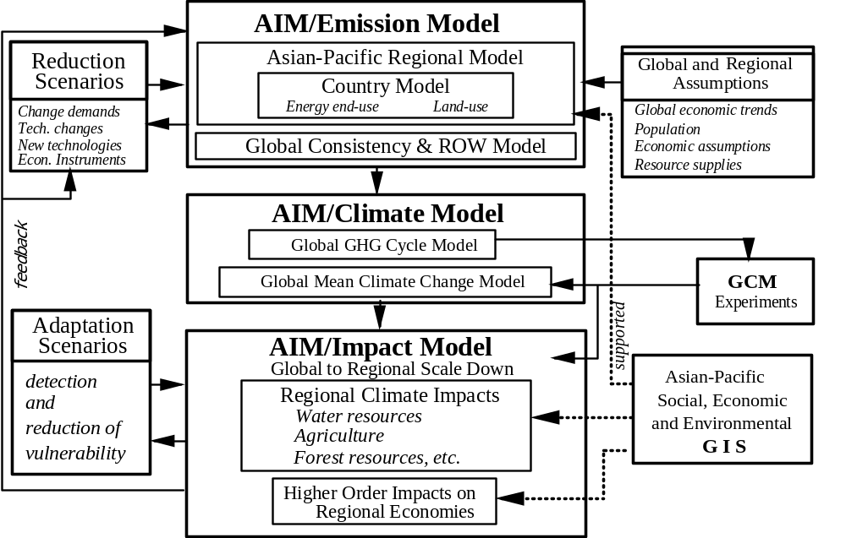

Figure 2. Structure of AIM Emission Model

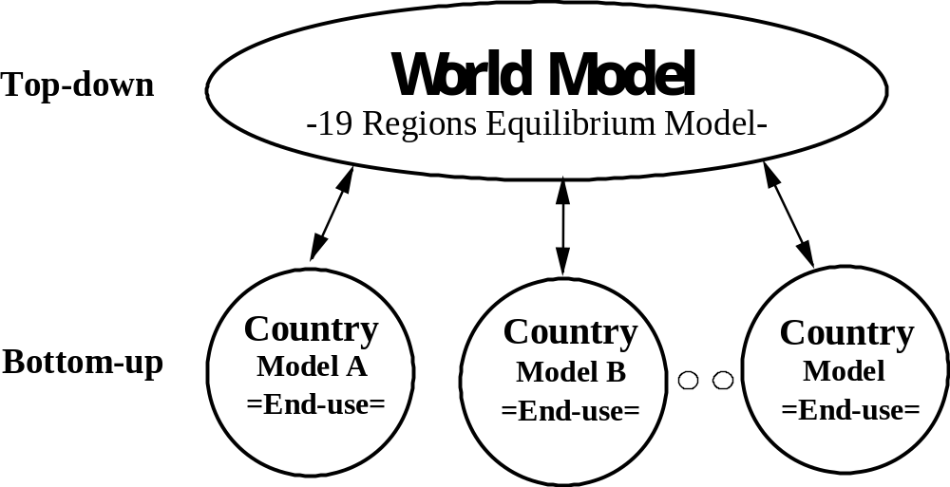

3. Outline of the AIM/End-Use Model

1) Aiming at Simulating Individual Energy Processes

Bottom-up models have so far been developed in two directions. One is a model for analyzing more efficient technologies and combinations by focusing on the supply and conversion side of energy. The other one, commonly known as “end-use model,” is a model focusing on the energy demand and consumption side that sums up details about how changing patterns of human activity in each sector change the energy demand.

We need a lot of energy services in our daily life. Included in it are the production of steel, cement, and plastics, cooling and heating, lighting, and transportation as well as steam and electricity that are used to produce such energy services. Technology such as blast furnaces, air conditioning and automobiles offer energy services by using energy such as oil, coal, and gas.

As shown in Figure 3, the AIM/end-use model first estimates energy service demands based on socio-economic factors such as population, economic growth, industrial structure, and lifestyle, and then calculates what kind of technology will be used to what extent. To compare and consider energy technologies, detailed technological data and energy data are prepared. Once the kind of energy technology to be used is known, the model calculates the energy necessary to provide the energy services and the amount of CO₂ emissions produced when each type of energy technology operates.

Figure 3. The Structure of AIM/End-use Model
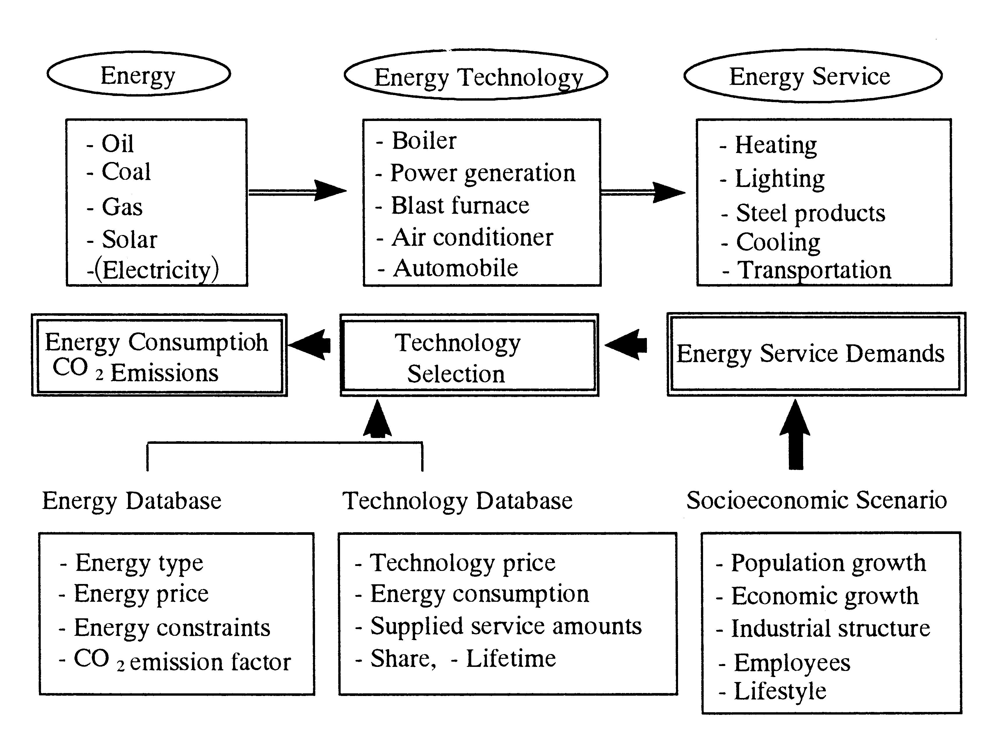
2) How is the Technology in the Model Selected?

For example, let us consider heating a room. There are a number of technologies like air conditioners and oil and gas stoves for heating a room. But which technology is selected for heating in reality? There are a number of criteria for selection. This model selects a technology on the basis of cost. In this case, the method of evaluation differs depending on whether the technology to offer heating service is already at hand or not.

Costs consist of fixed costs and maintenance costs such as fuel costs. Fuel costs accrue continuously every year, but fixed costs are necessary only at the time when one buys the machine. Since one uses the energy technology for a number of years, one looks at the future and compares prices when one considers the introduction of technology. As shown in Figure 4, there are two ways of making this comparison.

When one does not have a technology, or when the time has come to change a technology one already has, one includes the introduction costs and chooses the cheapest technology. If one already has a technology and the time to change it has not come yet, one looks at the operating costs of the old technology and the sum of the costs of introducing, or upgrading, the old technology to the new technology one is thinking of, and its operating cost. One replaces the old technology or upgrades it when the operating costs become less to an extent that compensates for the introduction costs.

Figure 4. Technology Selection Processes

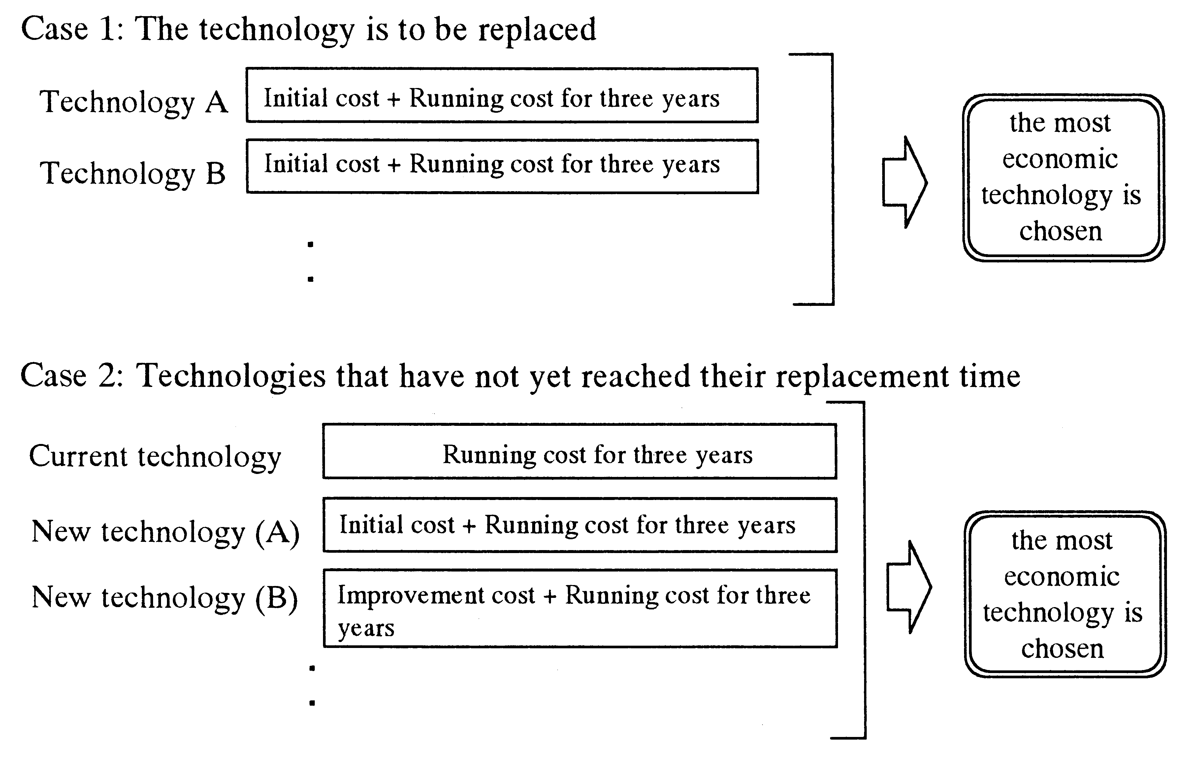
4. The Special Features and Limitations of the AIM/End-Use Model

1) Detailed Reproduction of Technology Substitution

To decrease CO₂ emissions, it is key what kind of energy-saving technology one can introduce to what extent from an end-use point of view. The AIM end-use model focuses on the fact that substitution technology will be available according to energy price fluctuation and estimates energy efficiency and energy consumption on the basis of each technology. Therefore, it is possible to evaluate the effectiveness of each policy or combined various policies.

2) No Guarantee for General Equilibrium

However, the end-use model has some limitations. The first is that so far it is not linked to a top-down economic model, so energy service demand is provided by scenarios. Thus, it cannot estimate macro-economic losses because it does not take into account direct effects of higher prices in controlling energy demand and indirect economic effects through suppression of consumption or reduction of savings. A second problem is that since it does not consider social costs, such as institutional obstacles, while selecting technologies, it might overestimate the reduction of CO₂ emissions caused by each technology. A third is that it might underestimate the overall CO₂ emissions reduction potentials, because technologies such as those currently not available are not included. Some of these limits arise from the inherent restrictions of the end-use model, as well as the model being still under development. Thus, it is necessary to take these points into considerations when interpreting the results of this research. However, even with these limitations, this model is superior as a tool for judging the effects of each policy options or joint effects of various policies, in terms of its practicality and policy supporting mechanisms, than normal economic models that persist on reproducing economic paradigms.

5. The Structure of the End-use Model

1) Five Sectors and 200 Technologies

Table 1 shows the sectors and fields that were used for forecasting Japanese CO₂ emissions. Energy service and technology selection for each sector and field are decided so that energy consumption and CO₂ emissions can be estimated. For this purpose, energy service demands are estimated based on socio-economic data. Next, basic data, such as introduction cost, energy consumption per unit and lifetime for almost 200 kinds of energy technologies are collected and included in a database. Fuel prices and CO₂ emission factors are also stored. Although limestone is not used as a fuel, it is included in the analysis because it causes CO₂ emissions while being used as a raw material in the cement industry and to remove impurities in the steel production process.
Table 1: Studied Sectors and Fields
Sectors | Industrial | Residential | Commercial | Transportation | Energy Conversion
Fields | Iron and Steel  Cement  Petrochemical  Pulp and Paper  Other  Industries | Cooling and  Heating  Hot Water  Supply  Lighting  Buildings  Transportation  etc. | Cooling and  Heating  Hot Water  Supply  Lighting  Building  Transportation  etc. | Passenger  Transport  Freight  Transport | City Gas Manufacturing  Oil Refining  Electric Power  Generation

2) Deciding the Most Suitable Energy Consumption

Based on these premises and data, the AIM end-use model estimates energy consumption and CO₂ emissions in the following way:

i) It calculates the amount of energy service (the demand for manufacturing of
products, transport, and air-conditioning, etc.) using scenarios and models.
ii) It selects the service technology to meet this service demand.
iii) It calculates the amount of energy necessary for the operation of the technology.
iv) It estimates the amount of CO₂ emissions on the basis of energy consumption by fuel type as determined above.

The most important judgment made in this procedure is that of selecting service technologies. Since the technology selection process is programmed in, technology selection changes when a carbon tax or subsidies are introduced, and as a consequence, the energy consumption and amount of CO₂ emissions change as well. For example, when one introduces a carbon tax, the price of energy increases, and because of this, the amount saved by not using as much fuel increases, and as a result, one can introduce relatively expensive energy-saving technologies. Similarly, if the initial cost of energy-saving technology decreases due to the introduction of a subsidy, the introduction of that technology will be promoted.

6. Case Studies in Japan

1) Anticipated Structural Change

When one looks at the long-term period, that is the first half of the next century, one must not forget that there is great uncertainty regarding the change of the social structure such as population. For example, the Japanese population will reach a peak in 2010 and then decrease. In addition, the majority of the post-war baby boom generation will move toward retirement around that time. It is possible that such changes will greatly change the life style of the people and the direction of economic development. Furthermore, if economy continues to become global in the next century, China and other countries will reach the economic standard of Japan in the 1970s by 2030. As a result, one can easily predict that the industrial structure of Japan will change greatly. On the other hand, we predict that wide-spread environmental impacts, such as acid rain from the burning of coal in China, will become apparent in East Asia in the beginning of the next century. Therefore, it is very likely that the investment for countermeasures against environmental pollution will increase at a breath and the cost for these technology will decrease very quickly. This kind of structural change will have great impact on the amount of CO₂ emissions. However, the degree of this change is very uncertain. For this reason, a perspective that incorporates this uncertainty is necessary.
Let us now assume two scenarios for Japan’s future. The first scenario is one in which little structural change occurs and the usual consumption-dependent lifestyle as well as the existing manufacturing productive activities are maintained as much as possible. Let us call this scenario the “contemporary materialistic nation scenario.” The other scenario is one where the Japanese social structure undergoes a great shift toward a production system and lifestyle that takes intellectual activities seriously, and we assume that structural change occurs on a great scale. We call it the “creative/knowledge-intensive nation scenario.”
If one assumes for each of these cases a scenario with parameters like economic growth rate, an industrial structure and shipments, necessary office space, and extent of transportation as depicted in Tables 2 and 3, what amount of CO₂ will be emitted? On the basis of these assumptions, we conducted the computer simulation analysis.

2) Quick Reduction Measures are Necessary

First, we determined by simulation what amount of energy services will be necessary for the two cases, and summed up the details of individual energy-using processes and determined what kind of technologies will be chosen in the market to meet the demand for these services. Figure 5 shows the future perspective of CO₂ emissions for the “contemporary materialistic nation scenario” and the “creative/knowledge-intensive nation scenario.”

If consumers and firms do not acknowledge the merit of fuel savings through energy saving and new technology does not spread (Frozen Technology Case), CO₂ emissions will increase by 26% by the year 2010 in comparison with 1990 for the “contemporary materialistic nation scenario” and 24% for the “creative/knowledge-intensive nation scenario.”

If the cheapest technology spreads based on the market principle (Market-Oriented Case), the increase of CO₂ emissions will be between 13% and 15%. Even if the energy-saving technology is somewhat expensive, the spread of the technology proceeds because it is possible to recover the costs through fuel savings in a short period of time. However, the computer model used does not take into account information imperfections in the market and other social factors, and thus it is possible that it overestimates the energy efficiency improvement. One must therefore assume that the actual amount of CO₂ emissions will be higher than this estimate.

In either case, if no special countermeasures such as government intervention occurs, the amount of CO₂ emissions will continue to increase. Quick actions are necessary to stabilize and reduce the CO₂ emissions.
Table 2: Simulation Assumptions (Contemporary Materialistic Nation Scenario)
 | 1990 |  |  | 1994 |  | 2000 |  | 2010
Population (1000 People) | 123,611 |  |  | 125,034 |  | 126,892 |  | 127,623
Economic Growth Rate (Annual Rate*) |  | 1.46% |  |  | 2.90% |  | 2.30%
Industrial Structure |  | (Real GDP, 1990 base)
Industrial Sector (Total) | 39.0% |  | 37.2% |  |  | 36.1% |  | 36.0%
Agriculture, Forestry, Fishing | 2.4% |  | 2.1% |  |  | 1.8% |  | 1.5%
Mining | 0.2% |  | 0.2% |  |  | 0.2% |  | 0.1%
Construction | 9.6% |  | 9.8% |  |  | 8.7% |  | 8.2%
Manufacturing Sector (Total) | 26.8% |  | 25.1% |  |  | 25.4% |  | 26.1%
Foodstuffs | 2.7% |  | 2.6% |  |  | 2.2% |  | 1.8%
Textiles | 0.6% |  | 0.5% |  |  | 0.4% |  | 0.3%
Paper and Pulp | 0.7% |  | 0.6% |  |  | 0.6% |  | 0.6%
Chemicals | 2.1% |  | 2.3% |  |  | 2.3% |  | 2.4%
Oil and Coal Products | 0.9% |  | 0.9% |  |  | 0.7% |  | 0.6%
Ceramics | 1.0% |  | 0.9% |  |  | 0.7% |  | 0.6%
Iron and Steel | 1.6% |  | 1.5% |  |  | 1.4% |  | 1.2%
Nonferrous Metals | 0.5% |  | 0.4% |  |  | 0.4% |  | 0.4%
Machinery | 12.5% |  | 11.9% |  |  | 12.7% |  | 14.6%
Other Industrial Sectors | 4.2% |  | 3.5% |  |  | 3.8% |  | 3.6%
Commercial Sector | 60.9% |  | 62.8% |  |  | 63.9% |  | 64.0%
Number of Households (1000) | 40,670 |  | 42,991 |  |  | 46,617 |  | 49,514
Office Space (Million m2) | 1,286 |  | 1,453 |  |  | 1,613 |  | 1,861
Passenger Transport (Billion People x km) | 1,298 |  | 1,360 |  |  | 1,500 |  | 1,755
Freight Transport (Billion Tons x km) | 547 |  | 544 |  |  | 583 |  | 654

Table 3: Simulation Assumptions (Creative/Knowledge-Intensive Nation Scenario)
 | 1990 |  | 1994 |  | 2000 |  | 2010
Population (1000 People) | 123,611 |  | 125,034 |  | 126,892 |  | 127,623
Economic Growth Rate (Annual Rate*) |  | 1.46% |  | 2.90% |  | 2.30%
Industrial Structure |  | (Real GDP, 1990 base)
Industrial Sector (Total) | 39.0% |  | 37.2% |  | 35.8% |  | 35.1%
Agriculture, Forestry, Fishing | 2.4% |  | 2.1% |  | 1.8% |  | 1.5%
Mining | 0.2% |  | 0.2% |  | 0.2% |  | 0.1%
Construction | 9.6% |  | 9.8% |  | 8.6% |  | 8.0%
Manufacturing Sector, Total | 26.8% |  | 25.1% |  | 25.2% |  | 25.5%
Foodstuffs | 2.7% |  | 2.6% |  | 2.2% |  | 1.8%
Textiles | 0.6% |  | 0.5% |  | 0.4% |  | 0.3%
Paper and Pulp | 0.7% |  | 0.6% |  | 0.6% |  | 0.5%
Chemicals | 2.1% |  | 2.3% |  | 2.3% |  | 2.4%
Oil and Coal Products | 0.9% |  | 0.9% |  | 0.7% |  | 0.6%
Ceramics | 1.0% |  | 0.9% |  | 0.7% |  | 0.6%
Iron and Steel | 1.6% |  | 1.5% |  | 1.4% |  | 1.1%
Nonferrous Metals | 0.5% |  | 0.4% |  | 0.4% |  | 0.4%
Machinery | 12.5% |  | 11.9% |  | 12.7% |  | 14.4%
Other Industrial Sectors | 4.2% |  | 3.5% |  | 3.8% |  | 3.5%
Commercial Sector | 60.9% |  | 62.8% |  | 64.2% |  | 64.9%
Number of Households (1000) | 40,670 |  | 42,991 |  | 46,617 |  | 49,514
Office Space (Million m2) | 1,286 |  | 1,453 |  | 1,624 |  | 1,901
Passenger Transport  (Billion People x km) | 1,298 |  | 1,360 |  | 1,500 |  | 1,755
Freight Transport (Billion Tons x km) | 547 |  | 544 |  | 583 |  | 654
*Note: The last Economic Deliberation Council report (12/1996) sees an annual growth rate of 1.9% for the years 200-2010, but here we use a higher economic growth rate that has been the assumption of this research all along.

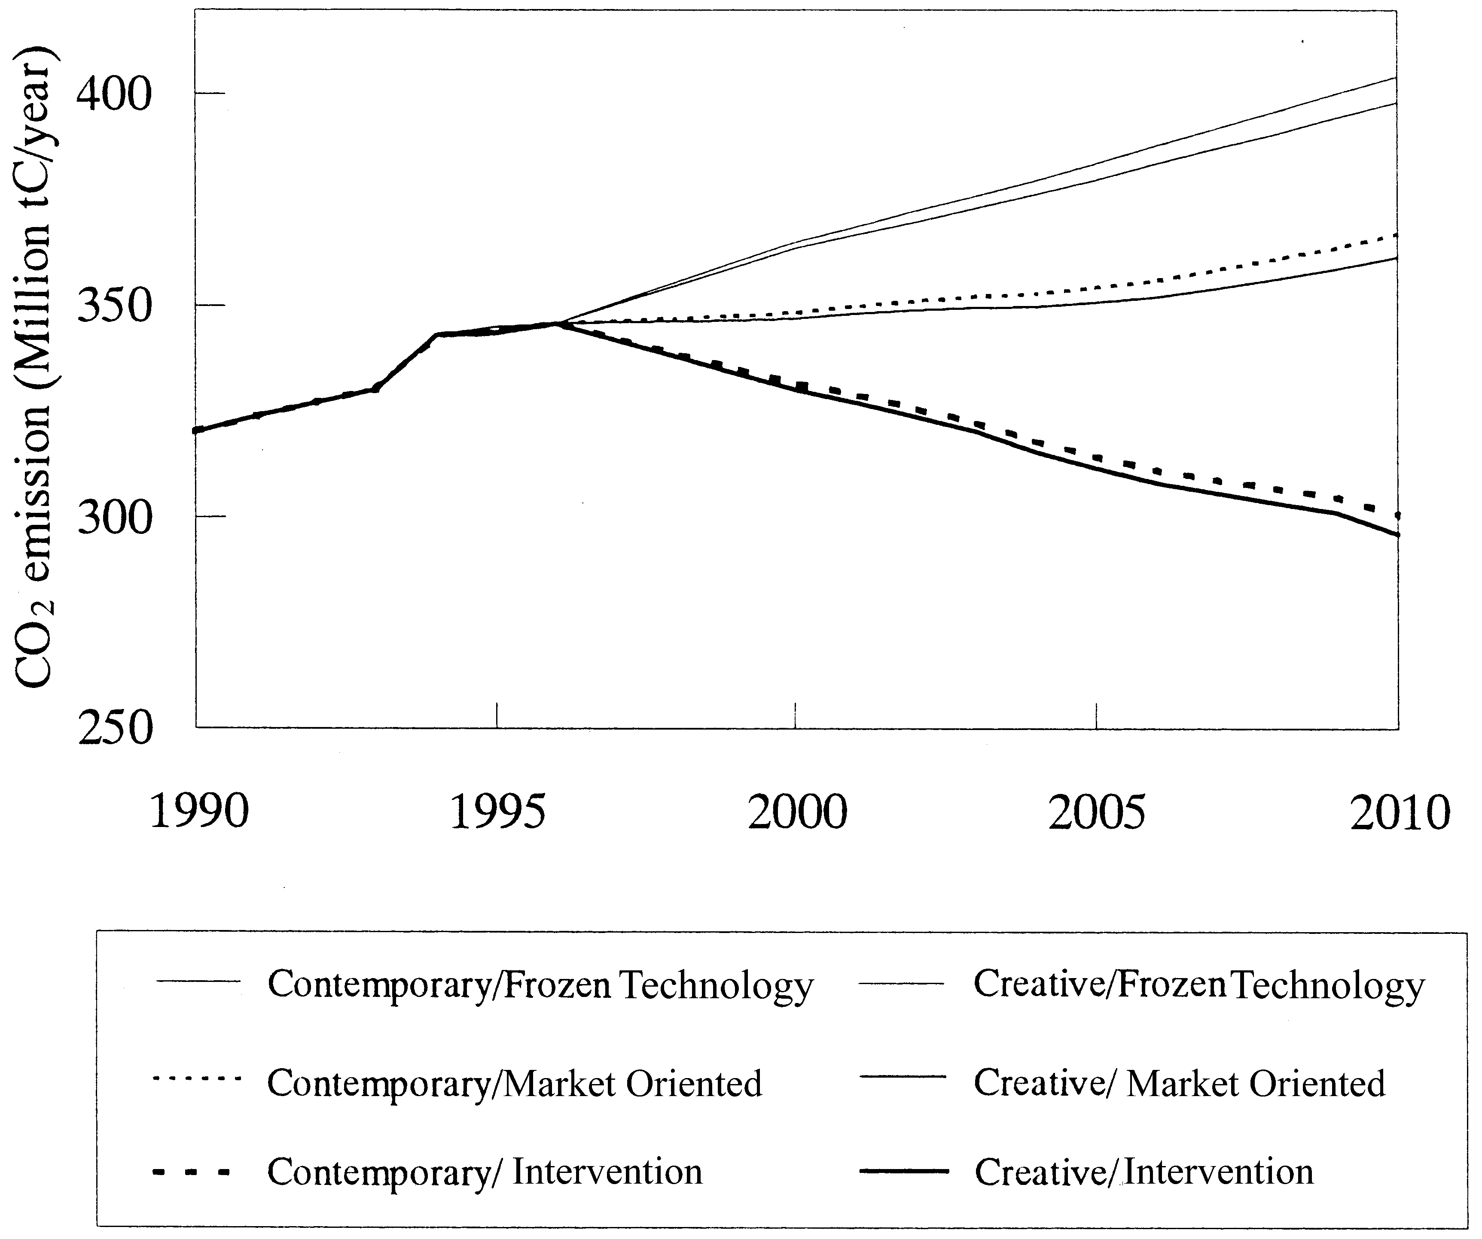
Figure 5.

3) How Much can CO₂ Emissions be Reduced

How much can CO₂ emissions be reduced through countermeasures? Without decreasing the production level and lowering the living standards as assumed in the two scenarios, we used the same model to simulate to what extent CO₂ emissions can be reduced just by introducing efficient technology. To be precise, in respect to energy-saving and recycling technology that are not market competitive with the predicted energy prices, we propose a carbon tax of, for instance, 30,000 yen (US$250) per ton of carbon to promote the technology. However. if we assume that this tax is returned to firms and households to introduce energy-saving and recycling technology, a carbon tax of 3,000 yen (US$25) per ton of carbon would be sufficient. This would mean a burden of 2 yen (US$0.017) per liter of gasoline and would accelerate the introduction of energy-saving technology across various fields.

Through such measures, it becomes possible to reduce CO₂ emissions by the year 2010 by 7.6% as compared to 1990 level for the "creative/knowledge-intensive nation scenario". For the "contemporary materialistic nation scenario", a possible reduction of 6.1% was indicated. For each sector, Tables 4 through 8 show the technology substitution that can occur in energy consumption use and production. Even increasing productive activities and raising standards of living, significant CO₂ reduction is possible.
7. Conclusions

It is possible to decrease CO₂ emissions without scaling back productive activity or standards of living in Japan. However, if one relies on the market mechanism alone, it cannot be done. Our analysis has clearly shown that it is indispensable to introduce new policies and measures such as carbon tax and subsidies.

If one tries to reduce CO₂ emissions even further, the necessary costs will certainly become larger. These are certainly costs for the firms and households to bear the burden of reducing CO₂ emissions. However, it is an increase of effective demand for the producers of energy-saving technology. It is estimated that the indirect cost for Japan as a whole will be extremely small through energized environmental industries.

The likelihood is high that in the next century social-structural change will transform our society from a "contemporary materialistic nation" to a "creative/knowledge-intensive nation". This transformation will make it relatively easier to control CO₂ emissions and take countermeasures to protect global environment. One could say that the social system of Japan is changing so that it will be advantageous to introduce environmental policies.

We are painting a scenario in which Japan grasps this chance and becomes a global leader in environmental policy, a scenario for a sustainable development of Japan. This concept is exactly what is needed in Japan today.

Acknowledgment
This research is funded by the Environment Research Program of the Japan Environment Agency. We are grateful to Masaya Yoshida, Go Hibino and Hisaya Ishii of the Fuji Research Institute Corporation, and Kenta Mizuno of Wakachiku Construction for their extensive supports.
Table 4: Technology Substitution in the Industrial Sector
Sector | Use | Technology | 1990 | 1994 | 2000 | 2010
Iron and  Steel | Coke Wet Adjustment | Without Coke Adjustment Equipment  Coke Wet Adjustment Equipment | 95.6%  4.4% | 95.1%  4.9% | 95.7%  4.3% | 80.0%  20.0%
Industry | Coke Production Process | Conventional Coke Oven | 100.0% | 100.0% | 100.0% | 80.0%
 |  | Next Generation Coke Oven | 0.0% | 0.0% | 0.0% | 20.0%
 | Coke Quenching Process | Coke Wet Type Quenching | 43.9% | 30.0% | 31.8% | 0%
 |  | Coke Dry Type Quenching | 56.1% | 70.0% | 68.2% | 100.0%
 | Blast Furnace Process  (Top Pressure Recovery | Without Top Pressure Recovery  Turbine | 3.4% | 0.8% | 0% | 0%
 | Power Generation) | Wet Top Pressure Recovery Turbines | 91.0% | 91.0% | 60.0% | 21.2%
 |  | Dry Top Pressure Recovery Turbines | 5.6% | 8.2% | 40.0% | 78.8%
 | Blast Furnace Process  (Waste Plastic) | Waste Plastic (kg/t-Hot Metal) | 0 | 0 | 3 | 10
 | Basic Oxygen Furnace | Without Scrap Use | 100% | 100% | 95.0% | 90.0%
 | Process | Scrap Use (25%) | 0% | 0% | 5.0% | 10.0%
 | Molten Steel Production  Process | Basic oxygen Furnace  Electric Arc Furnace | 69.3%  30.7% | 68.7%  31.3% | 65.0%  35.0% | 50.0%  40.0%
 |  | Direct Iron Ore Smelting Reduction  Furnace | 0.0% | 0.0% | 0.0% | 10.0%
 | Casting Process | Ingot making | 7.0% | 5.4% | 3.0% | 0.0%
 |  | Continuous Caster | 93.0% | 94.6% | 97.0% | 100.0%
 | Reheating Process | Conventional Reheating Furnace | 59.5% | 50.0% | 31.0% | 0.0%
 |  | Hot Charge Rolling | 40.5% | 50.0% | 69.0% | 100.0%
 | Annealing Process | Conventional Annealing Furnace | 56.5% | 56.9% | 52.1% | 5.6%
 |  | Continuous Annealing Furnace | 43.5% | 43.1% | 47.9% | 94.4%
 | Industrial-Owned Power | Conventional Power Plant | 93.9% | 93.0% | 88.2% | 0.0%
 | Generation | Repowering | 0.0% | 0.0% | 4.5% | 92.1%
 |  | Top Pressure Recovery Turbine/  Coke Dry Type Quenching | 6.1% | 7.0% | 7.3% | 7.9%
 | Electric Arc Furnace | Alternating Current Electric Arc  Furnace | 99.8% | 99.1% | 73.8% | 1.0%
 |  | Direct Current Arc Furnace | 0.2% | 0.9% | 26.2% | 99.0%
Cement  Industry | Raw Meal Grinding  Process | Tube Mill  Vertical Mill | 63.8%  36.2% | 59.3%  40.7% | 47.8%  52.2% | 18.1%  81.9%
 | Pyro-process | Other than NSP/SP | 7.7% | 11.9% | 0.0% | 0.0%
 |  | NSP /SP (New) Suspension Preheater | 92.3% | 88.1% | 100.0% | 91.8%
 |  | Fluidized Bed Sintering Furnace | 0.0% | 0.0% | 0.0% | 8.2%
 | Clinker Cooler Process | Conventional Clinker Cooler | 100.0% | 100.0% | 68.3% | 52.3%
 |  | High Efficiency Clinker Cooler | 0.0% | 0.0% | 31.7% | 47.7%
 | Clinker Grinding Process | Without Pre-grinder | 94.3% | 94.5% | 95.5% | 97.5%
 |  | Pre-grinder | 5.7% | 5.5% | 4.5% | 2.5%
 | Blast Furnace Slag | Tube Mill | 52.4% | 47.9% | 42.0% | 34.4%
 | Grinding | Vertical Mill | 47.6% | 52.1% | 58.0% | 75.6%
 | Industrial-owned Power | Conventional Power Generation | 61.0% | 58.5% | 38.8% | 5.5%
 | Generation | Waste Heat Power Generation | 39.0% | 41.5% | 44.9% | 51.1%
 |  | Combined Cycle Generation | 0.0% | 0.0% | 16.3% | 43.3%
 | Blast Furnace Slag | For Blast Furnace Slag Cement | 59.0% | 59.0% | 70.0% | 80.0%
 |  | Other Use | 41.0% | 41.0% | 30.0% | 20.0%
 | Fly Ash | For Fly Ash Cement | 6.0% | 6.0% | 20.0% | 100.0%
 |  | Other Use | 94.0% | 94.0% | 80.0% | 0.0%

Table 4b Technology Substitution in the Industrial Sector
Sector | Use | Technology | 1990 | 1994 | 2000 | 2010
Petrochemical  Industry | Naphtha Cranking  Process | Conventional Naphtha Cranking Device  High Performance Naphtha Cranking  Device | 51.1%  48.9% | 44.3%  55.7% | 27.3%  72.7% | 0.0%  100.0%
 | Low Density  Polyethylene  Manufacturing  Process | Conventional Low Density Polyethylene Manufacturing Device  High Performance LDPE Manufacturing  Device | 70.7%  29.3% | 66.4%  33.6% | 67.3%  32.7% | 40.1%  59.9%
 | Polypropylene  Manufacturing Device | Conventional Polypropylene  Manufacturing Device | 92.2% | 92.8% | 92.7% | 76.4%
 |  | High Performance Polypropylene  Manufacturing Device | 7.8% | 7.2% | 7.3% | 23.6%
 | Steam | Conventional Boiler | 100.0% | 100.0% | 93.9% | 53.8%
 |  | Boiler Combustion Control | 0.0% | 0.0% | 6.1% | 36.2%
 | Industrial-owned | Conventional Power Plant | 100.0% | 100.0% | 74.8% | 0.0%
 | Power Generation | Repowering | 0.0% | 0.0% | 25.2% | 100.0%
Pulp and Paper | Caustification | Conventional Caustification Device | 100.0% | 100.0% | 100.0% | 79.8%
Industry |  | Direct Caustification | 0.0% | 0.0% | 0.0% | 20.2%
 | Pulp Cooking Process | Conventional Cooking Device | 73.5% | 67.6% | 38.6% | 19.5%
 |  | Pre-filtration Continuous Cooking  Device | 26.5% | 32.4% | 61.4% | 80.5%
 | Pulp Washing Process | Conventional Pulp Washing Device | 67.0% | 54.8% | 32.3% | 16.0%
 |  | High Performance Pulp Washing Device | 33.0% | 45.2% | 67.7% | 84.0%
 | Delignification Process | Conventional Delignification Device | 75.0% | 65.8% | 37.0% | 0.0%
 |  | Oxygen Delignification Device | 25.0% | 34.2% | 63.0% | 100.0%
 | Bleaching Process | Drum Bleaching Device | 98.0% | 96.0% | 64.7% | 47.4%
 |  | Defuser Bleaching Device | 2.0% | 4.0% | 35.3% | 52.6%
 | Drum Vaporing | Conventional Vapor Drum | 91.0% | 88.6% | 47.3% | 0.0%
 | Process | High Performance Vapor Drum | 9.0% | 11.4% | 52.7% | 100.0%
 | Drying Process | Conventional Dryer Hood Device | 97.6% | 92.2% | 56.2% | 39.6%
 |  | High Performance Dryer Hood Device | 2.4% | 7.8% | 43.8% | 60.4%
 | Size Press Process | Conventional Size Press Device | 79.5% | 72.5% | 41.8% | 0.0%
 |  | High Performance Size Press Device | 20.5% | 27.5% | 58.2% | 100.0%
 | Dehydration Process | Conventional Bearing Dehydration  Device | 92.0% | 83.8% | 55.2% | 0.0%
 |  | High Performance Bearing Dehydration  Device | 8.0% | 16.2% | 44.8% | 100.0%
 | Industrial-owned | Conventional Power Plant | 100.0% | 100.0% | 74.8% | 0.0%
 | Power Generation | Repowering | 0.0% | 0.0% | 25.2% | 100.0%
 | Steam | Conventional Boiler | 100.0% | 100.0% | 88.6% | 85.7%
 |  | Boiler Combustion Control | 0.0% | 0.0% | 11.4% | 14.3%
 | Electric Media | Reduction of Production | 0.0% | 0.0% | 0.0% | 10.0%
 | Use of Waste Paper |  | 52.0% | 53.6% | 56.0% | 60.0%
Miscellaneous | Steam | Conventional Boiler | 100.0% | 100.0% | 73.2% | 55.1%
 |  | Boiler Combustion Control | 0.0% | 0.0% | 16.8% | 44.9%
 | Furnace | Conventional Furnace | 100.0% | 100.0% | 73.2% | 55.1%
 |  | High Performance Furnace | 0.0% | 0.0% | 16.8% | 44.9%
 | Motor | Conventional Motor | 100.0% | 100.0% | 84.0% | 56.0%
 |  | High Efficient Inverter Control Motor | 0.0% | 0.0% | 16.0% | 44.0%

Table 5: Technology Substitution in the Residential Sector
Sector | Use | Technology | 1990 | 1994 | 2000 | 2010
Residential | Cooling | Conventional Air-conditioners * | 100.0% | 99.8% | 32.4% | 0.0%
Sector |  | Energy-Saving Air-conditioners * | 0.0% | 0.0% | 67.6% | 100.0%
 |  | Gas Air-conditioners | 0.0% | 0.1% | 0.0% | 0.0%
 |  | Oil Air-conditioners | 0.0% | 0.1% | 0.0% | 0.0%
 | Heating | Conventional Air-conditioners | 13.8% | 14.8% | 17.3% | 0.0%
 |  | Energy-Saving Air-conditioners | 0.0% | 0.0% | 37.5% | 75.0%
 |  | Gas Air-conditioners | 0.0% | 0.1% | 0.0% | 0.0%
 |  | Oil Air-conditioners | 0.0% | 0.1% | 0.0% | 0.0%
 |  | Oil Stoves | 37.0% | 35.3% | 37.4% | 22.6%
 |  | Oil Fan Heaters | 21.7% | 21.0% | 6.6% | 1.6%
 |  | Oil Warm Air Heaters | 7.6% | 7.6% | 0.0% | 0.0%
 |  | Others ** | 20.0% | 21.2% | 1.2% | 0.8%
 | Hot Water | Oil Water Heaters | 18.1% | 17.5% | 17.3% | 10.2%
 |  | Gas Water Heaters | 67.4% | 66.4% | 70.0% | 42.3%
 |  | Electric Water Heaters | 8.1% | 11.1% | 3.0% | 19.8%
 |  | Latent Heat Recovery Type Water Heater | 0.0% | 0.0% | 3.5% | 19.0%
 |  | Solar Thermal Water Heater | 6.4% | 5.0% | 2.2% | 3.7%
 |  | Solar Systems | 0.0% | 0.0% | 4.0% | 5.0%
 | Lighting | Fluorescent Lights | 63.0% | 63.0% | 63.0% | 63.0%
 |  | Incandescent Lights | 37.0% | 37.0% | 18.5% | 7.4%
 |  | Fluorescent Lights of Incandescent Type | 0.0% | 0.0% | 18.5% | 29.6%
 | Houses | Highly Insulated Houses | 0.0% | 0.0% | 0.0% | 25.9%
 | Electricity | Photovoltaic Power Generation Plant | 0MW | 0MW | 0MW | 2160MW

* Including those for cooling only.
** Including gas fan heaters (LNG and LPG), gas warm air heaters (LNG and LPG), electric stoves, electric ceramics heaters.
*** Sum of LNG and LPG.

Table 6: Technology Substitution in the Commercial Sector
Sector | Use | Technology | 1990 | 1994 | 2000 | 2010
Commercial | Cooling | Cogeneration | 0.0% | 0.1% | 1.9% | 1.7%
Sector |  | Electric Air-conditioning | 99.9% | 99.7% | 97.8% | 83.3%
 |  | Gas Heat Pump | 0.1% | 0.2% | 0.3% | 15.0%
 | Heating | Cogeneration | 0.0% | 0.3% | 5.0% | 4.4%
 |  | Electric Heating | 6.9% | 11.7% | 7.1% | 0.0%
 |  | Oil Heating | 82.3% | 78.6% | 75.4% | 70.0%
 |  | Gas Heating * | 9.2% | 8.2% | 11.0% | 1.6%
 |  | Coal Heating | 1.5% | 1.0% | 1.0% | 1.0%
 |  | Gas Heat Pump | 0.1% | 0.2% | 0.5% | 23.0%
 | Hot Water | Cogeneration | 0.0% | 0.4% | 6.7% | 5.7%
 |  | Oil Boiler | 64.3% | 55.3% | 59.4% | 70.0%
 |  | Gas Boiler * | 27.9% | 33.6% | 24.6% | 10.0%
 |  | Solar Thermal Water Heater | 3.5% | 4.6% | 3.7% | 1.1%
 |  | Coal Boiler | 4.3% | 6.1% | 3.5% | 4.7%
 |  | Latent Heat Recovery Type Water  Heater* | 0.0% | 0.0% | 0.0% | 3.7%
 |  | Waste Heat Water Heater | 0.0% | 0.0% | 2.1% | 4.8%
 | Lighting | Fluorescent Light | 100.0% | 100.0% | 89.1% | 67.6%
 |  | Lights with High frequency  Inverter | 0.0% | 0.0% | 9.1% | 27.0%
 |  | Sensor-Controlled Lighting | 0.0% | 0.0% | 1.8% | 5.4%
 | Fire Exit | Conventional Fire Exit Light | 100.0% | 100.0% | 64.3% | 0.0%
 | Lighting | Extra Bright Fire Exit Light | 0.0% | 0.0% | 35.7% | 100.0%
 | Buildings | Energy-Saving Office Buildings | 0.0% | 0.0% | 0.0% | 7.6%
 | Electricity | Photovoltaic Power Generation | 0MW | 0MW | 0MW | 1690MW
* Including LNG and LPG.

Table 7: Technology Substitution in the Transport Sector
Sector | Field | Technology | 1990 | 1994 | 2000 | 2010
Passenger  Transport | Mini-sized motor Vehicles | Gasoline  Electric  Highly Efficient Electric Car | 100.0%  0.0%  0.0% | 100.0%  0.0%  0.0% | 100.0%  0.0%  0.0% | 100.0%  0.0%  0.0%
 | Small-sized motor Vehicles | Gasoline | 90.3% | 90.3% | 57.7% | 10.9%
 | Small-sized motor Vehicles | Diesel | 9.7% | 9.7% | 9.7% | 9.7%
 | Small-sized motor Vehicles | Gasoline Direct Injection | 0.0% | 0.0% | 32.6% | 79.3%
 | Small-sized motor Vehicles | Compressed Natural Gas | 0.0% | 0.0% | 0.0% | 0.1%
 | Small-sized motor Vehicles | Electric | 0.0% | 0.0% | 0.0% | 0.0%
 | Small-sized motor Vehicles | Highly Efficient Electric Car | 0.0% | 0.0% | 0.0% | 0.0%
 | Medium & Large-sized motor  Vehicles | Gasoline | 96.4% | 96.4% | 81.3% | 96.4%
 | Medium & Large-sized motor  Vehicles | Diesel | 3.6% | 3.6% | 3.6% | 3.6%
 | Medium & Large-sized motor  Vehicles | Gasoline Direct Injection | 0.0% | 0.0% | 15.1% | 0.0%
 | Medium & Large-sized motor  Vehicles | Highly Efficient Electric Car | 0.0% | 0.0% | 0.0% | 0.0%
 | Commercial | LPG | 93.6% | 93.6% | 93.6% | 93.6%
 | Vehicles | Gasoline | 1.5% | 1.5% | 0.5% | 0.0%
 |  | Diesel | 4.9% | 4.9% | 4.9% | 4.9%
 |  | Gasoline Direct Injection | 0.0% | 0.0% | 1.0% | 1.4%
 |  | CNG | 0.0% | 0.0% | 0.1% | 0.1%
 |  | Electric | 0.0% | 0.0% | 0.0% | 0.0%
 |  | Highly Efficient Electric Car | 0.0% | 0.0% | 0.0% | 0.0%
 | Private Bus | Gasoline | 5.0% | 5.0% | 5.0% | 5.0%
 |  | Diesel | 95.0% | 95.0% | 95.0% | 89.6%
 |  | CNG | 0.0% | 0.0% | 0.0% | 5.4%
 | Commercial | Diesel | 100.0% | 100.0% | 100.0% | 95.5%
 | Buses | Hybrid | 0.0% | 0.0% | 0.0% | 4.5%
Freight | Mini-sized | Gasoline | 100.0% | 100.0% | 100.0% | 99.6%
Transport | Freight Vehicles | CNG | 0.0% | 0.0% | 0.0% | 0.3%
 |  | Electric | 0.0% | 0.0% | 0.0% | 0.0%
 | Small Sized | Gasoline | 43.6% | 43.6% | 43.6% | 43.6%
 | Freight Vehicles | Diesel | 56.4% | 56.4% | 56.4% | 51.8%
 |  | CNG | 0.0% | 0.0% | 0.0% | 4.5%
 |  | Electric | 0.0% | 0.0% | 0.0% | 0.0%
 | Small-sized Commercial  Freight Vehicles | Gasoline | 2.8% | 2.8% | 2.8% | 2.8%
 | Small-sized Commercial  Freight Vehicles | Diesel | 97.2% | 97.2% | 97.2% | 97.2%
 | Medium & Large sized  Commercial  Freight Vehicles | Gasoline | 100.0% | 100.0% | 99.9% | 99.6%
 | Medium & Large sized  Commercial  Freight Vehicles | CNG | 0.0% | 0.0% | 0.1% | 0.3%
 | Medium & Large sized  Commercial  Freight Vehicles | Electric | 0.0% | 0.0% | 0.0% | 0.0%
 | Small | Gasoline | 7.4% | 7.4% | 4.3% | 7.4%
 | Commercial | Diesel | 92.6% | 92.6% | 94.0% | 88.1%
 | Freight Vehicles | CNG | 0.0% | 0.0% | 1.7% | 4.5%
 |  | Electric | 0.0% | 0.0% | 0.0% | 0.0%
 | Medium & Large sized Commercial  Freight Vehicles | Diesel | 100.0% | 100.0% | 100.0% | 91.4%
 | Medium & Large sized Commercial  Freight Vehicles | Hybrid | 0.0% | 0.0% | 0.0% | 8.6%

For the transport sector, we made the following assumptions in addition to those listed in the above table:

1) Modal Shift
Based on the “Environmental Agency Results of the Examination of the Evaluation Survey of Countermeasures Against Global Warming,” we assume for the intervention case a modal shift as follows:

Modal Shift, Accumulated Amount | Unit | 2000 | 2005 | 2010
Commercial Freight Vehicles to Railways | M Tons x km /Yr | 4500 | 8050 | 11600
Commercial Freight Vehicles to Ships | Same | 1663 | 3482 | 5456
Small Passenger Cars to Commercial Buses | M persons x km/Yr | 1643 | 2738 | 5475
Small Passenger Cars to Railways | Same | 5475 | 9125 | 18250

2) Reduction of Passenger Transport for Commuting due to the Spread of Information Technology
Based on the “Research and Survey Regarding Measures for the Spread of Information Transmission Systems for Reducing the Burden on the Environment” (Ministry of Post and Telecommunications, 4/1996), we assume for the intervention case a reduction in commuting from home, satellite offices (STO), and support offices (SPO) as noted below. The aforementioned report by the Ministry of Post and Telecommunications puts the average commuting distance per person at 3,100 km/year for railways and 950 km/year for cars.

TeleCommuting STO SPO TeleCommuting STO SPO Traffic Saved
(1,000 People) (1000) (1000) Commuting Saved Same (Same) Rail Cars
In the year 2010
5660 2260 3400 100% 50% 25% 23684 7258
(Million people x km)

3) Improvement in the Efficiency of Commercial Freight (Loading Rate Improvement, Delivery Efficiency Improvement, Rationalization).
For the intervention case, we are assuming an improvement in the efficiency of commercial freight by the year 2010 as noted below. This assumes that delivery concentration points are consolidated, the loading rate is improved, more use of wireless communications, and collaborative delivery are realized.

 | Transport | Efficiency Improvement
Mini-sized Commercial Freight Vehicles | 0.8 | %
Small-sized Commercial Freight Vehicles | 0.3 | %
Medium & Large sized Commercial Freight Vehicles | 0.3 | %

These assumptions are based on the article “Prediction of the Amount of Greenhouse Gas Emissions in the Transport Sector and Evaluation of Measures to Decrease Them” by Naoto Sagawa, Energy Economy, 11/1991.

4) Reduction of Transports like Business Trips Through TV Conferences
Based on the “Research and Survey Regarding Measures for the Spread of Information Transmission Systems for Reducing the Burden on the Environment” (Ministry of Post and Telecommunications, 4/1996), we assume for the intervention case a reduction in commercial trips as noted below and a spread of 500,000 communication terminals by the year 2010 (Case 2 for the Reduction of the Burden on the Environment Through Telecommuting in the aforementioned survey).

Field | Traffic Absorption Base Unit
Small Passenger Cars for Personal Use | 11,300 Persons x km/Terminals x Year
Railways | 157,000 Persons x km/Terminals x Year
Airplanes | 83,000 Persons x km/Terminals x Year

Table 8: Technology Substitution in the Energy Conversion Sector
Sector | Technology |  | 1990 | 1994 | 2000 | 2010
City Gas Production | Natural Gas Contents of City Gas System |  | 75.0% | 80.0% | 87.9% | 100%
Oil Refining | Conventional Refineries |  | 100.0% | 100.0% | 94¡5% | 61.1%
 | Highly Efficient Refineries |  | 0 | 0 | 5.5% | 38.9%
Electric Power | Transmission Loss |  | 5.5% | 5.3% | 5.0% | 4.5%
Generation | Nuclear Power
 | Double Standard Output /Extension  of continuous operation | MW | 0 | 0 | 0 | 53,544
 | Turbine Upgrading | MW | 0 | 0 | 0 | 14,786
 | Hydroelectric Power
 | Output Increase Through Overhaul | 10⁶kWh | 0 | 0 | 0 | 800
 | Coal Power
 | Conventional Power Plants |  | 100.0% | 100.0% | 100.0% | 32.7%
 | Re-powering |  | 0.0% | 0.0% | 0.0% | 67.3%
 | Oil Power
 | Conventional Power Plants |  | 100.0% | 100.0% | 100.0% | 32.7%
 | Re-powering |  | 0.0% | 0.0% | 0.0% | 67.3%
 | Gas Power
 | Conventional Power Plants |  | 100.0% | 100.0% | 80.7% | 46.9%
 | Re-powering |  | 0.0% | 0.0% | 0.0% | 33.7%
 | Combined Cycle Generation |  | 0.0% | 0.0% | 19.3% | 19.4%

References

AIM/Japan Project Team , 1994, An Energy-technology Model for Forecasting Carbon Dioxide Emissions in Japan, National Institute for Environmental Studies, F-64-‘94/NIES, Tsukuba 90p (in Japanese)

AIM Project Team, 1995, Long Term Global Scenarios based on the AIM model, AIM Interim Paper, IP-95-03.

AIM Project Team, 1996, A Guide to the AIM/ENDUSE Model -Technology Selection Program with Linear Programming, AIM Interim Paper, IP-95-05.

China's Project Team of AIM/EMISSION MODEL, 1996, Application of AIM/Emission Model in P.R. China and Preliminary Analysis on Simulated Results, AIM Interim Paper, IP-96-02, January.

AIM Project Team, 1996, An Estimation of a Negotiable Safe Emissions Corridor based on the AIM Model-Preliminary Study, AIM Interim Paper, IP-96-03(in Japanese).

AIM Project Team, 1997, Asian-Pacific Integrated Model, 83p, AIM Project Team.

AIM Project Team, 1997, On the possibility to reduce Japanese CO₂ emissions, AIM Interim Paper, IP-97-01 (in Japanese).

AIM Project Team, 1997, Development of the AIM end-use Model to evaluate policy options for reducing Japanese CO₂ Emissions, AIM Interim Paper, IP-97-01 (in Japanese).

AIM Project Team, 1997, Long-term CO₂ emission outlook in Japan, AIM Interim
Paper, IP-97-03.

Economic System Council for Assessing Global Warming, 1996, The Third Report on Economic system to tackle global warming, Japan Environment Agency (in Japanese)

Japan Environment Agency, 1996, reports on Technologies for Preventing Global Warming, paper presented to Council on evaluating Technologies for Preventing Global Warming (in Japanese).

Hibino, G., M. Kainuma, Y. Matsuoka and T. Morita, 1996, Two-level mathematical programming for analyzing subsidy options to reduce greenhouse gas emissions, IIASA working paper, WP-96-129, IIASA, Austria.

Kainuma, M., Y. Matsuoka and T. Morita, 1995, End-use Energy Model for Analyzing policy options to reduce greenhouse gas emissions, IIASA WP-95-121, IIASA, Austria.

Institute of Social Welfare and Population Problems, 1997, Population Projects in Japan (in Japanese)

Institute of Population Problems, Ministry of Health and Welfare, 1992, Population Projects in Japan, Statistical Association of Health and Welfare (in Japanese).

Matsuoka, Y., M. Kainuma and T. Morita, 1993, On the Uncertainty of estimating global climate change, (in) Coasts, Impacts, and Benefits of CO₂ Mitigation, (eds.) Y.Kaya, N. Nakicenovic, W.D. Nordhaus, F.L. Toth, CP-93-2, IIASA, Laxenburg, Austria, 371-384.

Matsuoka, Y. and T. Morita, 1994, An analysis of the consistency between population and economic growth assumption used for forecasting greenhouse gas emissions. Prepared for Lead Authors Meeting of IPCC WGIII Writing Team 10, 14-15 January 1994, Tsukuba 20page.

Matsuoka, Y., M. Kainuma and T. Morita, 1995, Scenario analysis of global warming using the Asian Pacific Integrated Model (AIM)’, Energy Policy, 23(4/5), 357-371.

Matsuoka, Y. and T. Morita, 1996, Integrated Modeling for Global Environment – frontier of global warming integrated modeling ‘, Frontier of environmental Economics and Policy Studies, 186-194 (in Japanese).

Matsuoka, Y., T. Morita and K. Mizuno, 1997a, Projection of carbon dioxide Emission and the Improvements of energy Consumption technology, Japanese society of civil engineering (submitted) (in Japanese).

Matsuoka, Y., T. Morita, M. Kainuma and K. Mizuno, 1997b, Projection of carbon Dioxide Emissions and the Effects of Several Reduction Policies, Japanese society of Civil Engineering (submitted) (in Japanese).

Morita, T., Y. Matsuoka, I. Penna and M. Kainuma, 1994, Global Carbon Dioxide Emission Scenarios and Their Basic Assumptions -1994 Survey-. CGER-I011-'94, Center for Global Environmental Research, Tsukuba, 77 pages.

Morita, T, Y. Matsuoka, M. Kainuma, D. Lee, K. Kai, G. Hibino and Y. Yoshida, 1996, An energy technology model for forecasting carbon dioxide emissions in Japan, Global warming, carbon limitation and economic development (A. Amano ed.), CGER-I1019-*96, Center for Global Environmental Research, Tsukuba.

Morita, T and Y. Matsuoka, 1996, Evaluating Global Environment – A platform for linking environmental science and policy’’, Frontier of Environmental Economics and Policy Studies, 178-185 (in Japanese).

Morita, T. and Y. Matsuoka, 1997, Eco-Policy Linkage, A Long-term Perspective on Environment and Development in the Asia-Pacific Region, Environment Agency, 92-98.

Energy Data and Modeling Center, 1996, Model Analysis on Japanese long-term Energy Supply and Demand, Energy Conservation Center, Tokyo, Japan (in Japanese).

Agency of Natural Resources and Energy, Ministry of International Trade and Industry (ed.), 1996, Long-term Energy Supply-Demand Outlook, Research Institute of International Trade and Industry, Tokyo, Japan (in Japanese).

For more information about this report or the WWF Climate Change Campaign, contact:

Yurika Ayukawa
WWF Climate Change Campaign
c/o WWF Japan
Nihonseimei Akabanebashi Bldg. 6F
3-1-14 Shiba, Minato-ku, Tokyo 105 Japan
Tel: +81-3-3769-1713
Fax: +81-3-3769-1717

Andrew Kerr
WWF European Policy Office
Avenue de Tervuren, 36
1050 Brussels
Belgium
Tel: +32-2-743-8800
Fax: +32-2-743-8819

Website:
http://www.panda.org/climate
http://wwwjapan.aaapc.co.jp/

Lars Georg Jensen
WWF Denmark
Ryesgade 3F
2200 Copenhagen N
Denmark
Tel: +45-35-36-36-35
Fax: +45-31-39-20-62

Dr. Stephan Singer
WWF Germany
Hedderichstrasse 110
60591 Frankfurt a/M
Germany
Tel: +49-69-60-50-030
Fax: +49-69-61-72-21

Sible Schone
WWF Netherlands
P. O. Box 7
3700 AA Zeist
Netherlands
Tel: +31-30-693-7333
Fax: +31-30-691-2064

Adam Markham
Director
WWF Climate Change Campaign
WWF US
1250 24th Street NW
Washington DC 20037-1175
Tel: +1-202-861-8388
Fax: +1-202-331-2391

Issued by
WWF Climate Change Campaign (1997)

Address
WWF Japan
Nihonseimei Akabanebashi Bldg. 6F, 3-1-14 Shiba, Minato-ku, Tokyo 105 Japan
Text
Dr Haruki Tsuchiya, Research Institute for System Technology, Japan
Professor Yuzuru Matsuoka, Nagoya University, Japan
Professor Tsuneyuki Morita, National Institute for Environmental Studies, Japan
Dr Mikiko Kainuma, National Institute for Environmental Studies, Japan
Dr Ad van Wijk, Utrecht University, Netherlands
Dian Phylipsen, Utrecht University, Netherlands
Production
Yurika Ayukawa, Andrew Kerr

Cover design
Kris Kras Design bv, Utrecht, Netherlands

Photo cover
William Andres (abc press)

Computer composition & Printing
Shunji Arakawa
Tadashi Funada,
Alpha One LTD., Tokyo.

Published on 3 Dec. 1997

Asia-Pacific Integrated Model for Evaluating Policy to Reduce GHG Emissions and Global Warming Impacts, developed by National Institute for Environmental Studies/Nagoya University.
New Energy and Industrial Technology Development Organization

