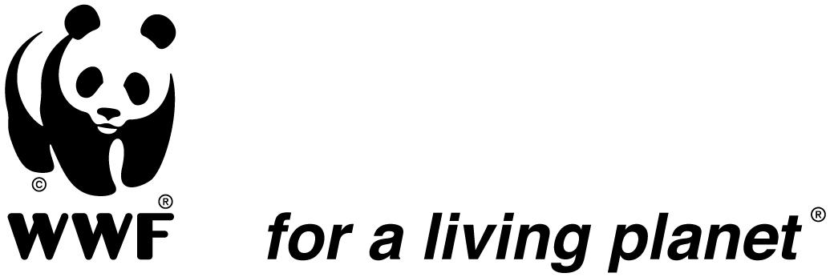

JOB DESCRIPTION

Position Title: Programme Coordinator - Mara Water Program (MWP)
Reports to: WWF TCO - Freshwater Programme Coordinator
Supervises: Technical and Support All Staff
Duty Station: Musoma, Tanzania
Date: Immediate

- General requirement and major functions

The Programme Coordinator will coordinate the delivery of Water Allocation Plan (WAP); among other outstanding outputs in the Mara River sub-basin work plan, as well as overseeing the implementation of other projects in the Tanzania side of the basin. The incumbent shall carry out her/his duties in the manner that embraces and encourages convergence of experiences and resources from key partners including but not limited to: Relevant Ministries, Institutions and other hierarch of water and natural resources management, private sector (mining, fishing etc.), other NGOs, Riparian Local Government Authorities, Education institutions - Schools and Colleges and whole stakeholders including vulnerable and poor communities; without forgetting the special needs of nature. The position requires a dynamic and experienced freshwater professional to work with these key partners to meet the need of people, wildlife and environmental flows of the Mara river

- Technical Duties and Responsibilities
  - Program Design and implementation:
- Coordinate the development and implementation of the Mara river programme in line with the project documents.
- Facilitate linkages and resource synergies between the MRWP and other projects to realise the greater impacts in project areas and ensure that those projects build and benefits from each other,
- Assist in designing simple tools (to be used by basin Authority) to allow water use within a sustainable limit guided by water allocation plan (WAP).
- Assist in designing and where appropriate, the implementation of training and capacity building initiatives for officials and beneficiaries in the respective partner institutions and communities
- Facilitate documentation of lessons and best practices from the Project interventions that would be shared with partners and also for supporting and influencing development of appropriate policies and mechanisms that would ensure long term sustainability of the project results.
- Ensure that Project operations under WWF-TCO are aligned and contribute to the WWF Global Freshwater Practices Strategy and Africa Regional Office (ROA) Strategy.
- Advise and collaborate with TCO Freshwater Programme Coordinator to ensure that national freshwater interests are addressed accordingly in priority landscapes within the Coastal East Africa Network Initiative and African Rift Lakes Region (ARLR) ,
- Support the project planning processes and coordinate respective fundraising activities in collaboration with the TCO and ROA management.
- Supervise all the projects activities to ensure effective management including timely development of annual work-plans, budgets, technical reports and effective partnerships.
- Facilitate respective projects evaluations and ensure implementation of agreed recommendations.
- Participating in the project related meetings, dialogues and discussions in the country and within the WWF-Network and work with TCO Freshwater Programme Coordinator to advice the Conservation Manager and Country Director accordingly on the Project issues of interest as appropriate,
- Maintain a good image of the organization to ensure that WWF remains among the most respected in the country and outside.
- Provide pro-active and constructive support to related global programmatic work including WWF’s Water Security and Water Stewardship programmes, and work on climate adaptation.

  - Program Communication and Sharing
- Work with colleagues to develop an effective approach to communications on MWP issues that supports programmatic objectives and promotes WWF as a leader in the field.
- Ensure lessons, stories and experiences are documented as appropriate and exchanged with colleagues in WWF-Tanzania and other WWF offices around the world.
- Support fundraising efforts for implementation of the components of the WWF Tanzania Conservation Strategy.
- Ensures the program is in compliance with donor policies and regulations. Be responsible for overseeing contractual agreements with program participants.

  - Financial management:
- With support from accountants, develops Program budgets for approval by Management in consultation with relevant donors and monitors expenditures against budgets.
- Ensures establishment of financial management systems for the program is adequately meet financial management needs and donor regulations and policies;
- Monitors accounting, administrative and operational procedures, standards and policies for the Program, including sub-grants;
- In collaboration with relevant program staff, prepares and submits monthly, quarterly, semi- annual and annual technical and financial reports and other specific reports according to schedules and work plan to Freshwater Coordinator/Donors in accordance with procedures established by WWF.

  - Human resources: In collaboration with Human Resources Manager, the Coordinator shall determine the personnel requirements of the Program and participates in the recruitment, selection and hiring of personnel. Conducts performance evaluation in compliance with WWF’s policies and personnel management systems

  - Material needs: Determines the material needs of the Program; develops/updates procurement plans with relevant staff for approval by management. Ensure proper maintenance of the Program equipment inventory

  - Monitoring and evaluation: In collaboration with WWF staff, develops and oversees the monitoring and evaluation system for the program. Monitors program implementation and identify and plan for evaluation needs. Develops knowledge management mechanism and oversees its implementation.

  - Program Relations: Develops key programme relations with local, national, regional stakeholders across the Africa Region Office (both government and non- government partners); and Maintain good relations among all program partners as well as other important stakeholders, especially Water Basins and Ministry of Water & Irrigation

  - Risk management: Develop and implement a Risk Register for review and approval, and ensure that mitigation actions are implemented as required.

  - Communications: Develop and implement a communication action plan, ensuring the program meets its objectives and generates required support from key stakeholders.

  - Program development: Establishing and nurture excellent relationships with present partners and donors and initiates new program concepts and partnerships to grow the program in compliance with WWF Tanzania’s Conservation strategic plan and resource mobilization strategy; takes the lead in project proposal formulations and design.

- Qualification and Experience
- A first degree or an advance Diploma in hydrology, water resources management or environmental studies.
- Minimum of 5 years of working experience in conservation work in relation to water resources management issues.
- Experience in carrying out ‘Environmental Flows’ and the use of participatory methodologies on maintaining the agreed water allocation.
- Facilitation skills including engagement of local communities and other stakeholders to participate in the delivery of project plans.

Additional Requirements
- Good analytical and writing skills in both Kiswahili and English
- Computer literacy
- Ability to work with others in a team including consultants
- Familiarity with the working area; Water allocation modeling and work experience with NGOs are added advantage

Working relationships: (a) Internal (WWF): Interacts with the Senior Management team and all WWF-TCO staff and (b) External: Interacts with various stakeholders/partners of the projects both in the country and WWF-network

Prepared by: _____________________ Date: _______________________
Freshwater Programe Coordinator

Reviewed by: ____________________ Date: _______________________
Human Resources Manager

Reviewed by: ____________________ Date: _______________________
Conservation Manager

Approved by: ___________________ Date: _______________________
Country Director

Accepted by: ______________________ Date: _______________________
Staff Member

