Vietnam Tuna Fisheries Improvement Plan (FIP) Roadmap

- General
On September 12th 2012 representatives of the Vietnam Department of Capture Fisheries and Resource Development (DECAFREP), WWF Vietnam, WWF Coral Triangle Network Initiative, MSC, the Vietnam Association of Seafood Exporters and Producers (VASEP), the Vietnam Tuna Association (Vinatuna), processors, fishermen, US and EU tuna importers and other stakeholders gathered in Nha Trang to discuss entering the Vietnam longline and handline tuna fishery into the process for MSC sustainability certification through a Fisheries Improvement Project.
Following a series of presentations on the current status and knowledge of Vietnam’s tuna fisheries and preliminary review of the tuna fishery documenting key shortcomings against MSC principles, a consensus position from meeting participants was obtain that:
- Confirmed unanimous support and interest for implementing a Fishery Improvement Project for tuna;
- Identified (through a quick vote) WWF to coordinate next steps including the development of a roadmap for going forward;
- Recognized that more consultations and information sharing was required ahead of moving into the early stages of a formal FIP, including identification of the proposed Unit of Certification and client group(s)
To that end, this preliminary roadmap aims to identify key steps and requirements up to the pre-assessment process as well as looking forward to the immediate steps to implement the FIP beyond the pre-assessment (i.e. Action Plan based on the pre-assessment results).
Since the time of the meeting, WWF has initiated some direct consultations with other key stakeholders, including government line agencies, NGOs and private sector representatives, in order to ensure full participation of all interest groups and to pinpoint further the key issues that would need to be brought to all participants for feedback ahead of the pre-assessment.
- Roadmap: primer on a FIP process
The FIP process outlined below is presented based largely on the multi-step FIP process described in the 2011 report “Transition to management best practice in Asian fisheries: Fisheries Improvement Planning Process (FIPP), a methodology for improved fisheries management and the development of Fisheries Management Plans (FMPs)” written by Richard Banks and Graeme Macfayden and Poseidon Aquatic Resource Management Ltd.

Fisheries Improvement Plans (FIPs) have arisen recently as a new and timely approach to sustainable fisheries management. The FIP approach distinguished itself from previous forms of intervention in that it recognizes the need in many fisheries for a “stepwise” approach of continual improvement, while remaining targeted towards (and measured against) the principles and criteria of Marine Stewardship Council (MSC) eco-certification. Merging government and market-led drivers for improved fisheries management, the FIP approach is particularly applicable in developing countries - where limited financial and human resources combined with generally weak fisheries management means that MSC certification is not practically achievable in the near-term. For some fisheries in the developing world the stepwise, yet clearly defined and measurable, approach of FIPs provides a useful tool for stakeholders – including buyers, suppliers, government managers and local fishers – to meet commitments about sourcing from sustainably-managed fisheries and/or improving fisheries management performance.
Recent experiences with FIPs have demonstrated that there are a number of key aspects to the approach and methodology being used. FIPs are typically externally facilitated by consultants/assessors with previous experience of conducting fisheries pre- and full-assessments. This is important because the FIP uses the MSC standard as a benchmarking tool for assessing and improving fishery management performance. The FIP engages multi-stakeholder participation, and incorporates a process whereby Government, the private sector, and fishers, all work together to specify and implement agreed improvements in how the fishery is managed.
The FIP utilises a stepwise approach that includes pre-assessment (measured against MSC criteria), scoping, stakeholder review and technical input, and the identification of a FIP work plan with agreed-upon priorities, activities, timelines and outputs/outcomes (see Figure 4).

Figure 1: General overview of the FIP process (source: based on materials from Poseidon Aquatic Resource Management Ltd.)

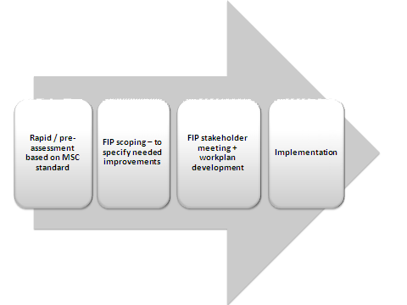
For the purposes of this discussion we will outline a 4-step FIP process, with “Implementation” identified as the 4th step. In reality “implementation” involves further component steps including preparation, planning and implementation of a fishery-specific management plan. It is not certain that in the case of Vietnam tuna that a FIP process would task itself with developing a specific tuna management plan, as indeed there is already a process underway with MARD and their partners to develop such plans. Instead it is likely that the tuna FIP in Vietnam would be optimized with this existing initiative and aim to ensure that verifiable improvements in fisheries management are indeed being made (and that the fishery is indeed addressing comprehensively identified deficiencies with respect to future MSC certification). However, like all FIPs the simplified process described in Figure 1 and articulated below places an emphasis on a clearly-described, agreed-upon work plan and set of activities for fishery improvement – with specific roles, responsibilities, budgets and outcomes articulated.

- Rapid / pre-assessment based on MSC standard

The first Step in the FIP process is to conduct a pre-assessment of the current status, impacts and management status of the fishery concerned. In defining ‘the fishery’ being assessed, the assessment must first define the ‘unit of assessment’ in terms of the target stock, the fleet or vessels targeting it, and the specific fishing gear being used. For example the unit of assessment could be Vietnamese landline and handline vessels targeting yellowfin and big eye tuna.
The methodology is guided by the application of three core MSC principles, specifically:
- Principle 1. Target Stock: Status, management, information and research (Covering the range of the stock)
- Principle 2 - Ecosystem elements (retained, bycatch, ETP, habitat and ecosystems): Status, management and information (Fishery specific)
- Principle 3 - Governance and fishery specific management (1-4, covering the range of the stock, 5-9 are fishery specific)
For each of the three Principles a number of different issues are considered, and the MSC standard specifies what would be expected in a well-management and sustainable fishery for each of the different issues.
To illustrate this, Figure 2 below shows a hypothetical example of part of a rapid/pre-assessment. As can be seen, in this example, different gear types have been rated as either “meeting standard”, “below standard” and “fail” for different elements of the MSC Performance Indicators.

Figure 2 – Hypothetical fishery pre-assessment
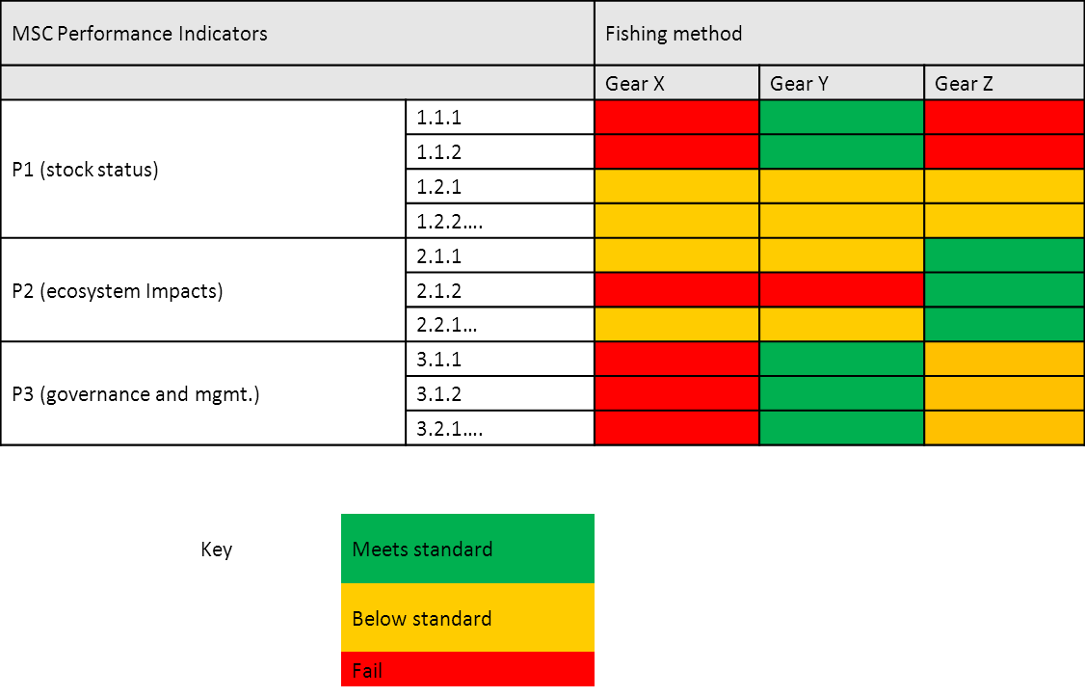

- FIP Scoping

Step 2 involves the assessor evaluating the outputs from the pre-assessment, scoping the potential improvements, and recommending a series of ‘actions’. These actions are designed to help improve performance against all individual Performance Indicators considered during Step 1, but they also incorporate best practice and lessons learned from other fisheries.

- FIP stakeholder workshop and workplan development

Once the pre-assessment and related scoping is completed and results circulated, a multi-stakeholder workshop is held. The main goals of the workshop are to:
- Identify and agree upon activities/actions required to achieve a “pass” in the scoring guideposts
- Determine roles and responsibilities of partners in relation to activities and tasks
- Identify and agree upon a timeframe for each activity, lead/supporting roles, and also for duration of project
- Detail the costs and funding needs associated with each activity

At the workshop stakeholders consider the practicality of the recommendations and refine these to suit local conditions. Stakeholders consider the priority of different actions and determine who will be responsible for what as well as set out the appropriate timelines. The timelines are mostly within year 1 and 2, with some activities such as review of mitigation strategies for year 3 and beyond

- FIP Implementation

Implementation of the FIP, and the first follow-up from the stakeholder meetings, typically involves:
- Revision of draft workplan with stakeholder
- Linking each activity in the workplan to specific performance indicators
- Writing an “action plan” based on discussion/activities from stakeholder meeting
Figure 3 – Portion of a hypothetical FIP Action Plan
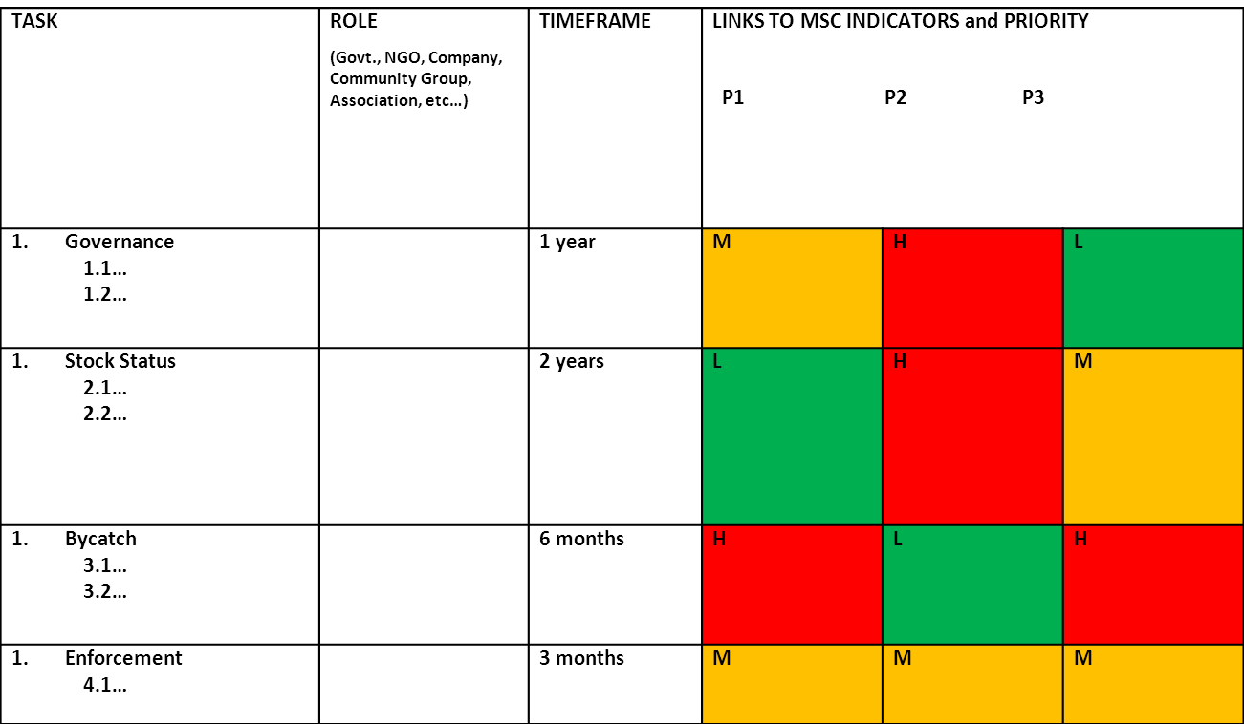
Based on the actions agreed as part of the stakeholder workshop, the assessor is then in a position to build on these actions (it is at this stage that these actions may be formally developed as a Fishery management Plan, or formally linked into existing formal FMPs).
The critical issue is that the FIP Action Plan and any associated logframe clearly and logically links objectives, outcomes, outputs, activities, roles, responsibilities, indicators and verification means.
Implementation of the FIP Action Plan may be structured around the three MSC Principles, but with additional goals, outcomes and activities added, particularly those linked to social and economic goals (for example, it could be linked to establishing local fishing organizations).
Planning for Action Plan / FMP implementation also includes, quite importantly, the appointment of a local coordinator, the mobilization of budgets and the preparation of clear ToRs for specific stakeholders.
It is expected that once the Action Plan / FMP is completed and budgets and resources mobilized, that the FIP will continue for three to five years, with MSC Full Assessment as the end point of the FIP.

- Vietnam Roadmap: calendar and timelines
Based on the initial inception meeting and follow-up discussions, the following calendar is suggested for next steps in the FIP, up to and including the Stakeholders Workshop:

Component/Activity | Timeline | Notes
Stakeholder pre-consultations | Oct 22 – Nov 12 2012 | Receive feedback on emailed list of consultation questions (e.g. Unit of Assessment; client group; other stakeholders to be involved; available financial and In Kind resources; separate MOUs for industry and govt? etc.)  Confirmation of buy-in and support  Draft MOU(s) and communication protocols for the FIP  (above led by WWF)
Pre-assessment | Dec 2012 | Conducted by independent assessors (Richard banks and Tony Lewis) including in-country meetings and data collection, enabled through cooperation with FIP
Circulation of pre-assessment for feedback | Jan to mid-Feb. 2013 | Translation and circulation of PA for comments  Finalize FIP project MOU and communication protocols  (led by WWF with key assistance from Government and private sector partners)
Stakeholders Workshop | Late Feb. or early March 2013 | Two day workshop  Likely in Nha Trang  Outcome: FIP Action Plan with agreed-upon priorities, activities, roles, timelines, budgets and outputs; Funding Agreements; Communications protocol

- Budget: pre-assessment

Component | Estimated Cost (USD) | Secured?
Assessor costs (2 international consultants) | 20,000 | Likely (MSC/WWF)
National consultant (appointed by DECAFIREP) | 5,000 (In Kind) | Yes (In Kind)
WWF consultant (for PA and planning of Stakeholder Workshop) | 10,000 | Yes (WWF)
Translation (consultant) | 2,000 | Yes (WWF)
Stakeholders Workshop (including event, venue and travel support) | 15,000 | Likely (MSC/WWF)

- Budget: Action Plan
The budget for implementation of the Action Plan will be determined in due course and finalized at the Stakeholders Workshop. Based on previous experiences it is estimated that the FIP Action Plan implementation, including local coordination, would cost out at $XXXXX to $XXXXX USD over 3 years. Thus, pre-determination (up until the workshop) of direct funding support, In Kind support and mobilization of funds is critical.

