FINAL REPORT

STUDY ON CLIMATE CHANGE SCENARIOS ASSESSMENT FOR CA MAU PROVINCE

Technical report

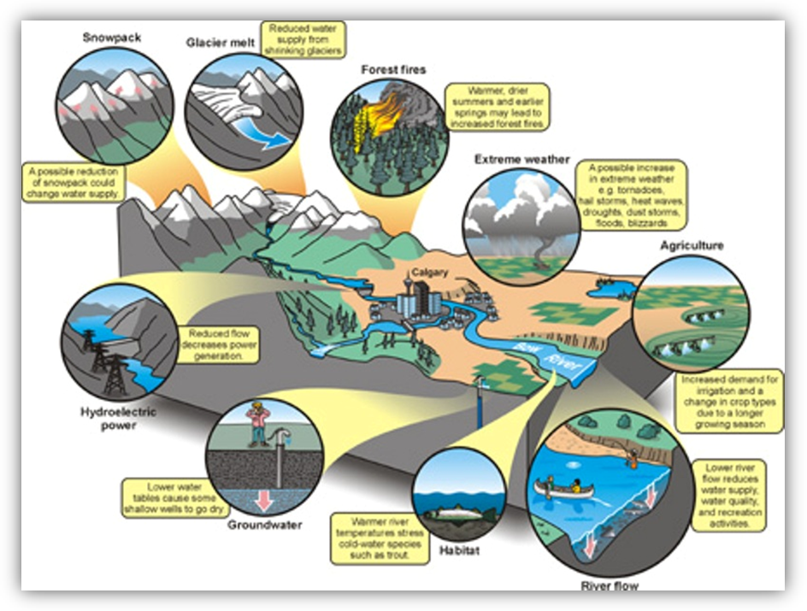

April 2008

Contents Amendment Record
This report has been issued and amended as follows:

Revision | Description | Date | Signed
0 | First Draft | 31/03/08 | X.Hien, Dat
1 | Checking grammar and more text | 01/04/08 | Ngoc, X.Hien
2 | More text to climate change introduction | 03/04/08 | X.Hien, Tan,  Gia Hien
3 | More text to scenario introduction | 08/04/08 | Ngoc, X.Hien,  Tan, Khoi
4 | Add figures: Map, table | 10/04/08 | Dat, Ngoc,  Khoi, Huong
5 | More text to assessments on simulation results | 14/04/08 | X.Hien, Tan,  Ngoc
6 | Revision after comments from SIWRP’s staff | 18/04/08 | X.Hien, Tan,  Gia Hien
7 | Draft Report | 25/04/08 | X.Hien, Tan
8 | Final Report | 12/06/08 | X.Hien, Tan

TABLE OF CONTENTS

EXECUTIVE SUMMARY...............................................................................11
CHAPTER I. INTRODUCTION 20
I.1 General 20
I.2 Objectives of Study 22
I.3 Main Works 23
I.4 Expect outputs 23
I.5 Consultant Team 23
CHAPTER II. GENERAL VIEW 24
II.1 Topography 24
II.2 Geology of Ca Mau province 24
II.3 Coastal geomorphology 25
II.4 Hydrometeorology 25
II.5 Hydrograph 26
II.6 Storms and tides 27
CHAPTER III. CURRENT SITUATION AND FUTURE DEVELOPMENT PLAN OF CA MAU PROVINCE 29
III.1 Assessment on current situations 29
III.1.1 Analysis and assessment on local conditions, locations 29
III.1.2 Assessment on natural conditions 30
III.1.3 Population 30
III.1.4 Aquaculture 31
III.1.5 Agriculture 31
III.1.6 Forestry 34
III.1.7 Industry, services, and commerce 35
III.1.8 Public health 36
III.1.9 Education and training: 37
III.1.10 The role of transportation structures 37
III.1.11 Electricity system 37
III.1.12 Current situations of water control system 38
III.2 Future development plan 39
III.2.1 Developing Target 39
III.2.2 Economy 40
III.2.3 Environment 41
III.2.4 Culture and society 42
III.2.5 National security 42
CHAPTER IV. CLIMATE CHANGE PREDICTIONS 43
IV.1 Overview 43
IV.2 Introduction 46
IV.3 Sea level rise 47
IV.3.1 In Asia 51
IV.3.2 In Viet Nam 52
IV.4 Temperature and Rainfall 53
IV.5 Extreme Weather 55
IV.6 Summary Climate Change Conclusions 56
CHAPTER V. MODEL APPLICATION 58
V.1 VRSAP Model Setup 58
V.1.1 Introduction of VRSAP Hydraulic Model 58
V.1.2 VRSAP model application 58
V.2 Input data of the VRSAP model 59
V.3 Output data of the VRSAP model 60
V.4 Mapping 60
V.5 Model Application for Ca Mau Province 60
V.5.1 VRSAP schematization 60
V.5.2 Input data 61
V.5.3 Model Calibration 62
CHAPTER VI. CLIMATE CHANGE SCENARIOS 63
VI.1 Scenarios setup 63
VI.2 Scenarios results 65
VI.2.1 Scenario A0 65
VI.2.2 Scenario A1 66
VI.2.3 Scenario A2 67
VI.2.4 Scenario B1 68
VI.2.5 Scenario B2 69
VI.2.6 Scenario B3 69
VI.2.7 Scenario B4 69
VI.2.8 Scenario C1 69
VI.2.9 Scenario C2 69
VI.2.10 Scenario D1 70
VI.2.11 Scenario D2 70
CHAPTER VII. ASSESSMENTS ON SIMULATED RESULTS 71
VII.1 Assessment of the Water resources planning Scenarios 71
VII.1.1 Impact to salinity intrusion 71
VII.1.2 Impact to water level 71
VII.1.3 Discussion 73
VII.2 Assessment of the Sea level rise Scenarios 75
VII.2.1 Impact of sea level rise to salinity intrusion 75
VII.2.2 Impact of sea level rise to water level 76
VII.2.3 Discussion 77
VII.3 Assessment of the Extreme climatic event Scenarios 80
VII.3.1 Impact to salinity intrusion 80
VII.3.2 Impact to water level 80
VII.3.3 Discussion 81
VII.4 Assessment of the complex SLR, CLC and Storm Scenarios 83
VII.4.1 Impact of sea level rise to salinity intrusion 83
VII.4.2 Impact to water level 83
VII.4.3 Discussion 85
VII.5 Summary of Discussion for Climate Change Scenarios 87
VII.6 Summary of Discussion for the effect of Climate Change on Sectors 89
VII.7 Summary discussion on the changes to water levels due to climate change 94
CHAPTER VIII. ASSESSMENT OF VULNERABILITY 99
VIII.1 Vulnerability in the Ca Mau Peninsula 99
VIII.2 Vulnerability by Demographic make-up 101
VIII.3 Vulnerability in Forestry sector 102
VIII.4 Vulnerability in the Farming sector 103
VIII.5 Vulnerability in Infrastructure sector 104
VIII.6 Vulnerability in Miscellaneous sectors 106
VIII.7 Vulnerability in Governance structures 107
VIII.8 Summary Assessment 108
CHAPTER IX. CONCLUSIONS & RECOMMENDATIONS 110

LIST OF TABLES IN REPORT

Table 1: Monthly average rainfall 26
Table 2: Population and its density in 2005 30
Table 3: Areas and quantity of shrimp farming in 2005 31
Table 4: Changing agricultural areas and rice quantity 32
Table 5: Situation of land usage 32
Table 6: Existing landuse in Ca Mau province 33
Table 7: Structure of Industry branch 35
Table 8: Norm of industrial production 35
Table 9: Percentile of Aquaculture Exportable market 36
Table 10: Public health services 36
Table 11: Forecast the transition of the economic structure of Ca Mau 40
Table 12: Norm of developing economic structure of Ca Mau province 40
Table 13: Land use planning up to 2020 in Ca Mau province 41
Table 14: Specifications of Climate change and Sea level rising 51
Table 15: Temperature change scenarios for 2010 and 2070 (°C) 54
Table 16: Rainfall scenarios for 2010 and 2070 (% change) 54
Table 17: Scenario setup for Ca Mau province 64
Table 18: Changing area of Max. Salinity intrusion in dry season 71
Table 19: Changing areas of Max. Water level in dry season 71
Table 20: Changing water level – Comparison: A1-A0, A2-A0 72
Table 21: Changing areas of Max. Water level in wet season 72
Table 22: Changing water level – Comparison: A1-A0, A2-A0 73
Table 23: Changing Max. Salinity areas in dry season 75
Table 24: Changing areas of Max. Water level in dry season 76
Table 25: Changing Max. Water level in dry season 76
Table 26: Changing areas of Max. Water level in wet season 77
Table 27: Changing Max. Water level in wet season 77
Table 28: Percentile of the increasing areas of Max. Water level 79
Table 29: Changing area of Max. Salinity intrusion in dry season 80
Table 30: Changing areas of Max. Water level in dry season 80
Table 31: Changing water level – Comparison: C1-A1, C2-A2 80
Table 32: Changing areas of Max. Water level in wet season 81
Table 33: Changing water level – Comparison: C1-A1, C2-A2 81
Table 34: Changing Max. Salinity areas in dry season 83
Table 35: Changing areas of Max. Water level in dry season 83
Table 36: Changing Max. Water level in dry season 84
Table 37: Changing areas of Max. Water level in wet season 84
Table 38: Changing Max. Water level in wet season 84
Table 39: Changing Max. water level during the stormy period: D1-A1, D2-A2 85
Table 40: Percentile of the increasing areas of Max. Water level 87
Table 41: Analysis the impacts of climate change scenarios to the different sector 92
Table 42: Risk Classification for Sectors of the Ca Mau Province 100
Table 43: Risk and vulnerability matrix for Ca Mau Province 109

LIST OF FIGURES IN REPORT

Figure 1: Location of Ca Mau province 20
Figure 2: Land use map of Ca Mau province 34
Figure 3: Land use map for the future development of Ca Mau province 43
Figure 4: Climate change 45
Figure 5: Uncertainty in comprehensive climate model 46
Figure 6: Regional study 47
Figure 7: Regional effected 47
Figure 8: Physical factors contributing to rising sea levels, based on 1961-2003 data (blue) and 1993-2003 data (brown) 48
Figure 9: Schematic diagram of sea level rise 48
Figure 10: The geographic distribution in longterm 1955-2003 49
Figure 11: The geographic distribution in short term 1993-2003 49
Figure 12: Sea level change prediction 50
Figure 13: Sea level change prediction 52
Figure 14: Temperaturechange prediction 54
Figure 15: VRSAP schematization of the Ca Mau peninsula 61
Figure 16: Water resources planning up to 2020 of the Ca Mau peninsula 63
Figure 17: Possible mangrove response scenarios to SLR (Hashimoto, 2001) 86
Figure 18: Summary seasonal statistics for the 10 future scenarios 88
Figure 19: Climate Change Assessment of impact by sector 90
Figure 20: Climate Change risk on Population sector 101
Figure 21: Climate Change risk on forestry sector 102
Figure 22: Climate Change risk on farming sector 104
Figure 23: Climate Change risk on irrigation works sector 105
Figure 24: Climate Change risk on transport sector 105
Figure 25: Climate Change risk on miscellaneous sector 106

EXECUTIVE SUMMARY

The objective of the study is to assist authorities and people in Ca Mau Province in revising and achieving the best development plan, which is sustainable and resilient to future climate change. More specifically, the immediate objectives of the study are:
Map the likely impacts of climate change on the province and land use changes as a result of development plans up to 2015 and 2030;
Assess the impacts of climate change on development within the province;
Provide recommendations for the best development path for the province.
Ca Mau province is a low-lying coastal region that forms the southernmost extent of the Mekong Delta. It is the bounded by the Gulf of Thailand and the South China Sea, with a natural area of 5,329km² and a population of more than 1.2million people. Its fresh water is provided by precipitation, underground aquifers and surface flows from the Bassac River. The province possesses a long coastline of 170 km, elaborate waterways and many water transition areas. Ca Mau is the only province in the country regulated by two conflicting tidal regimes, which drive saline intrusion into both surface and groundwater. The complex saline-freshwater interaction coupled with the flat terrain and local geology open the region to the following extremes in the water regime:
- Extensive flooding regime (driven by heavy seasonal rainfall May-December), strong winds and cyclones can inundate dike routes, residential and agricultural areas, erode banks and contaminate drainage;
- Dry season fresh water shortages and salinity intrusion from the sea;
- Acid Sulphate Soils (ASS) exist in some areas of the province, which can generate highly acidic waters in the first flushes of the rainy season;
- Follow-on effects of droughts, such as crop failure, forest fires, ASS, saline intrusion, salinization of groundwater;
- Increased sediment loading due to deforestation, and upstream effects

The province continues to be primarily agrarian (rice/fruit agriculture, and shrimp/fish aquaculture), and a significant amount of infrastructure already exists to support these activities and their communities. These include flood and salinity control systems (Dikes, dams, sluices), irrigation systems (canals, embankments) and transport road networks. However, recent years have seen a growing importance of urban/industrial centres, as well as tourism and shipping. This has largely been due to a revised strategic development plan, aiming to diversify the provincial economy and integrate land use with the ever-evolving needs of the local community.

In order to quantify the effects of Climate Change to the province, this study utilized findings and conclusions published by the IPCC. Based on this information it was concluded that the significant risks to Ca Mau peninsula from a warming climate would be; rising sea levels (SLR: +25cm and +50cm), storm surge events (based on observed data from the 1997 Linda Storm) and extreme climate events (CLC: 10% increase in wet season rainfall and 10% decrease in dry season rainfall). The study then outlined the vulnerability of the province for each of its sectors, in order to predict the impacts of climate change. The main provincial sectors considered in this study were:
- Farming Sector: aquaculture (shrimp and fisheries) and agriculture (rice, mixed rice/fish, mixed rice/shrimp, vegetables, annual and perennial plants and residential areas)
- Forestry Sector: specialized, protected and plantation forests
- Irrigational Works Sector: sea and river dikes, primary/secondary culverts and embankments, interior fields and canals
- Transportation Sector: roads (national, provincial, district, local)
- Population Demographic Sector: urban and rural households
- Miscellaneous Sector: buildings, zones and centers of provincial significance (industrial zones, tourist areas, hospitals and health centers, schools, cultural centers and post offices)

Vulnerability of coastal areas is a function of both the susceptibility of the biophysical area to changes, and the adaptability of the region and its institutions to these changes. Consequently, management plans, can be successful in reducing the effects of climate change through appropriate mitigating works such as ‘hard structures (dikes, levees, flood walls and barriers) or ‘soft structures’ (beach nourishment, dune restoration, wetland creation, revegetation).
Furthermore, there is a strong causal relationship between poverty, degraded environments and higher disaster risks. Risks, are therefore twofold, those associated with an increasing frequency of extreme weather events and rising sea levels, and those associated with an increase in societal vulnerabilities, from both these extreme events and subsequent stresses on water availability, sanitation, agriculture and degraded ecosystems. For the Ca Mau peninsula this problem is exacerbated by high population growth rates.
Changes to both maximum surface water levels and salinity concentrations over time were used to qualify areas prone to risks under these categories. Water level changes under the two major climate change factors were considered (SLR and SLR together with extreme storm event) under two separate management plans (2015 and 2030 plans). This lead to six scenarios that were compared to the modeled water levels under the respective management plan with no climate change (i.e. baseline scenarios).
Associated risks were classified based on the magnitude of increase in water levels compared to the no climate change scenario. A HIGH (>0.3m) risk rating indicates that, structural and strategic assumptions of the management plan need to be reviewed, as there are far reaching ramifications of climate change largely unaccounted for in current plans. The risk assessment was applied to each of the six scenarios for each sector and then an overall risk assessment was averaged for that sector based on its general performance. The conclusions are summarized below:
- Vulnerability by demographic make-up (Overall Risk High)
The population sector is differentiated into urban and rural households. In Ca Mau province, urban households tend to have better connectivity to health and civil infrastructure, making them less vulnerable to risks.
- Development plans are capable of dealing with low SLR scenarios; a comprehensive review of plans is required for high SLR scenarios.
- Vulnerability of rural populations should be reviewed for the short term and high SLR scenarios, while long term high SLR scenarios should be reviewed for both urban and rural households.
- Plans need further exploration of emergency evacuation and long term relocation options.
- Studies should be undertaken to identify locally appropriate measures of increasing drainage efficiency immediately after major flood events as prolonged periods of high water levels is one of the fundamental factors driving rural vulnerability
- Vulnerability in the Forestry sector (Overall Risk High)
The forestry sector is split into three sub-sectors; specialized forests, protected reserves and productive forests. Forested areas are generally centered around Tran Van Thoi district on the western coast of the province, the southern tip of the province (south of the Bay Hap River), and between the coast and the sea dike system on the eastern coastline
- Even under conservative CC estimates, long term plans will require major revisions.
- Vulnerability of the forestry sector increases under high SLR. Therefore, both short and long-term planning needs to be reviewed.
- Both plans fail to suitably manage forested areas under extreme storms. Research should be undertaken to reassess the design storm event used to define development plans.
- Productive forests (regardless of the modeling scenario) are likely to be the most affected (~60% of the total effected area), followed by protected forests (~24%) and specialized forests (~16%).
- The vulnerability of the forestry sector has historically been a secondary concern for local, provincial and national authorities, primarily because of the urgent concerns of national food security. Without diminishing this, it is crucial that the risks faced by the forests of Ca Mau province be given greater importance.
- Efforts should be made to improve understanding of how the forestry sector interacts with other sectors, what part ecosystem services can play in disaster mitigation and the economic benefits they provide the province.
- Further studies be initiated into the effects of the mangroves on saline intrusion and flooding regimes in the province (historically lacking in the research). This could include a ‘prevention dividend’, attributing tangible economic value to ecosystem services.
- Vulnerability in the Farming sector (Overall Risk High)
- Risk increases with increased SLR (Med – High).
- For all sub-sectors there is a constant and significant change in water levels, which are not adequately handled by either short or long term development plans (except the rice-fish sub-sector and the perennial plants/residential sub-sector, which handle low SLR in the 2015 plan).
- Authorities periodically reassess the best mix of aqua/agriculture for Ca Mau province. It is recommended that as part of this process, workshops are conducted with the local community, planners and scientists to discuss the future changes to the farming sector and integrate predicted CC effects into the decision making process.
- Vulnerability in the Infrastructure sector (Overall Risk High)
The infrastructure sector comprises ten sub-sectors including irrigational works (fields, embankments, culverts, dikes and buffer zones) and transport (local, district, provincial and national roads).
- The vulnerability of the infrastructure sector increases with increasing SLR.
- Management plans have been successful in addressing most infrastructure issues with the exception of buffer zones, which have not been incorporated into the modeling framework.
- The infrastructure sector is consistent across the modeling scenarios. In terms of irrigation works, interior fields and secondary embankments are likely to suffer the worst impacts. Similarly for transportation works; 90% of the roads effected by CC are predicted to be local and district roads.
- Better understanding is needed of sediment and erosion processes, as these are one of the main causes of inefficiency and failure in canal performance.
- Complementary environmental works like revegetation of river banks could provide long term preventative benefits for the infrastructure sector.
- Vulnerability in Miscellaneous sectors (Overall Risk High)
- Some 585 hospitals and health centers will be effected and since the greatest effect to these services is likely to coincide with the greatest effect on the population health, there is a subsequent increased potential for disease risk.
- 172 existing industrial zones are likely to be effected, which will increase the risk of further pollution problems.
- Efforts should be continued and improved to identify and study the fate and transport of pollutants in Ca Mau waterways after significant flooding events, and the first flush of the wet season.
- Vulnerability in Governance structures
Currently, poverty reduction has been the focus of governmental planning. This has meant that environmental regulation has been a secondary issue and comprehensive regulations/environmental protection mechanisms remain in their infancy. Furthermore, the adoption of integrated water management strategies (IWMS) is a comparatively recent phenomenon in Vietnam and the government continues to face some difficulty in re-aligning institutions (such as MONRE and MARD) in accordance with IWMS principles.
- Governance institutions of the province are experienced and well prepared for the effects of climate change, because the future problems to be faced are expected to be similar to those currently experienced (with changes to both the magnitude and timing).
- There is sufficient institutional capacity in the Vietnamese governance structures to adapt existing development and management plans and implement appropriate initiatives to respond to climate change in the Ca Mau peninsula
- However, the negative side of a strong centralized structure is a rigid administration structure, which is slow to adapt and when coupled with the fact that hydrologic unit boundaries do not coincide with administrative boundaries, results in some difficulty in fostering inter-province co-operation.

SUMMARY ASSESSMENT

This study identified SLR, cyclones (and subsequent flooding), together with subsidiary effects of water shortages (both drinking/domestic and farm use) and waterborne diseases as the most significant risks affecting the Ca Mau community. In addition, these major risks can be further divided by their expected probability of occurrence. Cyclones and extreme weather events, though the most severe single risks occur sporadically, while SLR and water availability will be continuous effects on the community.
The study has also concluded that Strategic Development and Basin Development Plans have proven themselves as successful centralized methods of planning and that within the current Restructured Strategic Development Plan (RSDP), there is some capacity to manage vulnerability. Specifically: flood control, fresh and saline water distribution and engineering works planning.
In Ca Mau province, conservation and the expansion of farming activities have been required to find a balance, in order to alleviate hunger in the country, as well as maintain mangrove ecosystems. On the one hand, shrimp farming, and wood collection has reduced the areas of mangroves, forests and riparian vegetation, while multi-crop techniques and the seasonal oscillation between agriculture and aquaculture have improved yield efficiencies for areas in the province, and reduced the demand for new cleared land. Therefore, the fundamental change required in management planning is to further emphasize the importance of Integrated Water Management Strategies considering sectors as interactive systems.
The study indicates that, the impacts of storms and SLR on Ca Mau province is highly likely to pose a serious threat to both the existing biophysical and socio-economic environments and that both short-term and long-term management initiatives are, as they currently stand, insufficient to meet this emerging risk. In order to mitigate and adapt to climate change, provincial planners should apply a combination of both construction-measures and non-construction measures. Construction measures are hydraulic works built in order to control the volumes and quality of water within enclosed areas through the use of physical barriers to the movement of water. Non-construction measures are measures used to mitigate damages caused by climate change and include; long-term and short-term climate change forecasts; risk identification and education for all community stakeholders (workshops etc), the maintenance of buffer zones. The development of modern communications systems in order to monitor key disaster parameters, the establishment of relief teams, allows prompt communication and response to emergency situations. Arrangement of production sectors and cultivation seasons must be suitable in order to avoid damages and to increase efficiency. A close combination between construction measures and non-construction measures will increase benefits and decrease investment cost.
The following recommendations will assist authorities and local communities in the province to revise and work towards a provincial development plan that is integrated, sustainable, and affords proper recognition of the importance of the peninsula to the Mekong Delta in general:
- Head works
Ensure the system of hydraulic works is comprehensive, flexible, and able to meet different production requirements of specific regions:
- Increase the capacity to store fresh water in dry season
- Define measures and distribute hydraulic works system matching the changes in farming production.
- Define list of priority of structures, give priority to urgent structures or head works in high vulnerability-high risk areas (eg secondary and tertiary canal structures).
- Define measures and distribute hydraulic works system matching each region to heighten construction efficiency and avoid long-term conflicts.
- Increase the capacity to drain acid-sulphate areas and improve inundation.
- Combine the development of hydraulic works with that of new infrastructure, new rural areas and local natural disaster control and mitigation (NDCM) strategies.
- Construct new and upgrade existing sea and river dike systems and review sluice system to drain water and embankments, especially the ageing West Sea dike system.
- Undertake research to further understanding of erosion, sediment aggradations and local mangrove response to changes in sea levels.
- Repair degrading forest ring dike (~185 km, built in the 1980s).
- Protect and develop protective forest along the coast line.
- Dredge canals to supply clean water and drain waste water, reclaim land, change river flow and repair riparian vegetation to minimize erosion.
- Population Dynamics
Ca Mau province is an area of varied demography, with people living scattered along rivers and coastlines. This leaves a significant proportion of the rural population isolated and at greater risk from SLR and extreme storm events. Initiatives need to be identified to reduce the vulnerability of these communities, for example the relocation of people to form denser clusters, which can be better protected and evacuated.
- Invest to build resettlement areas that ensure all criteria on cultural and social life (electricity, roads, schools, health practices, to provide clean water, and implement land contract).
- Further efforts are needed to secure water supply, as climate change is expected to exacerbate outbreaks, health and availability issues associated with drinking and domestic water supplies.
- Policies to stabilize post-disaster local life and production make preferential policies for survivors’ households, ethnic minorities, and the poor. For example: low interest loans for different economic sectors, support funds for those who lost houses or working tools, distribute free food, medicines, and other necessities, support breeding animal and plants, encourage agriculture and fishery extension for disaster-suffered areas to stabilize lives.
- Diversify the provinces economy, as much as possible, to reduce vulnerability. The continued promotion of responsible tourism, industrial activity and forestry is a suitable measure in this direction.
- Land Use Strategies
- Invest in the construction of irrigation works, reserve fresh water, transform planting structure and husbandry, and apply scientific techniques to production to improve yearly alum and saline lands.
- Plans of protecting and developing forest resource (cajuput forest) and coastal protective forest should be set up in order to protect the land lines in the West and East from tidal impact such as erosion, water overflowing into the mainland.
- A forestation and forest farming activities should incorporate multi-species planting, to ensure their ecological effectiveness as spawning grounds.
- Scientific quantification of the damage to mangroves resulting from the design storm needs to be undertaken.
- An evaluation of fertilizer and pesticide application, quantifying the effect that these pollutants are having on fish species.
- An evaluation of the fate and transport of domestic, industrial and medical waste in the province, focussing on the health and ecosystems threats they might pose to human and ecosystem health
- Infrastructure Development
- Should review development plans to upgrade and strengthen secondary infrastructure works.
- Invest to construct inter-district road and those from province to districts of tertiary standard or above, construct inter-commune, inter-hamlet roads connecting to residential areas and administrative centres.
- Clear waterways for a smooth transportation of goods and food, and evacuation routes.
- Avoid sediment build up in secondary/tertiary canals using appropriate alignment of intakes.
- Construct solid waste treatment facilities to treat waste from industrial areas, frozen factories, and hospitals.
- Develop suitable water sanitation facilities to minimize untreated sewerage entering surface waters.
- Natural Disaster Control and Mitigation Strategy
- Develop measures for collecting information, building forces, strengthening the capacity and efficiency of natural disaster forecasting-warning, and community response strategies
- Upgrade and construct communication systems in important places such as, coastal towns or townships, district stations, concentrated residential areas and border army posts.
- Encourage local residents, especially fishermen to carry equipment such as walkie-talkies, compass, maps and train them in storm- warning signal system. All work should be coordinated from provincial to local levels.
- Regularly update staff and volunteers responsible for monitoring data and information collection. This can be achieved through information collection and processing training sessions, demonstrations/drills of some frequent natural disasters, and site visits to other deltaic/coastal environments, which have recently experienced natural disasters common for Ca Mau province.
This study is intended to assist authorities and people in the province in producing the most suitable development plans for Ca Mau province in a warming climate.
Additionally there is many data on the existing social, economic and to a lesser extent environmental conditions of the province. This information allows for the characterization of the local and provincial vulnerability of the people, their practices, environment and infrastructure to the risk posed by climate change. The major vulnerabilities in the economic sphere arise from damage and decreased production because of severe flooding, storms and SLR.
From a social perspective, the Ca Mau community is vulnerable to health risks and hindrances to development associated with both disasters and ongoing pollution, as well as from institutional inhibitions to adaptation (i.e. coordination of planning across sectors and provincial/national boundaries).
From an environmental perspective, bio systems are vulnerable due to a insufficient knowledge about the current state of ecosystems as well as of the driving hydro-geological processes of the delta (sediment aggradations, bank erosion, ASS etc). They are also vulnerable to degradation and adverse effects generated by activity in other sectors.
The issues explored throughout this report culminated in the conclusions listed above, which serve as a preliminary guide to direct and improve development planning for Ca Mau province. For these initiatives to be successful many, will require multi-lateral involvement and support from the provincial/national authorities, trans-boundary institutions (MRC, ADB), NGOs and the people of Ca Mau province themselves.

INTRODUCTION
  - General
Ca Mau province (CMpr) is a low-lying coastal region that forms the southernmost extent of the Mekong Delta. It is bounded by the Gulf of Thailand and the South China Sea and was formed on 01/Jan/ 1997 after separating from Minh Hai province. It consists of eight districts and one city: U Minh, Thoi Binh, Tran Van Thoi, Dam Doi, Cai Nuoc, Phu Tan, Nam Can, Ngoc Hien, and Ca Mau city. The province has a natural area of 5,329 km2, and population of 1,219,505 people (According to demographic report in year 2006). The spatial extent of Ca Mau province is as follows:
- North bordering with Kien Giang, Bac Lieu provinces;
- East bordering the East Sea;
- West bordering the West Sea;
- South bordering the East Sea
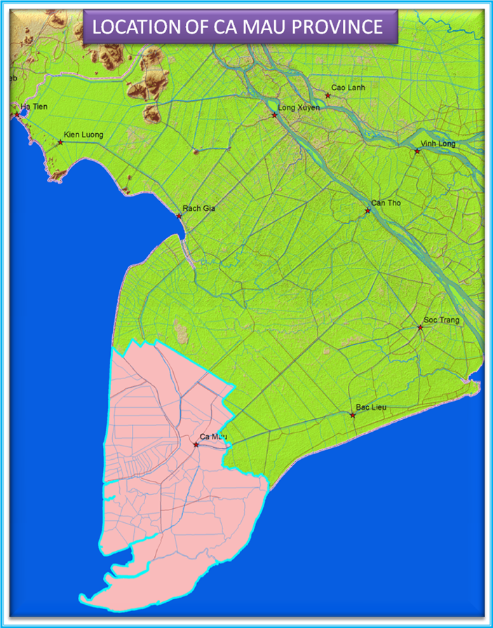

Figure 1: Location of Ca Mau province
Ca Mau province is suited for agricultural activity based on its surrounding hydrogeology; in particular, sediment laden freshwater flows provide fertile grounds for crops, while seasonal saline intrusion allows aquiculture to flourish. Ongoing infrastructure works in recent decades have built a large network of canals, sluices and dams, which have allowed farmers to control water availability and quality, increasing yields and productivity in the province. However, in spite of these factors the province still experiences difficulty developing both socially and economically. Poverty rates in Ca Mau province are estimated at 30-40% (MRC, September 2007).
Ca Mau is the only province in the country regulated by two conflicting tidal regimes. The East Sea is a large amplitude semidiurnal tide, while the West Sea is a diurnal tide of smaller amplitude. The complex saline-freshwater interaction coupled with the flat terrain and local geology open the region to the following extremes in the water regime:
- Flood season with heavy rains and high tide result in flooded cultivated land and strong winds, cyclones and lightning during heavy rains, lasting from May to December;
- Shortage of fresh water and devastating salinity intrusion in the dry season from the East Sea and West Sea;
- Acid sulphate soils (ASS) exist in some areas of the province, which can generate highly acidic waters in the first flushes of the rainy season. This is prevalent in most of the canals in the study area lying in a Northeast-Southwest direction connecting the East Sea and West Sea;
- The province is susceptible to droughts and extreme dry periods, typically December to April
- Follow-on effects of droughts, including, more sunshine, higher temperatures, lack of fresh water, salinity intrusion, and acid water generation. Furthermore, in a post-drought environment these problems are likely to occur throughout the province. Forest fires, made by dried trees and the carelessness of local people (particularly in the neighbouring provinces of U Minh and Tran Van Thoi districts), can exacerbate the negative effects of drought.
- Tropical low-pressure systems and storms often occur from the East Sea concomitant with heavy rain, and whirlwinds from May to December.
- During October to December, flooding, tidal waves and extreme downpours, can also inundate some dike routes, residential areas, escalate bank erosion in coastal protective forests, and pollute drainage.
- Cyclone and strong winds can cause huge waves detrimental to lives and properties in coastal areas.

In Ca Mau province, agriculture and aquiculture are widely regarded as the key sectors in its Socio-Economic Plan and the biggest water consumers of which a large proportion supplies rice production. The strategic development plan, however, was restructured toward a more diversified approach in order to accommodate non-rice industries such as brackish fisheries. This gradual transformation aims to promote sustainable development in Ca Mau province and integrate land use with the ever-evolving needs of the local community.
In order to further support, the agriculture and aquiculture production and increasing people’s living conditions, some works have already been built in the area, including:
- Flood control systems: dykes, dams, sluices.
- Salinity control systems: dykes and sluices preventing salinity intrusion from the East Sea and the West Sea coasts.
- In-land irrigation system.
- Transport roads network…
The people, economy and infrastructure of Ca Mau province remain vulnerable to climatic fluctuations and extremes in the current water regime (as mentioned above), and efforts continue to be made to better manage and mitigate these issues. However, little attention has been given to assess the future vulnerability of the province in a warming climate. There is an urgent need for a comparative study, which will map the likely impacts of climate change on the province and compare them to land use changes as the result of development plans over the next 10 and 25 years. Efforts must be made to determine probable climate and development change scenarios, in order to spatially overlay this information, and allow recommendations to be made that can steer provincial and regional development plans towards a sustainable and thriving Ca Mau province.

  - Objectives of Study
The ultimate objective of the study is to assist authorities and people in the province in revising and achieving the best development plan, which is sustainable and resilient to future climate change. More specifically, the immediate objectives of the study are:
- Map the likely impacts of climate change on the province and land use changes as a result of development plans over the next 10 and 25 years;
- Assess the impacts of climate change on development within the province;
- Provide recommendations for the best development path for the province.

  - Main Works
- Task 1: Develop visual scenarios to map the likely impacts of climate change for CMpr over the next 10 and 25 years
- Task 2: A detailed survey of existing plans for the expansion of key economic sectors in the target provinces,
- Task 3: Basic modelling of how climate change is likely to affect future development of those sectors in the target province.
- Task 4: A vulnerability assessment within the target provinces, looking at environmental and social issues

  - Expect outputs
- Datasets on development during 2002-2006 and existing plans on aquaculture, agriculture, tourism, and infrastructure development.
- Datasets of scenarios for the next 10 and 25 years without and with climate change from modelling of the projected impacts.
- A set of maps showing projected impacts of sea level rise, salinity intrusion, hydrological change, extreme climatic events and storm surge.
- A report summarizing the detailed assessment of the environmental and social vulnerability of CMpr, and then make recommendations of measures and mitigation strategies for the provinces successful adaptation to climate change.

  - Consultant Team
- Mr. Nguyen Xuan Hien, Deputy Director of SIWRP and Manager of the Study;
- Mr. Nguyen Huu Tan, Chief of Technical Division;
- Mr. Pham Gia Hien, Director of Centre of Water Quality and Environment;
- Mr. Nguyen Huy Khoi, Modeller
- Mr. Nguyen Van Ngoc, Modeller
- Mr. Nguyen Dinh Dat, Modeller
- Mrs. Tran Thi Lan Huong, GIS Specialist
Furthermore, the team relied upon, and was grateful for, the excellent assistance from the staff of SIWRP throughout the study.

GENERAL VIEW
  - Topography
Ca Mau is a flat and low-lying coastal area. Typically, the elevation of ground surface above sea level is lower than most areas in the Mekong Delta.
- North of Ca Mau:
- Average elevation max: (+) 1.35 m ÷ (+) 1.50 m
- Elevation average: (+) 0.75 m ÷ (+) 1.35 m
- Average elevation min: (+) 0.30 m ÷ (+) 0.75 m.

- South of Ca Mau:
- Average elevation max: (+) 1.30 m ÷ (+) 1.60 m
- Elevation average: (+) 0.75 m ÷ (+) 1.30 m
- Average elevation min: (+) 0.50 m ÷ (+) 0.75 m
Due to this low-lying topography inundation in the rainy season can impede everyday life and disrupt agricultural activities.
Road transportation services have improved during recent years, with the advent and completion of significant infrastructure works. Currently, districts and communes are connected via motorways, while 90% wards are connected to communes via roads
Ca Mau peninsula has a complex and interlacing canal system, and despite improvements in road access the majorty of local transportation relies heavily on this elaborate network of waterways. Canals and ditches divide farms and act as a life-line for domestic activities in the communes. The structure of communes has developed with these waterways at the core, which is an advantage for river traffic but continues to impede the development of road traffic because of the need for numerous bridges and sluices. Furthermore, the weak geology (see below) of Ca Mau also restricts the expansion of infrastructure.

  - Geology of Ca Mau province
Ca Mau soils are geologicannnnlly young formations compared to other provinces in the Mekong delta of Vietnam. The whole sediment surface was formed by the dynamic interactions between the East Sea and West Sea (Gulf of Thailand). Previously, this area was covered by mangrove forests and intruded by alum. Light gray or brownish sandy clay with organic impurities which originated in shallow sea, turned into fine silt dominated by coastal marshes.
- Permanent salty soil: coastal young soil, previously covered by mangrove forests which were then destroyed. Its main shortcoming is of high salty rate which can be invested for shrimp farming with very high cost.
- Seasonal salty soil: of low and moderate salty rate, gradually less affected by the sea. In dry season when fresh water is in a shortage, salt from underground layers penetrate into surface soil by capillary. In rainy season, thanks to salt free, 1-2 crops can be cultivated and even 3 crops with high yield if supplied enough fresh water.
- Seasonal, shallow, and salty acid-sulfate soil: of low and moderate salty rate, distributed far from the sea, less affected by salinity intrusion. However, the shallow acid-sulfate layer causes difficulty for agricultural production. In rainy season, rice, sugar cane, pineapple, etc. can be cultivated.
- Seasonal, deep acid-sulfate soil: of light and moderate salty rate, distributed inner-field, unaffected by salinity intrusion. From 1 to 2 paddy crops can be cultivated on this deep acid-sulfate layer.
- Peat soil: of large reserves but now reduced to 10,425 ha accounting for 6.75 % of the total area with bad quality because of unplanned exploitation and forest fire; mainly distributed in U Minh III plantation, some in U Minh I plantation. Peat plays an important part in environment protection and local socio-economic development. However, the acid-sulfate layer lying under the destroyed peat layer hinders the development of production and plants.

  - Coastal geomorphology
Ca Mau borders the sea on two sides. The total length of coastline is approximately 170 km with changing geomorphology in accordance with tides. The southern coastal area, Ngoc Hien district, is alluvial encroaching hundreds of meters into the sea annually. The eastern coastal area is often subject to bank erosion because of high amplitude tides and a significant difference between low and high tides. Large areas of protected forests (melaleucas, mangrove, etc...) are located along the western coastal sea. Several kilometres inland, dividing the pennisula along an approximate east-west axis, is an intra-region sea dike system with total length of 97km. These dikes are used to control the inland intrusion of saline water, and to mitigate impacts of natural disasters. However, in the southern and the eastern zones, the incomplete sea dikes and protective forests leave interior farming areas open to connection with tidal excursion and the potential for great losses

  - Hydrometeorology
The local climate is tropical monsoon with 2 distinct seasons: dry season from December to April sharing the same period with winter monsoon of which the dominant wind direction is east – northeast. The rainy season is from May to November sharing the same period with summer monsoon of which the dominant wind direction is west – southwest. The average annual rainfall is relatively high, over 2,300mm/year and distributed unevenly in terms of time and space: 90% of the total annual rainfall falls during the rainy season. In the dry season, the rainfall remains very low. Table 1 presents the average monthly rainfall for Ca Mau Pennisula.
Local drought is serious due to little rainfall in dry season resulting in chapped and dried up fields and salinity intrusion in the whole region. Even during the rainy season, 5-15-day-droughts, called “Ogress Drought”, cause difficulties to agricultural production.

Table 1: Monthly average rainfall
Month | 1 | 2 | 3 | 4 | 5 | 6 | 7 | 8 | 9 | 10 | 11 | 12 | Year
Rainfall (mm) | 19 | 8 | 31 | 102 | 229 | 319 | 332 | 351 | 351 | 329 | 187 | 83 | 2391
Source: Hydrology and Meteorology Section of Ca Mau province
Other climate parameters for the province are summarized below:
- Evaporation: high temperature and lots of sunlight leads to a very high total annual evaporation: from 1,200 to 1,500 mm/year. The evaporation depends on seasons with higher evaporation in dry season. Daily evaporation during the dry season is 4mm/day and in rainy season is 2.2 mm/day .
- Humidity: annual humidity is relatively stable, average monthly humidity varies from 83% - 85 % with maximum humidity in rainy season from 82 % - 88% and maximum humidity in dry season from 79%-80%. The average humidity min reflects greater seasonal variation: under 57% during the dry season and over 65% during the rainy season. Typically, October has the highest humidity, while March has the lowest.
- Temperature: average annual temperature is from 26.6ºC to 26.7ºC. April is the hottest month with the average temperature of 28.5ºC, while January is the coolest with an average temperature of 25.1ºC. Average sunlight hours range from 2,300 -2,600 hours/year. March gains the most sunlight hours of 315 hours while September has the least of 147 hours.

  - Hydrograph
The region is dominated by an elaborate network of waterways which are instrumental in transporting and storing freshwater around the province. In both the dry and the rainy seasons water levels are influenced by the tidal regime. Tidal amplitude dissipates quickly as it penetrates into the estuaries due to friction losses and obstacles. The tidal amplitude in Ca Mau accounts for 1/3 of that in Ganh Hao estuary. The difference between two daily peak tides ranges from 15 – 75 cm in areas along the West Sea while that in Ca Mau city reduces to 20 – 50 cm.
Tidal periods in the interior of the pennisula are altered from those experienced in coastal estuaries (high-tide is shortened while low–tide is lengthened). This is primarily due to sloping riverbed, friction losses, and upstream flow.
Tidal amplitude of regional rivers and channels is under greater influence of the East Sea’s tide than that of the West Sea’s.
- Typical water level in some regional stations:
- Ganh Hao estuary: high season occurs in October and November, minimum water level is -2.1 m in June and July annually. Water level with 10% frequency is 1.96 m.
- Nam Can: high season occurs in October and November, minimum water level is –1.8m in June and July. Water level with 10% frequency is 1.4 m.
- Ca Mau: high season occurs in November and December; minimum water level is – 0.5m in April and May. Water level with 10% frequency is 1.2 m.
Underground water is abundant and is present in multiple aquifers.
- Upper aquifer:
The quality of groundwater changes in accordance with seasons and tidal regime due to tidal direct effects. It is salty, colorless, odorless, and fairly opaque.
- Lower aquifer:
According to research undertaken by the Ministry of Water Resources and Geology Union No. 8: The lower groundwater lens is, in general, under pressure, with a phreatic surface 80-100m below ground level. It is generally better quality than the upper aquifer, suitable for community use, and is extracted from numerous locations throughout Ca Mau province.
- Flood Duration:
In spite of inundation free, under the influence of tide, upstream flow increases stagnant drainage capacity of main canals. Besides, low land elevation, high on farm water level, and high water level on main rivers worsen drainage capacity of rain water. Some areas are often indundated to a depth of 0.6 -1.0 m and can remain so for long periods, such that production is hindered.

  - Storms and tides
- Tide: Tidal influence in the Ca Mau pennisula are the result of the complex interation of two discrete tidal regimes from the East Sea and West Sea.
The semi-solar tidal regime of the South China Sea stretches out to Bay Hap estuary experiencing 2 high tides and 2 low tides every day. High tides last about 5 hours while low tides last 6- 7 hours. Except during peak tides which last longer, up to 10 hours, with a shorter corresponding low tides ( average cycle is 1-2.5 hours/tide).
The uneven tidal regime in the Gulf of Thailand affects estuaries from Dam Cung upward where the period for high tide and low tide is almost the same, lasting approximately 11.5 – 12 hours. Peak tides, typically last 1-1.5 hours longer.
The East Sea’s tide is fairly high. During high tide, tidal amplitude ranges from 3.0 – 3.5m while low tide varies from 1.8 – 2.2m. In comparison, the West Sea tide reaches amplitudes of approximately 0.8m.
In some years, the highest season occurs simultaneaous with the dry season (October - March). Furthermore, northeast winds can cause rising water levels. During peak months (October, November, December), maximum tidal amplitude at Ganh Hao can reach up to 3.5m.
The lowest season occurs in May - August because the southwest monsoon triggers water drainage over the Southern continental shelf. During the lowest season (June, July), minimum tidal amplitude at Ganh Hao reaches 1.6m.
Tide vibration amplitude is small; therefore, farm canals are rarely affected. Furthermore, water exchange capacity is hindered by low flow velocities and by obstacles in/on canals.

- Inland wind:
Average yearly wind velocity is 2.7 m/s; maximum yearly wind velocity is 57m/s from the West.
- Winter monsoon: lasts from December to April, the dominant wind direction is northeast and east. Average wind velocity is from 1.6 – 2.8 m/s. Maximum wind velocity is 48m/s from northeast.
- Summer monsoon: lasts from May to November, the dominant wind direction is southwest or west. Average wind velocity is from 1.8 – 4.5 m/s. Storms often occur during this period, with strong wind of 7, 8 grades or higher. The measured wind velocity is 57m/s from the west.

- Vegetation cover:
The forest area of Ca Mau province is made up of mangrove and melaleuca forest with a total area of 145,638ha, of which mecaleuca forest covers 56,900 ha and is mainly distributed in U Minh, Thoi Binh, Tran Van Thoi districts. Forest fires have destroyed and reduced the area of primeval forests of which melaleuca, other hardwood and softwood plants have grown on peat land. Grasslands enjoy growing in fallow land or under the cover of Melaleucas and pose a fire hazard during the dry season and periods of drought.

CURRENT SITUATION AND FUTURE DEVELOPMENT PLAN OF CA MAU PROVINCE
  - Assessment on current situations
The Government of Vietnam has produced a delta-wide development plan (Mekong Delta Master Plan, MDMP) for the Mekong which was executed during the 1990s, however, development in the region occurred at an accelerated rate, and it was found that strict adherence to the MDMP became impractical. The main outcomes of the MDMP were; increased crop production (with a focus on freshwater crops), a restriction of infrastructure damage, and agricultural land intensification (i.e. more land was converted to farmland and several crops were grown annual).
In addition, as part of Vietnam’s commitments to the Mekong River Commission (MRC), a Basin-wide Development Plan (BDP) was written (last issued in 2004) and is currently being updated. The Ca Mau provincial authority and People’s committee have also produced a local development plan. Assessment of the status of current development and future plans are based on these latter two sources.

Analysis and assessment on local conditions, locations
Ca Mau is the southernmost province of Vietnam, adjoins the sea on two sides and is regulated by two tidal of both the East Sea, and West Sea. Its fresh water is provided by Bassac river via QL-PH system with small flow enjoys long coastal line of 170 km, elaborate waterways, many water transition areas; major areas are prone to salinity and acid-sulphate intrusion.
The above geographical position and natural conditions create both advantages and disadvantages for the cultural and socio-economic development of the province.
Ca Mau province is directly impacted by natural disasters: cyclones and lightning destroy houses, kill people, and erode banks, while heavy rains cause inundation, destroy agriculture and can bring outbreaks of water borne diseases. Generally speaking, there are no shields or measures in place which could protect the whole region against these disasters.
This province adjoins the sea on three sides, is largely regulated by tides, and bordered with some northern provinces such as Bac Lieu, Kien Giang, Hau Giang, etc. Due to the QL-PH system and Cai Lon river, the Ca Mau peninnsula acts as a buffer protecting the entire region south of the the Hau River from some natural disasters, such as salinity intrusion during long periods of droughts.

Assessment on natural conditions
Ca Mau is a coastal plain which is low lying with the average elevation from +0.30 to +1.60 m, with elaborate waterways flowing from east to west, and major rivers flowing into the sea. In recent years, local and regional government bodies have instigated such natural disaster control and mitigation measures as public education campaigns, technical workshops and construction of structures to lessen the rammifications of disaster risks. However, there remains minimal capacity for local authorities to utilise exisitng environmental conditions in order to better manage the risk arising from natural disasters .

Population
The population of Ca Mau in 2005 was 1,219,505 with the average density of 229 people/km2. The population is unevenly distributed, approximately 250-300people/km2 in the agricultural and aqua-culture areas, and only 80-120people/km2 in forestry areas. Populations in agricultural and aquaculture areas account for 72.18%, while the rest live in non-agricultural, service, and commercial regions.
Low living standards in rural areas are driven by; high population growth rates (1.55%), poor infrastructure farming tools,funding, and significant unemployment rate.

Table 2: Population and its density in 2005
No. | Region/Districts | Population | Percentile | Average density
 |  | (people) | (%) | (people/km2)
 | Ca Mau province | 1,219,505 | 100.00 | 229
1 | Ca Mau city | 202,471 | 16.60 | 810
2 | U Minh District | 90,331 | 7.41 | 117
3 | Thoi Binh District | 142,560 | 11.69 | 223
4 | Tran Van Thoi District | 194,561 | 15.95 | 272
5 | Cai Nuoc District | 145,271 | 11.91 | 348
6 | Dam Doi District | 184,483 | 15.13 | 223
7 | Nam Can District | 67,079 | 5.50 | 131
8 | Phu Tan District | 110,523 | 9.06 | 238
9 | Ngoc Hien District | 82,226 | 6.74 | 112
Source: Annual report in 2006 and Statistical yearbook 2005 of Ca Mau province

Aquaculture
Aquaculture is the spearhead economic sector of the province and is the most lucrative farming practice for people in rural areas. Profits from shrimp farming can amount to times the profits of rice crops. A key strategic initiative is the implementation of diversified farming practices, allowing for the best use of the land according to seasonal changes in the hydrologic cycle, the stabiliziation of about 248,406ha of farming area, shrimp-rice rotational cultivation, intensive farming and cultivating aquatic animals in coastal areas.
Efforts have been made to apply latest scientific technology to; the cultivation of freshwater fish and other freshwater/brackish products, strengthen fishery expansion, and to relocate inshore fisheries to offshore ones. Increasde investment in fisheries infrastructure could raise total yield to 380,000 tons, with an increase of 8% in the average yearly yield of aquatic. Aqualculture contributes approximately 50 million VND/ha/year.

Table 3: Areas and quantity of shrimp farming in 2005
No. | District/City | Area (Hectares) | Quantity (Tons)
 | Whole Ca Mau province | 248,406 | 81,100
1 | Ca Mau city | 11,592 | 3,778
2 | Thoi Binh | 36,444 | 7,304
3 | U Minh | 12,000 | 1,500
4 | Tran Van Thoi | 15,827 | 3,088
5 | Cai Nuoc | 31,626 | 10,748
6 | Phu Tan | 33,495 | 8,800
7 | Dam Doi | 60,901 | 24,810
8 | Ngoc Hien | 22,521 | 10,340
9 | Nam Can | 24,000 | 10,782
Source: Annual report in 2006 and Statistical yearbook 2006 of Ca Mau province

Agriculture
The provincial development plan intends to develop production efficiency. Extend planning sub-areas in order to develop aquaculture farming, cultivating rice and other plants. Encourage, invest, and support production of one annual rice crop on shrimp farming area, fruit trees, and secondary crops in areas where cultivated land can be expanded.
Encourage animal husbandry on large scale; strengthen activities of veterinary, agricultural extension, application of scientific technique; develop kinds of agricultural services. Cultivated area registers at about 120,000 ha/year (35-40 thousand ha of 2 rice) with average annual rice yield ranging from 450,000-500,000 tons. Strive for per-capita value of 45 million VND/ha/year. Cultivating makes up 70% of total value, while animal husbandry and service comprise 20 % and 10% respectively.
Table 5 identifies the the change in rice growing for each district between 2000 and 2005. Table 6 presents the existing landuse in Ca Mau province.

Table 4: Changing agricultural areas and rice quantity
District | Year 2000 |  | Year 2005
District | Areas  (Ha) | Quantity  (Ton) | Areas  (Ha) | Quantity  (Ton)
Whole Ca Mau province | 248,241 | 850,399 | 109,640 | 386,950
Ca Mau city | 26,559 | 104,376 | 8,056 | 34,254
Thoi Binh | 56,768 | 207,486 | 20,323 | 75,020
U Minh | 38,596 | 120,946 | 24,549 | 86,024
Tran Van Thoi | 56,212 | 181,069 | 55,781 | 190,163
Cai Nuoc | 42,203 | 141,938 | 83 | 133
Phu Tan |  |  | 770 | 1,230
Dam Doi | 27,843 | 94,524
Ngoc Hien | 20 | 60
Nam Can |  |  | 78 | 126

Table 5: Situation of land usage
Type of land | Year |  |  | Comparison: Incr.(+)/Decr.(-)
 | 1997 | 2000 | 2005 | 2005/2000 | 2005/1997
Total: | 521,080 | 521,107 | 532,916 | 11,809 | 11,836
I. Agricultural soil | 349,315 | 351,344 | 371,614 | 20,270 | 22,299
1. Soil for fruit tree | 193,336 | 186,298 | 87,820 | -98,478 | -105,516
2. Soil for Perennial tree | 48,042 | 51,959 | 19,810 | - 32.149 | - 28.232
3. Aquaculture | 107,937 | 113,087 | 227,908 | 114,821 | 119,971
II. Forestry land | 96,425 | 104,815 | 106,089 | 1,274 | 9,664
III. Specialized land | 14,439 | 17,072 | 20,129 | 3,057 | 5,690
IV. Building land | 5,245 | 5,502 | 6,631 | 1,129 | 1,386
V. Uncultivated land | 55,061 | 42,374 | 28,453 | -13,921 | -26,608

Table 6: Existing landuse in Ca Mau Province
 |  |  | Uint: ha
Catergory | Year 2001 | Year 2003 | Year 2006
Total area | 519,506 | 520,157 | 532,913
1. Agriculture land | 352,442 | 337,722 | 370,805
* Of which :
- Annual crops | 115,405 | 94,354 | 88,370
+ Paddy land | 107,818 | 87,229 | 80,664
+ Other cereals and annual industrial crops | 7,587 | 7,125 | 7,706
+ Vegetables
- Perenial crop land | 27,701 | 33,141 | 54,945
* Of which :
+ Perenial industrial crops | 18,868 | 26,981 | 47,939
+ Fruit crops | 8,833 | 6,160 | 7,006
- Pasture | 79 | - | -
- Agriculture land for aquaculture | 209,257 | 210,227 | 227,490
2. Forestry land | 107,803 | 121,512 | 104,418
- Natural forest | 17,731 | 32,458 | 15,770
- Plantation forest | 90,072 | 89,054 | 88,648
3. Special used land | 17,455 | 18,874 | 20,414
Of which : - Construction land | 1,320 | 2,355 | -
+ Transportation land | 3,804 | 3,670 | 5,105
+ Irrigation land | 12,331 | 12,849 | 15,309
4. Resident land | 5,578 | 5,774 | 6,716
5. Uncultivated land | 19,666 | 18,450 | 10,779
Of which : + Flat land | 16,876 | 15,660 | 10,724
+ Mountainous land | - | 0,26 | 55
+ Water surface use land | 883 | 696 | -
+ Other uncultivated land | 2,790 | 2,790 | -
6. Other land | 16,562 | 17,825 | 19,781
Source: Land survey service and agriculture service of Ca Mau province
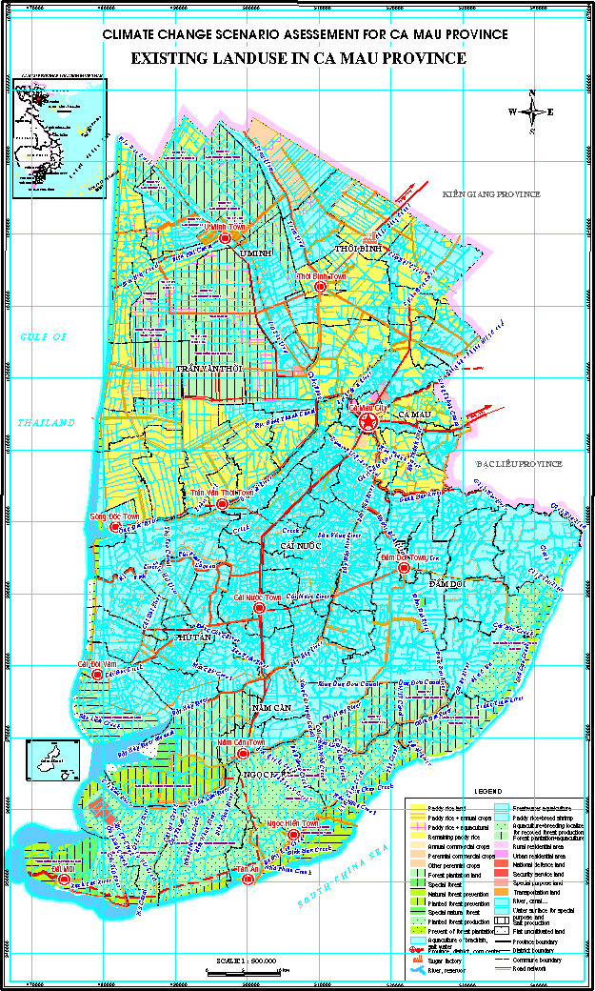

Figure 2: Land use map of Ca Mau province

Forestry
Strengthen the management of forestry land in accordance with Instruction No. 10 by Provincial Standing Committee; renovate the management structure of forestry land and forests in accordance with Project No. 24 by PPC; arrange, allocate, and develop plantations and fisheries in accordance with Resolution No. 28 by 10th Politburo and Decree No. 200 by the Government. Develop Dat Mui and U Minh Ha National Parks; strengthen protective and developing measures for protection coastal forests.
Implement the policy of land and forest assignment to farmers; encourage forest investment and trade in accordance with the model of collection and suitable exploitation; mobilize funds for forestation, strengthen forest protection and forest fire control, mobilize the masses to grow trees to increase forest coverage, etc.
According to re-check plan of Foresty Service, with 145,638.3 hectares, that involvement: 19.168,2 ha of specialized forest, 12.099,4 ha protective forest and 114.370,7 ha produceable forest.

Industry, services, and commerce
- Industry:
Distribution of industrial production: Existing some small industrial park like Ward No.8, Ward No.1 of Ca Mau city, Tri Phai of Thoi Binh district and Song Doc of Tran Van Thoi district, which are basis to take shape the concentrated industrial zone. In addition the industrial zone, namely Gas-Electricity-Fertilizer is investing...is the most important condition help to hasten the rate of industrial developing.

Table 7: Structure of Industry branch
Industry branch | 2000 |  | 2005
Industry branch | Value (VND) | % | Value (VND) | %
Total | 3,768,951 | 100.00 | 13,989,163 | 100.00
1- Processable Industry | 3,758,603 | 99.73 | 13,928,843 | 99.57
+ Provision | 3,377,649 | 89.62 | 13,569,785 | 97.00
+ Clothing trade | 1,958 | 0.05 | 11,249 | 0.08
+ Processable wood | 19,845 | 0.53 | 142,640 | 1.02
+ Chemical | 10,992 | 0.29 | 127,977 | 0.91
+ Metallic product | 215,047 | 5.71 | 35,479 | 0.25
+ Other branch | 133,112 | 3.53 | 41,713 | 0.30
2-Manufacture, Electrical and Water supply | 10,348 | 0.27 | 60,320 | 0.43
Source: Statistical yearbook and Industry service of Ca Mau province

Table 8: Norm of industrial production
Norms | Unit | Year 2000 | Year 2005 | Year 2006
Total value industrial product | Bill. VND | 2,862.9 | 6,542.8 | 7,001.5
Industrial production branch | Branch | 4,260 | 2,727 | 3,100
Industrial labour | People | 23,593 | 22,377 | 26,255
Main industrial product
+ Frozen Shrimp | Ton | 26,875 | 70,813 | 75,213
+ Frozen water | 1000 Tons | 443.2 | 524.6 | 524.9
+ Fish sauce | 1000 litre | 985 | 165 | 163
+ Cane sugar | Ton | 7,800 | 12,930 | 23,894
+ Rice husking | 1000 Tons | 251.7 | 140 | 134
+ Tap-water supply | 1000 m3 | 4,367 | 7,445 | 8,045
Source: Statistical yearbook and Industry service of Ca Mau province
- Commerce:
The activities of export are growing in high rate: Aquaculture, Rice is the main exportable commodity with expansible export market to 40 countries with more 100 customers.

Table 9: Percentile of Aquaculture Exportable market
Exportable market | Year 2002 | Year 2003 | Year 2004 | Year 2005
Japan | 33.5 | 35.5 | 37.2 | 34.8
USA | 54.5 | 50.9 | 43.0 | 41.7
EU | 0.9 | 1.7 | 1.2 | 6.6
Australia | 1.0 | 2.9 | 4.1 | 3.4
Canada | 0.1 | 1.4 | 2.2 | 3.8
Hong Kong, Taiwan | 1.9 | 1.6 | 1.3 | 2.5
Korea | 4.4 | 1.6 | 0.7 | 0.9
Singapore | 0.1 | 0.2 | 2.4 | 0.5
Other countries | 3.6 | 4.2 | 7.9 | 5.8
Source: Procession and Aquaculture Export association of Ca Mau province
- Services:
The local authority planned investing in some tourist areas like Dat Mui, Khai Long breach, Da Bac inland, to promote growth in other sectors. Hotel and restaurants are also scheduled for upgrades.

Public health
Medical network has developed significantly. To date, every district has hospitals, and 100% of communes and wards have clinics or health practices. However, these places are under-equiped and there is a shortage of doctors or physicians working in rural areas. The ratio of doctors and sick-beds for every 10 thousand people are as follows:

Table 10: Public health services
Norm | Year 2000 | Year 2005 | Year 2006
Total health office | 91 | 110 | 110
+ Provincial hospital | 3 | 4 | 4
+ District hospital | 7 | 9 | 9
+ Health centre in Ward |  | 97 | 97
Sick-bed | 1.491 | 2.448 | 2.503
Physician | 294 | 556 | 565
Sick-bed out of every 10 thousand | 12,91 | 20,07 | 20,27
Physician out of every 10 thousand | 2,55 | 4,56 | 4,57
Percentile of Vaccine children | 92,11 | 95% | 95%
Percentile of undernourished children | 31,3% | 23% | 21,7%

Education and training:
To date, in all wards, communes, and districts in the province have lower and upper secondary schools respectively. The system of universal primary education has been adopted by 100% of wards and communes. However, teaching and learning conditions are hindered by the lack of classrooms, 3-shift-learning roster, out-of-dated equipments, lack of teaching staff, lack of general resources.

The role of transportation structures

Regarding the relationship between the provinces within the Cuu Long Delta, Ca Mau posseses the following important waterways and roads:
- National road, namely 1A, connection from Ho Chi Minh - Bac Lieu – Ca Mau – Nam Can (and will be extended to Dat Mui);
- National road No. 63 (from Ca Mau to Kien Giang province);
- Provincal road Quan Lo - Phung Hiep.
- National waterway from Ca Mau to Ho Chi Minh city.
The majority of local transportation utilises the elaborate network of waterways. Local waterways are on farm connected canals and ditches from hamlets to communes and acts as a life-line in domestic life, production. Road transportation has gained some significant changes during the recent years. Districts and communes are now connected via motorways, while 90% wards are connected to communes via roads.

Electricity system
Electricity has lighted 95% of wards and communes and 75% households who take its advantage for life and production; thank to electricity, people can update information from TV, radio, approach scientific-technological advances and disaster news in the region.

Current situations of water control system
Before 1997, Ca Mau was considered as region No. 2 in former Minh Hai province, and investment in hydraulics works was given a lower priority. After the separation, the investment scale has increased. However, the existing hydraulic system remains asynchronous and inefficient due to the fact that most hydraulic works here are earthen, temporary, or degraded without regular maintenance. In the recent years, unpredictable weather such as rising water and cyclones have caused significant damage to existing waterways infrastructure. Some sea dike sections, in particular, are under serious erosion without any solutions. There are 9 places of serious erosion with total length of 1.515 m along the sea dike section of 55 km in length from Tieu Dua to Doc river; in estuaries, 4.760 m of bank is eroded: Da Bac, Lung Ranh, Khanh Hoi, Kiem Lam, Cong Nghiep, Cai Cam, Quang Thep, Kenh Moi, Kenh Tu, Ba Tinh, Sao Luoi, Da Bac, Song Doc, Ho Gui, Ca Mau cape, etc. and also about 2.500m of riverbank in some residential areas such as Tan Tien, Nam Can, Vam Dam near major rivers is under erosion.
However, the construction of hydraulic works in Ca Mau has gained achievements in terms of quality and quantity and significantly contributed to the prevention of salinity, protection of fresh water, drainage of acid-sulfate for fresh water eco-system, at the same time provides salt water and drains waste water for shrimp farming areas.
Since 1975, the Government water resources’ fund provided for Ca mau can not meet actual requirements with the total investment of about 161 billion VND. Details are as follows:
+ Sau Dong Project: 24 billion VND funded for the constructions of Sau Dong canal of 18 km in length in 1982, and 2 culverts (Cay Duong and Hiep Hoa) in 1987.
+Quan Lo Phung Hiep Project: 55 billion VND funded for the construction of 6 culverts (Tac van, Ca Mau, Bach Nguu, Duong Xuong, Thi Phong, Og Huong) and dredging of 3 secondary canals (Bach Nguu, Duong Xuong, Tan Phong).
+Sea dike in estuaries and on dike structures: 82 billion VND funded for the improvement and upgrading of Ca Mau sea dike (West Sea) of 92 km in length; construction of 3 culverts on West Sea dike (Ba Tinh, Kenh Moi, Da Bac culverts); construction of the left dike of Doc River of 9.5 km in length.
Meanwhile, in the period from 1998 – 2005, provincial budget of 202 billion VND, district budget of 180 billion VND, and mobilized fund from local people of 61 billion VND were used, mainly for seasonal dredging of canals and maintaining culverts. In addition, local people self-invest to construct and dredge tertiary canals, strengthen dams, etc. With the total budget of over 1.500 billion VND. Although these activities partly contribute to local natural disaster control and mitigation, they can not meet production requirements.
The majority of local system of canals, dikes, and culverts have been improved and upgraded with thousands of kilometres of canal banks, sea dikes, river dikes, hundreds of culverts along the dikes. However, due to unconcentrated investment of small scale and lack of fund, they can not meet requirements of production, domestic life, etc.
In the region, fresh water for drinking, living, and production come from underground and rain water. In rainy season, local people use canal water which is freshened for domestic life and save rain water for drinking. They also use under ground water, where available. In places where no wells are founds, people use saved rain water and water from ponds.
Only 67% of households in the province are provided with fresh water that is an obstacle to the improvement of local people’s living standard.

Future development plan

Developing Target
Ca Mau provine belongs to Ca Mau - Can Tho - An Giang - Kien Giang region, it is one of 4 economic region of VietNam Mekong Delta, and is also a key province in determining the success of development plans of motivative economic region of VietNam Mekong Delta (Ca Mau’s Gas-Electricity-Fertilizer, Ca Mau’s flooded forest...)
Regarding the relationship between the provinces within Viet Nam Mekong Delta, Ca Mau is connected via its transport infrastructure (see above):
Therefore, within regional relationship, forming two associate developing way from Ca Mau: Ca Mau - Can Tho và Ca Mau – Kien Giang and An Giang.
With 254 km of coastline belongs to the Eastern economic coastal corridor (Bac Lieu - Ganh Hao - Ca Mau - Nam Can), giving it a central location in the South-East Asian region, especially within the Gulf of Thailand. This has significant transport potential allowing the coastal corridor to compete in national and international trading routes, positioned to benefit from the significant oil and gas reserves (Gulf of Thailand), as well as enormous potentiality for ecotourism and sea-island tourism.
However, still concomitance with more difficulty but with its geographic co-ordinates and natural conditions, Ca Mau province has much advantage during developing process of its economics, culture and society. The broad aim of development in the province can be summarized as:

General target: Continuation strive for economic growth, upgrading the effect of neccessary development, intensify building the substructure with the aim that in 2015 an economic Industry-Service-Agriculture development structure will be set up and implemented, such that by 2020 Ca Mau will became a province with a strong, diverse economy, especially in the sector of shipping, ports and tourism. It is planned that Ca Mau will contribute to the development of the economy of Cuu Long Delta.

Economy
The average annual GDP rate is growing rapidly at 12- 12.5 %. The 2020 economic structure in correspondence with actual prices is as follows:

Table 11: Forecast the transition of the economic structure of Ca Mau
Branch | Year 2005 | Year 2010 | Year 2015 | Year 2020
Agriculture | 52.46% | 39.95% | 28.71% | 19.67%
Industry and Construction | 24.21% | 31.96% | 37.81% | 43.47%
Service | 23.33% | 28.29% | 33.48% | 36.90%

Table 12: Norm of developing economic structure of Ca Mau province
Target | Unit | Year  2010 | Year  2015 | Year  2020 | Ave. Increasing Percentile (%)
 |  |  |  |  | 06-10 | 11-15 | 16-20
1- Population | 1000 people | 1,330 | 1,418 | 1,500
2- GDP (Comparison with 1994) | Bil. VND | 14,377 | 27,339 | 53,212 | 13.3 | 13.7 | 14.2
Consist:  + Agro-Fishery-Forestry | " | 4,895 | 6,550 | 8,561 | 6.5 | 6.0 | 5.5
+Industry and Construction | " | 4,893 | 10,728 | 23,520 | 19.0 | 17.0 | 17.0
+ Service | " | 4,589 | 10,061 | 21,131 | 17.0 | 17.0 | 16.0
3- GDP (actual prices) | Bil. VND | 20,273 | 37,564 | 71,649
Consist: + Agriculture | " | 8,059 | 10,785 | 14,095
+ Industry, Construction | " | 6,479 | 14,205 | 31,143
+ Service | " | 5,735 | 12,575 | 26,411
4- GDP/per person | Mil. VND | 15.24 | 26.49 | 47.77
(Transfer to USD) | USD | 962 | 1,671 | 3,014 | 10.6 | 11.7 | 12.5
5- Structure of GDP (actual prices) | % | 100 | 100 | 100
+ Agro-Fishery-Forestry | % | 39.75 | 28.71 | 19.67
+Industry and Construction | % | 31.96 | 37.81 | 43.47
+ Service | % | 28.29 | 33.48 | 36.9
Source: Report of developing plan of Ca Mau province

Environment
- Forest coverage accounts for 65%, coverage in concentration forests claims for 24% of natural areas, plant areas in urban areas increase.
- Collected solid waste rate: 90%
- Treated waste rate from factories and hospitals: 100%

Table 13: Land use planning up to 2020 in Ca Mau province
No. | Item | Year 2010 | Year 2015 | Year 2020
 | Natural land area (ha) | 532,916 | 532,916 | 532,916
A | Agricultural land | 474,202 | 470,862 | 467,317
I | Agricultural produce area | 140,745 | 154,772 | 168,042
1 | Annual tree area | 87,208 | 102,324 | 116,704
1.1 | Rice growth area | 80,215 | 85,000 | 90,000
1.2 | Area of rice-based shrimp | 34,000 | 35,000 | 4,000
1.3 | Other annual tree area | 7,000 | 6,950 | 6,892
2 | Perennial tree area | 53,500 | 52,448 | 51,338
II | Area of forests | 110,000 | 111,000 | 112,000
III | Aquaculture area | 222,207 | 203,850 | 186,000
IV | Other agricultural produce area | 11,250 | 1,240 | 1,275
B | Non-agricultural land | 48,413 | 52,517 | 56,988
I | Settlement land | 7,805 | 8,980 | 10,155
1 | Rural area | 6,677 | 7,535 | 8,393
2 | Urban area | 1,128 | 1,445 | 1,762
II | Specialized area | 22,406 | 25,209 | 28,379
III | Area for religion | 76 | 76.3 | 76.3
IV | Area for cemetery | 325 | 423.4 | 522.3
V | River/Canal surface | 17,660 | 17,828.3 | 17,855.4
C | Non-produce area | 10,817 | 9,537 | 8,611
Source: Report of developing plan of Ca Mau province

Culture and society
- 100% of communes, precincts, and towns have gained universal lower-secondary education standard, 20% of communes reaching universal upper-secondary education standard.
- 100% of districts and cities, 50% of communes, precincts, and towns have culture – information – sports centers.
- 95% of households, 85% of hamlets, 55% of communes and towns have gained cultural standard.
- Natural population growth rate remains under 1.3%.
- 100% of communes, precincts, and towns have gained standardized clinics.
- Rate of malnourished children under 5 years old remains at 16%.
- Agricultural labor makes up 60% of social labor
- Rate of poor household claims for lower than 10%
- Rate of solid and semi-solid houses reaches 70 %.

National security
- Good implementation of border defense program, good understanding of enemies’ activities on the border and offshore, cooperate with authorities in such important periods as holidays, Tet festival, etc. to find solutions.
- Encouragement of public involvement in border and national defense and social security: provide information and cooperate with localities in dealing with social evils and crime.
- Cooperation with localities to develop the movement “Self-management of safe boats” for fishermen, propaganda for the good implementation of Government Decree No. 66/2005/NĐ – CP on ensuring security for people and ships offshore and not violating coastal areas of regional countries.
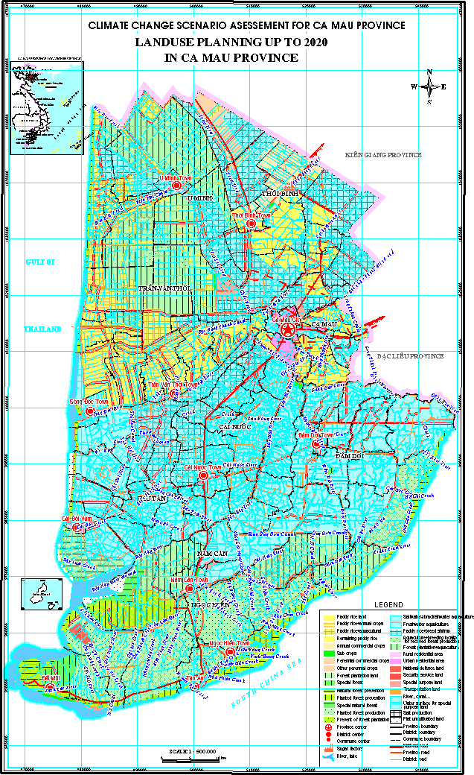

Figure 3: Land use map for the future development of Ca Mau province

CLIMATE CHANGE PREDICTIONS

Overview
Meteorology is a complex science based on nonlinear and dynamical physical processes, which makes it difficult to quantify. Climatology, on the other hand, can be understood as the average state of the weather and includes parameters such as the average temperature, precipitation, cloud cover, days of sunlight, drought, flooding etc... as well as trends in the magnitude and frequency of these factors. Climate change predictions uses best available records of climate parameters to infer how they might change over time. Arguably, atmospheric and surface temperatures, and atmoshoperic carbon dioxide levels are the most common indicators used to measure climate change.
There are two components to climate change, the natural or base fluctutations in global parameters, and the influence of anthropogenic activities. There is consensus amongst the scientific community that global temperatures are increasing, and most research indicates that human activities are an integral component which has accelerated this. The Intergovernmental Panel on Climate change (IPCC), one of the leading research bodies on the phenonmena have just released their fourth assessment report (AR4). It states that since 2005 the concentration of carbon dioxide in the earth’s atmosphere has exceeded the natural range which had existed for the previous 650,000 years. The consequences of this can be seen in the evidence that since instrumental records started in 1850, 11 of the warmest years occured during the last 12 years. Furthermore, there has been an increase of 0.74 degC in the average temperature during the 20th century and the range of feasible predictions for the rise in the global temperature from 1.8 up to 4.0degC. These will have follow on effects, one of which is a rise in sea levels. Already sea levels rised 17cm during the last 100years.
Changes to the hydrological cycle are expected to be the most significant aspect of climate change to affect the Mekong Delta. These include, changes to sea levels, precipitation patterns, monsoon cycles, including both frequency and magnitude of these climatic events.
The IPCC Technical Paper on Climate Change and Water (2008) outlines the effect that Climate Change is having on the hydrological cycle. The following general conclusions from its research, are considered relevent to Vietnam and the Ca Mau peninsula:
- Observations of global warming correlate with changes to the hydrological cycle. Including; increasing atmospheric water vapour content, changing patterns and intensity of precipitation.
- Climate models consistently predict that precipitation is likely to increase in the tropics, decrease in some subtropical and lower mid-lattidue positions. However, model certainty is greater for some regions than for others, and agreement between models decreases with decreasing spatial domain.
- By the middle of the 21st century global water availability is expected to shift from its current distribution. Many arid, semi-arid, mid-latitude and dry tropical areas are expected to get drier, while river runoff and water availability are expected to increase at high altitudes and some wet tropical areas. There is a high level of confidence in these predictions. It should be noted that, this conclusion does not take into account changes in nonclimatic factors (e.g. irrigation) which could influence water availability.
- There is a likely increase in the risk of flooding and drought, with an increase in the frequency of heavy rainfall and extreme events (typhoons, hurricanes).
- Increasing water temperatures and changes to flooding/drought regimes are expected to affect water quality, exacerbating effects from pollution such as sediments, nutrients, pathogens, pesticides, dissolve organic carbon, and salt. There will be significant economic, environmental and health-related rammifications for human communties.
- Globally, climate change is expected (with a high degree of confidence) to have an overall negative impact on freshwater systems.
- Changes to the hydrological cycle are expected to reduce food security and increase vulnerability of rural farmeres, especially in the Asian megadeltas.
- Lowlying megadeltas in Asia and Africa are identified as highly vulnerable regions, and likely to be greatly affected by changing hydrological regimes.
This study is primarily focused on predicting the effects of rising sea levels and changes to the precipitation regime in the Ca Mau peninsula. These factors may cause inundation of coastal areas and islands, shoreline erosion, and destruction of important ecosystems such as wetlands and mangroves. As global temperatures increase, sea level rise, already underway, is expected to accelerate due to thermal expansion of upper layers of the ocean and melting of glaciers.
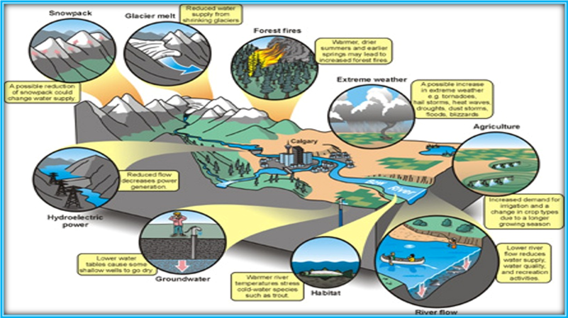

Figure 4: Climate change
- Climate Change Model Accuracy:
It should be noted, that climate change predictions incorporate the results of many physical and chemical models, each containing their own uncertainties and errors. By way of example, Figure 12 below represents the process by which climate models are built. The uncertainty in the comprehensive climate model is therefore the culmination of the uncertainty in all the models used to create it.
Furthermore, the IPCC have drawn on several climate models, comparing their outputs. Confidence in predictions are stated together with the appropriate level of confidence, so that the higher the degree of uncertainty and the more the climate models diverge form each other, the lower the confidence in the climate predictions. It is typical for IPCC findings to rely on up to 20 separate comprehensive climate models to verify one conclusion about climate change.
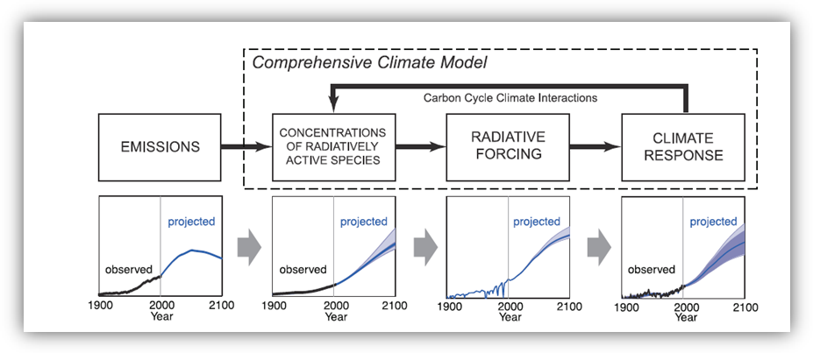

Figure 5: Uncertainty in comprehensive climate model

Introduction
Vietnam is located in the tropical region of Asia and is potentially one of the countries where a rise in sea level could have the most dramatic impact. While many forecasters predict dire consequences for low-lying Bangladesh, Vietnam would also be badly hit, and "nearly a quarter of the population of this country could be directly affected." Figure 14 indicates the nature of the effects that climate change is likely to have around the world, produced by the IPCC it suggest Vietnam is likely to face both drought and changes to the prevaling hydrological regime.
Vietnam, has a population of 84 million, and over 3.200 kilometres of coastline. It suffered 10 typhoons and severe storms last year, and concentrates much of its food production in the low-lying Mekong delta.
If sea levels rise by one metre, Vietnam would lose more than 12 percent of its land, home to 23 percent of its people. Climate change could also increase the frequency and severity of typhoons, and rising temperatures and changing rainfall patterns would also affect Vietnam's agriculture and water resources.
Vietnam’s economy grew by over eight percent last year, and is one of the fastest growing economies in Asia. At the same time, it is also emitting more pollutants, with the amount of greenhouse gases (GHGs) released projected to increase by a factor of 2.3 from 1994-2020.

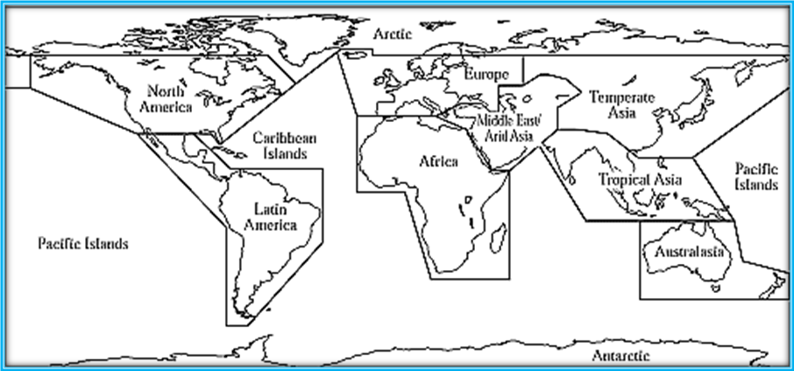

Figure 6: Regional study
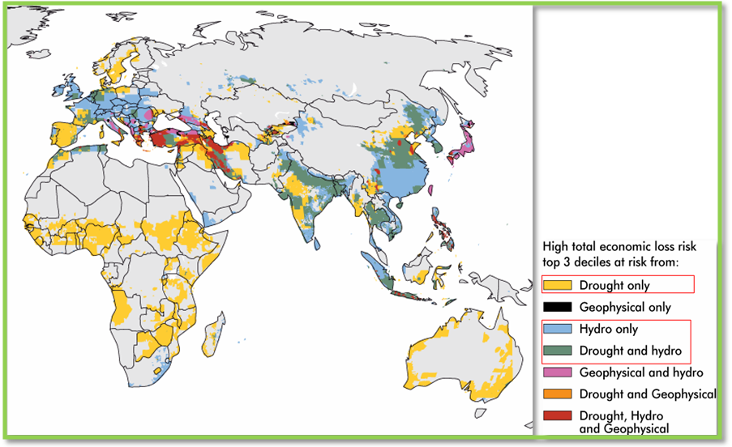

Figure 7: Regional effected

Source: Intergovernmental Panel on Climate Change Organization

Sea level rise
Sea level rise by climate change is a serious global danger and it is more serious for countries that have high population densities in coastal and lowlands like Vietnam.
The danger of sea level rise can come from three sources: (i)The first is the continuing increase of the greenhouse effect and along with it the gradual warming of the earth. Most of the global thermal energy is stored in the world’s oceans, so an increase in temperature will result in increased water temperatures. The increased temperatures will cause the sea water to expand thereby increasing sea levels. According to scientists, this phenomenon could make the sea level rise by 1-3m in the 21st century; (ii) In addition, icebergs in Greenland and West Antarctica are quickly melting, up to over 1m a month in some places; and this could increase the level of the sea by 5m; (iii) The third is the increase of underground water exploitation, especially under big cities, which makes land surfaces sink. These processes are summarized in the figure below, which is based on observed changes in the state of world’s oceans. .
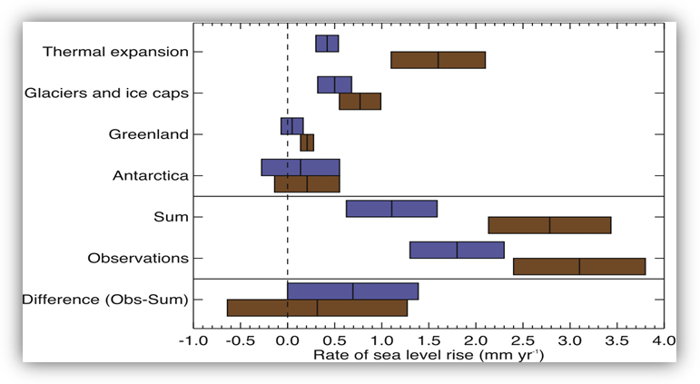

Figure 8: Physical factors contributing to rising sea levels, based on 1961-2003 data (blue) and 1993-2003 data (brown)
The resulting rise in sea levels is not uniform throughout the world’s oceans, and is dependent on latitude, as represented in Figure 8.

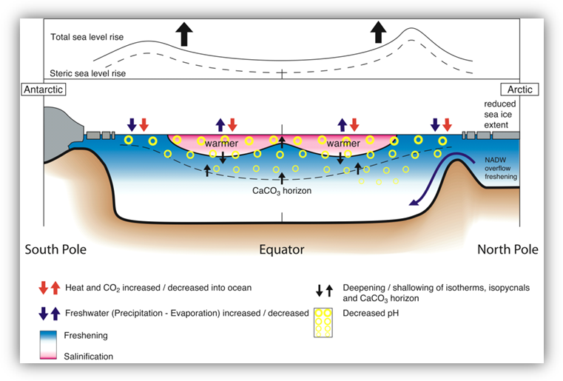

Figure 9: Schematic diagram of sea level rise
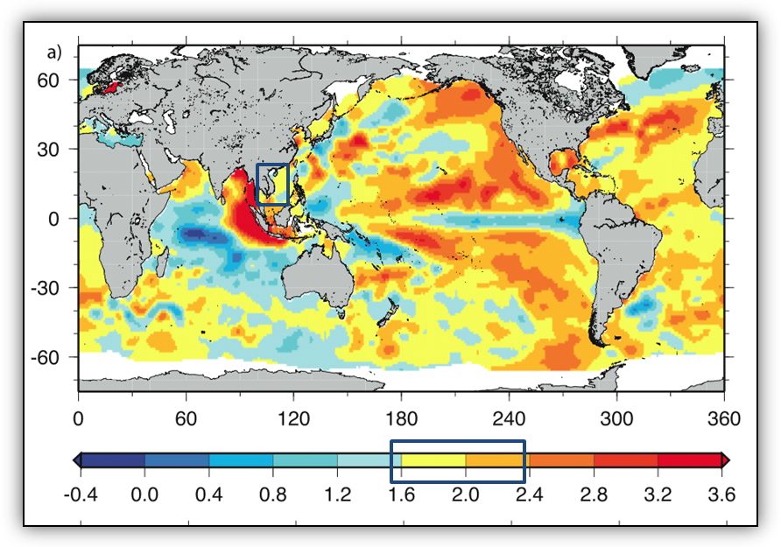

Figure 10: The geographic distribution in longterm 1955-2003
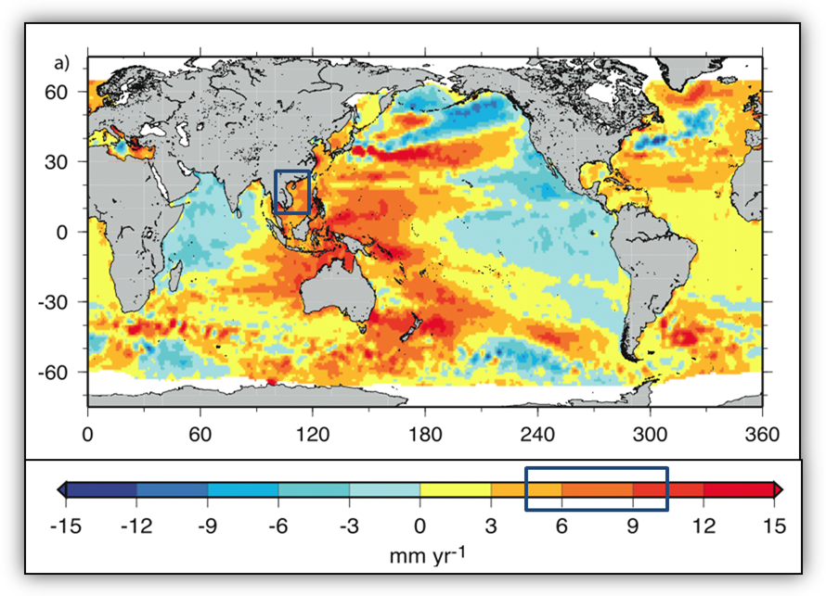

Figure 11: The geographic distribution in short term 1993-2003
Figure 10, 11 shows the geographic distribution in long term 1955-2003and short term 1993-2003 linear trends in mean sea level, based on satellite imagery reported by the IPCC (2008). The short term increase in sea level can be seen to be escalating in accordance with the escalated thermal expansion of sea water over the same time period.
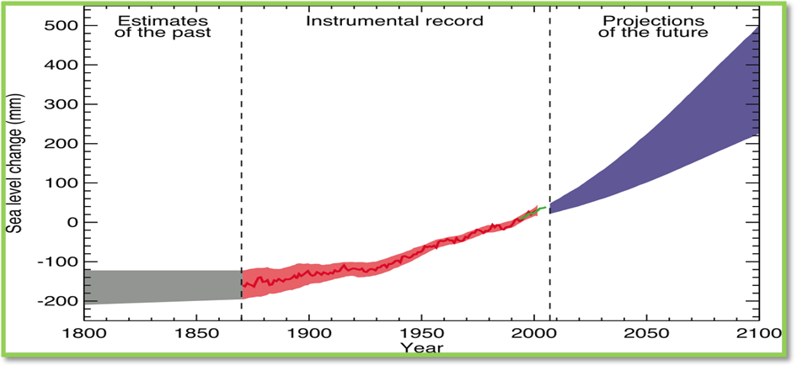

Figure 12: Sea level change prediction
Source: Intergovernmental Panel on Climate Change Organization
Web site: http://www.ipcc.ch/pdf/assessment-report/
Figure 12 represents a times series of the global mean sea levels and contains the projections of numerous models as reported by the IPCC. No instrumental records were available for the pre-1870 period. Tidal gauges were in use in the period 1870- and have been used to reconstruct the global sea mean level, with variations presented as the red shadow. The small section of green line is taken from satellite altimetry records and was added to show the correlation bewteen the two measurement methods. The blue shading shows the range of model projections relative to the 1980-1990 mean. It can be seen that sea levels are rising at an increasing rate, and secondly, that current models diverge in the second half of the 21st century. The implication of this, is that regardless of which mitigation strategies are adopted, the first half of this century is already committed to the effects of Climate Change. After this time, the influence of what has already happened (i.e. pre 2007) will diminish to the point where during the period 2090-2099 only 20% of the change will be dependent on the pre-2007 situation, the remainder will be dependent on what happens in the interim.
The result of all these factors, is that on a global level even the most conservative of the modelling scenarios predict a minimum rise of 0.4m in the sea level by the end of this century, while a rise of up to 1.4m can be projected for the next 50years with reasonable confidence.

In Asia
The effects of Climate Change are region dependent. The IPCC produces reports specific to each of the regions presented earlier in Figure 12, however at the time of writing the AR4 Regional update had not yet been released. In light of this, predictions of changes to the hydrologic cycle within Asia rely on the Third Assessment Report (TAR), released by the IPCC in 1997. The IPCC has noted that the AR4 confirms the vast majority of the conclusions of the TAR, the main difference being an improvement in the agreement between modelling efforts imbuing a greater degree of confidence in the results. Therefore, the use of the TAR published data is considered acceptable, but subject to any revisions required with the publication of the AR4 update.
In the Asian Region, the TAR concludes:
- Marine and coastal ecosystems in Asia are likely to be affected by sea-level rise and temperature increases (high confidence)
- Sea-level rise is very likely to result in significant losses of coastal ecosystems and a million or so people along the coasts of South and South-East Asia will likely be at risk from flooding (high confidence)
- Sea-water intrusion due to sea-level rise and declining river runoff is likely to increase the habitat of brackish water fisheries but coastal inundation is likely to seriously affect the aquaculture industry and infrastructure particularly in heavily-populated megadeltas (high confidence).
- Stability of wetlands, mangroves and coral reefs around Asia is likely to be increasingly threatened (high confidence).
- Recent risk analysis of coral reef suggests that between 24% and 30% of the reefs in Asia are likely to be lost during the next 10 years and 30 years, respectively (medium confidence).

Table 14: Specifications of Climate change and Sea level rising
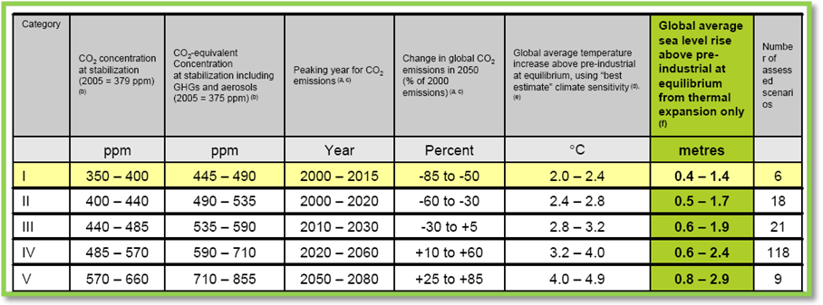

Source: Intergovernmental Panel on Climate Change Organization

Figure 13: Sea level change prediction
Source: Intergovernmental Panel on Climate Change Organization
Web site: http://www.ipcc.ch/pdf/assessment-report/

In Viet Nam
In East Asia, Vietnam is expected to be the nation that will suffer the heaviest impacts with the majority of impacts centred around the low lying Red River and Mekong River deltas. If the sea level rises by 1m, around 5.3% of land, 10.8% of population, 10.2% of GDP, 10.9% of urban area, 7.2% of agricultural area, and 28.9% of low ground will be affected. Material losses caused by this phenomenon have not been calculated, and lie outside the scope of this study, but on such a large scale, the lives of millions of Vietnamese people will experience great changes.
This study assesses the impact of sea level rise, one of the most probable consequences of global climate change, for the water regime in the Ca Mau province. This is done using hydraulic models that have a long history of use and reliability in the Mekong delta. The model computes water levels, under two different sea level rise scenarios of 25cm (=25) and 50cm (=50), respectively. Based on the understanding of sea level rise, these values have been chosen as being indicative of a conservative (25cm) and maximum (50cm) change in sea level. Model results were then overlayed on spatial imagery so that the effects of sea level rise could be quantified against current land use, and provincial development plans for the future.
The outputs show that the contour lines of water levels will be shifted up to 25 km (25) and 50 km (50) towards the sea due to higher sea levels. GIS techniques were used to delineate areas with different levels of vulnerability. These adverse impacts could affect all three cropping seasons, Mua (main rainfed crop), Dong Xuan (Winter-Spring) and He Thu (Summer-Autumn).

Temperature and Rainfall
Temperature and rainfall scenarios are based on simulated changes averaged over two essential seasons: the SouthWest monsoon and the northeast monsoon. Temperature scenarios for Tropical Asia reported by Whetton (1994) and the Climate Impact Group (1992) suggest that temperature would increase throughout most of the region, although the amount of warming is projected to be less than the global average. Moreover, results presented in Table 15 indicate that there may be differences within the region, depending on proximity to the sea. Thus, warming is projected to be least in the islands and coastal areas throughout Indonesia, coastal south Asia and Indo-China and greatest in inland continental areas of south Asia and Indo-China-except from June to August in south Asia, where reduced warming could occur.
Mean Precipitation: In monsoonal and tropical areas, a warmer climate is expected to generally increase precipitation, while the subtropics are expected to decrease. Globally averaged mean water vapor, evaporation and precipitation are projected to increase.

Precipitation Extremes and Droughts: In general the intensity of precipitation events is expected to increase, this is particularly so for monsoonal regions. Periods between rainfall events are also likely to be changed, with subtropical areas expected to experience longer periods of drought. Extreme precipitation events are likely to increase more in the tropical areas than other areas of Asia.

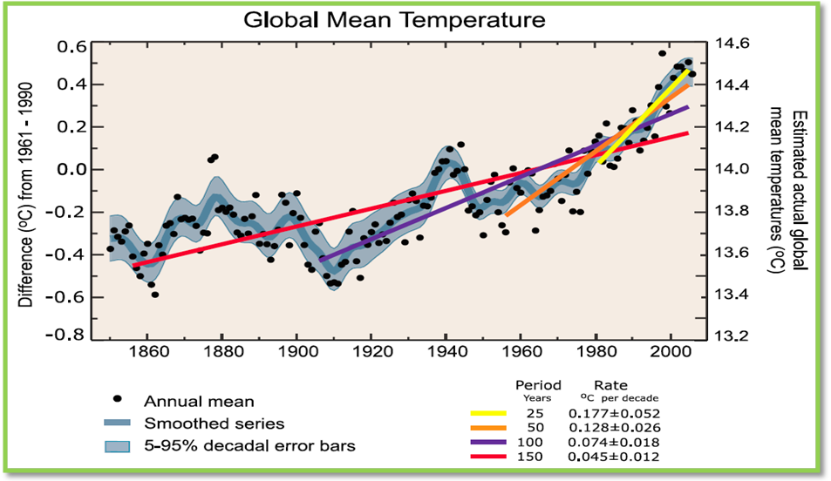

Figure 14: Temperaturechange prediction

Table 15: Temperature change scenarios for 2010 and 2070 (°C)
Region | Year
Region | 2010 | 2070
Indonesia, Philippines, and coastal south and southeast Asia | 0.1-0.5 | 0.4-3.0
Inland south and southeast Asia (in June-July-August) | 0.3-0.7 | 1.1-4.5
Inland south Asia in June-July-August | 0.1-0.3 | 0.4-2.0
Source: Whetton, 1994. Web site: http://www.grida.no/climate/ipcc/regional/

In terms of rainfall, the models considered by Whetton (1994) suggested an April-to-September maximum over south Asia and the Indo-China peninsula and a minimum over Indonesia and areas near Australia. Projections of regionally averaged changes in rainfall for the years 2010 and 2070 are given in Table 16.

Table 16: Rainfall scenarios for 2010 and 2070 (% change)
Region | 2010  Wet Season | 2010  Dry Season | 2070  Wet Season | 2070  Dry Season
South West Monsoon Region India, Pakistan, Bangladesh, Philippines (western part), and Viet Nam (except east coast) | 0 | 0 | 0 to 10 | -10 to +10
Northeast Monsoon Region Indonesia, Philippines (east part), Viet Nam (east coast), Sri Lanka, and Malaysia | 0 to -5 | 0 | -5 to +15 | 0 to +10
South Asia region (15-30°N; 65-95°E) | 0 to +10 | -5 to +5 | +5 to +50 | -5 to +20
Source: Whetton, 1994.
Web site: http://www.grida.no/climate/ipcc/regional/
Other simulations of changes in rainfall indicated a tendency for an increase in wet-season rainfall in both monsoon regions, with changes ranging from -5% to +18% (Climate Impact Group, 1992). More consistent and much larger rainfall increases are projected for the south Asia subregion wet season, with values ranging from +17% to +59%. Changes in dry-season rainfall are less consistent and are estimated only as broad-scale regional rainfall changes; local-scale changes could be much greater.
Systematic increases in average rainfall intensity are a common feature in simulated daily rainfall experiments, along with associated increases in the projected frequency of heavy rainfall events. Whetton et al. (1994) conclude that there is reason for higher confidence in increasing rainfall intensity in south and southeast Asia under enhanced greenhouse conditions than in increases or decreases in total rainfall in particular regions.

Extreme Weather
Climate change predictions, tend to focus on means; particularly the change in global temperatures averages are expected to rise. But most of the potentially damaging consequences relating to climate change are associated with extremes, for example, the number of heat waves, floods, or severe storms. Since extreme weather events hold great potential for loss of life and property, it is important to understand what impact global warming may have on their occurrence. While we often think of climate in terms of averages, the extremes are an equally important factor for engineers and policy makers.
Extreme weather events in Asia were reported to provide evidence of increases in the intensity or frequency on regional scales throughout the 20th century. The Third Assessment Report (TAR) predicted that the area-averaged annual mean warming would be about 3°C in the decade of the 2050s and about 5°C in the decade of the 2080s over the land regions of Asia as a result of future increases in atmospheric concentration of greenhouse gases. The rise in surface air temperature was projected to be most pronounced over boreal Asia in all seasons.
It remains difficult to assess the impact of global warming on extreme weather events, in large part because this analysis depends greatly on regional forecasts for global warming. There is less confidence in the predictions of changes to their frequency or intensity.
Since the importance of extreme events is typically related to risk analysis and mitigation measures that can be used to control damages, it was concluded for this study, the impact of extreme weather would be assessed based on the biggest historical storm to hit Ca Mau province. These storms occurred in 1997.

Summary Climate Change Conclusions

The IPCCs AR4 report draws the following conclusions regarding water resources in asian megadeltas (2008):
Climate change affects the function and operation of existing water infrastructure—including hydropower, structural flood defenses, drainage, and irrigation systems—as well as water management practices. (High confidence)
Current water management practices may not be robust enough to cope with the impacts of climate change on water supply reliability, flood risk, health, agriculture, energy and aquatic ecosystems. In many locations, water management cannot satisfactorily cope even with current climate variability, so that large flood and drought damages occur. As a first step, improved incorporation of information about current climate variability into water-related management would assist adaptation to longer-term climate change impacts. Climatic and non-climatic factors, such as growth of population and damage potential, would exacerbate problems in the future. (Very high confidence)
Adaptation options designed to ensure water supply during average and drought conditions require integrated demand-side as well as supply-side strategies. The former improve water-use efficiency, e.g. by recycling water. Expanded use of economic incentives, including metering and pricing to encourage water conservation and development of water markets and implementation of virtual water trade, holds considerable promise for water savings and reallocation of water to highly valued uses. Supply-side strategies generally involve increases in storage capacity, abstraction from water courses, and water transfers.
Integrated water resources management provides an important framework to achieve adaptation measures across socio-economic, environmental and administrative systems. To be effective, integrated approaches must occur at the appropriate scale or scales needed to facilitate effective actions for specific outcomes.
Mitigation measures can reduce the magnitude of impacts of global warming on water resources, in turn reducing adaptation needs. However, they can have considerable negative side effects, such as increased water requirements for afforestation/reforestation activities or bio-energy crops, if these are not sustainably located, designed and managed. On the other hand, water management policy measures, e.g., hydro-dams, can influence greenhouse gas emissions. Hydro-dams are a source of renewable energy. Nevertheless, they produce greenhouse gas emissions themselves. The magnitude of these emissions depends on specific circumstance and mode of operation.
Several gaps in knowledge exist in terms of observations and research needs related to climate change and water. Observational data and data access are prerequisites for adaptive management, yet many observational networks are shrinking. There is a need to improve understanding and modeling of changes in climate related to the hydrological cycle at scales relevant to decision making. Information about the water-related impacts of climate change is incomplete, especially with respect to water quality, aquatic ecosystems, groundwater, including their socio-economic dimensions. Finally, current tools to facilitate integrated appraisals of adaptation and mitigation options across multiple water-dependent sectors are inadequate.
Water resources management clearly impacts on many other policy areas e.g., energy, health, food security, nature conservation. Thus, the appraisal of adaptation and mitigation options needs to be conducted across multiple water-dependent sectors. Low-income countries and regions are likely to remain vulnerable over the medium term, with fewer options than high-income countries for adapting to climate change. Therefore, adaptation strategies should be designed in the context of development, environment and health policies.
These conclusions confirm the importance of assessing the versatility of current water management and their ability to meet a likely future climate regime. This will be achieved through the quantifcation of the identified climate change problems affecting Ca Mau pennisula through the use of computer simulation.

MODEL APPLICATION
  - VRSAP Model Setup

Introduction of VRSAP Hydraulic Model
The “Vietnam River Systems and Plains” (VRSAP) model is designed to simulate one-dimensional hydrodynamic river flow and quasi two-dimensional flow on floodplains. An implicit finite difference scheme is used to solve the one-dimensional Saint-Venant equations and VRSAP is able to model complex branched and looped river networks. VRSAP is also designed to model the advection-dispersion equation for dissolved or suspended material (e.g. salinity, acidity etc) using the implicit finite difference scheme.
The VRSAP model was originally developed in 1978 and has been refined by the modeling group headed by Prof. Nguyen Nhu Khue at the Sub-Institute for Water Resources Planning and Management (SIWRPM). The model is written in FORTRAN, but a new user-friendly version in Visual Basic (Programmed by Dr. Chu Thai Hoanh - International Hydrodynamic Model Expert) has been prepared for running on PC.

VRSAP model application
The VRSAP model has been used in a number of water control projects in Vietnam, such as:
- The project of Salinity Intrusion Studies in the Mekong Delta, supported by Australia through the Interim Mekong Committee from 1981 to 1991;
- The Eco-development Planning (1989) and the study of Pre-feasibility of Water Control in the Quan Lo Phung Hiep area (1990-1992), Mekong Delta, Vietnam, supported by the Mekong Secretariat and CIDA, Canada;
- The Mekong Delta Master Plan project supported by UNDP and conducted by NEDECO, the Netherlands, from 1990 to 1993. In this Project, the VRSAP model has been used to simulate both flood and dry flows including salinity intrusion in a network of over 900 segments, 800 nodes and 300 plains;
- A lot of water resources development projects in the Mekong Delta and Dong Nai basin carried out by the Sub-Institute for Water Resources Planning and Management since 1987; and
- The study of flood control planning for the Mekong Delta, a state high priority study after the high flood in 1994 in the Mekong Delta.
- The Project of Flood Control Planning For Development of The Mekong Delta, supported by Korea Government through the MRCs from 1999 to 2000.
- The Integrated Water Resources Planning Project for the Mekong Delta from 2002 to 2005.
- Water resources planning Project for the Ca Mau Peninsular, Mekong Delta from 2003 to 2006.

Input data of the VRSAP model
The Main capability of the program can be described by the following input data, which are separated in two files:
- A file of hydrological data comprising of water level, discharge, salinity at the boundaries and under initial conditions
- A file of topographic data comprising of the structure and hydraulic elements of the water system.
Hydrological data needed to the program are boundary conditions and initial conditions. Boundary conditions are as follows:
- Water level at stations corresponding to boundary nodes (upstream sites, river mouths or any internal nodes);
- Discharge (in/outflow, constant or varying with respect to time) at boundary segments;
- Salinity at boundary nodes; and
- Rainfall from stations located within the delta.
- Initial conditions comprise water level and salinity at node locations, and flow conditions in all segments.
Topographic data comprises geometric information on each segment of the river/ canal/ sewer and each parcel of the plain. Each segment is defined by a section bounded by two nodes. Water level and salinity at the nodes are computed while flow is calculated at the ends of each segment.
For each segment, required data includes:
- Segment type: river/canal or sewer pipe or hydraulic structure such as dam, weir, sluice, culvert, one-direction gate, etc;
- Length and roughness coefficient;
- Mean cross-section;
- Dispersion coefficient; and
- Rainfall station corresponding to the segment;
For each parcel of plain (rural or urban land), the following data are required:
- Operation mode in connection with river/canal segment or node, for example, opened, directly connected or conditionally connected through a culvert, sluice or small creeks;
- Area and volume of the plain corresponding to different water level;
- Code of segment or node where the plain is connected;
- Rainfall station corresponding to the plain;
- Rainfall run-off coefficient; and
- Size and water conveyance capacity of the connection.
By coding segments, nodes and plains, the program will automatically generates a scheme of the network and the sequence of computation.

Output data of the VRSAP model
Output data including water level, salinity at selected nodes and flow at two ends of selected segments can be generated in tabular format and linked to the graphic software and GIS.
Besides the simulation of the existing condition, the effects of different water control alternatives or variations in water resources such as water extraction, canal excavation, building hydraulic structures, changes in natural flow, etc. can be predicted by changing topographic and hydrological data inputted to the model.

Mapping
The output from the VRSAP model will be processed and analyzed in the MapInfo/ArcGIS program to determine the spatial effects of climate change within Ca Mau province. MapInfo/ArcGIS has the ability through its VerticalMapper component to produce a grid-based map that represents the projected water level and salinity concentrations across the Ca Mau area from the VRSAP output.
The water level and salinity output from VRSAP is processed by performing a natural neighbour analysis to project a user defined grid of the water level over the Ca Mau province. The natural neighbour analysis creates regions around each individual data point (VRSAP nodes) by using an area-weighting technique (Thiessen polygon method). A slope-based solution is then applied to the regions to produce a grid value that is determined by averaging the extrapolated slope of each surrounding natural neighbour region. This process interpolates a smooth water level and salinity profile over the entire area of the Ca Mau province.

  - Model Application for Ca Mau Province

VRSAP schematization
Ca Mau peninsula has the complex and interlacing canal system, among them Ca Mau is southern coastal part, it is not only effected by both tidal regimes but also supplied much more fresh water from Bac Lieu and Western Bassac river. That is main cause when we setup VRSAP schematization for the Ca Mau province base on schematization for Ca Mau peninsula, and much updated schematization for the Ca Mau area was completed with:
- 302 Main Canals
- 1758 nodes
- About 1758 cross-sections
- 966 flood plains

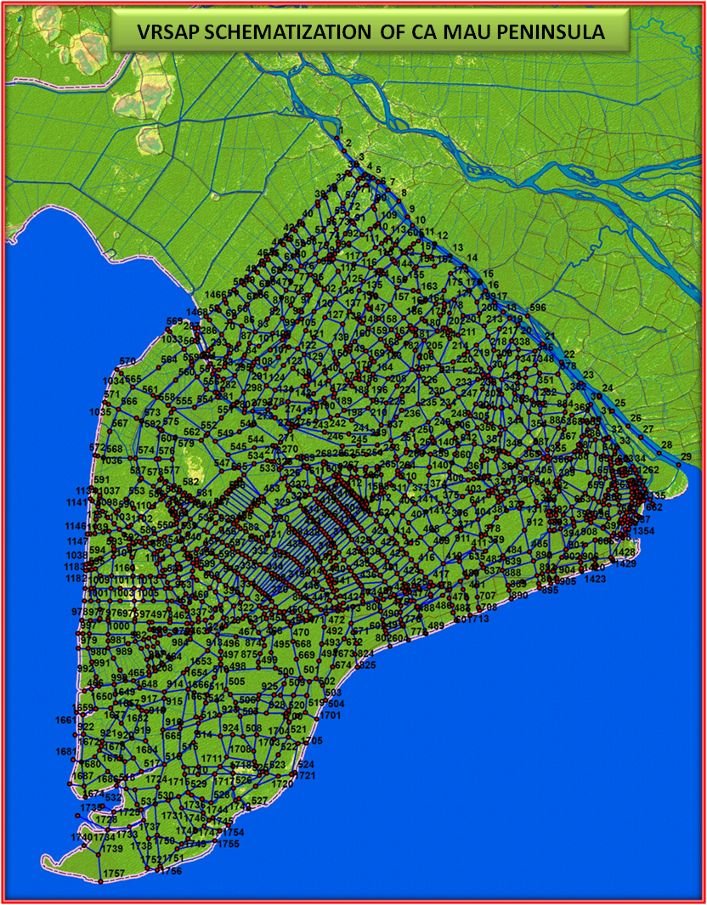

Figure 15: VRSAP schematization of the Ca Mau peninsula

Input data
- Topographic data of canals, rivers, plains, dykes, roads etc... was updated to 2006;
- Water level and salinity boundaries of 7 main stations (Long Xuyen, Dai Ngai, My Thanh, Ganh Hao, Ong Doc, Xeo Ro, Rach Gia);
- Rainfall and evaporation at 10 stations (Long Xuyen, Tan Hiep, Can Tho, Rach Gia, Vi Thanh, Phung Hiep, Dai Ngai, Soc Trang, Bac Lieu, Ca Mau)
  - Rainfall inserted directly into the hydrodynamic model in each branch, cross-section and flood plain.
  - Sluice operation: The Operation Rules of Salinity control Sluices such as: Ca Mau, Bach Nguu, Long Thanh... will be depended by agenda of seasonal work, annually

Model Calibration
Calibration of the VRSAP model was undertaken for 2004 to represent low and normal flow years.
The calibration process for calculating water level in the VRSAP model consists of determining initial conditions, friction coefficients of the rivers and canals (Manning’s ‘n’ value) and checking the suitability of topographic data in rivers, canals and plains to be used. By adjusting these values, agreement between computed water levels and observed data was found to be satisfactory at the hydrological stations where data is available. Calibration of flow is more difficult due to the lack of topographic data available, however the results are acceptable.
Calibration of salinity is more difficult than of water level, one of the reasons being that the measured data is assumed representative of a well-mixed situation. However, salinity over a cross-section is not uniform and the difference between near riverbank concentration and the concentration in the middle of the river is not easy to determine. Most measurements of salinity at the hydrological stations are carried out near the embankments or even in adjacent creeks so it can be assumed that completely representative for a river branch. Therefore, only a fair result on salinity could be achieved, however the results can be acceptable.

CLIMATE CHANGE SCENARIOS
  - Scenarios setup
Based on the review of existing climate change literature, it was concluded that the significant risks to Ca Mau peninsula from a warming climate would be result of; rising sea levels, storm surge events and extreme climate events.
The Water resources development plan of Ca Mau province is closely related to the water resources plan of Ca Mau peninsula therefore, the latter should be followed.

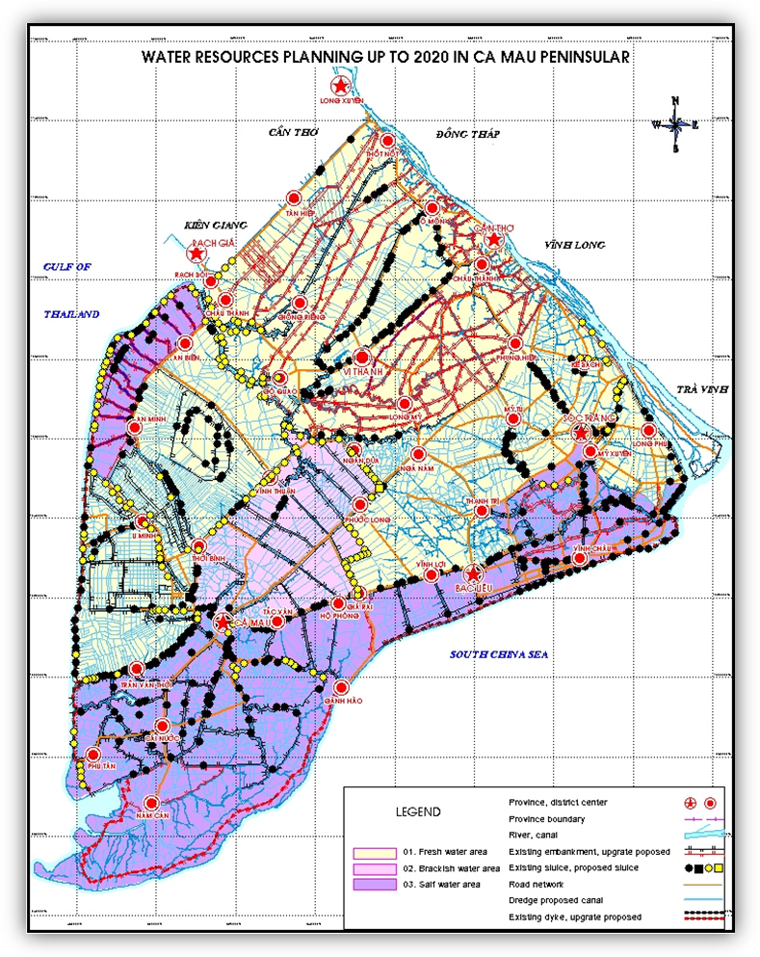

Figure 16: Water resources planning up to 2020 of the Ca Mau peninsula

For the future development plan, Ca Mau peninsula will be divided into three areas with different water requirement as follows and indicated in the above figure:
- Fresh water area – predominantly in the northern section of the peninsula, with the majority of water from the Bassac river and direct precipitation (marked yellow)
- Brackish water area – comparatively small area in the centre of the peninsula just north of Ca Mau city. Water quality depends on the season and operation strategy for the sluices. Generally freshwater during the rainy season and salty water during the dry season (marked mauve)
- Salt-water area - southern and coastal areas of the peninsula, water is dominated by marine intrusion (marked purple)
In light of this, water control structures have been arranged to ensure the appropriate water conditions as reflected in the plan (Refer to figure 16).
In the study, scenarios were modelled to assess the impacts of sea level rise, storm surge and extreme climate events on the Ca Mau Province. The modelled scenarios are shown in the following table:

Table 17: Scenario setup for Ca Mau province
Climate change | Scenarios | Description
Normal | A0 | Existing condition
Normal | A1 | Based on Developing plan up to 2015 of Ca Mau
Normal | A2 | Based on Developing plan up to 2030 of Ca Mau
Sea level rise  (SLR) | B1 | Development plan to 2015, sea level rises 25 cm (Based on prediction report of IPCC)
Sea level rise  (SLR) | B2 | Development plan to 2015, sea level rises 50 cm (Based on prediction report of IPCC)
Sea level rise  (SLR) | B3 | Development plan to 2030, sea level rises 25 cm (Based on prediction report of IPCC)
Sea level rise  (SLR) | B4 | Development plan to 2030, sea level rises 50 cm (Based on prediction report of IPCC)
Extreme climate events  (CLC) | C1 | Development plan to 2015, increase rainfall 10% in the rainy season and decrease rainfall 10% in dry season (Based on prediction report of IPCC)
Extreme climate events  (CLC) | C2 | Development plan to 2030, increase rainfall 10% in the rainy season and decrease rainfall 10% in dry season (Based on prediction report of IPCC)
Storm surge | D1 | Development plan to 2015, sea level rise 50cm and rainfall, crest of tide based on observed data during the stormy period of the storm, namely Linda (1997)
Storm surge | D2 | Development plan to 2030, sea level rise 50cm and rainfall, crest of tide based on observed data during the stormy period of the storm, namely Linda (1997)

  - Scenarios results
The summary and tabulated results from the spatial analysis carried out using GIS are represented below. The maps include water level maps and salinity concentration maps produced from the VRSAP model output for the 11 scenarios listed above.

Scenario A0
The following are tables and maps (Refer to Appendix) to present the variation of water level and salinity intrusion correspond with monthly conditions of Scenario A0:
- Discussion:
Under the existing conditions, Ca Mau province does not yet fully protect the coastline of the West Sea by dikes and sluices. Therefore, the saline water intrudes inland in two directions and from the river mouths. The Upper and Lower U Minh preservation zones retain rainwater from the beginning of January by closing all the temporary earth dams. During the dry season, salinity levels exceed 28g/L in approximately 70% of the province landmass, with peak levels in May. Water depth in two regions continues to reduce up to the end of May, when the advent of the rainy season causes water levels to rise. Furthermore, as the dry season continues the distinction between high and low saline zones increases, with few areas of intermediate salt concentration. Such that in the month of May, more than 90% of the land mass is covered by salinity greater than 28g/L or less than 4g/L (i.e. there is not the range in salinity concentrations across the scale as observed in the wet season).
Fluctuations in both the salinity and water level maps show good correlation with natural tidal regimes:
The East Sea tide with high crest concomitant with easterly wind is the main driver behind saline intrusion into the land mass, especially the strip of land that forms the east coastline. In addition, several hydrological features serve to enhance the tidal penetration including, the complex and interlacing canal system, and some rivers, which drain into the East Sea such as: Ganh Hao, Dam Doi, Bay Hap.
In January, fresh water remains in rivers, canals and some pools within Ca Mau province, in part due to the supply of water from upper region (Western Bassac River) such as: KH canal-system, Chac Bang, QL-PH, Bac Lieu canal.
According to the simulated result, water levels spread down from coastline to the interior field: the maximum water level varied within 0.4 to 1.0m and spread across the whole areas that diminish salinity intrusion. The area among Trem Trem-Cai Tau River, some sub-regions including U Minh preservation forest and rice field were completely protected from salinity intrusion, with salinity in these areas remaining under 4g/l throughout the year. Lower than average water levels were evident in the rice field protection and U Minh forest areas, resulting in increased risk of fire and water quality issues during the dry season.
In the existing situation, the salinity control system along the right bank of Cai Lon River, the Western Coastline and Tac Thu sluice remains unfinished. Meanwhile, together with the operation of salinity sluice system along the national roads No.1, saline water intrudes into Ca Mau province through Cai Tau river, Bay Hap river, and Ganh Hao river.
The Upper U Minh preservation forest stores fresh water from January, so a lack of water in dry periods (From February to April) reduces the average water levels which begin to be replenished in May to June with the onset of the rainy season . This stored water is of environmental significance, protecting the environment in case of adverse situations.
The Lower U Minh preservation forest with some self-contained sub-regions such as North Bien Nhi, Bien Nhi-Minh Ha, Minh Ha-Song Doc are solely dependent on rainfall within their boundaries. Because they are far from the source of fresh water supply, and do not receive water from neighbouring areas because the temporary earth dams are closed in order to retain water. Therefore, during the dry season, rice production in the above mentioned provinces depends entirely on the weather.
During the dry season, approximately 23% of the landmass is affected to a water level of 0.4-0.6m., while during the rainy season 37% of the landmass is affected to a water level of 0.8-1.0m. These depths represent the most common water level bracket observed in the modelling for each season. The median water level is 0.8-1.0m for both seasons.

Scenario A1
- Discussion:
In this case, Upper U Minh, Lower U Minh will retain its ecological fresh water, therefore the salinity control system along Western coastline, together with sluice system along Cai Lon River from Can Gao canal to Xeo Can canal will be closed during the dry season. Some sub-regions like Eastern Trem River, Cai Tau – Trem River, Northern Bien Nhi canal, Bien Nhi – Minh Ha, Minh Ha – Song Doc will be supplied more fresh water through sluices Sau Sanh, Truong Toa, Kiem Lam when saline water on Cai Lon-Cai Be river is under 4 g/l.
The Ngan Dua sluice will be built on Quan Lo-Phung Hiep (QL-PH) canal to separate salty and fresh zone. The close coordination between Ca Mau, Bac Lieu and Soc Trang‘s authorities in operating the salinity control system along the National Road No.1 allows for salinity to be dealt with and water quality/quantity to be managed throughout the Quan Lo-Phung Hiep region.
The West Bassac river is connected to the Cai Be river with some structures which will be closed to prevent salinity intrusion, while other structures drain off water based on tidal regime to supply more water into U Minh region for rice field and against fire forest. In addition, Tac Thu and Ca Mau sluice open to drain off water sometimes every month to improve the water quality.
Under the development plan to 2015, salinity intrusion will peak in April/May with levels above 28g/L covering approximately 57-59% of the province landmass. This is an approximate 10% reduction in the area of land affected by salinity under existing conditions. There is a comparable 10% increase in the area of land experiencing low saline levels (0-4g/L) in scenario A1.
During the dry season, 66% of the land area is covered in water less than 1.0m deep. This drops to 58% during the wet season.
During the dry season, approximately 28% of the landmass is affected to a water level of 0.6-0.8m (an increase of ~0.2m from scenario A0), while during the rainy season 39% of the landmass is affected to a water level of 0.8-1.0m. These depths represent the most common water level bracket observed in the modelling for each season. The median water level remains is 0.8-1.0m for both seasons.

Scenario A2
- Discussion:
Scenario A2, which sees the provincial development plan extended to 2030, is based on the fundamentals of scenario A1, together with constructing Cai Lon (200m, -5.0m), Cai Be (80m, -4.0m) sluices on the main Cai Lon, Cai Be rivers. In an effort to prevent salinity intrusion from the West Sea, the structures located behind Cai Lon and Cai Be sluices will be fully opened, the purpose of this scenario is to increase quantity of fresh water not only in West Bassac river area but also for Upper U Minh, Lower U Minh and the Eastern part of QL-PH region.
To maintain ecological fresh water, the salinity control system along the Western coastline, together with two sluices in the Cai Lon, Cai Be Rivers will be closed during the dry season. The upper U Minh and lower U Minh areas will be supplied with additional fresh water from the Bassac river, therefore the water level and water quality in these areas are much improved.
The Ngan Dua sluice will be built on Quan Lo-Phung Hiep (QL-PH) canal to separate the saline and fresh zone. Close co-ordination between Ca Mau, Bac Lieu and Soc Trang‘s authorities in operating the salinity control system along the National Road No.1 allows for salinity to be dealt with and water quality/quantity to be managed throughout the Quan Lo-Phung Hiep region.
Under the development plan to 2030, salinity intrusion will peak in April/May with levels greater than 28g/L covering approximately 83-85% of the province landmass. This is an approximate 7% increase in the area of land affected by salinity under existing conditions. There is a comparable 10% increase in the area of land experiencing low saline levels (0-4g/L) in scenario A1.
During the dry season, 66% of the land area is covered in water less than 1.0m deep. This drops to 60% during the wet season.
During the dry season, approximately 27% of the landmass is affected to a water level of 0.4-0.6m, while during the rainy season 35% of the landmass is affected to a water level of 0.8-1.0m. These depths represent the most common water level bracket observed in the modelling for each season. The median water level is 0.8-1.0m for both seasons.

Scenario B1
- Discussion:
Under the development plan to 2015 including a 25cm rise in sea levels, the peak of salinity intrusion into the province landmass remains April/May with levels greater than 28g/L covering approximately 60% of the province landmass. This is comparable to the area of land affected by high salinity under existing conditions. There is a comparable area of land experiencing low saline levels (0-4g/L) as in existing baseline scenario. During the dry season, just over 40% of the land area is covered in water less than 1.0m deep. This drops to just 15% during the wet season. The implication is that with a 25cm rise in sea level there is a marked increase in the magnitude of inundation. The major change is in the percentage of land, which is affected to a water level of 1.0-1.2m. In Scenario A0, this bracket accounted for approximately 12% during both the wet and the dry season. However, under Scenario B1, the same bracket increased to 22% during the dry season and 40% during the rainy season.
During the dry season, approximately 24% of the landmass is affected to a water level of 0.4-0.6m, while during the rainy season 35% of the landmass is affected to a water level of 0.8-1.0m. These depths represent the most common water level bracket observed in the modelling for each season. The median water level is 1.0-1.2m for both seasons (an increase of ~0.2m from scenario A0).

Scenario B2
- Discussion:
During the dry season, approximately 22% of the landmass is affected to a water level of 1.2-1.4, while during the rainy season 33% of the landmass is also affected to a water level of 1.2-1.4m. These depths represent the most common water level bracket observed in the modelling for each season. The median water level is 1.2-1.4m for both seasons (an increase of ~0.4m from scenario A0).

Scenario B3
- Discussion:
During the dry season, approximately 27% of the landmass is affected to a water level of 0.6-0.8m, while during the rainy season 31% of the landmass is affected to a water level of 1.0-1.2m. These depths represent the most common water level bracket observed in the modelling for each season. The median water level is 1.0-1.2m for both seasons (an increase of ~0.2m from scenario A0).

Scenario B4
- Discussion:
During the dry season, approximately 30% of the landmass is affected to a water level of 0.8-1.0m, while during the rainy season 26% of the landmass is affected to a water level of 1.2-1.4m. These depths represent the most common water level bracket observed in the modelling for each season. The median water level is 1.2-1.4m for both seasons (an increase of ~0.4m from scenario A0).

Scenario C1
- Discussion:
During the dry season, approximately 27% of the landmass is affected to a water level of 0.6-0.8m, while during the rainy season 32% of the landmass is affected to a water level of 0.8-1.0m. These depths represent the most common water level bracket observed in the modelling for each season. The median water level is 0.8-1.0m for both seasons (comparable to scenario A0).

Scenario C2
- Discussion:
During the dry season, approximately 27% of the landmass is affected to a water level of 0.4-0.6m, while during the rainy season 35% of the landmass is affected to a water level of 0.8-1.0m. These depths represent the most common water level bracket observed in the modelling for each season. The median water level is 0.8-1.0m for both seasons (comparable to scenario A0).

Scenario D1
- Discussion:
During the dry season, approximately 23% of the landmass is affected to a water level of 1.2-1.4m, while during the rainy season 39% of the landmass is affected to a water level of 1.2-1.4m. These depths represent the most common water level bracket observed in the modelling for each season. The median water level is 1.2-1.4m for both seasons.

Scenario D2
- Discussion:
During the dry season, approximately 30% of the landmass is affected to a water level of 0.8-1.0m, while during the rainy season 26% of the landmass is affected to a water level of 1.2-1.4m. These depths represent the most common water level bracket observed in the modelling for each season. The median water level is 1.2-1.4m for both seasons.

ASSESSMENTS ON SIMULATED RESULTS
  - Assessment of the Water resources planning Scenarios

Impact to salinity intrusion

Table 18: Changing area of Max. Salinity intrusion in dry season
Levels | Comparison: A1 – A0 |  | Comparison: A2 – A0
Levels | Different (km2) |  | Different (km2)
Levels | Increase | Decrease | Increase | Decrease
S = 0 - 4 g/l | 355.1 |  | 360.5
S = 4 - 8 g/l |  | -58.7 |  | -54.9
S = 8 - 12 g/l |  | -3.0 | 4.7
S = 12 - 16 g/l |  | -34.0 | 62.3
S = 16 - 20 g/l |  | -16.0 | 76.6
S = 20 - 24 g/l | 191.4 |  | 160.8
S = 24 - 28 g/l | 178.4 |  | 83.3
S > 28 g/l |  | -613.2 |  | -693.3
Total | 724.9 | -724.9 | 748.3 | -748.3

Impact to water level
- In dry season:

Table 19: Changing areas of Max. Water level in dry season
Levels | Comparison: A1 – A0 |  | Comparison: A2 – A0
Levels | Different (km2) |  | Different (km2)
Levels | Increase | Decrease | Increase | Decrease
Z = 0.4 - 0.6m |  | -576.49 | 174.94
Z = 0.6 - 0.8m | 430.94 |  |  | -257.19
Z = 0.8 - 1.0m | 163.84 |  | 99.06
Z = 1.0 - 1.2m | 13.23 |  | 15.04
Z = 1.2 - 1.4m |  | -20.20 |  | -20.52
Z = 1.4 - 1.6m |  | -4.41 |  | -4.40
Z = 1.6 - 1.8m |  | -1.36 |  | -1.36
Z = 1.8 - 2.0m |  | -5.56 |  | -5.56
Total | 608.01 | -608.01 | 289.03 | -289.03

Table 20: Changing water level – Comparison: A1-A0, A2-A0
Remark | Value (m) |  | Areas (km2)
Remark | From | To | A1 - A0 | A2 - A0
Reducing | -0.05 | 0.00 | 1005.2 | 1,005.2
Rising | 0.00 | 0.05 | 3790.0 | 3,523.5
Rising | 0.05 | 0.10 | 213.6 | 480.0
Rising | 0.10 | 0.15 | - | -
Rising | 0.15 | 0.20 | - | -
Rising | 0.20 | 0.30 | 488.6 | 488.6
 | Total |  | 5,497.34 | 5,497.34
- In wet season:

Table 21: Changing areas of Max. Water level in wet season
Levels | Comparison: A1 – A0 |  | Comparison: A2 – A0
Levels | Different (km2) |  | Different (km2)
Levels | Increase | Decrease | Increase | Decrease
Z = 0.4 - 0.6m |  | -1,015.75 |  | -1,015.75
Z = 0.6 - 0.8m | 539.83 |  | 1,006.37
Z = 0.8 - 1.0m | 136.14 |  |  | -132.79
Z = 1.0 - 1.2m | 323.07 |  | 119.44
Z = 1.2 - 1.4m | 4.83 |  | 9.45
Z = 1.4 - 1.6m | 10.30 |  | 11.62
Z = 1.6 - 1.8m | 0.80 |  | 0.66
Z = 1.8 - 2.0m | 0.81 |  | 0.78
Z > 2.0m |  | -0.04 | 0.23
Total | 1,015.79 | -1,015.79 | 1,148.54 | -1,148.53

Table 22: Changing water level – Comparison: A1-A0, A2-A0
Remark | Value (m) |  | Areas (km2)
Remark | From | To | A1 - A0 | A2 - A0
Reducing | -0.05 | 0.00 | - | -
Rising | 0.00 | 0.05 | 3,420.3 | 3,901.0
Rising | 0.05 | 0.10 | 1,363.4 | 337.0
Rising | 0.10 | 0.15 | 187.6 | -
Rising | 0.15 | 0.20 | 166.5 | 312.8
Rising | 0.20 | 0.30 | 359.5 | 946.5
 | Total |  | 5,497.34 | 5,497.34

Discussion
Based on the results, the development plans leading up to 2015 and 2030 are expected to have the following impacts on the hydrological regime of Ca Mau province:
In this case, the salinity controls system along the Western coastline, such as Tieu Dua, and Bien Nhi sluice, together with sluice system along Cai Lon River from Can Gao canal to Xeo Can canal will be completed. In the dry season, both of them are closed to prevent salinity intrusion into the interior from the West Sea. Some regions like Eastern Trem River, Cai Tau – Trem River, Northern Bien Nhi canal, Bien Nhi – Minh Ha, Minh Ha – Song Doc will be supplied with more water from surrounding small rivers with salinity levels under 4 g/L. Furthermore, salinity intrusion of the province is expected to reduce between 2015 and 2030.
The Western Bassac River region is separated into three sub-regions, and has eight sluices along the right Bassac River’s bank. These sluices are operated according to the tidal regime in order to secure more water for the sub-region. In addition, the out flow helps to supply more water to UMT, UMH region, and participates in reducing the salinity along Cai Lon- Cai Be River, from river mouth into the field.
The aquaculture area among QL-PH region is separated from the agricultural area through the salty-fresh demarcation along QL-PH canal (at Ninh Quoi). Relying on this, local farmers take the initiative to control salinity intrusion, and ameliorate salinity effects to the water quality downstream.
In year 2030, building two sluices in Cai Lon River (200m, -5m), Cai Be River (80m, -4m), together with completed dyke system along coastline, so the South of UMT region which from Can Gao canal to the North of Chac Bang Canal and whole UMH region are complete fresh by irrigated structures.
Management decisions indicated in the development plans suggest that water levels along the western coastal areas of the peninsula (south of Cai Lon River and west of Chac Bang canal, where the existing eucalypt forests are) are likely to be effected. There is an expected drop in water levels in this region (~0.2m) between 2015 and 2030, for both the wet and the dry seasons.
There is close coordination between Ca Mau, Bac Lieu and Soc Trang‘s authorities in the operation of the salinity control system along the National Road No.1 to deal with salinity and water quality/quantity in whole Ca Mau peninsula. This is important to the success of the development plans for the peninsula.
Some structures belonging to Cai San-Thot Not region, together with some others, drain off water according to the tidal regime in order to supplement water supply into U Minh region, and to prevent salinity intrusion into the rice-growing interior. In addition, Tac Thu and Ca Mau sluice open monthly to drain off water and reduce the salt content of the water.
Thanks to canals throughout the study area, the most significant difference between A1/A2 and A0 is the operation of control sluice system: the control sluice system around U Minh region opens to receive the water from Cai Lon - Cai Be River in order to supplement water supply. However, in case the water demand for agriculture increases during the dry season then the water level still rises around 1-5cm (Refer to Appendix) and continues to satisfy the requirement in Argo-Forestry production and also ensure the local water quality. In wet season, the water level rises due to increased rainfall and added flow from Cai Lon and Cai Be River. The comparison of, wet season water level between A1/A2 and A0 suggests a rise of around 5cm – 10cm in the U Minh region. The details of these values are represented in the map.
Prevention of salinity intrusion from the East Sea and concomitant with more added flow from the Western Bassac region to ensure the salinity from the West Sea spread into the field through Cai Lon - Cai Be river is unable to overcome transfuse-water points to penetrate into UMT, UMH regions.
Thanks to the operation of the salinity control system, during the dry season there is an increase to around 36,000.0 hectares, which experience salinity under 4g/l (Refer to table 18). Due to expanding farmland, the area affected by high salinity (over 28 g/l) is reduced, in existing condition, by more than 60,000.0 ha. Between Trem Trem and Bay Hap River salinity is currently over 28g/l but in the modelled future, have reduced a fluctuate from 20g/l to 28g/l (Refer to Appendix). That is favourable conditions for aquaculture. It is corresponding to the table 21, that represent the area which water level (from +0.6 to +1.2m) increase in whole year, look into tables 21, 22 - the comparison with A0, water level increase from 0cm – 20cm, concomitant with table 18 showing the lower salinity in Ca Mau.
However, there are some places that may lack water during the dry season because of the expansion of farming, increase water demand, and the presence of areas where the elevation of farmland is a bit higher than mean water level (Refer to Appendix). This point needs to be considered when making the decision of the developing plan.
One of the significant changes between the existing conditions (A0) and the future scenarios (A1 and A2), is an expected increase in water levels in the northern half of the peninsula. During the dry season, this increase (~0.2m) is localised in the ‘brackish’ area immediately north of Cau Mau city, while during the rainy season the increased water levels are widespread between Ca Mau City – U Minh and the province’s northern border. In the wet season, with more added flow from the Western Bassac region through some transfuse-water points and dredging canals, the water level rise spreads down from the North of the peninsula to the Sea. Mean increases in water levels fluctuates from 5 to 30cm (Refer to Appendix), especially the north of Ca Mau where border with Bac Lieu and is supplied directly water from QL-PH canal system.

  - Assessment of the Sea level rise Scenarios

Impact of sea level rise to salinity intrusion

Table 23: Changing Max. Salinity areas in dry season
Level | B1 - A1 |  | B2 - A1 |  | B3 - A2 |  | B4 - A2
Level | Areas (km2) |  | Areas (km2) |  | Areas (km2) |  | Areas (km2)
Level | Incr | Decr | Incr | Decr | Incr | Decr | Incr | Decr
S = 0 - 4 g/l |  | -1.5 |  | -12.9 |  | -2.9 |  | -4.9
S = 4 - 8 g/l |  | -0.2 | 5.4 |  |  | -2.0 |  | -3.0
S = 8 - 12 g/l |  | -0.6 | 1.4 |  |  | -5.4 |  | -7.1
S = 12 - 16 g/l | 12.1 |  |  | -0.1 |  | -91.2 |  | -81.6
S = 16 - 20 g/l |  | -20.5 |  | -4.7 |  | -7.8 |  | -107.2
S = 20 - 24 g/l |  | -59.9 |  | -72.0 | 89.6 |  | 109.8
S = 24 - 28 g/l | 42.0 |  | 43.6 |  | 1.8 |  | 66.1
S > 28 g/l | 28.6 |  | 39.3 |  | 18.0 |  | 27.9
Total | 82.8 | -82.8 | 89.8 | -89.8 | 109.3 | -109.3 | 203.8 | -203.8

Impact of sea level rise to water level
- In dry season:

Table 24: Changing areas of Max. Water level in dry season
Levels | B1 - A1 |  | B2 - A1 |  | B3 - A2 |  | B4 - A2
Levels | Different (km2) |  | Different (km2) |  | Different (km2) |  | Different (km2)
Levels | Increase | Decrease | Increase | Decrease | Increase | Decrease | Increase | Decrease
Z = 0.4 - 0.6m |  | -74.6 |  | -706.0 |  | -1,457.4 |  | -1,457.4
Z = 0.6 - 0.8m |  | -716.5 |  | -889.7 | 606.9 |  |  | -853.8
Z = 0.8 - 1.0m |  | -567.0 |  | -566.6 |  | -528.2 | 302.2
Z = 1.0 - 1.2m | 628.0 |  | 107.0 |  | 648.6 |  |  | -7.1
Z = 1.2 - 1.4m | 388.1 |  | 944.1 |  | 388.0 |  | 938.1
Z = 1.4 - 1.6m | 44.8 |  | 404.1 |  | 44.8 |  | 483.3
Z = 1.6 - 1.8m |  | -43.6 | 127.9 |  |  | -43.7 | 27.2
Z = 1.8 - 2.0m |  | -93.8 |  | -106.9 |  | -93.6 |  | -109.4
Z > 2.0m | 434.5 |  | 685.9 |  | 434.5 |  | 676.9
Total | 1,495.5 | -1,495.5 | 2,269.1 | -2,269.1 | 2,122.9 | -2,122.9 | 2,427.6 | -2,427.6

Table 25: Changing Max. Water level in dry season
Remark | From (m) | To (m) | B1 - A1 | B2 - A1 | B3 - A2 | B4 - A2
Rising | 0.05 | 0.10 | 1,022.4
Rising | 0.10 | 0.15 | 415.3
Rising | 0.15 | 0.20 | 1,382.2 |  | 1,332.0
Rising | 0.20 | 0.30 | 2,677.4 | 1,070.0 | 4,165.3
Rising | 0.30 | 0.40 |  | 1,622.7 |  | 2,920.6
Rising | 0.40 | 0.50 |  | 2,804.6 |  | 2,576.7
Total |  |  | 5,497.3 | 5,497.3 | 5,497.3 | 5,497.3

- In wet season:

Table 26: Changing areas of Max. Water level in wet season
Levels | B1 - A1 |  | B2 - A1 |  | B3 - A2 |  | B4 - A2
Levels | Different (km2) |  | Different (km2) |  | Different (km2) |  | Different (km2)
Levels | Increase | Decrease | Increase | Decrease | Increase | Decrease | Increase | Decrease
Z = 0.4 - 0.6m
Z = 0.6 - 0.8m |  | -988.8 |  | -988.8 |  | -1,455.3 |  | -1,455.3
Z = 0.8 - 1.0m |  | -1,363.3 |  | -2,167.7 |  | -478.7 |  | -1,898.8
Z = 1.0 - 1.2m | 1,310.3 |  | 43.9 |  | 925.9 |  | 640.9
Z = 1.2 - 1.4m | 551.6 |  | 1,409.9 |  | 510.5 |  | 1,049.7
Z = 1.4 - 1.6m | 206.5 |  | 825.5 |  | 213.4 |  | 847.5
Z = 1.6 - 1.8m |  | -17.7 | 361.2 |  |  | -17.1 | 295.2
Z = 1.8 - 2.0m |  | -2.3 |  | -46.9 |  | -2.7 |  | -26.7
Z > 2.0m | 303.8 |  | 562.9 |  | 303.9 |  | 547.3
Total | 2,372.1 | -2,372.1 | 3,203.3 | -3,203.3 | 1,953.8 | -1,953.8 | 3,380.7 | -3,380.7

Table 27: Changing Max. Water level in wet season
Remark | From (m) | To (m) | B1 - A1 | B2 - A1 | B3 - A2 | B4 - A2
Rising | 0.10 | 0.15 | 857.8
Rising | 0.15 | 0.20 | 356.5 |  | 412.1
Rising | 0.20 | 0.30 | 4,283.1 | 813.9 | 5,085.2
Rising | 0.30 | 0.40 |  | 584.3 |  | 752.0
Rising | 0.40 | 0.50 |  | 4,099.1 |  | 4,745.4
Total |  |  | 5,497.3 | 5,497.3 | 5,497.3 | 5,497.3

Discussion
A sea level rise of 25cm or 50cm will affect the Ca Mau province as follows:
In the years 2015 and 2030, the Lower U Minh preservation region and the upper part of Ca Mau province, that border with Kien Giang province will be fully protected from salinity intrusion.
The remains from Ong Doc river, Ganh Hao river to East and West sea are strongly affected by tides. For the salinity concentration, the sea level rise scenarios by 25 cm, 50 cm are insignificant impact to salinity intrusion for this region. The reason for that, with and without sea level rise scenarios, the Southern part of Ca Mau province has the same situation of the fully impact from salinity intrusion from the east and west seas.
Currently, the area is effected by high salinity increase, because the crest of the East Sea’s tide is the favourable condition for far reaching salinity intrusion into the field, especially the strip along the coastline where fresh water is scarce. During the dry period (Feb to May), when rainfall is infrequent and there is a lack fresh water, the area affected by salinity concentrations over 20 g/l increases as follows:
- In case SLR 25cm:
- Year 2015: increase around 7,600.0 ha, correlative with 1.3% of total areas.
- Year 2030: increase around 10,900.0 ha, correlative with 2.0% of total areas.
- In case SLR 50cm:
- Year 2015: increase around 8,300.0 ha, correlative with 1.5% of total areas.
- Year 2030: increase around 20,400.0 ha, correlative with 3.7% of total areas.
When the sea level rises, the water level gradient between the northern part of the province and the coastline is small and spread across the entire field, so that the out flow is reduced. Furthermore, water levels during the dry season will be increased by 10cm and 50cm (Refer to Tables 23-27). Except the U Minh region, which is fully protected from salinity intrusion, the remain area of Ca Mau province is affected by salinity intrusion, therefore, even rising water level in the South of province during dry season, salt water concentration is still difficulty for crop production there.
The impacts of sea level rise (SLR) on the hydrological conditions will be especially pronounced during the dry season. It is predicted that during the dry season, even small increments in the sea level will affect large areas of the Ca Mau province. On the other hand, water cover in the dry season is primarily restricted to the rivers/canals; therefore, a higher water level will probably not cause significant impacts on rice production, since it can be managed by canal infrastructure. In fact, a large part of the Ca Mau province is suffering from limited water availability during dry season that may be improved by higher water level because of the reduction in outflows caused by SLR back pressure. However, this projection does not take any unforeseen environmental degradation such as deeper salinity intrusion into consideration.
In the dry season, the area affected by salinity intrusion, approximately 0.4 million ha, comprises of a broad strip along the coastal area of the province. The period of simulation for the low flow is in March and April, when salinity intrusion is greatest.
Rising sea levels increases the potential for salinity intrusion from West Sea. Salinity in the peninsula is primarily controlled by the QL-PH system which is currently operational. At the time of construction research indicated that the predominate influx of salinity was from the East Sea, however rising sea levels increase the potential for salinity intrusion from West Sea through the Cai Lon and Cai Be rivers. This is the reason why the water quality of along the border with Bac Lieu showed high levels of salinity, particularity from February to May, when the water demand (for activities, irrigation, aquiculture...) increases. During that time, the level of freshwater is low, which further exacerbates salinity intrusion from West Sea into this area, so under the increased hydraulic head of an elevated tide, a small area - about 500 ha – is likely to have salinity issues, when previously salt concentrations were under 4g/L..
Simulated data on water levels were transferred into a GIS database to display the spatial effects of SLR within the course of the wet season. Thus, we have produced a series of seasonal maps for this report. In the wet season, water level is below 2.5m amsl along the downstream part of the main rivers and the Ca Mau province.

Table 28: Percentile of the increasing areas of Max. Water level
From  (m) | To  (m) | B1 - A1 (%) |  | B2 - A1 (%) |  | B3 - A2 (%) |  | B4 - A2 (%)
From  (m) | To  (m) | Dry | Wet | Dry | Wet | Dry | Wet | Dry | Wet
1.0 | 1.8 | 19.3 | 37.6 | 28.8 | 48.0 | 19.7 | 30.0 | 26.3 | 51.5
> 2.0 |  | 7.9 | 5.5 | 12.5 | 10.2 | 7.9 | 5.5 | 12.3 | 10
In those cases, not shown here (to limit space needed for figures), the water level contour lines of 1m and 2m amsl were shifted throughout the entire CMpr. Therefore, we produced a series of water level maps showing the differences in water level of respective scenarios and present sea level. The seasonal maps of wet season were chosen for this presentation because they correspond to the critical periods, i.e., harvesting and planting, of rice crops during the wet season.
The water level maps clearly show that SLR will affect the entire CMpr from September to December, the water level increases towards coastline where water levels are elevated by 30 - 50cm, respectively (Refer to table 27). As expected, the magnitude of the change in sea levels affects the magnitude of rise in water levels in both the wet and the dry season. In addition, there is a noticeable difference between water levels in the northern and southern sections of the peninsula, which becomes less pronounced during the wet season.

  - Assessment of the Extreme climatic event Scenarios

Impact to salinity intrusion

Table 29: Changing area of Max. Salinity intrusion in dry season
Levels | Comparison: C1 – A1 |  | Comparison: C2 – A2
Levels | Different (km2) |  | Different (km2)
Levels | Increase | Decrease | Increase | Decrease
S = 0 - 4 g/l |  | -0.05 |  | -0.51
S = 4 - 8 g/l |  | -0.02 |  | -0.16
S = 8 - 12 g/l |  | -0.04 |  | -0.37
S = 12 - 16 g/l |  | -0.07 |  | -1.23
S = 16 - 20 g/l |  | -0.44 |  | -2.06
S = 20 - 24 g/l |  | -0.75 |  | -0.68
S = 24 - 28 g/l |  | -8.79 | 1.71
S > 28 g/l | 10.16 |  | 3.29
Total | 10.16 | -10.16 | 5.01 | -5.01

Impact to water level
- In dry season:

Table 30: Changing areas of Max. Water level in dry season
Levels | Comparison: C1 – A1 |  | Comparison: C2 – A2
Levels | Different (km2) |  | Different (km2)
Levels | Increase | Decrease | Increase | Decrease
Z = 0.4 - 0.6m | 56.04 |  | 22.37
Z = 0.6 - 0.8m |  | -37.76 |  | -22.21
Z = 0.8 - 1.0m |  | -18.29 |  | -0.16
Total | 56.04 | -56.04 | 22.37 | -22.37

Table 31: Changing water level – Comparison: C1-A1, C2-A2
Remark | Value (m) |  | Areas (km2)
Remark | From | To | C1 – A1 | C2 – A2
Reducing | -0.05 | 0.00 | 5,497.34 | 5,497.34
Total |  |  | 5,497.34 | 5,497.34
- In wet season:

Table 32: Changing areas of Max. Water level in wet season
Levels | Comparison: C1 – A1 |  | Comparison: C2 – A2
Levels | Different (km2) |  | Different (km2)
Levels | Increase | Decrease | Increase | Decrease
Z = 0.6 - 0.8m | 11.99 |  |  | -7.04
Z = 0.8 - 1.0m |  | -401.03 | 7.04
Z = 1.0 - 1.2m | 379.81 |  |  | -0.39
Z = 1.2 - 1.4m | 9.23 |  | 0.39
Total | 401.02 | -401.03 | 7.43 | -7.43

Table 33: Changing water level – Comparison: C1-A1, C2-A2
Remark | Value (m) |  | Areas (km2)
Remark | From | To | C1 – A1 | C2 – A2
Rising | 0.00 | 0.05 | 4,938.76 | 5,497.3
Rising | 0.05 | 0.10 | 558.58 | -
Total |  |  | 5,497.34 | 5,497.34

Discussion
Water resources of Ca Mau province depends on ground water and rainfall. In the dry season, water for production and environmental flows are based on rainfall which has been stored during the rainy season. Therefore, the increase of rainfall 10% in the rainy season and decrease rainfall 10% in dry season would make drainage more difficult in the rainy season and drought more serious in the dry season, especially for the fresh water areas in the north of Ca Mau province (U Minh area). The results show that the water levels in the entire Ca Mau province increase from by 0.05m during the rainy season and decrease by 0.05m during the dry season.
When the salinity controls system along Western coastline, together with sluice system along Cai Lon River from Can Gao canal to Xeo Can canal, are completed, they will be used to prevent dry season salinity intrusion from the West Sea. Some regions like Eastern Trem River, Cai Tau – Trem River will be supplied more water from the surrounding small rivers with salinity levels under 4 g/l.
Some structures, in the Cai San-Thot Not region, are closed to prevent salinity intrusion into this region for rice production, and operate in conjunction with other infrastructure designed to drain or supply water into the U Minh region according to tidal regime. Even with the canals improve, together with the operation of the control sluice system around U Minh region receive more water from Cai Lon - Cai Be River. So the impacts of climate change (CLC) on the hydrological conditions will be more pronounced during the dry. For instance, a 10% reducing of rainfall will cause the dry season water level to sink around 1-5cm (Refer to table 29-33) in whole CMpr. This will have an adverse effect on crop production.
During the dry season, the area affected by salinity intrusion (about 0.404 million ha), comprises a broad strip along the coastal areas. The period of simulation for the low flow is in March and April, when the salinity intrusion is maximum.
Changes to the rainfall regime will affect water quality along the Bac Lieu border, exacerbating the predicted effects of SLR in this region (see previous section). Lower rainfall during the dry season will allow salt water to intrude further up the Cai lon and Cai Be rivers into this area. In addition, there will be a lack fresh water to dilute salt water. Therefore, the area effected by increased salinity levels amounts to approximately 500ha, because the affected area with water level from 0.6m to 1.0m decrease 10% than present condition.
In wet season, with a 10% increase in rainfall, together with the added flow from Cai Lon and Cai Be Rivers, water levels for scenarios C1, C2 are predicted to increase by approximately 5cm (Refer to Appendix).
For the case of CLC, the affected area with water level from 1.0m to 1.4m increases compared with present conditions. Maps of wet season were chosen for this presentation because they correspond to the critical periods, i.e., harvesting and planting, of rice crops during the wet season. A graphical summary of the changes to both the wet season and the dry season are presented.
The water level maps clearly show that CLC will affect the entire CMpr from September to December; the water level increases towards coastline where water levels are elevated by 0cm - 5cm, respectively (Refer to table 31,33).

  - Assessment of the complex SLR, CLC and Storm Scenarios

Impact of sea level rise to salinity intrusion

Table 34: Changing Max. Salinity areas in dry season
Level | D1 - A1 |  | D2 – A2
Level | Areas (km2) |  | Areas (km2)
Level | Increase | Decrease | Increase | Decrease
S = 0 - 4 g/l |  | -15.03 |  | -7.8
S = 4 - 8 g/l | 5.90
S = 8 - 12 g/l | 1.23 |  |  | -7.1
S = 12 - 16 g/l |  | -0.69 |  | -81.7
S = 16 - 20 g/l |  | -6.11 |  | -107.1
S = 20 - 24 g/l |  | -98.19 | 110.3
S = 24 - 28 g/l | 58.45 |  | 49.4
S > 28 g/l | 54.45 |  | 44.0
Total | 120.03 | -120.03 | 203.7 | -203.7

Impact to water level
- In dry season:

Table 35: Changing areas of Max. Water level in dry season
Levels | D1 - A1 |  | D2 - A2
Levels | Different (km2) |  | Different (km2)
Levels | Increase | Decrease | Increase | Decrease
Z = 0.4 - 0.6m |  | -705.95 |  | -1,457.38
Z = 0.6 - 0.8m |  | -895.09 |  | -853.75
Z = 0.8 - 1.0m |  | -557.25 | 296.37
Z = 1.0 - 1.2m | 145.74 |  |  | -19.17
Z = 1.2 - 1.4m | 935.23 |  | 955.99
Z = 1.4 - 1.6m | 482.69 |  | 483.28
Z = 1.6 - 1.8m | 27.17 |  | 13.03
Z = 1.8 - 2.0m |  | -109.41 |  | -95.26
Z > 2.0m | 676.89 |  | 676.88
Total | 2,267.71 | -2,267.71 | 2,425.56 | -2,425.56

Table 36: Changing Max. Water level in dry season
Remark | From (m) | To (m) | D1 - A1 | D2 – A2
Rising | 0.20 | 0.30 | 1,082.7
Rising | 0.30 | 0.40 | 1,863.2 | 2,916.9
Rising | 0.40 | 0.50 | 2,551.5 | 2,580.5
Total |  |  | 5,497.3 | 5,497.3

- In wet season:

Table 37: Changing areas of Max. Water level in wet season
Levels | D1 - A1 |  | D2 – A2
Levels | Different (km2) |  | Different (km2)
Levels | Increase | Decrease | Increase | Decrease
Z = 0.6 - 0.8m |  | -988.76 |  | -1,455.30
Z = 0.8 - 1.0m |  | -2,167.69 |  | -1,898.76
Z = 1.0 - 1.2m |  | -211.56 | 634.42
Z = 1.2 - 1.4m | 1,738.15 |  | 1,055.97
Z = 1.4 - 1.6m | 818.50 |  | 847.09
Z = 1.6 - 1.8m | 279.95 |  | 285.07
Z = 1.8 - 2.0m |  | -67.80 |  | -67.80
Z > 2.0m | 599.21 |  | 599.31
Total | 3,435.81 | -3,435.81 | 3,421.86 | -3,421.87

Table 38: Changing Max. Water level in wet season
Remark | From (m) | To (m) | D1 - A1 | D2 – A2
Rising | 0.20 | 0.30 | 573.8
Rising | 0.30 | 0.40 | 1,360.4 | 647.4
Rising | 0.40 | 0.50 | 3,081.5 | 4,180.2
 | 0.50 | 1.10 | 481.7 | 669.8
Total |  |  | 5,497.3 | 5,497.3

Table 39: Changing Max. water level during the stormy period: D1-A1, D2-A2
Remark | Value (m) |  | Areas (km2)
Remark | From | To | D1 – A1 | D2 – A2
Rising | 0.30 | 0.40 | 2,493.61 | 2,238.24
Rising | 0.40 | 0.50 | 1,942.02 | 2,236.82
Rising | 0.50 | 1.10 | 1,061.72 | 1,022.28
Total |  |  | 5,497.34 | 5,497.34

Discussion
The scenarios modelled under D1 and D2 represent a reasonable prediction of an extreme event likely to hit Ca Mau peninsula in a warming climate. It combines the most probable climate changes to effect the peninsula (rising sea levels, changes to rainfall patterns) with data from the most recent, and extreme recorded storm event (Linda Storm).
In general, there is a large increase in salinity under these scenarios, due to conditions being favourable for the crest of the East Sea’s tide to intrude into the project area, especially along the coastal areas where there is a lack fresh water. During the dry period (Feb to May) with low rainfall and lack fresh water, this can have a negative impact on agricultural production. Salinity concentrations greater than 20g/L indicate the maximum levels observed in the peninsula and changes to the areas experiencing these maximum levels can quantify the expected changes under scenarios D1 and D2:
- Year 2015: increase around 11,300.0 ha, correlative with 2.1% of total areas.
- Year 2030: increase around 20,400.0 ha, correlative with 3.7% of total areas.
During the dry season, despite a 10% reduction in rainfall, SLR remains the dominant impact on the hydrological conditions. When the sea level rises, the water level gradient between the northern part of the province and the coastline is small and spread across the entire field, so that the deltaic out flow is reduced. Furthermore, water levels during the dry season will be increased by 30cm to 50cm (Refer to Table 34-39). Except in the U Minh region, which is protected, the rising water in the Ca Mau peninsula may not necessarily be a benefit to agricultural production because of a simultaneous increase in salinity levels. Efforts should be implemented to manage water quantity during crop production in these coastal areas.
Remnant coastal mangroves in the peninsula will also be affected by rising sea levels and subsequent shoreline recession. The specific nature of change will depend on the rate of sea level rise, relative to the rate of sediment deposition. With a rapid rise in sea level mangrove systems will migrate further inland, as they attempt to maintain their position relative to the rising water surface (b). However, if the rate of SLR is comparable or slower to future rates of sedimentation, then it is likely that the mangroves will be able to maintain their habitat through substrate aggradation (a). As yet, there is insufficient climate change modelling to quantify both the rate of SLR and changes to the rate of sedimentation, and therefore, determine which of these options is more realistic for mangroves in the Ca Mau peninsula.
The issue is complicated further by the presence of water control infrastructure along the coastline. These structures may potentially impede the migration of mangroves experiencing SLR, causing them to die out (c).
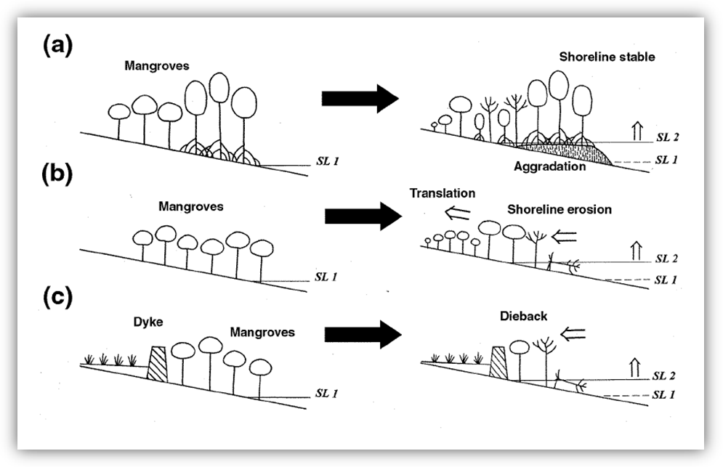

Figure 17: Possible mangrove response scenarios to SLR (Hashimoto, 2001)
As in the two SLR scenarios, B2 and B4, the area affected by salinity intrusion, covers approximately 0.40 million ha, comprising of a broad strip along the coastal area. The period of simulation for the low flow is in March and April, when the salinity intrusion is highest in the peninsula.
Simulated data on water levels were transferred into a GIS database to display the spatial effects of SLR throughout the course of the wet season. Thus, we have produced a series of seasonal maps for this report. In the wet season, water level is below 2.5m amsl along the downstream part of the main rivers and the peninsula.
For this case, the affected area has water levels from 2.0 to 2.5m above present conditions. During the stormy period (from 01/11 to 07/11), an expected SLR of 1.0m concomitant with heavy rain, would increase water levels by up to 2.8m among the strip along the coastal area.
In general, some regions with water level from 1.0 to 1.8m, these areas are increased. Sea level rise, that diminish discharge out flow to the sea, is main cause to make water level inside affected areas increasing. Of course, total natural areas are constant so that the remaining areas have to decrease.

Table 40: Percentile of the increasing areas of Max. Water level
From | To | D1 - A1 (%) |  | D2 – A2 (%)
From | To | Dry | Wet | Dry | Wet
1.0m | 1.8m | 28.9 | 51.6 | 26.4 | 51.3
> 2.0m |  | 12.3 | 10.9 | 12.3 | 10.9

In these cases, which are not shown here to limit space needed for figures, the contour lines of 1.0m and 2.5m amsl were shifted throughout CMpr, especially, during the stormy period (from 01/11 to 07/11) the contour lines of 1.4m and 2.8m amsl were shifted whole CMpr. Therefore, we produced a series of water level maps showing the differences in water level of respective scenario and present sea level. The monthly maps for the wet season were chosen for this report because they correspond to the critical periods, i.e., harvesting and planting, of rice crops during the wet season.
The water level maps clearly show that SLR will affect the entire peninsula, in September and December; the water level increases towards coastline where water levels are elevated by 30 - 50cm (Refer to table 37-39). During the stormy period (from 01/11 to 07/11), the water level increases from 50 cm to 110cm in comparison with present conditions, spreading down from coastline to the mainland (Refer to table 39). Both comparisons demonstrate that, the impact of storm and SLR on water level throughout Ca Mau peninsula is obvious. It is highly recommended that both the local government and local communities prepare to manage the dangerous impact of future storms and SLR. Integrating this worst-case scenario into current provincial management plans, and educating the local communities will allow stakeholders to mitigate the risks and damages associated with these events.

Summary of Discussion for Climate Change Scenarios
The following graphs compare the impact of the eleven different modelling scenarios on seasonal water levels and salinity concentrations. On top of the results and observations listed in sections V11.1 – V11.5, which focussed on a detailed analysis of each scenario, this section attempts to draw out some broad system-level changes which could be expected from the future scenarios in comparison with existing conditions.

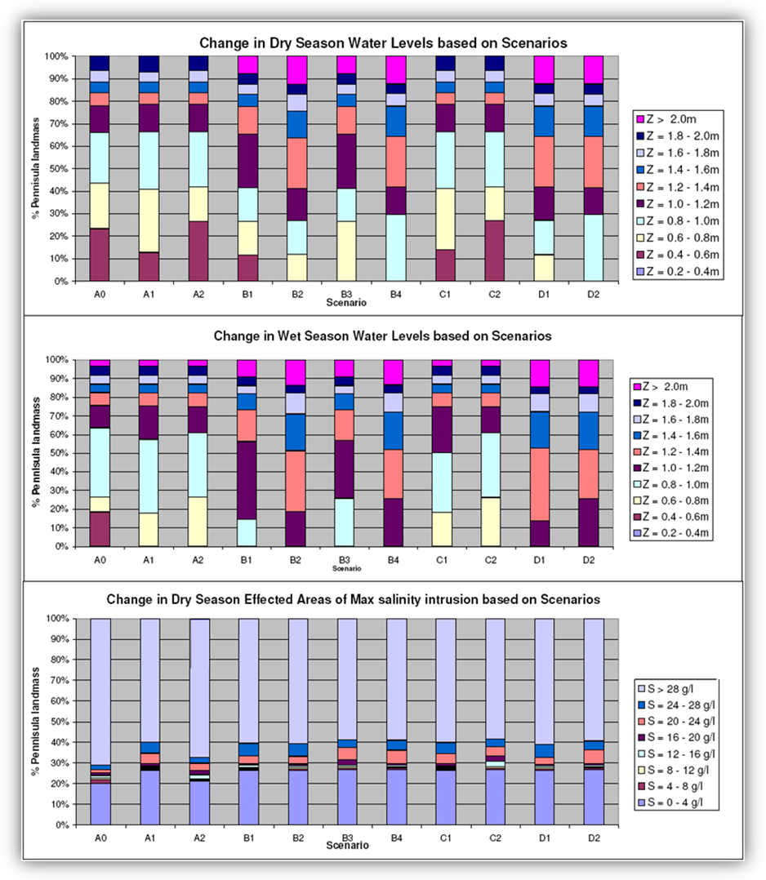

Figure 18: Summary seasonal statistics for the 10 future scenarios
Some general observations can be drawn from the potential future climate change scenarios.
Firstly, the existing dry season salinity regime in Ca Mau province is clearly defined into a saline and a fresh water zone. Typically, more than 70% of the land area will have salinity concentrations elevated above 28g/L, while 20% of the remaining area will have low levels (<4g/L). Therefore, intermediate or ‘mixed’ concentrations exist in less than 10% of the peninsula during the dry season. Under all future scenarios, the proportion of land area with intermediate concentrations is likely to grow to 10-20% of the total province area. Averaging the data suggests that the percentage of land area with high salinity concentrations (>28g/L) will drop to ~61%, while the percentage of land with low salinity concentrations (<4g/L) will increase slightly to ~26%.
Water levels in the province are expected to increase by the year 2015 (scenario A1) with the increase more pronounced during the rainy season. By 2030 (scenario A2) this effect, during the dry season, is likely to stabilize and return to levels similar to those currently existing, however a pronounced increase in water levels is likely to remain during the wet season.
With a 25cm increase in sea level the same trends manifest, with greater magnitudes of increase. However, by 2030 the water levels during the dry season are not expected to return to existing conditions and will remain elevated. The scenario of a 50cm rise in sea levels shows similar trends to the 25cm case, except that the increase in water levels is much more pronounced.
The effect of a change in rainfall patterns (as modelled with scenarios C1 and C2) is predicted to be minor, but dependent on the season. During the dry season a 10% reduction in rainfall will slightly reduce water levels over the province. While a 10% increase in rainfall during the rainy season is likely to increase water levels slightly. However, the predicted rise in sea levels is expected to have a greater effect on the future water levels of Ca Mau province than the modelled changes to rainfall patterns.
The final modelling set analysed the impact of a 50cm rise in sea level, change in rainfall patterns coupled with a major storm event (1997 Linda Storm) for both the 2015 and 2030 situations. Results indicate that water levels increased the most out of all the scenarios modelled.

Summary of Discussion for the effect of Climate Change on Sectors

Based on the sectors established in provincial development plans, further assessment was undertaken to determine the effect of the modeling scenarios on the major sectors of the Ca Mau peninsula. They are summarized in the six graphs represented, and discussed below. It should be noted, that in this analysis there is no sensitivity to the nuances in magnitude between different effects, and it is intended to be indicative only of the area effected, not what that effect is likely to be, nor its severity .
In the farming sector, it was observed that the effects of the climate change are consistent across the scenarios. The only difference being that scenario B1 is likely to have a slightly less impact on rice and a greater impact on vegetable growing areas. Shrimp farming is expected to be impacted most heavily, which can be attributed to the dominance of SLR and the proximity of shrimp farming lands to the coast.
Approximately 108,000ha of forested areas are expected to be effected by climate change, the majority of which is classified as productive forests. This is not likely to vary with specific climate change scenarios because even the most conservative scenario simulated is likely to affect the vast majority of the existing forests.
It is likely that more than 45,000km of irrigational works are to be effected by climate change, the majority will be within interior fields, and primary and secondary embankments. As with forested areas, this is not likely to vary with specific climate change scenarios.
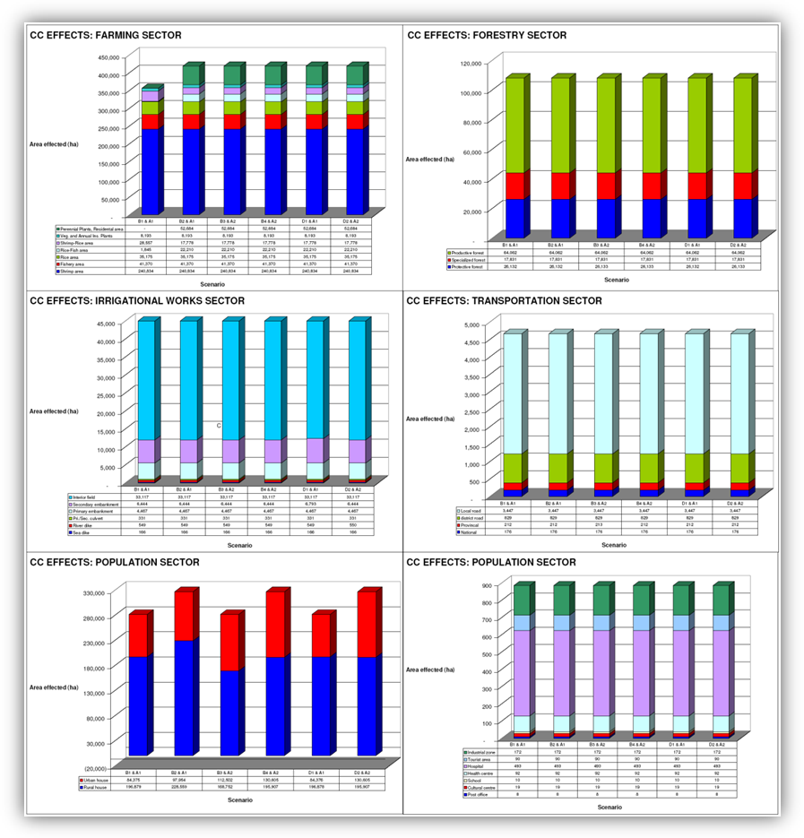

Figure 19: Climate Change Assessment of impact by sector

Table 41: Analysis the impacts of climate change scenarios to the different sector
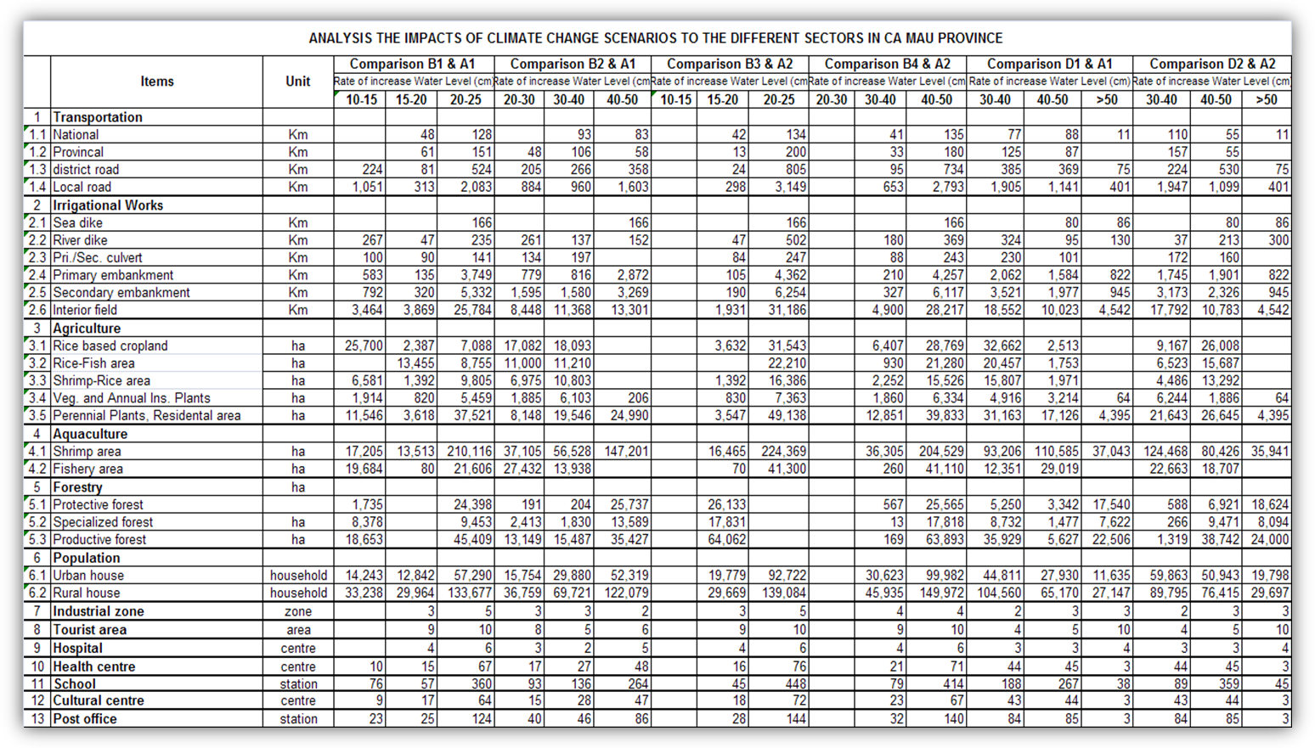
The majority of impacts to the transportation sector are likely to be on local roads. Under SLR scenarios approximately 4,500km of road is expected to be effected. This figure jumps to ~13,000km when considering extreme climatic events and storms.
Climate change is expected to effect 275,000-325,000 households in the Ca Mau peninsula, depending on the modelling scenario. In general by 2015, 275,000households are likely to be effected, with this figure rising to 325,000 in 2030. This holds regardless whether climate change is considered as SLR or extreme storm events.
The last graph shows the effects of the modelled climate change across various community sectors (schools, hospitals, health centres, tourist areas, industrial zones), and the importance of the particular type of infrastructure should be considered when determining the risk facing the community. As with other sectors, this is not likely to vary with specific climate change scenarios.
Although the preceding assessment is consistent with the macroscopic changes to each sector that can be expected under the different modelling scenarios, it would be inaccurate to take these conclusions as saying that there is no difference between the modelling scenarios and their impacts. Table 41 breaks down the impact of each scenario based on the increase in water level that the sector is predicted to experience.
For the transportation sector, Local roads are the most severely impacted in all the model scenarios (as stated above), however the following differences exist:
Under scenario B1 (25cm SLR in 2015), 30% of the affected local roads have less than a 15cm increase in water levels, while 60% have increases of 20-25cm, with similar proportions existing for other road types. By 2030 (scenario B3) a 25cm SLR will result in more than 90% of the effected local roads experiencing rises of 20-25cm, with the remaining 10% limited to a 15-20cm rise.
With a 50cm SLR in 2015 (scenario B2) almost 50% of the effected local road area will have increases of 40-50cm, with approximately 25% experiencing a 30-40cm increase and the remaining 25% a 20-30cm increase. By 2030, the effect on local roads will have been managed to some extent, with 80% of effected local roads experiencing an increase 30-40cm, while the remainder is limited to smaller elevations in water levels.
Storm scenario D1 (2015) suggests that only 12% of effected local roads will experience levels greater than 50cm. 55% will be limited to increases of 30-40cm, while the remainder will experience increases of 40-50cm. Surprisingly, scenario D2 (in the year 2030) displays a similar distribution of effected water levels. This suggests that the continuation of current development strategies will not prevent flooding and damage to local roads.
Regarding the population, in general more rural households will be affected than urban households. In scenario B1 approximately 68% of the affected rural households will experiences increases of 20-25cm. By 2030 (Scenario B3), this figure is likely to increase to more than 80%. This suggests that the continuation of current development strategies will not prevent flooding and damage to rural households. The situation is similar for urban households.
Under the more extreme scenario B2, 53% of the affected rural households will experiences water level increases of 30-40cm. By 2030 (scenario B4), only 33% will experience 30-40cm increases in water levels, while the remaining 77% of the affected rural households will be subject to increases of 40-50cm. Under the storm events, there is likely to be a more even spread of water levels 30cm and above.
With regard to shrimp farming, across all SLR modelling scenarios, the vast majority of affected areas will experience increases within the maximum bracket”: 20-25 (B1, B3), 40-50cm (B2, B4). During extreme storm events the vast majority of affected shrimp farming areas are likely to experience increases of between 30-50cm. For fisheries, the total affected area is lower, and a greater majority of this area is likely to experience lower water level increases than shrimp farming.
Modelling of agricultural areas indicates that mitigation measures are likely to have some effect between 2015 and 2030. Under scenario B1 almost 50% of the affected agricultural area will experience water level rises of 20-25cm, this is likely to be reduced by 2030 (scenario B3) when more all of affected agricultural areas will experience water level increase of less than 20cm. There is a similar trend for the two 50cm SLR scenarios (B2, B4) though the difference between 2015 and 2030 is not as pronounced in this case.
Modelling of forestry areas also indicates that mitigation measures are likely to have some effect between 2015 and 2030. Under scenario B1 (yr2015) more than 73% of the affected forest is likely to experience water levels increases greater than 20cm, however by 2030 (B3) it is expected that all forested areas will only experience water level increases of less than 20cm, indicating that long-term management measures have had some success in controlling water level rise in forestry areas. However if the SLR reaches 50cm, this reduction in elevated water levels because of the 2030 plan is not expected to happen, suggesting that under extreme SLR current mitigation strategies are ineffectual. 70% of the affected area in B2 will experience increases of greater than 50cm, by 2030 (B4) this will rise to 99%.

Summary discussion on the changes to water levels due to climate change
The following conclusions are drawn from figure 28 to figure 69 presented in the appendix, which were made by overlaying the modelling data on GIS land-use information.
- Up to 2015 with 25cm SLR (B1 & A1)
The maximum increase in water levels, compared to the no-CC case, is approximately 20-25cm.
The two areas least effected under this scenario are; Tran Van Thoi (south of U-Minh town and west of the Cai Tau River) with an increase of only 10-15cm and the wedge of land between Ca Mau City, the Bac Lieu border and the coast, with an increase of 15-20cm. Both regions are utilized for agricultural and aqua cultural farming, Tran Van Thoi also includes significant forest reserves while the second zone includes the urban areas of the provincial capital city.
The remaining areas of the province are expected to experience increases of 20-25cm in maximum water levels. The southern tip of the peninsula (i.e. the area south of Tran Van Thoi Town) is dominated by brackish, aquaculture and forested areas, while the northern section (centred on Thoi Binh Town) also supports some agricultural practices, such as rice and perennial vegetables. The increased water levels in these areas also correspond to an increased salinity concentration in the southern tip of the peninsula and the area south of Thoi Binh Town.
Industrial activity is concentrated in the following three areas; northern Ca Mau City, Song Doc and Nam Can, with smaller scale activity in Cai Doi, Dam Doi and Toi Binh. All industrial zones, except for southern parts of the Ca Mau City industrial area lie in areas predicted to experience the greatest increase in max water levels. This is a serious concern across all modelling scenarios. In the B1/A1 scenario, this correlates to an expected 20-25cm increase during the wet season.

- Up to 2015 with 50cm SLR (B1 & A1)
The maximum increase in water levels, compared to the no-CC case, is approximately 40-50cm.
The same two areas are likely to be least effected under this scenario. The Tran Van Thoi area is bounded by some significant canals and rivers, and so the area effected remains the same as the lower SLR scenario, with a predicted 20-30cm increase in max water level. The Ca Mau City-Bac Lieu area is afforded some protection by the existing sea dike system, which becomes more pronounced as max water levels rise. Consequently, the area from Ca Mau City, east to the Bac-Lieu border and south toward the confluence of the Dam Doi and Gai Be rivers only experiences a 30-40cm increase in max water levels. The additional area is largely brackish aqua-cultural areas.
The remaining areas of the province are expected to experience increases of 40-50cm in maximum water levels. The southern tip of the peninsula is dominated by brackish, aquaculture and forested areas, while the northern section (centred on Thoi Binh Town) also supports some agricultural practices, such as rice and perennial vegetables.
All industrial zones, except for southern parts of the Ca Mau City industrial area lie in areas predicted to experience the greatest increase in max water levels. This is a serious concern across all modelling scenarios. In the B2/A1 scenario, this correlates to an expected 40-50cm increase during the wet season.

- Up to 2030 with 25cm SLR (B3 & A2)
The maximum increase in water levels, compared to the no-CC case, is approximately 20-25cm.
In comparison to the 2015 low SLR case, the area effected by a 20-25cm rise in water level includes the Tran Van Thoi area (as well as the southern tip and the northern area centred on Thoi Binh Town). The Tran Van Thoi area is protected by an ageing sea dike system along the western coastal area, and the comparable increase in max water levels between protected and unprotected areas of the western coastline suggests that the existing dike system will not be an effective water control structure in the long term.
On the other hand, the Ca Mau City - Bac Lieu border area, which extends to the eastern coast line and 5-10km south of the provincial border experiences some infrastructure protection, with increase in water levels limited to 15-20cm. Initiatives in the development plan are predicted to be successful in mitigating large elevation in water levels under this scenario.
All industrial zones, except for southern parts of the Ca Mau City industrial area lie in areas predicted to experience the greatest increase in max water levels. This is a serious concern across all modelling scenarios. In the B3/A2 scenario, this correlates to an expected 20-25cm increase during the wet season.

- Up to 2030 with 50cm SLR (B4 & A2)
The maximum increase in water levels, compared to the no-CC case, is approximately 40-50cm.
Under this high SLR scenario for 2030, the areas effected by max increases in water levels are comparable to B3&A2, except that the Ca Mau City-Bac Lieu area, which only experiences increases of 30-40cm, extends further south to the confluence of the Dam Doi and Cai Be rivers. This is largely due to the eastern sea dike system, which offers greater protection to some additional forest recovery zones used for aquaculture and breeding.
All industrial zones, except for southern parts of the Ca Mau City industrial area lie in areas predicted to experience the greatest increase in max water levels. This is a serious concern across all modelling scenarios. In the B4/A2 scenario, this correlates to an expected 40-50cm increase during the wet season.

- Up to 2015 with extreme event (D1 & A1)
Under an extreme climate event and 2015 management plans, the distribution of increased water levels become more complex, with five distinct zones.
The largest rise, more than 50cm, is expected in a thin 5-7km wide band running parallel to the coast from the Ganh Hao River towards Tan An town. This area covers natural and plantation forests together with some aquacultural and forested breeding zones. As mentioned in Section VII 4.3, mangrove areas are sensitive to water levels, and further research should be conducted into drainage in mangrove systems and the resilience of individual species to fluctuating water levels. Such research could have a positive impact on future planting and recovery strategies.
The Tran Van Thoi area remains the same size as under previous scenarios, and experiences the smallest increase in maximum water levels (20-30cm). The coastal fringe between Song Doc Town and the Tieu Dua Creek will see a 40cm rise in water levels.
The Ca Mau City – Bac Lieu border area encroaches further south up to Dam Doi Town, with a rise in water levels of 30-40cm. The remaining areas of the province will experience a 40-50cm increase in max water levels.
All industrial zones are predicted to experience 30-50cm increases in max water levels under the D1 scenario.

- Up to 2030 with extreme event (D2 & A2)
In comparison to the D1 scenario, under the D2 scenario, the distribution of increased water levels becomes simpler, with only three distinct zones.
The thin band (5-7km) band running parallel to the coast from the Ganh Hao River extends past Tan An Town, encompassing the southern tip of the peninsula and almost reaching up to the Cua Lon River. This area includes large tracts of ‘special forest’. The rise in water level is expected to be greater than 50cm, making it the worst effected in this scenario.
The Ca Mau City – Bac Lieu border area also reaches as far south as Dam Doi Town expecting a 30-40cm increase in water levels. Currently, this is the most protected area in the province, experiencing the smallest (though still significant) increase in max water levels.
The remaining areas experience a 40-50cm and include the vast majority of the province, including the vast majority of existing industrial zones.

- Salinity Risk in a changing climate
In Ca Mau province, salinity intrusion under the existing tidal regime is so extensive that the effects of climate change are not predicted to have a major effect on the future profile of salinity intrusion in the peninsula. This is confirmed by the salinity maps produced in this study. Existing salinity levels approach oceanic concentrations (28g/L compared to 32g/L) and penetrate the peninsula as far north as Tran Van Thoi Town and Ca Mau City.
The exception is under the D2 (high SLR and extreme climate event) scenario, in which salinity in the province south of Tran Van Thoi Town and Ca Mau City reaches 32g/L that is, 4g/L higher than in all other scenarios. However, the Chac Bang Canal prevents additional areas in U Minh district from being effected.

ASSESSMENT OF VULNERABILITY

Vulnerability in the Ca Mau Peninsula
Vulnerability of coastal areas is a function of both; the susceptibility of the biophysical area to changes, and the adaptability of the region and its institutions to these changes. In this regard many of the potential disasters may be avoided or mitigated through appropriate preventative management strategies. This means that efforts, directed by management plans, can be successful in reducing the effects of climate change through appropriate mitigating works by using either ‘hard structures; (dikes, levees, flood walls and barriers) or ‘soft structures’ (beach nourishment, dune restoration, wetland creation, revegetation). Additionally, shifts in development and management paradigms can be used to restructure aspects of the community and also reduce vulnerabilities in some areas. It is therefore essential that both soft and hard structures incorporate a high level of flexibility in their functionality, in order to ensure the long-term utility and to accommodate changes in the agriculture/aquaculture priorities of the local farmers (in response to the global price on rice, for example).
According to the UN International Strategy for Disaster Reduction (ISDR), there is a strong causal relationship between poverty, degraded environments and higher disaster risks. It argues that the risk posed by climate change as being two-fold. There are the risks associated with an increasing frequency of extreme weather events and rising sea levels, but there is also likely to be an increase in societal vulnerabilities, from both these extreme events and subsequent stresses on water availability, sanitation, agriculture and degraded ecosystems. For the Ca Mau peninsula, as with other developing regions in the world, this problem is exacerbated by high population growth rates.

This chapter qualifies the risks associated with each sector of Ca Mau province and assesses the adaptability of current management planning to deal with them. By doing so, conclusions can be drawn regarding the vulnerability of each of the major sectors to climate change, and what can be done to mitigate this.
The main sectors are:
- Farming Sector: includes; aquaculture (shrimp and fisheries) and agriculture (rice, mixed rice/fish, mixed rice/shrimp, vegetables, annual and perennial plants and residential areas)
- Forestry Sector: includes; specialized, protected and plantation forests
- Irrigational Works Sector: includes; sea and rive dikes, primary and secondary culverts, primary and secondary embankments, interior fields and canals
- Transportation Sector: includes roads (national, provincial, district and local)
- Population Demographic Sector: includes; urban and rural households
- Miscellaneous Sector: includes buildings, zones and centers of provincial significance (industrial zones, tourist areas, hospitals and health centers and community health concerns, schools, cultural centers and post offices)
In general, the risks facing Ca Mau province from Climate Change include; natural resource exploitation, urban development, environmental degradation, loss of ecosystems services (that regulate flood and fires), all of which act to increase the vulnerability of the people living in the province. Specifically, the effects of CC would fall into one, or a combination of the following categories: clinical health, social, economic, infrastructure, and environmental.
Changes to both maximum surface water levels and salinity concentrations over time were used to qualify areas prone to risks under these categories. Water levels and quality were chosen as indicators, because these parameters play a driving role in all four of the risk categories mentioned above.
Water level changes under the two major climate change factors were considered (SLR of 25cm and 50cm, and SLR together with extreme storm event) under two separate management plans (2015 and 2030 plans). This lead to six scenarios that were compared to the modeled water levels under the respective management plan with no climate change (i.e. baseline scenarios). Associated risks were classified based on the magnitude of increase in water levels compared to the no climate change scenario, as outlined in the following table.

Table 42: Risk Classification for Sectors of the Ca Mau Province
RISK CATEGORY | CRITERIA | DESCRIPTION
LOW | <15cm increase | considered manageable with only minor revisions to management plans
MED | 15-30cm increase | major changes are required to improve the security of key sector assets
HIGH | >30cm increase | structural and strategic assumptions of the management plan need to be reviewed, as there are far reaching ramifications of climate change largely unaccounted for in current plans
The risk assessment was applied to each of the six scenarios for each sector, presented graphically below, and then an overall risk assessment was averaged for that sector based on its general performance.

Vulnerability by Demographic make-up
The population sector was differentiated into urban and rural households. In Ca Mau province, urban households tend to have better connectivity to health and civil infrastructure, making them less vulnerable to risks posed by climate change.

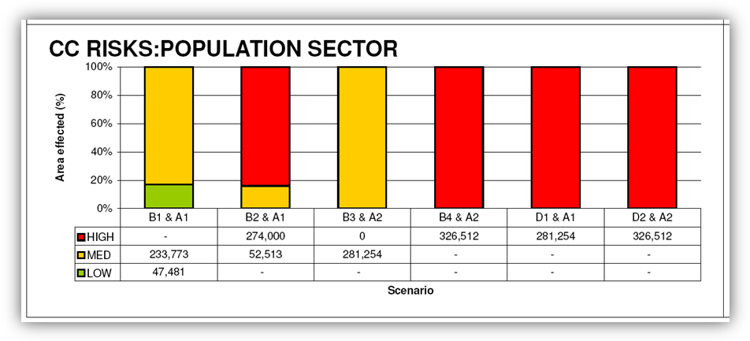

Figure 20: Climate Change risk on Population sector
Based on the above figure, the Overall Risk that climate change poses to the population sector is: HIGH.
In general, development and management plans are capable of dealing with low SLR scenarios, but require major revisions, while a more comprehensive review is required for high SLR scenarios involving a rethinking of the strategies and key structural assumptions. Furthermore, development plans perform better in the short term than in the long term, which is to be expected since there is greater uncertainty in both the plans and modeling for long term scenarios.
Generally, rural households in Ca Mau province are more vulnerable than urban ones. Under the 2015 development scenario, high SLR is going to have a greater effect on the rural rather than the urban population. However, over the long term the proportion of effected households is likely to even out slightly as the effected rural population stabilizes and there is an increase in affected urban areas. Therefore, vulnerability of rural populations should be reviewed for the short term high SLR scenarios, while long term high SLR scenarios should be reviewed for both urban and rural households.
Given the vulnerability of rural households, revisions to existing management plans should, as a minimum, explore emergency evacuation and long term relocation options. In addition studies should be undertaken to identify locally appropriate measures of increasing drainage efficiency immediately after major hydrological events as prolonged periods of high water levels is one of the fundamental factors driving rural vulnerability.

Vulnerability in Forestry sector
The forestry sector is split into three sub-sectors; specialized forests, protected reserves and productive forests. Forested areas are generally centered around Tran Van Thoi district on the western coast of the province, the southern tip of the province (south of the Bay Hap River), and between the coast and the sea dike system on the eastern coastline.
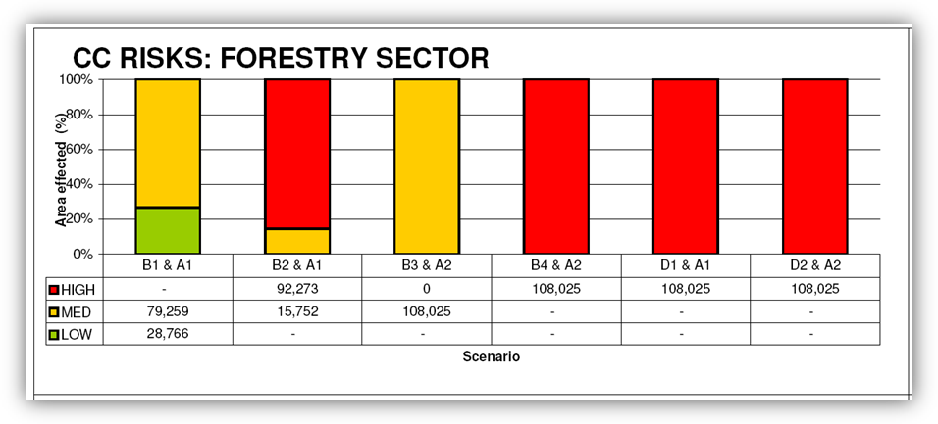

Figure 21: Climate Change risk on forestry sector
Based on the above figure, the Overall Risk that climate change poses to the forestry sector is: HIGH.
Increases in extreme storms and SLR result in a general increase in the risk faced by forest systems. However, some management initiatives have been successful. The 2015 development plan is reasonably capable of dealing with low SLR (25cm) scenario. However, the 2030 plan is less suited to dealing with this case suggesting that, even under conservative CC estimates, existing management plans will require major revisions.
Vulnerability of the forestry sector becomes more pronounced under high SLR There is an obvious capacity for changes to be integrated into both short and long-term planning to improve its appropriateness and given the risk associated with high SLR scenario, it is recommended that such a review be undertaken.
Both plans also fail to suitably manage forested areas under extreme storms. Research should be undertaken to reassess the design storm event used to define development plans, predicting the revised likelihood of a storm event of this size, as well as to study the effect of a 50+cm increase in max water levels.
The area of forest effected in each of the three sub-sectors is consistent across the six comparisons. Productive forests (regardless of the scenario) are likely to be the most affected (~60% of the total effected area), followed by protected forests (~24%) and specialized forests (~16%)
The vulnerability of the forestry sector has historically been a secondary concern for local, provincial and national authorities, primarily because of the urgent concerns of national food security and the environmental legacy of the American War. Without diminishing the importance of food security, it is crucial that the risks faced by the forests of Ca Mau province be given greater importance. An initial step would be to conduct further research into the environmental, social and economic importance of the forestry sector at a local and basin-wide level.
Sound environmental management and ecosystem services can play a crucial part in disaster mitigation and adaptation to climate change by increasing community resilience to natural hazards and efforts should be made to improve understanding of how the forestry sector interacts with other sectors. For example, there is a shift in global opinion towards utilizing, wherever possible, non-structural defenses against environmental hazards. This by, no means, implies that no conventional engineering works are to be utilized/built, rather it stresses the importance of using existing factors of local ecosystems to minimize the amount of infrastructure works required in order to reduce building and maintenance cost, as well as provide a healthier ecosystem with a greater array of ecosystem services for other provincial sectors.
This has been lacking in Ca Mau province. In the past, hydrological research of flooding has not taken into account the effects of coastal mangroves and forests on the hydrological regime. It is suggested that further studies be initiated into the effects of the mangroves on saline intrusion and flooding regimes in the province. This could include a ‘prevention dividend’ on ecosystem services. A prevention dividend, attributes an economic value to existing vegetation and quantifying questions like: what would preserving mangroves save in terms of farming and infrastructure?

Vulnerability in the Farming sector
The farming sector comprises seven subareas; shrimp, fishery, rice, rice-fish, rice-shrimp, vegetables and annual plants, perennial plants and residential areas. The land use map presented earlier describes the general location of these areas.

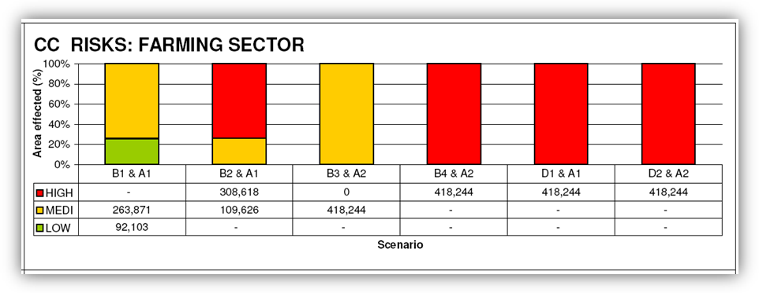

Figure 22: Climate Change risk on farming sector
Based on the above figure, the Overall Risk that climate change poses to the farming sector is: HIGH.
Risk increases with increased SLR, starting at ‘Medium’ for low SLR and moving to ‘High’. There is a general consistency across modeled scenarios for all subsectors, with the exception of the rice-fish sub-sector and the perennial plants/residential sub-sector. For both these subsectors, management plans are expected to handle low SLR in the short term (to 2015). However, for other scenarios there is a constant and significant change in water levels in these two sub-sectors, which should be addressed as per the other sub-sectors.
Provincial and national authorities periodically reassess the best mix of aqua/agriculture for Ca Mau province, based on available scientific information and expressed desires of local farmers. It is recommended that as part of this process workshops are conducted with the local community, planners and scientists to discuss the future changes to the farming sector and integrate predicted CC effects into the decision making process.

Vulnerability in Infrastructure sector
Hydraulic and hydrological modeling informs all infrastructure, agricultural, aqua-cultural and environmental works in the province, forming the basis for the assessment and reduction of risk. The infrastructure sector comprises ten sub-sectors including irrigational works (fields, embankments, culverts and dikes) and transport (local, district, provincial and national roads). The main works of the infrastructure sector are:
- The Construction of arterial and access roads, to link coastal/vulnerable areas to areas deemed safer.
- Development of man-made and natural vegetation buffer zones in coastal areas
- Development of buffer zones: fish farms and parks in vulnerable areas which are not suitable for human settlement.
Management plans have been successful in addressing the first two points; however the last point is yet to be integrated into future risk planning. Specifically, water resource management modeling in Ca Mau province has not, in the past, incorporated the buffering capabilities of the provinces mangroves into its architectural framework.
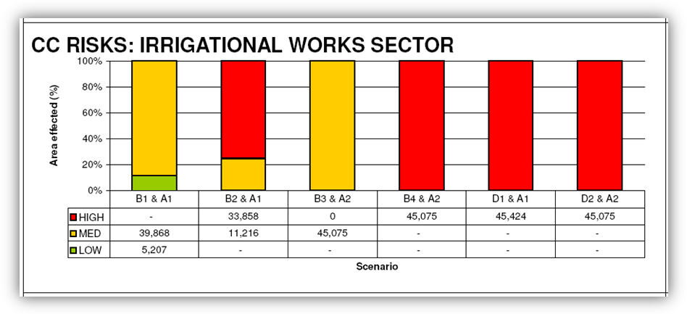

Figure 23: Climate Change risk on irrigation works sector
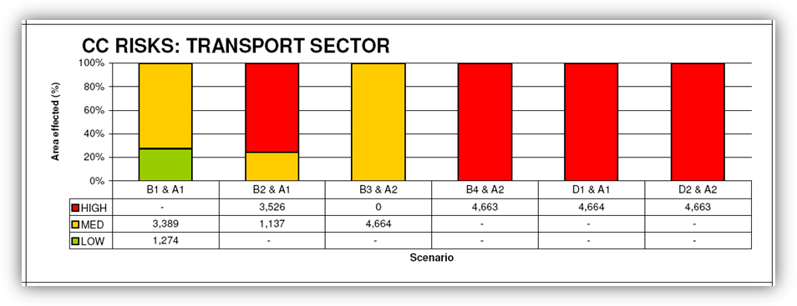

Figure 24: Climate Change risk on transport sector

Based on the above figures, the Overall Risk that climate change poses to the infrastructure sector is: HIGH.
The vulnerability of the infrastructure sector increases with increasing SLR. As with the farming sector, the performance of the infrastructure sector is consistent across the modeling scenarios. In terms of irrigation works, interior fields and secondary embankments are likely to suffer the greatest effect due to climate change. A similar trend exists for transportation works; 90% of the roads effected by CC are predicted to be local and district roads.
Planners and provincial authorities should review development plans to upgrade and strengthen secondary infrastructure works (i.e. secondary embankments/canals and local/district road networks). Also better understanding is needed of sediment and erosion processes, as these are one of the main causes of inefficiency and failure in canal performance. Complementary environmental works like revegetation of river banks could provide long term preventative benefits for the infrastructure sector.

Vulnerability in Miscellaneous sectors
This sector considers civic institutions and industrial zones within the Ca Mau province, including; tourist areas, hospitals, schools, post-offices, health and cultural centers and industrial zones, together with community concerns related to these institutions such as health, access and communication.
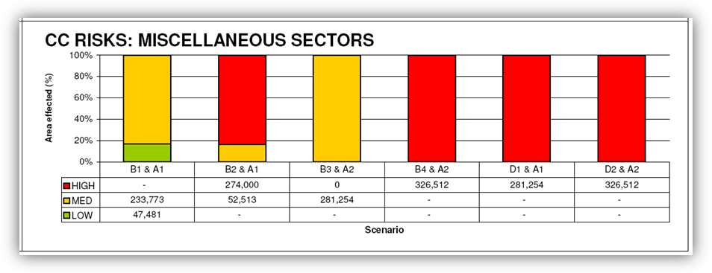

Figure 25: Climate Change risk on miscellaneous sector
Based on the above figure, the Overall Risk that climate change poses to the miscellaneous sector is: HIGH.
As with other sectors, the number of centers affected from each subsector appears to remain consistent regardless of the specific modeling comparison. Although there will be a difference in the magnitude of the effect depending on the severity of the risk. Some 585 hospitals and health centers will be effected and since the greatest effect to these services is likely to coincide with the greatest effect on the population health (flooding, rural isolation etc), there is a subsequent increased potential for disease and health-related risks.
Furthermore, 172 existing industrial zones are likely to be effected, which will increase the risk of further pollution problems. Efforts should be continued and improved to identify and study the fate and transport of pollutants in Ca Mau waterways after significant flooding events, and the first flush of the wet season.

Vulnerability in Governance structures
Currently, the focus in government planning is on development as a means to reducing poverty, and improving the livelihoods of not just the citizens of Ca Mau but also the whole of Vietnam who rely on produce from the province. This has meant that environmental regulation has traditionally only been considered as a secondary issue and comprehensive regulations/environmental protection mechanisms remain in their infancy. Furthermore, the adoption of integrated water management systems (IWMS) is a comparatively recent phenomenon in Vietnam, and the government continues to face some difficulty in re-aligning institutional structures (such as MONRE and MARD) in accordance with IWMS principles. Collaboration with international organisations and the MRC has been instrumental in providing the technical and logistical framework for the adoption of integrated water management strategies.
According to the UNISDR, governance and institutions play a critical role in reducing the risk of disaster. In this regard, the Ca Mau province is well prepared for the effects of climate change, because the predicted nature of the future problems to be faced are expected to be similar to those current faced by the peninsula (with a change in both the magnitude and timing). Provincial, national and transnational authorities have a long history of planning and strategic development in the area built on an extensive sampling and monitoring network.
The nature of Vietnamese political institutions results in strong cohesion between all levels of governance, which means that all development strategies, provided they have approval by the relevant ministries, can be efficiently and universally implemented. There is, therefore, sufficient institutional capacity in the Vietnamese governance structures to adapt existing development and management plans and implement appropriate initiatives to respond to climate change in the Ca Mau peninsula.
However, some issues regarding governance have emerged in previous efforts to implement management plans, and remain relevant for CC scenarios. Firstly, the negative side of a strong centralized structure is a rigid administration structure, which takes time to adapt and when coupled with the fact that hydrologic unit boundaries do not coincide with administrative boundaries, results in some difficulty in fostering inter-province co-operation.
This is likely to rise as an issue in two aspects of the provincial development plan. The first is in coordinating a response strategy with Bac Lieu province addressing flooding and SLR. The second is in coordinating a study of all of the CLD and parts of the upstream catchment to estimate and manage sediment loading in the Mekong, which is the main source for sediment aggravation on the peninsula tip.

Summary Assessment
The results of this study identify SLR, cyclones (and subsequent flooding), together with subsidiary effects of water shortages (both drinking/domestic and farm use) and waterborne diseases as the most significant risks affecting the Ca Mau community. Furthermore, these major risks can be further divided by their expected probability of occurrence. Cyclones and extreme weather events, though the most severe single risk, are predicted to occur sporadically, while SLR and water availability are likely to be continuous effects on the community.
The study has also concluded that Strategic Development and Basin Development Plans have proven themselves as successful centralized methods of planning and that within the current Restructured Strategic Development Plan, there is some capacity to manage vulnerability. Specifically: flood control, fresh and saline water distribution and engineering works planning.
However, current planning does not address all of the key vulnerabilities in Ca Mau province; the following issues would require greater attention in the RSDP in order to improve the province’s ability to cope with climate change.
- Some categories of disaster preparedness: communities, coordination & cooperation, hazards & disaster, capacity & preparedness, vulnerabilities (especially accessibility of information, new techniques like GIS should continue to be used to make IWMS more effective).
- Expected hazards and their location, put into a table (eg. Point source pollution from industrial zones)
- Water availability (droughts, prolonged flooding), especially in the southern tip and northern area of the province.
- Water Quality (salinity) south of Song Doc Town-Tran Van Thoi- Ca Mau City and northeast toward the Bac Lieu border
- Water quality (for drinking). This is likely to be an overarching problem for the province, due to the increasing population and sanitization of groundwater, and the province’s continued reliance on it.
- Epidemics and contagious diseases
- Building and Infrastructure collapse
- Open sewage/sanitation

These risks can be assigned to the four categories identified at the beginning of this chapter in the table below.

Table 43: Risk and vulnerability table for Ca Mau Province
General Health | Social | Economic | Infrastructure | Environment
Increased mortality rate (due to disease or disaster events) | Dispersion, homelessness and internal displacement | Limited income diversity | Degradation of streets | Salinization of groundwater aquifers
Spreading of diseases (particularly water borne) | Increase in poverty | Lack of effective services | Electricity net interruption and destruction of electricity grid in urban areas (especially during extreme events) | Destruction of mangrove and mellaleuca forest areas, through changes in land-sea interface
Strain on primary care services (vaccinations etc) | Neglect of handi-capped, and elderly | Lack of infrastructure | Destruction of sewage/water network | Deforestation due to land use conflicts (primarily farming)
Injury from flooding |  | Poor harvests | Destruction of agricultural wealth | Reduced sediment aggradations on southern tip
Injury from traffic related accidents | Unfinished schooling/lower literacy levels | Loss of private belongings | Loss of strategic stores (medicine food) | Land surface submergence
 | Isolation of communities and regions due to floods and inappropriate infrastructure | Wastage of energy resources | Loss or absence of effective communication infrastructure with remote citizens | Expansion of ASS areas
 |  | Inefficient farming practices and strategies | Destruction of hospitals/shortage of beds | Erosion of eastern shore of peninsula
 |  |  | Collapse of buildings | Subsequent reduction in biodiversity

Poverty is strongly linked to environmental degradation and the exacerbation of potential hazards, however, ecosystem conservation is never a solution by itself. In Ca Mau province, conservation and the expansion of farming activities have been required to strike a balance, in order to alleviate hunger in the country, as well as maintain mangrove ecosystems. On the one hand, shrimp farming, and wood collection has reduced the areas of mangroves, forests and riparian vegetation. Multi-crop techniques and the seasonal oscillation between agriculture and aquaculture have improved yield efficiencies for areas in the province, and reduced the demand for new cleared land. Therefore, the fundamental change required in management planning is to further emphasize the importance of Integrated Water Management Strategies considering sectors as interactive systems.

CONCLUSIONS & RECOMMENDATIONS
Ca Mau peninsula, the southernmost province of Vietnam, adjoins the sea on three sides and is regulated by the tidal regimes of both the West Sea and East Sea. Its fresh water is provided by precipitation, underground aquifers and surface flows from the Bassac River. The province possesses a long coastal line of 170 km, elaborate waterways and many water transition areas. The provinces population is small, sparse for the CLD but growing rapidly. The provinces’ economy remains agrarian based but continues rapid diversification into industrial (sugar, fisheries, fertilizers, frozen, gas and electricity) and service (tourism) sectors. Being a deltaic environment surface topography is low-lying with a complex system of rivers and streams and a continuing evolving coastline. Surface waters dominate the hydrological regime, in particular the interaction between river/overland flow and tidal excursions, while the biotic systems are dominated by mangroves and brackish environments.
A NEDECCO study (1993) identified the following five problems as the major land and water problems facing the Cuu Long Delta:
- acute flooding in the wet season;
- acid sulphate soils, and their effects on soil productivity, drainage water quality and aquatic productivity;
- dry season saline intrusion;
- adverse impacts of salt intrusion sluices on land/water production and acidification;
- depletion of coastal mangroves and protected areas for fish breeding;
- increased sediment load due to deforestation.
Predicted changes due to global warming are likely to exacerbate all five of these problems, potentially compromising the effectiveness of existing water resource management practices. However, of these issues, land and water contamination is considered to be the most significant, driven by the twin issues of; salinity intrusion and acid-sulphate soil generation. Furthermore, this area is relatively sensitive to the impact from current natural disasters, which is likely to become more pronounced in the future.
The study indicates that, the impacts of storms and SLR on Ca Mau province is highly likely to pose a serious threat to both the existing biophysical and socio-economic environments and that both short-term and long-term management initiatives are, as they currently stand, insufficient to meet this emerging risk. In order to mitigate and adapted with climate change, provincial planners should apply a combination of both construction-measures and non-construction measures. Construction measures are hydraulic works built in order to control the volumes and quality of water within enclosed areas through the use of physical barriers to the movement of water. Non-construction measures are measures used to mitigate damages caused by climate change and include; long-term and short-term climate change forecasts; risk identification and education for all community stakeholders (workshops etc); the development of modern communications system in order to monitor key disaster parameters the establishment of relief teams, allows prompt communication and response to emergency situations. Arrangement of production sectors and cultivation seasons must be suitable in order to avoid damages and to increase efficiency. A close combination between construction measures and non-construction measures will increase benefits and decrease investment cost.
This is in accordance with the UNDP Global Report for Reducing Disaster Risk, which reiterates the socio-cultural aspects of vulnerability, defining it as “…a human condition or process resulting from the physical, social, economic and environmental factors, which determine the likelihood and scale of damage from the impact of a given hazard.” This combination of both construction and non-construction measures is expected to strengthen the regulatory and institutional frameworks of the peninsula.
The following recommendations will assist authorities and local communities in the province to revise and work towards a provincial development plan that is integrated, sustainable, and affords proper recognition of the importance of the peninsula to the Mekong Delta in general.
The development, strengthening, upgrading, and new construction of prevention works in Ca Mau province should focus on the following urgent problems:
- Head works
Focus on headwork’s structures, which significantly influence socio-economic development and climate change adaptation and mitigation efficiency and ensure the system of hydraulic works is comprehensive, flexible, and able to meet different production requirements of specific regions:
- Define suitable structural measures in order to increase the capacity to store fresh water in dry season for the forest fire protection, indigo forest development, production stabilization, fallow land reduction, and domestic life.
- Define measures and distribute hydraulic works system matching the changes in farming production structure.
- Define list of priority of structures, give priority to urgent structures or head works in high vulnerability-high risk areas.
- Define measures and distribute hydraulic works system matching with every region to heighten construction efficiency and avoid long-term conflicts.
- Increase the capacity to drain acid-sulphate areas and improve inundation.
- Combine the development of hydraulic works with that of new infrastructure, new rural areas and local natural disaster control and mitigation (NDCM) strategies.
- Construct new and upgrade existing sea and river dike systems and review sluice system to drain water and embankments, especially the ageing West Sea dike system.
- Undertake research to further understanding of erosion, sediment aggradations and local mangrove response to changes in sea levels.
- The forest ring dike of 185.04 km total length, which was built in 1980s to protect against fire and salinity intrusion with surface width: 6.0 m and a crest elevation of + 1.5 to + 2.0 m has been degraded and some sections cannot meet design requirements.
- Protect and develop protective forest along the coastal lines to avoid over flooding and prevent salinity intrusion.
- Recently, high water requirements for production cannot be satisfied because canals have become built up with sediment blocking water flow, Plans should aim to dredge canals to supply clean water and drain waste water, reclaim land, change river flow and repair riparian vegetation to minimize erosion.
- Population Dynamics
Ca Mau province is an area with different demographic components living scattered along rivers and coastlines. This leaves a significant proportion of the rural population isolated and at greater risk from SLR and extreme storm events. Initiatives need to be identified to reduce the vulnerability of these communities, for example the relocation of people to form denser clusters, which can be protected.
- Invest to build resettlement areas that ensure all criteria on cultural and social life, to construct such infrastructure as electricity, roads, schools, health practices, to provide clean water, and implement land contract.
- Further efforts are needed to secure water supply, as climate change is expected to exacerbate outbreaks and health issues associated with drinking and domestic water supplies. Water source for domestic supply and production is mainly underground water and rainwater, with only a small part from ponds and lakes. Where no water supply is found, a minority of the population use mineral water with low quality and overexploitation, resulting in the pollution of underground water. Therefore, it is necessary to have plans to manage and exploit this natural resource sustainably, such as to construct water supply and treatment systems at a suitable scale for the peninsula community. Research is needed to ascertain whether small delocalised treatment systems (such as slow sand filtration units, rain water harvesting/collection tanks) or a centralized treatment plant (conventional or desalination) will be the best option for the peninsula.
- Policies to overcome consequences post-disaster should, as a minimum, stabilize local life and production, make preferential policies for survivors’ households, ethnic minorities, and the poor. For example: low interest loans for different economic sectors, support funds for those who lost houses or working tools, distribute free food, medicines, and other necessities, support breeding animal and plants, encourage agriculture and fishery extension for disaster-suffered areas to stabilize lives.
- Diversify the provinces economy, as much as possible, to reduce vulnerability. The continued promotion of responsible tourism, industrial activity and forestry is a suitable measure in this direction.
- Land Use Strategies
- Invest in the construction of irrigation works (sluices, dredge canals, upgrade dykes and dams, see above), reserve fresh water, transform planting structure and husbandry, and apply scientific techniques to production to improve yearly alum and saline lands.
- Plans of protecting and developing forest resource (cajuput forest) and coastal protective forest should be set up in order to protect the land lines in the West and East from tidal impact such as erosion, water overflowing into the mainland.
- Mangrove and forestry preservation should be given a high priority in future management plans. Though there is still some uncertainty in quantifying all the benefits they provide to the province, there is clear qualitative evidence concluding that they are an integral component of the Mekong Delta environment and of the local Ca Mau rural/urban communities.
- Aforestation and forest farming activities should incorporate multi-species planting, to ensure their ecological effectiveness (their capacity to represent and maintain biodiversity), especially as spawning grounds for fish and shrimp populations.
- Mangroves are likely to be divested by extreme events like Linda Storm, this will be an ongoing and increasingly important, problem for Ca Mau peninsula as the frequency of occurrence for extreme storm events is predicted to increase. Most mangrove areas lie outside of most protection measures and so remain as high risk areas. Mangrove estuarine environments are key features in deltaic ecosystems. However, their continued destruction will also have far reaching negative impacts on local communities and farming practices. Natural fish and shrimp stocks are likely to be depleted without estuarine breeding grounds, and the nature of saline intrusion into the peninsula is also likely to be affected, with subsequent effects on the hydrologic regime. Scientific quantification of the damage to mangroves resulting from the design storm needs to be undertaken.
- An evaluation of fertilizer and pesticide application, quantifying the effect that these pollutants are having on fish species.
- An evaluation of the fate and transport of domestic, industrial and medical waste in the province, focussing on the health and ecosystems threats they might pose to human and ecosystem health
- Infrastructure Development
- Road transportation: Invest to construct inter-district road and those from province to districts of tertiary standard or above, construct inter-commune, inter-hamlet roads connecting to residential areas and administrative centres in order to improve socio-economic development, facilitate access to civic services and contribute to climate change adaptation and mitigation.
- There is an elaborate network of canals and ditches; therefore, waterways should also be paid sufficient attention in order to clear ways for a smooth transportation of goods and food, to save time and increase efficiency.
- Wherever possible, new canals should not be built perpendicular to direction of flow in main and secondary systems, so that the problems of sediment build up is not concentrated in small tertiary canals, which can quickly reduce their effectiveness and increase maintenance costs on the local farmer.
- Environmental pollution is an urgent issue for the province. It is necessary to construct solid waste treatment factories to treat waste from industrial areas, frozen factories, and hospitals. And to develop suitable water sanitation facilities to minimize untreated sewerage entering surface waters.
- Natural Disaster Control and Mitigation Strategy
The NDMC is the primary framework responsible for emergency and disaster response in the province.
- Develop measures for collecting information, building forces, strengthening the capacity and efficiency of natural disaster forecasting-warning, and community response strategies
- Besides existing communication centres such as: provincial post office and those in communes and districts, it is necessary to upgrade and construct communication systems in important places such as, coastal towns or townships, district stations, concentrated residential areas and border army posts.
- Encourage local residents, especially fishermen to carry equipment such as walkie-talkies, compass, maps. In order to fully understand storm- warning signal. All work should be coordinated from provincial to local levels.
- Collecting and processing information plays a key role in climate change adaptation and mitigation as improved data sets will improve the accuracy and efficiency of forecasts and responses. The full-time staff from the Province to grassroots community volunteers, who collect and process information from weather station, etc., are selected carefully and opportunities should be made available to regularly update their professional skills. This can be achieved through information collection and processing training sessions, demonstrations/drills of some frequent natural disasters, and site visits to other deltaic/coastal environments, which have recently experienced natural disasters common for Ca Mau province.

This study is intended to assist authorities and people in the province in producing the most suitable development plans for Ca Mau province in a warming climate. There is strong scientific evidence and agreement amongst the scientific communities that the earth’s atmosphere is warming, and that the major effects of this process in low-lying deltaic environments is rising sea level, changes to precipitation patterns, and an increased frequency of extreme climate events. These changes produce the greatest risks facing Ca Mau province.
Additionally there is a lot of data on the existing social, economic and to a lesser extent environmental conditions of the province. This information allows for the characterisation of the local and provincial vulnerability of the people, their practices, environment and infrastructure to the risk posed by climate change. The major vulnerabilities in the economic sphere arise from damage and decreased production because of severe flooding, storms and SLR. From a social perspective, the Ca Mau community is vulnerable to health risks and hindrances to development associated with both disasters and ongoing pollution. As well as from institutional inhibitions to adaptation (i.e. coordination of planning across sectors and provincial/national boundaries). From an environmental perspective, bio systems are vulnerable due to a insufficient knowledge about the current state of ecosystems as well as of the driving hydro-geological processes of the delta (sediment aggradations, bank erosion, ASS etc). They are also vulnerable to degradation and adverse effects generated by activity in other sectors.
The issues explored throughout this report culminated in the conclusions listed above, which serve as a preliminary guide to direct and improve development planning for Ca Mau province. For these initiatives to be successful many, will require multi-lateral involvement and support from the provincial/national authorities, trans-boundary institutions (MRC, ADB), NGOs and the people of Ca Mau province themselves.

FINAL REPORT

STUDY ON CLIMATE CHANGE SCENARIOS ASSESSMENT FOR CA MAU PROVINCE

Appendix

April 2008

TABLE OF CONTENTS
LIST OF TABLES IN REPORT 4
LIST OF FIGURES IN REPORT 5
CHAPTER I. SIMULATED RESULTS 6
I.1 Scenario A0 6
I.2 Scenario A1 13
I.3 Scenario A2 14
I.4 Scenario B1 15
I.5 Scenario B2 16
I.6 Scenario B3 17
I.7 Scenario B4 18
I.8 Scenario C1 19
I.9 Scenario C2 20
I.10 Scenario D1 21
I.11 Scenario D2 22
CHAPTER II. ASSESSMENTS ON SIMULATED RESULTS 24
II.1 Assessment of the Water resources planning Scenarios 24
II.1.1 Impact to salinity intrusion 24
II.1.2 Impact to water level 24
II.2 Assessment of the Sea level rise Scenarios 27
II.2.1 Impact of sea level rise to salinity intrusion 27
II.2.2 Impact of sea level rise to water level 28
II.3 Assessment of the Extreme climatic event Scenarios 32
II.3.1 Impact to salinity intrusion 32
II.3.2 Impact to water level 32
II.4 Assessment of the complex SLR, CLC and Storm Scenarios 35
II.4.1 Impact of sea level rise to salinity intrusion 35
II.4.2 Impact to water level 35

LIST OF TABLES IN REPORT

Table 1: Effected areas by Max. Salinity intrusion within Ca Mau province 6
Table 2: Max surface water areas in Dry season within Ca Mau province 6
Table 3: Max surface water areas in Wet season within Ca Mau province 7
Table 4: Effected areas by Max. Salinity intrusion within Ca Mau province 13
Table 5: Max surface water areas within Ca Mau province 14
Table 6: Effected areas by Max. Salinity intrusion within Ca Mau province 14
Table 7: Max surface water areas within Ca Mau province 15
Table 8: Effected areas by Max. Salinity intrusion within Ca Mau province 15
Table 9: Max surface water areas within Ca Mau province 16
Table 10: Effected areas by Max. Salinity intrusion within Ca Mau province 16
Table 11: Max surface water areas within Ca Mau province 17
Table 12: Effected areas by Max. Salinity intrusion within Ca Mau province 17
Table 13: Max surface water areas within Ca Mau province 18
Table 14: Effected areas by Max. Salinity intrusion within Ca Mau province 18
Table 15: Max surface water areas within Ca Mau province 19
Table 16: Effected areas by Max. Salinity intrusion within Ca Mau province 19
Table 17: Max surface water areas within Ca Mau province 20
Table 18: Effected areas by Max. Salinity intrusion within Ca Mau province 20
Table 19: Max surface water areas within Ca Mau province 21
Table 20: Effected areas by Max. Salinity intrusion within Ca Mau province 21
Table 21: Max surface water areas within Ca Mau province 22
Table 22: Effected areas by Max. Salinity intrusion within Ca Mau province 22
Table 23: Max surface water areas within Ca Mau province 23

LIST OF FIGURES IN REPORT

Figure 1: Max. Salinity intrusion – Scenario A1 & A2 24
Figure 2: Max. Water level in dry season– Scenario A1 & A2 25
Figure 3: Changing of Max water level in dry season : A1-A0, A2-A0 25
Figure 4: Max. Water level in wet season – Scenario A1, A2 26
Figure 5: Changing of Max water level – Comparison: A2-A0, A1-A0 26
Figure 6: Max. Salinity intrusion – Scenario B1 & B2 27
Figure 7: Max. Salinity intrusion – Scenario B3 & B4 27
Figure 8: Max. Water level in Dry season – Scenario B1, B2 28
Figure 9: Max. Water level in Dry season – Scenario B3, B4 28
Figure 10: Changing of Max water level – Comparison: B1-A1, B2-A1 29
Figure 11: Changing of Max water level – Comparison: B3-A2, B4-A2 29
Figure 12: Max. Water level in wet season – Scenario B1, B2 30
Figure 13: Max. Water level in wet season – Scenario B3, B4 30
Figure 14: Changing of Max water level – Comparison: B1-A1, B2-A1 31
Figure 15: Changing of Max water level – Comparison: B3-A2, B4-A2 31
Figure 16: Max. Salinity intrusion – Scenario C1 & C2 32
Figure 17: Max. Water level in Dry season – Scenario C1, C2 33
Figure 18: Changing of Max water level – Comparison: C1-A1, C2-A2 33
Figure 19: Max. Water level in wet season – Scenario C1, C2 34
Figure 20: Changing of Max water level – Comparison: C1-A1, C2-A2 34
Figure 21: Max. Salinity intrusion – Scenario D1 & D2 35
Figure 22: Max. Water level in Dry season – Scenario D1, D2 36
Figure 23: Changing of Max water level – Comparison: D1-A1, D2-A2 36
Figure 24: Max. Water level in wet season – Scenario D1, D2 37
Figure 25: Changing of Max water level – Comparison: D1-A1, D2-A2 37
Figure 26: Changing of Max water level during the stormy period – D1 & A1 38
Figure 27: Changing of Max water level during the stormy period – D2 & A2 38
Figure 28: to Figure 69: Impacts of Climate Change on sectors.............................39-80

SIMULATED RESULTS
  - Scenario A0
- Table and graph results:

Table 44: Effected areas by Max. Salinity intrusion within Ca Mau province
Levels | EFFECTED AREAS BY MAX. SALINITY INTRUSION OF SCENARIO A0 (km2)
Levels | Jan | Feb | Mar | Apr | May | Jun | Dry season | %
S = 0 - 4 g/l | 1,143.74 | 1,118.62 | 1,103.19 | 1,099.90 | 1,104.19 | 1,141.95 | 1,105.38 | 20.1
S = 4 - 8 g/l | 209.23 | 152.71 | 118.62 | 118.18 | 124.41 | 134.83 | 101.59 | 1.8
S = 8 - 12 g/l | 326.70 | 93.71 | 74.01 | 45.90 | 58.18 | 72.05 | 39.25 | 0.7
S = 12 - 16 g/l | 300.61 | 122.00 | 74.66 | 70.35 | 67.63 | 76.91 | 72.59 | 1.3
S = 16 - 20 g/l | 143.77 | 282.81 | 105.93 | 74.26 | 50.58 | 63.16 | 70.49 | 1.3
S = 20 - 24 g/l | 1,616.54 | 358.61 | 171.49 | 84.11 | 78.20 | 255.13 | 84.56 | 1.5
S = 24 - 28 g/l | 1,756.74 | 1,715.41 | 227.68 | 259.70 | 117.25 | 259.63 | 115.13 | 2.1
S > 28 g/l | 0.00 | 1,651.48 | 3,621.77 | 3,744.94 | 3,896.90 | 3,493.69 | 3,908.35 | 71.1
Total | 5,497.34 | 5,497.34 | 5,497.34 | 5,497.34 | 5,497.34 | 5,497.34 | 5,497.34 | 100.0

Table 45: Max surface water areas in Dry season within Ca Mau province
Levels | SURFACE WATER AREAS OF SCENARIO A0 (km2)
Levels | Jan | Feb | Mar | Apr | May | Jun | Dry season (DS) | % of DS
Z = 0.2 - 0.4m | 0.00 | 1,810.69 | 1,854.45 | 1,930.55 | 1,279.13 | 1,147.49 | 0.00 | 0.0
Z = 0.4 - 0.6m | 2,003.47 | 338.87 | 341.96 | 1,181.66 | 1,501.16 | 676.24 | 1,282.44 | 23.3
Z = 0.6 - 0.8m | 400.38 | 1,378.73 | 1,135.10 | 844.33 | 923.80 | 1,962.64 | 1,110.94 | 20.2
Z = 0.8 - 1.0m | 1,225.56 | 724.31 | 729.58 | 474.40 | 577.56 | 598.18 | 1,234.33 | 22.5
Z = 1.0 - 1.2m | 659.18 | 373.33 | 421.39 | 232.97 | 304.62 | 311.72 | 660.16 | 12.0
Z = 1.2 - 1.4m | 310.06 | 294.24 | 274.95 | 243.41 | 236.76 | 283.02 | 310.78 | 5.7
Z = 1.4 - 1.6m | 263.32 | 290.98 | 281.29 | 254.19 | 232.81 | 273.94 | 263.32 | 4.8
Z = 1.6 - 1.8m | 282.75 | 286.19 | 458.62 | 335.83 | 253.72 | 244.12 | 282.75 | 5.1
Z = 1.8 - 2.0m | 352.63 | 0.00 | 0.00 | 0.00 | 187.79 | 0.00 | 352.62 | 6.4
Z > 2.0m | 0.00 | 0.00 | 0.00 | 0.00 | 0.00 | 0.00 | 0.00 | 0.0
Total | 5,497.34 | 5,497.34 | 5,497.34 | 5,497.34 | 5,497.34 | 5,497.34 | 5,497.34 | 100.0

Table 46: Max surface water areas in Wet season within Ca Mau province
Levels | SURFACE WATER AREAS OF SCENARIO A0 (km2)
Levels | Jul | Aug | Sep | Oct | Nov | Dec | Wet season (WS) | % of WS
Z = 0.2 - 0.4m | 1,054.24 | 918.97 | 800.49 | 0.00 | 0.00 | 0.00 | 0.00 | 0.0
Z = 0.4 - 0.6m | 805.74 | 421.70 | 986.58 | 1,049.84 | 1,025.45 | 1,087.24 | 1,015.75 | 18.5
Z = 0.6 - 0.8m | 2,162.31 | 894.69 | 1,347.87 | 899.94 | 1,101.04 | 439.36 | 448.93 | 8.2
Z = 0.8 - 1.0m | 495.55 | 2,053.92 | 1,178.37 | 1,857.98 | 1,933.43 | 1,969.62 | 2,031.55 | 37.0
Z = 1.0 - 1.2m | 265.81 | 397.27 | 278.08 | 548.48 | 404.32 | 655.15 | 654.47 | 11.9
Z = 1.2 - 1.4m | 268.25 | 363.44 | 192.62 | 256.36 | 264.86 | 386.09 | 384.85 | 7.0
Z = 1.4 - 1.6m | 277.53 | 447.34 | 213.39 | 220.62 | 253.04 | 250.31 | 248.48 | 4.5
Z = 1.6 - 1.8m | 167.92 | 0.00 | 225.94 | 225.69 | 279.43 | 260.70 | 254.91 | 4.6
Z = 1.8 - 2.0m | 0.00 | 0.00 | 274.00 | 252.71 | 235.78 | 448.88 | 269.55 | 4.9
Z > 2.0m | 0.00 | 0.00 | 0.00 | 185.73 | 0.00 | 0.00 | 188.84 | 3.4
Total | 5,497.34 | 5,497.34 | 5,497.34 | 5,497.34 | 5,497.34 | 5,497.34 | 5,497.34 | 100.0

- Mapping:
SALINITY INTRUSION | 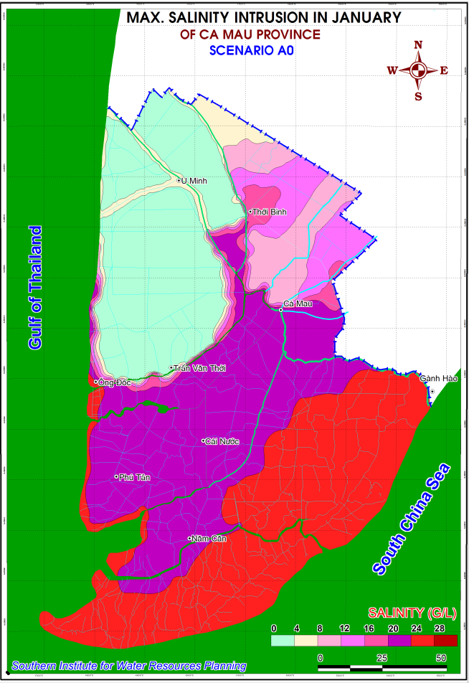
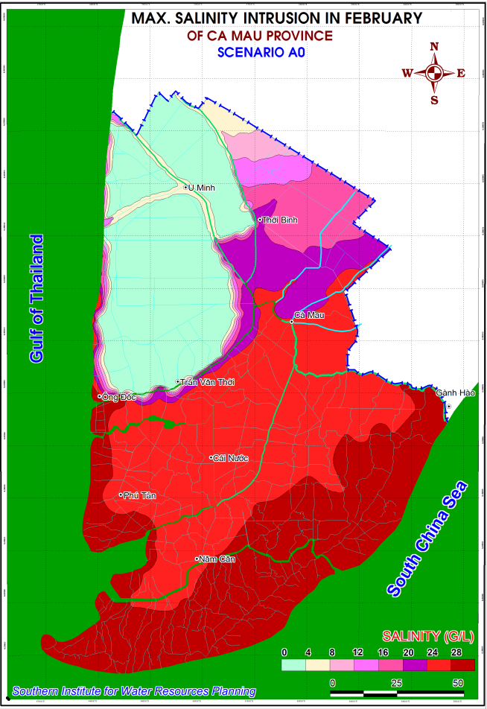 | 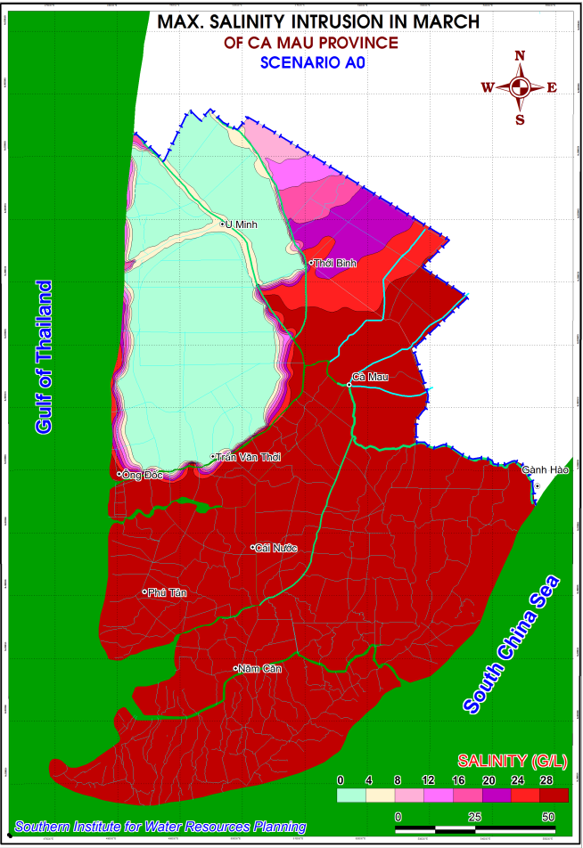
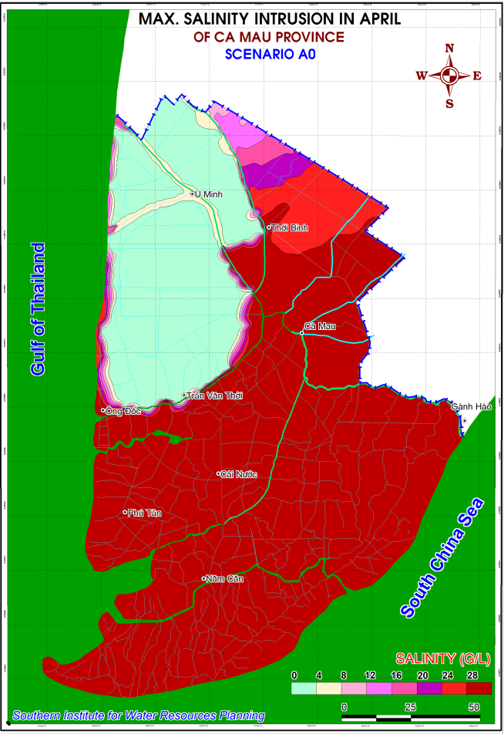 | 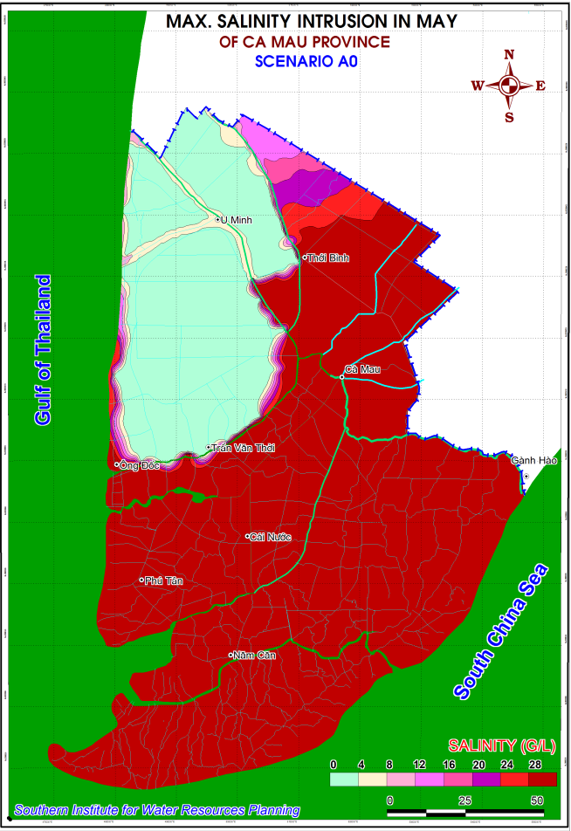
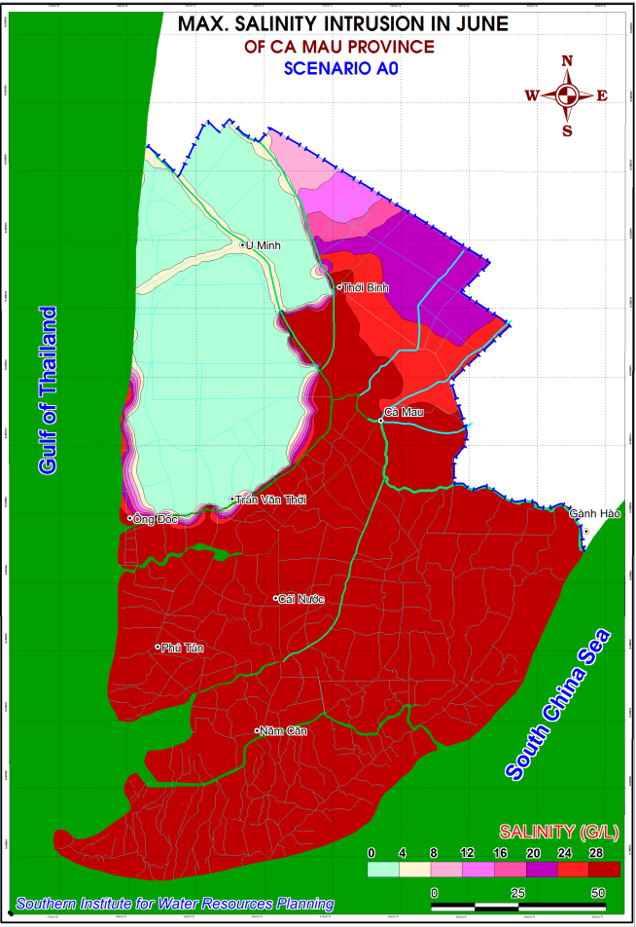 | 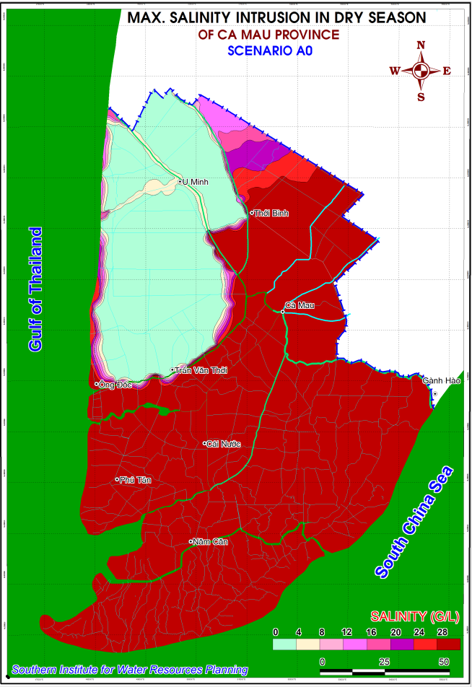
MAX. WATER LEVEL  IN DRY SEASON | 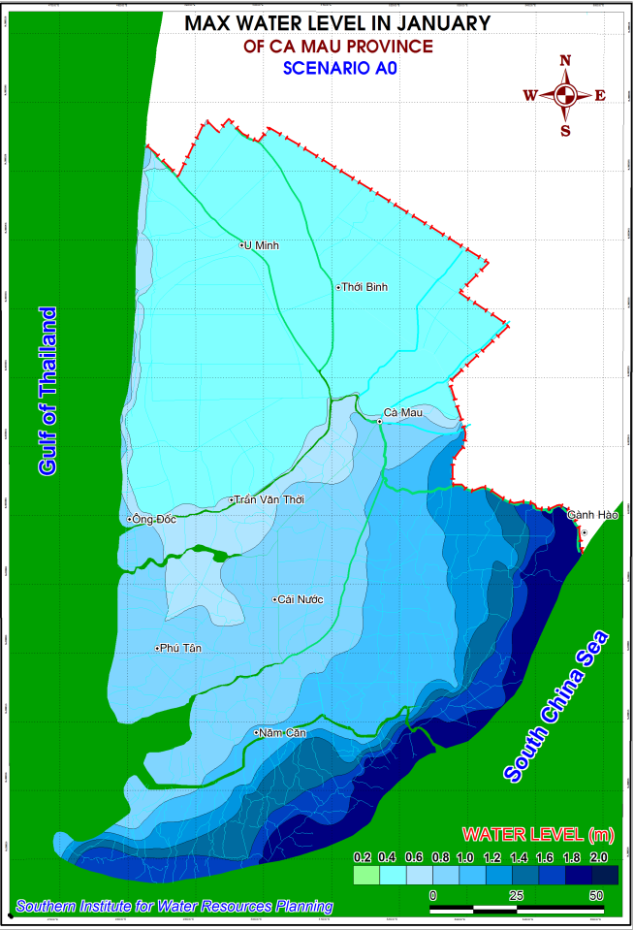
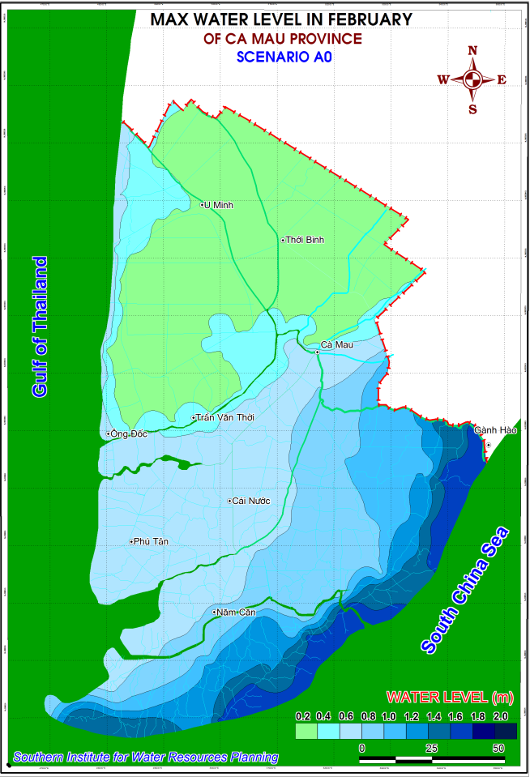 | 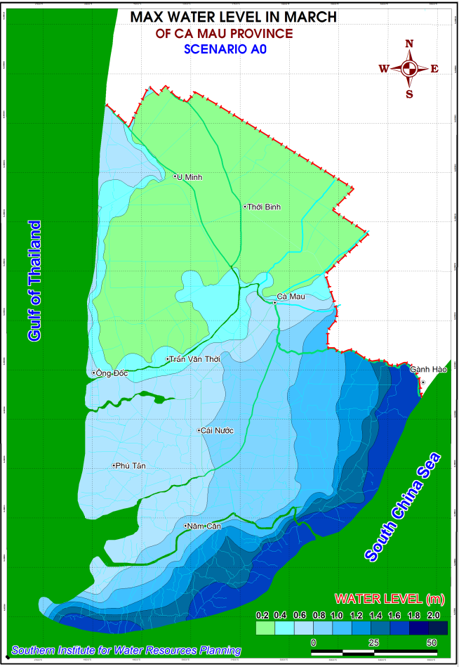
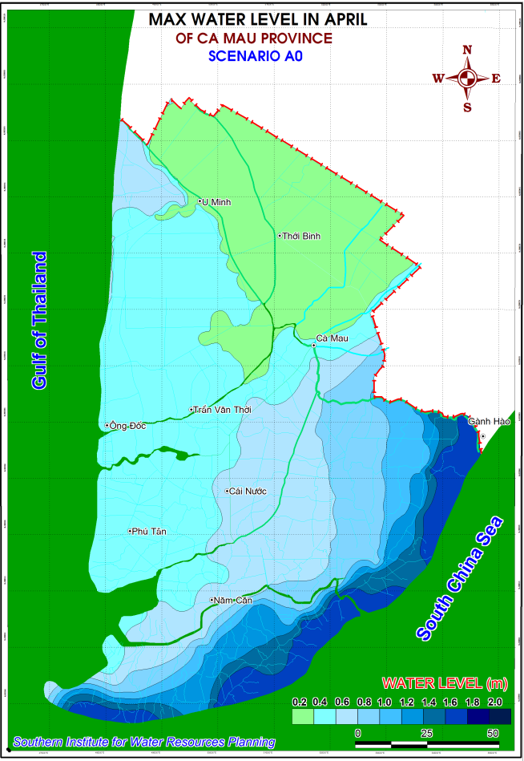 | 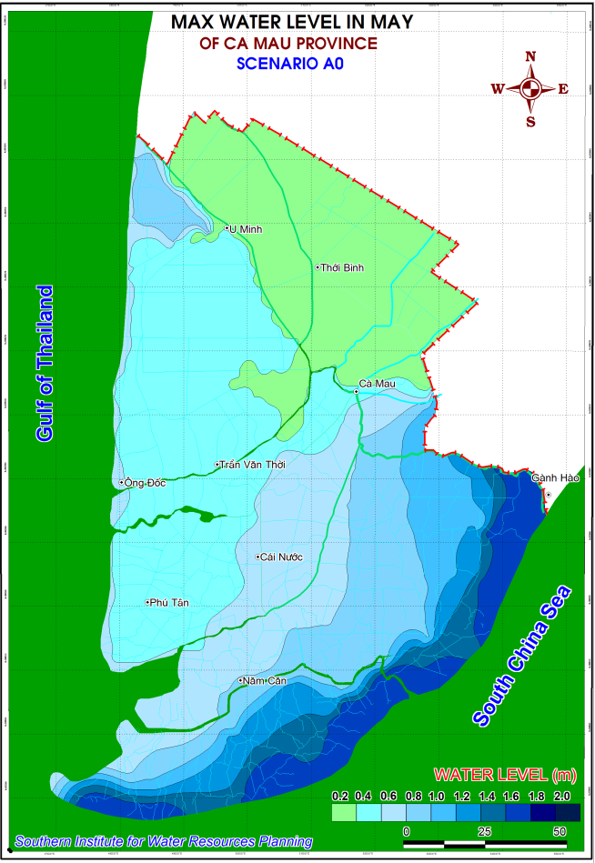
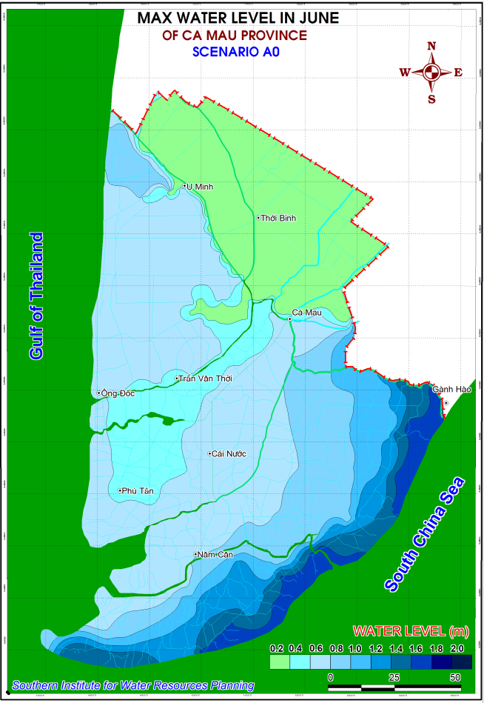 | 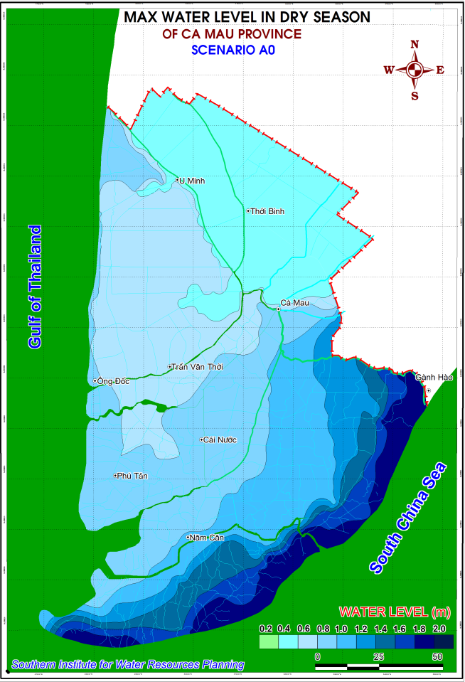
MAX. WATER LEVEL  IN WET SEASON | 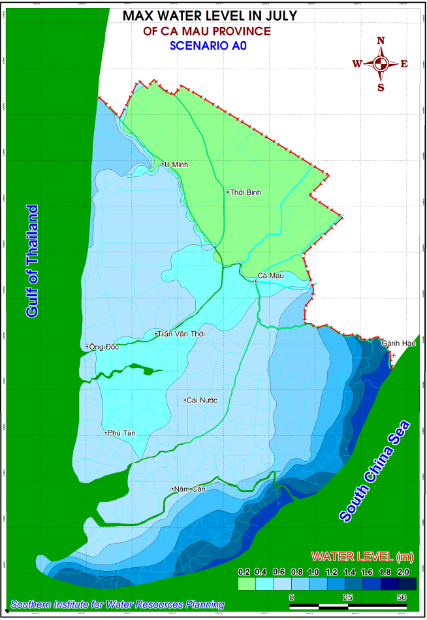
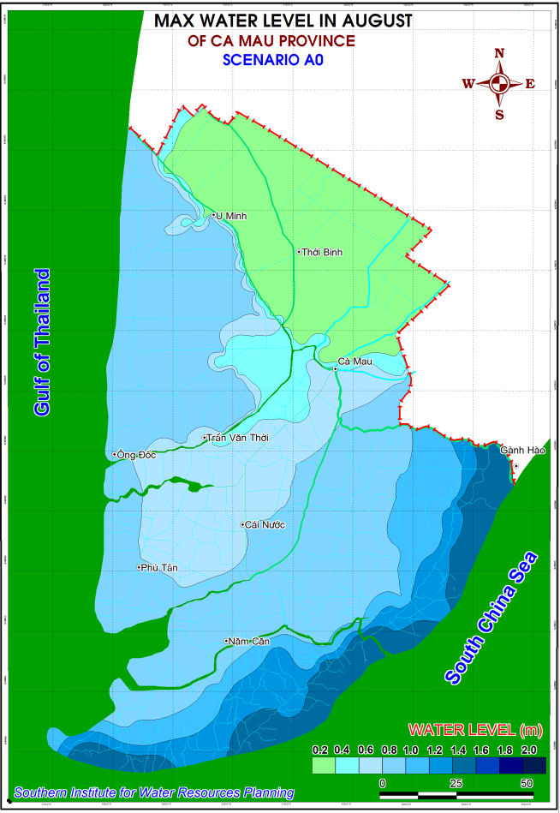 | 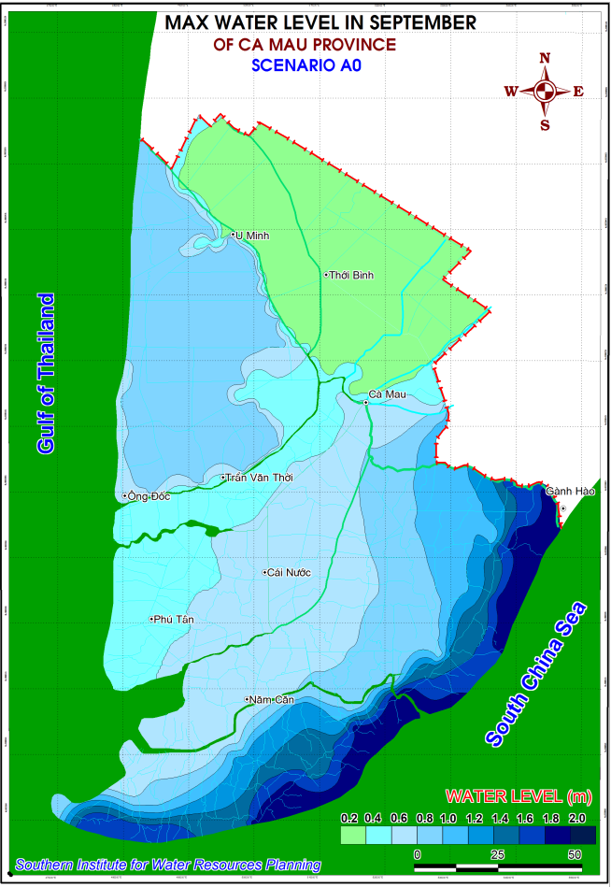
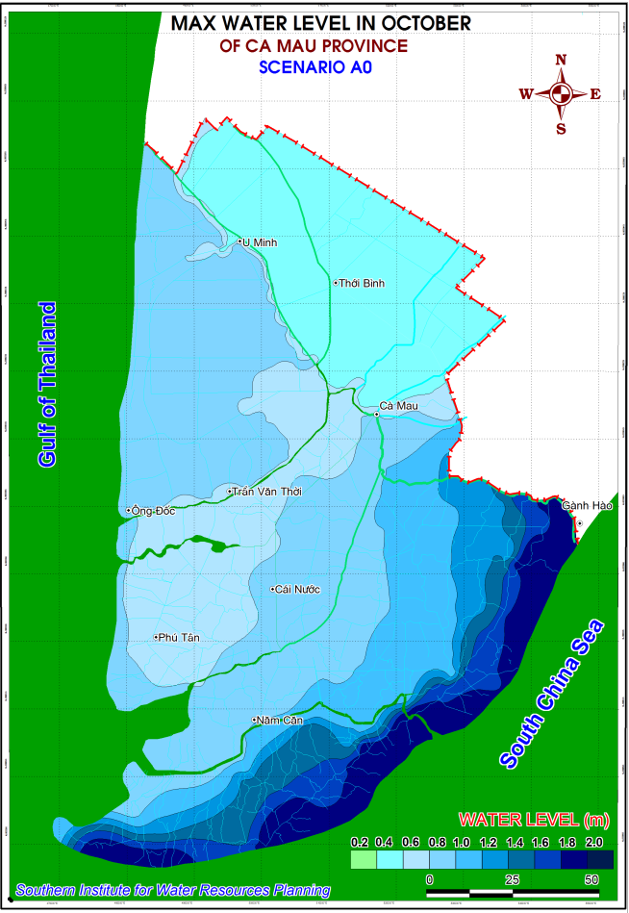 | 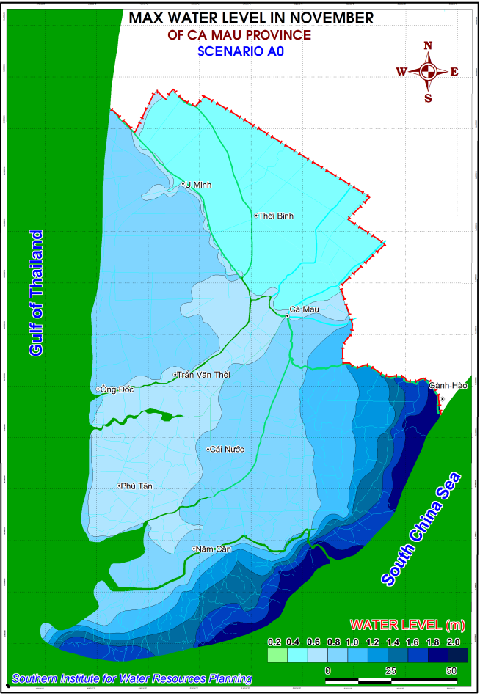
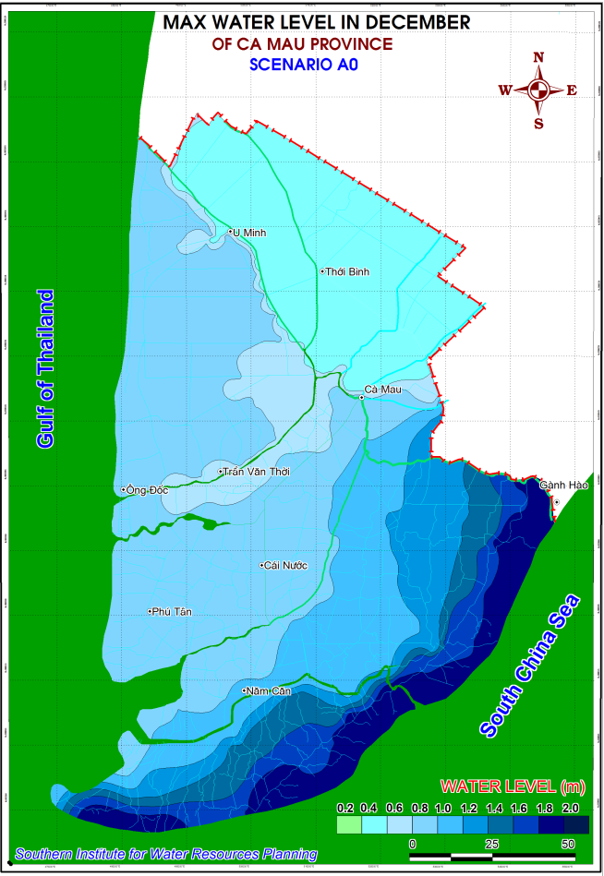 | 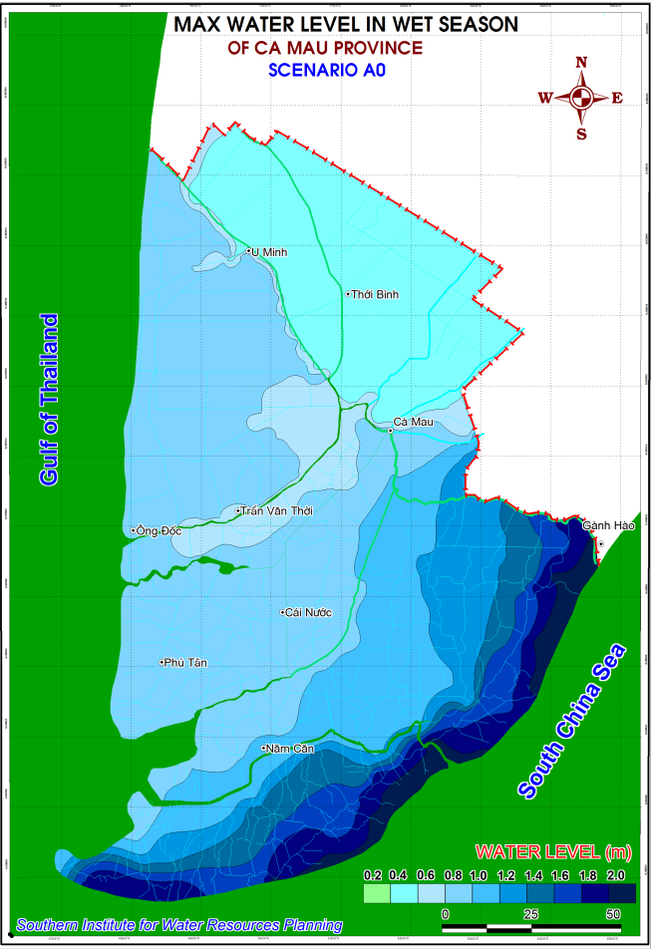

Scenario A1

Table 47: Effected areas by Max. Salinity intrusion within Ca Mau province
Levels | EFFECTED AREAS BY MAX. SALINITY INTRUSION OF SCENARIO A1 (km2)
Levels | Jan | Feb | Mar | Apr | May | Jun | Dry season | %
S = 0 - 4 g/l | 1,488.53 | 1,466.73 | 1,464.33 | 1,467.50 | 1,476.82 | 1,527.78 | 1,460.47 | 26.6
S = 4 - 8 g/l | 70.67 | 45.03 | 43.85 | 46.69 | 55.18 | 51.46 | 42.92 | 0.8
S = 8 - 12 g/l | 43.04 | 39.69 | 38.10 | 45.66 | 228.83 | 230.14 | 36.29 | 0.7
S = 12 - 16 g/l | 76.92 | 51.44 | 42.16 | 152.21 | 203.76 | 150.67 | 38.64 | 0.7
S = 16 - 20 g/l | 166.71 | 47.57 | 94.16 | 151.14 | 92.33 | 118.37 | 54.45 | 1.0
S = 20 - 24 g/l | 1,903.03 | 414.72 | 356.45 | 117.06 | 61.94 | 300.92 | 275.96 | 5.0
S = 24 - 28 g/l | 1,748.45 | 1,953.79 | 699.30 | 281.87 | 197.40 | 677.37 | 293.51 | 5.3
S > 28 g/l | 0.00 | 1,478.36 | 2,759.00 | 3,235.23 | 3,181.08 | 2,440.63 | 3,295.10 | 59.9
Total | 5,497.34 | 5,497.34 | 5,497.34 | 5,497.34 | 5,497.34 | 5,497.34 | 5,497.34 | 100.0

Table 48: Max surface water areas within Ca Mau province
Level | Dry season |  | Wet season
Level | Area | % | Area | %
Z = 0.4 - 0.6m | 705.952 | 12.8 | 0.00 | 0.0
Z = 0.6 - 0.8m | 1541.88 | 28.0 | 988.762 | 18.0
Z = 0.8 - 1.0m | 1398.17 | 25.4 | 2167.69 | 39.4
Z = 1.0 - 1.2m | 673.394 | 12.2 | 977.536 | 17.8
Z = 1.2 - 1.4m | 290.572 | 5.3 | 389.685 | 7.1
Z = 1.4 - 1.6m | 258.91 | 4.7 | 258.782 | 4.7
Z = 1.6 - 1.8m | 239.39 | 5.1 | 255.714 | 4.7
Z = 1.8 - 2.0m | 389.075 | 6.3 | 270.365 | 4.9
Z > 2.0m | 0.00 | 0.0 | 188.805 | 3.4
Total | 5,497.34 | 100.0 | 5,497.34 | 100.0

Scenario A2

Table 49: Effected areas by Max. Salinity intrusion within Ca Mau province
Levels | EFFECTED AREAS BY MAX. SALINITY INTRUSION OF SCENARIO A2 (km2)
Levels | Jan | Feb | Mar | Apr | May | Jun | Dry season | %
S = 0 - 4 g/l | 1,489.24 | 1,472.28 | 1,472.47 | 1,474.61 | 1,481.88 | 1,530.05 | 1,465.92 | 26.7
S = 4 - 8 g/l | 72.20 | 49.41 | 52.15 | 57.65 | 63.91 | 53.02 | 46.65 | 0.8
S = 8 - 12 g/l | 46.28 | 48.55 | 195.35 | 232.85 | 243.06 | 187.63 | 43.99 | 0.8
S = 12 - 16 g/l | 115.68 | 147.98 | 186.77 | 140.79 | 152.82 | 148.77 | 134.85 | 2.5
S = 16 - 20 g/l | 167.83 | 249.94 | 99.82 | 103.14 | 84.28 | 185.28 | 147.06 | 2.7
S = 20 - 24 g/l | 1,864.06 | 617.24 | 164.07 | 117.22 | 132.14 | 432.99 | 245.41 | 4.5
S = 24 - 28 g/l | 1,742.05 | 1,506.84 | 305.52 | 170.55 | 212.89 | 601.76 | 198.44 | 3.6
S > 28 g/l | 0.00 | 1,405.10 | 3,021.18 | 3,200.53 | 3,126.37 | 2,357.84 | 3,215.03 | 58.5
Total | 5,497.34 | 5,497.34 | 5,497.34 | 5,497.34 | 5,497.34 | 5,497.34 | 5,497.34 | 100.0

Table 50: Max surface water areas within Ca Mau province
Level | Dry season |  | Wet season
Level | Area | % | Area | %
Z = 0.4 - 0.6m | 1,457.38 | 26.5 | 0.00 | 0.0
Z = 0.6 - 0.8m | 853.75 | 15.5 | 1,455.30 | 26.5
Z = 0.8 - 1.0m | 1,333.38 | 24.3 | 1,898.76 | 34.5
Z = 1.0 - 1.2m | 675.20 | 12.3 | 773.91 | 14.1
Z = 1.2 - 1.4m | 290.25 | 5.3 | 394.30 | 7.2
Z = 1.4 - 1.6m | 258.91 | 4.7 | 260.10 | 4.7
Z = 1.6 - 1.8m | 281.40 | 5.1 | 255.57 | 4.6
Z = 1.8 - 2.0m | 347.07 | 6.3 | 270.33 | 4.9
Z > 2.0m | 0.00 | 0.0 | 189.07 | 3.4
Total | 5,497.34 | 100.0 | 5,497.34 | 100.0

Scenario B1

Table 51: Effected areas by Max. Salinity intrusion within Ca Mau province
Levels | EFFECTED AREAS BY MAX. SALINITY INTRUSION OF SCENARIO B1 (km2)
Levels | Jan | Feb | Mar | Apr | May | Jun | Dry season | %
S = 0 - 4 g/l | 1,485.56 | 1,465.03 | 1,462.22 | 1,465.62 | 1,474.37 | 1,524.94 | 1,458.98 | 26.5
S = 4 - 8 g/l | 68.96 | 44.99 | 43.54 | 45.42 | 52.28 | 48.59 | 42.76 | 0.8
S = 8 - 12 g/l | 39.43 | 39.15 | 37.01 | 41.02 | 66.49 | 159.62 | 35.64 | 0.6
S = 12 - 16 g/l | 37.54 | 50.25 | 39.58 | 63.79 | 360.27 | 278.03 | 50.78 | 0.9
S = 16 - 20 g/l | 119.41 | 41.55 | 51.81 | 225.10 | 114.33 | 111.59 | 33.94 | 0.6
S = 20 - 24 g/l | 1,605.53 | 526.11 | 367.74 | 143.22 | 59.78 | 173.53 | 216.02 | 3.9
S = 24 - 28 g/l | 2,140.90 | 1,795.83 | 663.03 | 272.66 | 183.58 | 696.41 | 335.53 | 6.1
S > 28 g/l | 0.00 | 1,534.43 | 2,832.42 | 3,240.52 | 3,186.23 | 2,504.64 | 3,323.69 | 60.5
Total | 5,497.34 | 5,497.34 | 5,497.34 | 5,497.34 | 5,497.34 | 5,497.34 | 5,497.34 | 100.0

Table 52: Max surface water areas within Ca Mau province
Level | Dry season |  | Wet season
Level | Area | % | Area | %
Z = 0.4 - 0.6m | 631.40 | 11.5 | 0.00 | 0.0
Z = 0.6 - 0.8m | 825.33 | 15.0 | 0.00 | 0.0
Z = 0.8 - 1.0m | 831.13 | 15.1 | 804.36 | 14.6
Z = 1.0 - 1.2m | 1,301.44 | 23.7 | 2,287.80 | 41.6
Z = 1.2 - 1.4m | 678.67 | 12.3 | 941.27 | 17.1
Z = 1.4 - 1.6m | 303.76 | 5.5 | 465.30 | 8.5
Z = 1.6 - 1.8m | 237.80 | 4.3 | 237.98 | 4.3
Z = 1.8 - 2.0m | 253.29 | 4.6 | 268.07 | 4.9
Z > 2.0m | 434.52 | 7.9 | 492.57 | 9.0
Total | 5,497.34 | 100.0 | 5,497.34 | 100.0

Scenario B2

Table 53: Effected areas by Max. Salinity intrusion within Ca Mau province
Levels | EFFECTED AREAS BY MAX. SALINITY INTRUSION OF SCENARIO B2 (km2)
Levels | Jan | Feb | Mar | Apr | May | Jun | Dry season | %
S = 0 - 4 g/l | 1,480.03 | 1,454.99 | 1,453.63 | 1,457.26 | 1,466.51 | 1,517.15 | 1,447.53 | 26.3
S = 4 - 8 g/l | 70.95 | 49.50 | 47.10 | 47.70 | 53.44 | 50.06 | 48.34 | 0.9
S = 8 - 12 g/l | 39.09 | 40.83 | 38.28 | 40.33 | 61.32 | 45.43 | 37.71 | 0.7
S = 12 - 16 g/l | 35.43 | 44.19 | 40.25 | 45.81 | 314.49 | 414.76 | 38.53 | 0.7
S = 16 - 20 g/l | 63.64 | 51.54 | 52.73 | 205.24 | 185.62 | 121.37 | 49.77 | 0.9
S = 20 - 24 g/l | 1,712.58 | 974.42 | 388.72 | 246.64 | 64.71 | 165.54 | 203.95 | 3.7
S = 24 - 28 g/l | 2,095.61 | 1,286.26 | 658.55 | 216.03 | 165.98 | 733.68 | 337.13 | 6.1
S > 28 g/l | 0.00 | 1,595.60 | 2,818.09 | 3,238.34 | 3,185.29 | 2,449.36 | 3,334.39 | 60.7
Total | 5,497.34 | 5,497.34 | 5,497.34 | 5,497.34 | 5,497.34 | 5,497.34 | 5,497.34 | 100.0

Table 54: Max surface water areas within Ca Mau province
Level | Dry season |  | Wet season
Level | Area | % | Area | %
Z = 0.6 - 0.8m | 652.22 | 11.9 | 0.00 | 0.0
Z = 0.8 - 1.0m | 831.60 | 15.1 | 0.00 | 0.0
Z = 1.0 - 1.2m | 780.42 | 14.2 | 1,021.39 | 18.6
Z = 1.2 - 1.4m | 1,234.71 | 22.5 | 1,799.56 | 32.7
Z = 1.4 - 1.6m | 663.05 | 12.1 | 1,084.32 | 19.7
Z = 1.6 - 1.8m | 409.31 | 7.4 | 616.89 | 11.2
Z = 1.8 - 2.0m | 240.14 | 4.4 | 223.51 | 4.1
Z > 2.0m | 685.90 | 12.5 | 751.67 | 13.7
Total | 5,497.34 | 100.0 | 5,497.34 | 100.0

Scenario B3

Table 55: Effected areas by Max. Salinity intrusion within Ca Mau province
Levels | EFFECTED AREAS BY MAX. SALINITY INTRUSION OF SCENARIO B3 (km2)
Levels | Jan | Feb | Mar | Apr | May | Jun | Dry season | %
S = 0 - 4 g/l | 1,485.83 | 1,468.74 | 1,468.27 | 1,470.31 | 1,479.33 | 1,529.86 | 1,463.04 | 26.6
S = 4 - 8 g/l | 69.55 | 46.58 | 46.57 | 49.32 | 56.80 | 51.41 | 44.61 | 0.8
S = 8 - 12 g/l | 40.01 | 41.91 | 43.21 | 59.58 | 203.23 | 179.24 | 38.62 | 0.7
S = 12 - 16 g/l | 39.24 | 56.54 | 130.40 | 317.19 | 218.11 | 174.89 | 43.63 | 0.8
S = 16 - 20 g/l | 137.81 | 142.58 | 302.62 | 134.05 | 96.49 | 194.63 | 139.24 | 2.5
S = 20 - 24 g/l | 1,915.67 | 888.61 | 221.09 | 128.84 | 125.98 | 258.15 | 334.98 | 6.1
S = 24 - 28 g/l | 1,809.23 | 1,395.88 | 260.89 | 132.28 | 187.48 | 719.93 | 200.19 | 3.6
S > 28 g/l | 0.00 | 1,456.49 | 3,024.30 | 3,205.76 | 3,129.91 | 2,389.23 | 3,233.04 | 58.8
Total | 5,497.34 | 5,497.34 | 5,497.34 | 5,497.34 | 5,497.34 | 5,497.34 | 5,497.34 | 100.0

Table 56: Max surface water areas within Ca Mau province
Level | Dry season |  | Wet season
Level | Area | % | Area | %
Z = 0.6 - 0.8m | 1,460.67 | 26.6 | 0.00 | 0.0
Z = 0.8 - 1.0m | 805.22 | 14.6 | 1,420.06 | 25.8
Z = 1.0 - 1.2m | 1,323.78 | 24.1 | 1,699.84 | 30.9
Z = 1.2 - 1.4m | 678.25 | 12.3 | 904.76 | 16.5
Z = 1.4 - 1.6m | 303.75 | 5.5 | 473.54 | 8.6
Z = 1.6 - 1.8m | 237.68 | 4.3 | 238.50 | 4.3
Z = 1.8 - 2.0m | 253.46 | 4.6 | 267.64 | 4.9
Z > 2.0m | 434.54 | 7.9 | 493.01 | 9.0
Total | 5,497.34 | 100.0 | 5,497.34 | 100.0

Scenario B4

Table 57: Effected areas by Max. Salinity intrusion within Ca Mau province
Levels | EFFECTED AREAS BY MAX. SALINITY INTRUSION OF SCENARIO B4 (km2)
Levels | Jan | Feb | Mar | Apr | May | Jun | Dry season | %
S = 0 - 4 g/l | 1,483.65 | 1,466.37 | 1,465.62 | 1,466.87 | 1,475.99 | 1,526.55 | 1,461.04 | 26.6
S = 4 - 8 g/l | 68.85 | 45.46 | 44.66 | 45.84 | 52.60 | 47.47 | 43.62 | 0.8
S = 8 - 12 g/l | 38.33 | 39.98 | 39.23 | 42.04 | 66.16 | 66.79 | 36.89 | 0.7
S = 12 - 16 g/l | 34.76 | 52.02 | 57.43 | 139.46 | 332.07 | 312.40 | 53.25 | 1.0
S = 16 - 20 g/l | 57.56 | 47.39 | 302.31 | 303.67 | 121.69 | 196.56 | 39.89 | 0.7
S = 20 - 24 g/l | 1,821.10 | 1,158.06 | 310.09 | 174.48 | 132.77 | 159.94 | 355.16 | 6.5
S = 24 - 28 g/l | 1,993.10 | 1,101.80 | 241.22 | 119.67 | 184.43 | 623.83 | 264.55 | 4.8
S > 28 g/l | 0.00 | 1,586.27 | 3,036.88 | 3,205.31 | 3,131.62 | 2,563.81 | 3,242.94 | 59.0
Total | 5,497.34 | 5,497.34 | 5,497.34 | 5,497.34 | 5,497.34 | 5,497.34 | 5,497.34 | 100.0

Table 58: Max surface water areas within Ca Mau province
Level | Dry season |  | Wet season
Level | Area | % | Area | %
Z = 0.8 - 1.0m | 1,635.59 | 29.8 | 0.00 | 0.0
Z = 1.0 - 1.2m | 668.13 | 12.2 | 1,414.85 | 25.7
Z = 1.2 - 1.4m | 1,228.32 | 22.3 | 1,444.04 | 26.3
Z = 1.4 - 1.6m | 742.20 | 13.5 | 1,107.64 | 20.1
Z = 1.6 - 1.8m | 308.57 | 5.6 | 550.78 | 10.0
Z = 1.8 - 2.0m | 237.66 | 4.3 | 243.65 | 4.4
Z > 2.0m | 676.88 | 12.3 | 736.38 | 13.4
Total | 5,497.34 | 100.0 | 5,497.34 | 100.0

Scenario C1

Table 59: Effected areas by Max. Salinity intrusion within Ca Mau province
Levels | EFFECTED AREAS BY MAX. SALINITY INTRUSION OF SCENARIO C1 (km2)
Levels | Jan | Feb | Mar | Apr | May | Jun | Dry season | %
S = 0 - 4 g/l | 1,488.50 | 1,466.69 | 1,464.31 | 1,530.05 | 1,476.61 | 1,528.11 | 1,460.42 | 26.6
S = 4 - 8 g/l | 70.64 | 45.01 | 43.81 | 187.63 | 54.84 | 51.92 | 42.89 | 0.8
S = 8 - 12 g/l | 42.98 | 39.65 | 38.04 | 148.77 | 222.23 | 233.36 | 36.25 | 0.7
S = 12 - 16 g/l | 76.30 | 51.41 | 42.05 | 185.28 | 210.03 | 149.93 | 38.57 | 0.7
S = 16 - 20 g/l | 166.07 | 47.13 | 86.12 | 2,357.84 | 92.46 | 118.19 | 54.01 | 1.0
S = 20 - 24 g/l | 1,904.21 | 378.91 | 362.95 | 53.02 | 62.19 | 312.97 | 275.21 | 5.0
S = 24 - 28 g/l | 1,748.64 | 1,985.34 | 694.83 | 432.99 | 188.97 | 682.60 | 284.72 | 5.2
S > 28 g/l | 0.00 | 1,483.19 | 2,765.24 | 601.76 | 3,190.01 | 2,420.25 | 3,305.26 | 60.1
Total | 5,497.34 | 5,497.34 | 5,497.34 | 5,497.34 | 5,497.34 | 5,497.34 | 5,497.34 | 100.0

Table 60: Max surface water areas within Ca Mau province
Level | Dry season |  | Wet season
Level | Area | % | Area | %
Z = 0.4 - 0.6m | 761.99 | 13.9 | 0.00 | 0.0
Z = 0.6 - 0.8m | 1,504.13 | 27.4 | 1,000.75 | 18.2
Z = 0.8 - 1.0m | 1,379.88 | 25.1 | 1,766.66 | 32.1
Z = 1.0 - 1.2m | 673.39 | 12.2 | 1,357.35 | 24.7
Z = 1.2 - 1.4m | 290.57 | 5.3 | 398.91 | 7.3
Z = 1.4 - 1.6m | 258.91 | 4.7 | 258.78 | 4.7
Z = 1.6 - 1.8m | 281.40 | 5.1 | 255.72 | 4.7
Z = 1.8 - 2.0m | 347.07 | 6.3 | 270.36 | 4.9
Z > 2.0m | 0.00 | 0.0 | 188.81 | 3.4
Total | 5,497.34 | 100.0 | 5,497.34 | 100.0

Scenario C2

Table 61: Effected areas by Max. Salinity intrusion within Ca Mau province
Levels | EFFECTED AREAS BY MAX. SALINITY INTRUSION OF SCENARIO C2 (km2)
Levels | Jan | Feb | Mar | Apr | May | Jun | Dry season | %
S = 0 - 4 g/l | 1,489.44 | 1,472.27 | 1,472.18 | 1,473.93 | 1,481.36 | 1,529.91 | 1,465.41 | 26.7
S = 4 - 8 g/l | 71.82 | 49.31 | 51.89 | 56.75 | 62.60 | 52.98 | 46.48 | 0.8
S = 8 - 12 g/l | 46.03 | 48.28 | 167.57 | 223.67 | 234.01 | 185.04 | 43.62 | 0.8
S = 12 - 16 g/l | 114.57 | 145.91 | 212.43 | 145.85 | 158.78 | 148.23 | 133.62 | 2.4
S = 16 - 20 g/l | 164.41 | 248.38 | 98.93 | 103.46 | 82.94 | 178.86 | 145.00 | 2.6
S = 20 - 24 g/l | 1,865.01 | 603.09 | 159.81 | 117.86 | 124.69 | 432.22 | 244.73 | 4.5
S = 24 - 28 g/l | 1,746.07 | 1,514.30 | 288.68 | 176.19 | 199.03 | 605.22 | 200.15 | 3.6
S > 28 g/l | 0.00 | 1,415.80 | 3,045.86 | 3,199.63 | 3,153.95 | 2,364.88 | 3,218.33 | 58.5
Total | 5,497.34 | 5,497.34 | 5,497.34 | 5,497.34 | 5,497.34 | 5,497.34 | 5,497.34 | 100.0

Table 62: Max surface water areas within Ca Mau province
Level | Dry season |  | Wet season
Level | Area | % | Area | %
Z = 0.4 - 0.6m | 1,479.75 | 26.9 | 0.00 | 0.0
Z = 0.6 - 0.8m | 831.54 | 15.1 | 1,448.26 | 26.3
Z = 0.8 - 1.0m | 1,333.23 | 24.3 | 1,905.81 | 34.7
Z = 1.0 - 1.2m | 675.19 | 12.3 | 773.52 | 14.1
Z = 1.2 - 1.4m | 290.26 | 5.3 | 394.69 | 7.2
Z = 1.4 - 1.6m | 258.91 | 4.7 | 260.10 | 4.7
Z = 1.6 - 1.8m | 281.40 | 5.1 | 255.57 | 4.6
Z = 1.8 - 2.0m | 347.07 | 6.3 | 270.33 | 4.9
Z > 2.0m | 0.00 | 0.0 | 189.07 | 3.4
Total | 5,497.34 | 100.0 | 5,497.34 | 100.0

Scenario D1

Table 63: Effected areas by Max. Salinity intrusion within Ca Mau province
Levels | EFFECTED AREAS BY MAX. SALINITY INTRUSION OF SCENARIO D1 (km2)
Levels | Jan | Feb | Mar | Apr | May | Jun | Dry season | %
S = 0 - 4 g/l | 1,479.11 | 1,453.36 | 1,452.02 | 1,455.35 | 1,464.95 | 1,515.51 | 1,445.44 | 26.3
S = 4 - 8 g/l | 70.86 | 49.88 | 47.36 | 47.80 | 53.23 | 49.79 | 48.82 | 0.9
S = 8 - 12 g/l | 38.67 | 40.70 | 38.08 | 39.84 | 60.53 | 43.62 | 37.52 | 0.7
S = 12 - 16 g/l | 34.48 | 51.70 | 39.65 | 44.24 | 261.56 | 402.98 | 37.95 | 0.7
S = 16 - 20 g/l | 54.63 | 41.97 | 51.13 | 161.04 | 212.63 | 110.20 | 48.35 | 0.9
S = 20 - 24 g/l | 1,642.62 | 750.32 | 305.66 | 238.28 | 78.82 | 152.86 | 177.77 | 3.2
S = 24 - 28 g/l | 2,176.97 | 1,511.20 | 722.44 | 272.20 | 184.32 | 595.58 | 351.96 | 6.4
S > 28 g/l | 0.00 | 1,598.20 | 2,841.02 | 3,238.59 | 3,181.30 | 2,626.80 | 3,349.55 | 60.9
Total | 5,497.34 | 5,497.34 | 5,497.34 | 5,497.34 | 5,497.34 | 5,497.34 | 5,497.34 | 100.0

Table 64: Max surface water areas within Ca Mau province
Level | Dry season |  | Wet season
Level | Area | % | Area | %
Z = 0.6 - 0.8m | 646.79 | 11.8 | 0.00 | 0.0
Z = 0.8 - 1.0m | 840.92 | 15.3 | 0.00 | 0.0
Z = 1.0 - 1.2m | 819.13 | 14.9 | 765.98 | 13.9
Z = 1.2 - 1.4m | 1,225.80 | 22.3 | 2,127.84 | 38.7
Z = 1.4 - 1.6m | 741.60 | 13.5 | 1,077.29 | 19.6
Z = 1.6 - 1.8m | 308.56 | 5.6 | 535.67 | 9.7
Z = 1.8 - 2.0m | 237.65 | 4.3 | 202.56 | 3.7
Z > 2.0m | 676.89 | 12.3 | 788.01 | 14.3
Total | 5,497.34 | 100.0 | 5,497.34 | 100.0

Scenario D2

Table 65: Effected areas by Max. Salinity intrusion within Ca Mau province
Levels | EFFECTED AREAS BY MAX. SALINITY INTRUSION OF SCENARIO D2 (km2)
Levels | Jan | Feb | Mar | Apr | May | Jun | Dry season | %
S = 0 - 4 g/l | 1,483.69 | 1,466.39 | 1,465.57 | 1,466.96 | 1,475.99 | 1,526.68 | 1,461.09 | 26.6
S = 4 - 8 g/l | 68.81 | 45.44 | 44.65 | 45.83 | 52.58 | 47.52 | 43.62 | 0.8
S = 8 - 12 g/l | 38.33 | 39.97 | 39.22 | 42.05 | 66.14 | 66.92 | 36.89 | 0.7
S = 12 - 16 g/l | 34.76 | 52.01 | 57.41 | 139.30 | 331.46 | 313.39 | 53.17 | 1.0
S = 16 - 20 g/l | 57.55 | 47.35 | 302.29 | 303.88 | 122.79 | 199.32 | 40.00 | 0.7
S = 20 - 24 g/l | 1,803.86 | 1,157.71 | 319.60 | 174.87 | 137.59 | 159.05 | 355.68 | 6.5
S = 24 - 28 g/l | 2,010.35 | 1,102.19 | 231.62 | 123.15 | 183.16 | 625.01 | 247.83 | 4.5
S > 28 g/l | 0.00 | 1,586.28 | 3,036.99 | 3,201.31 | 3,127.62 | 2,559.46 | 3,259.07 | 59.3
Total | 5,497.34 | 5,497.34 | 5,497.34 | 5,497.34 | 5,497.34 | 5,497.34 | 5,497.34 | 100.0

Table 66: Max surface water areas within Ca Mau province
Level | Dry season |  | Wet season
Level | Area | % | Area | %
Z = 0.8 - 1.0m | 1,629.76 | 29.6 | 0.00 | 0.0
Z = 1.0 - 1.2m | 656.03 | 11.9 | 1,408.33 | 25.6
Z = 1.2 - 1.4m | 1,246.25 | 22.7 | 1,450.27 | 26.4
Z = 1.4 - 1.6m | 742.20 | 13.5 | 1,107.19 | 20.1
Z = 1.6 - 1.8m | 294.42 | 5.4 | 540.64 | 9.8
Z = 1.8 - 2.0m | 251.81 | 4.6 | 202.53 | 3.7
Z > 2.0m | 676.88 | 12.3 | 788.38 | 14.3
Total | 5,497.34 | 100.0 | 5,497.34 | 100.0

ASSESSMENTS ON SIMULATED RESULTS
  - Assessment of the Water resources planning Scenarios

Impact to salinity intrusion
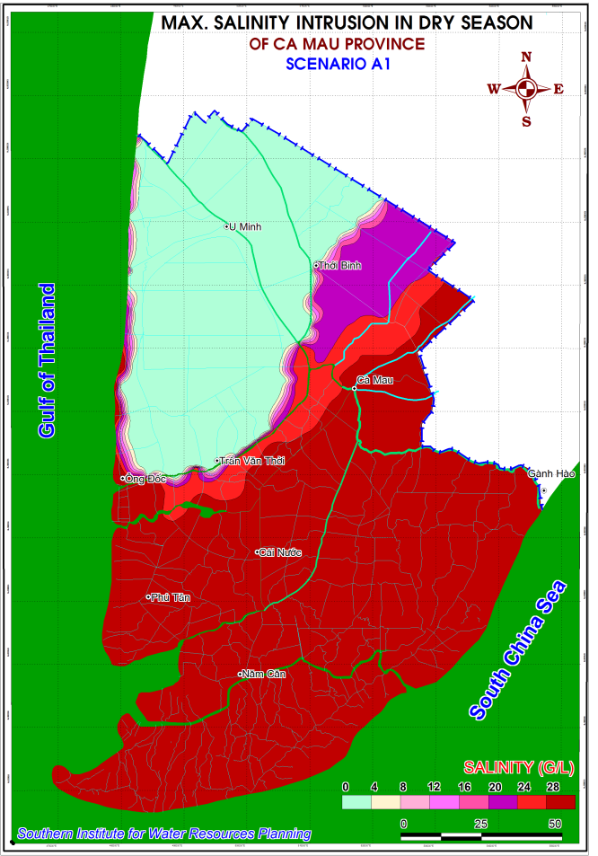  Max. Salinity intrusion in Dry season - Sce. A1 | 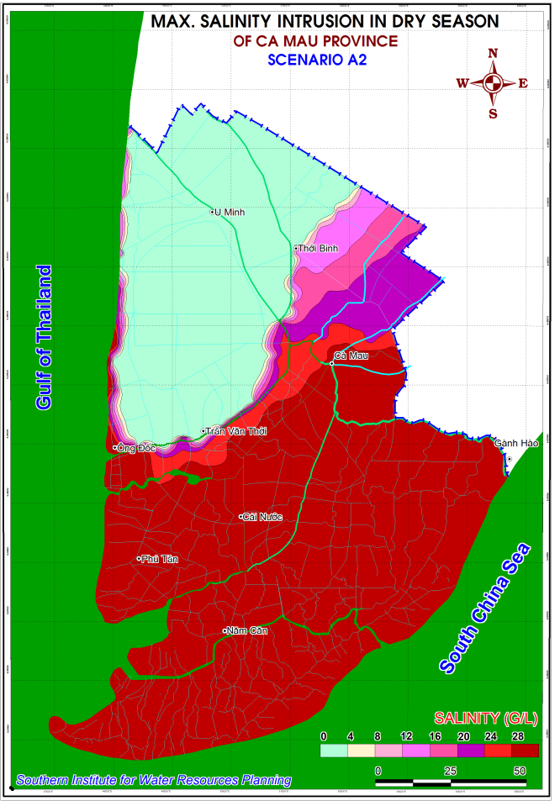  Max. Salinity intrusion in Dry season - Sce. A2

Figure 26: Max. Salinity intrusion – Scenario A1 & A2

Impact to water level
- In dry season:
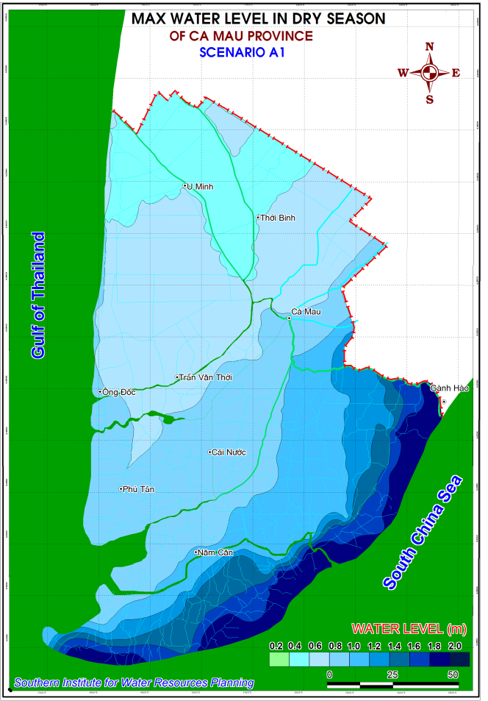  Max. Water level in Dry season – Sce. A1 | 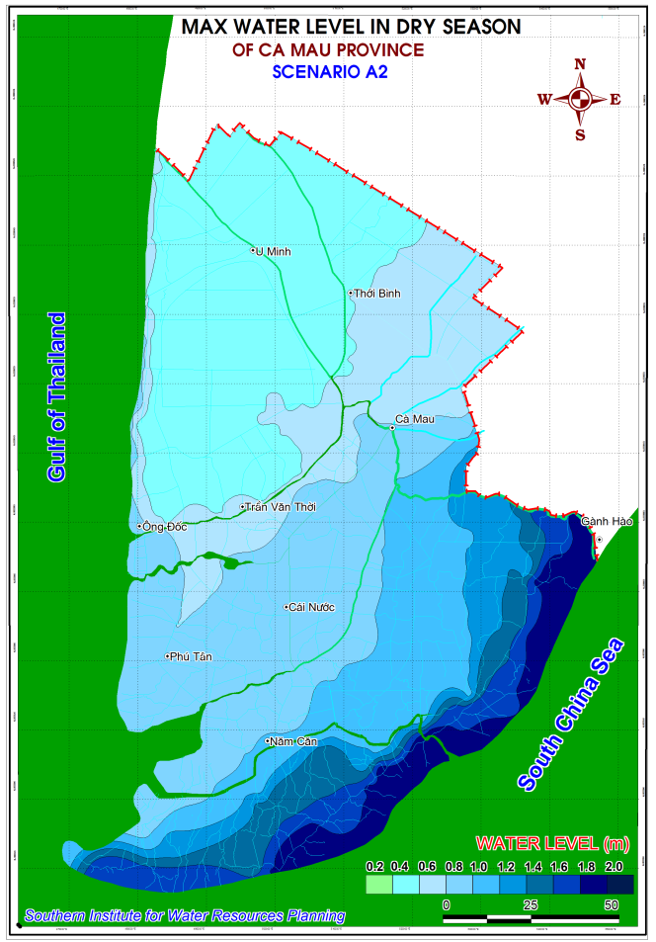  Max. Water level in Dry season – Sce. A2

Figure 27: Max. Water level in dry season– Scenario A1 & A2
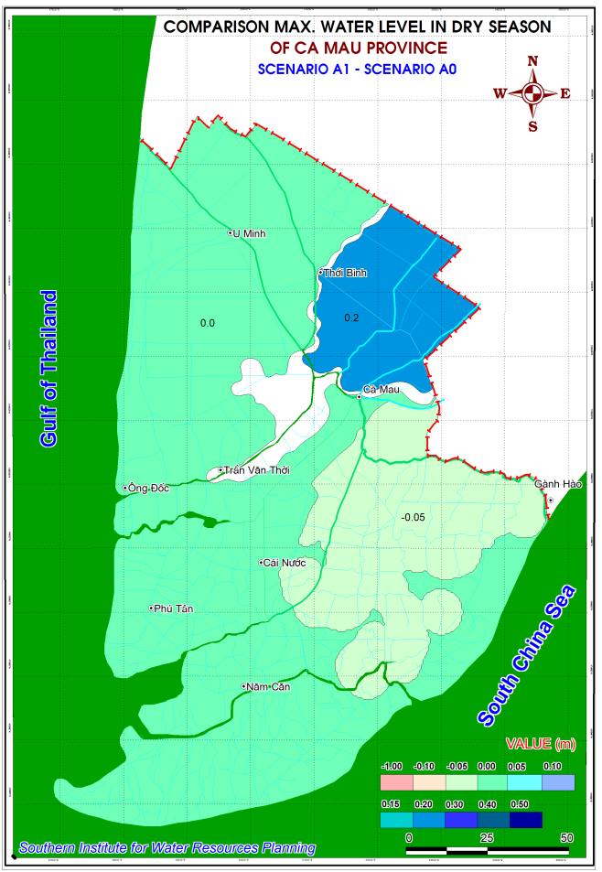  Comparison: A1 & A0 | 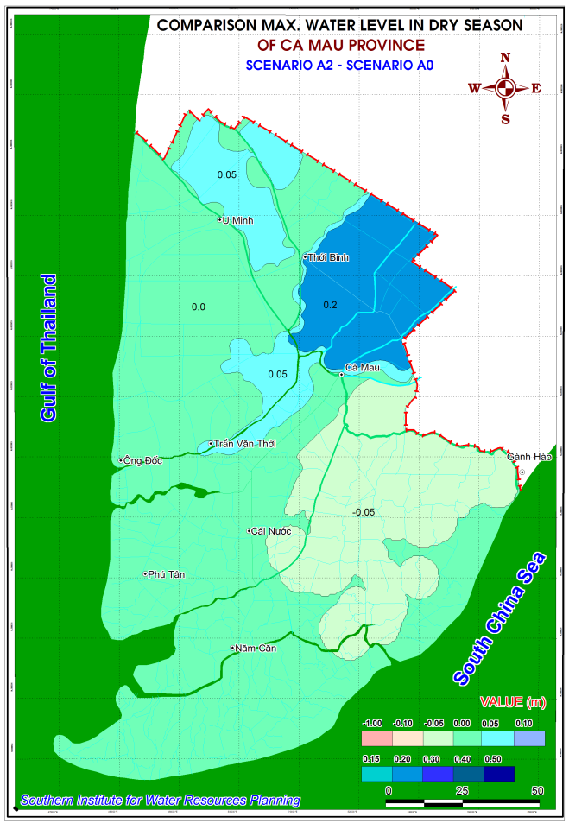  Comparison: A2 & A0

Figure 28: Changing of Max water level in dry season : A1-A0, A2-A0
- In wet season:
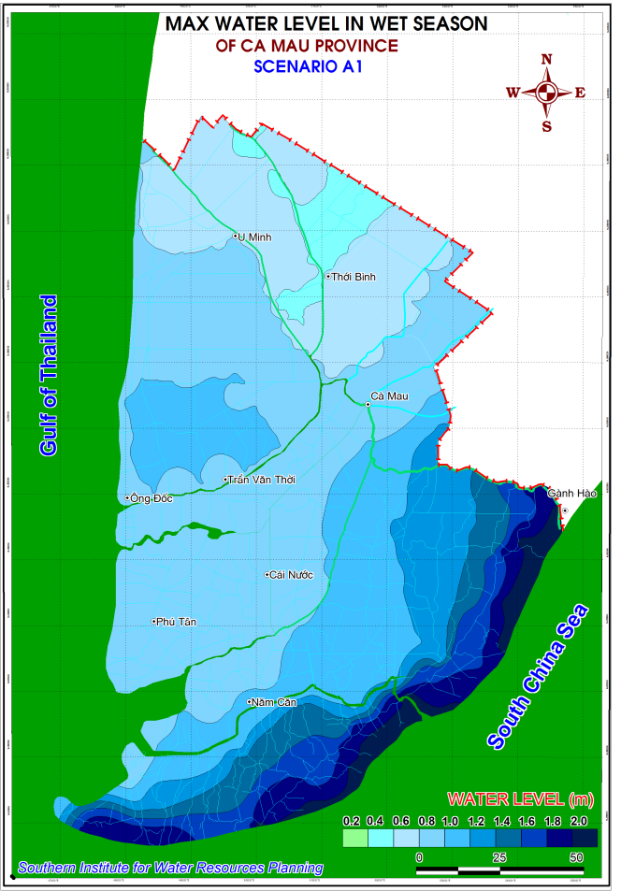  Max. Water level in Wet season – Sce. A1 | 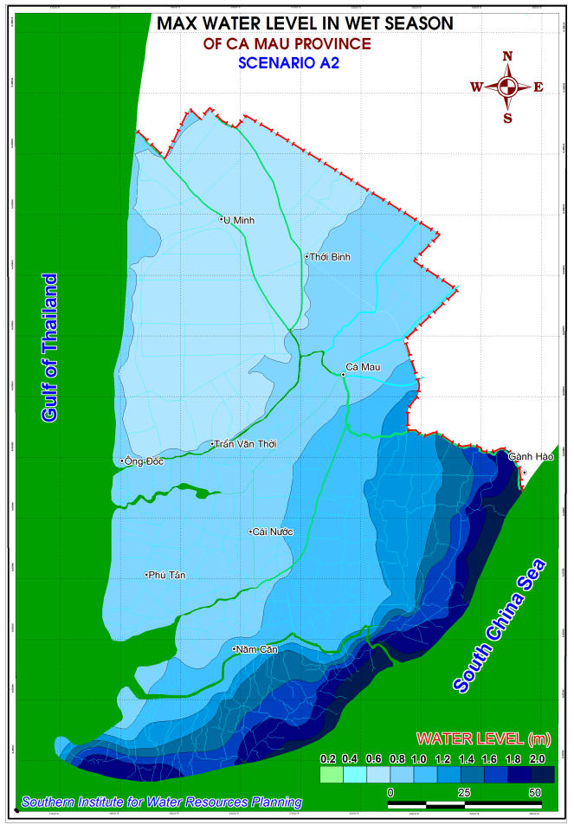  Max. Water level in Wet season – Sce. A2

Figure 29: Max. Water level in wet season – Scenario A1, A2
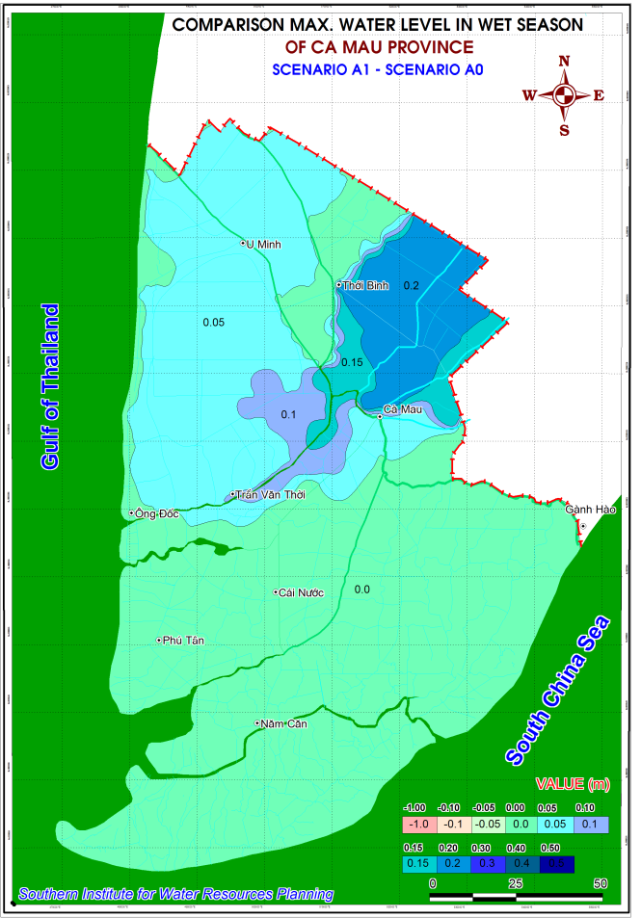  Comparison: A1 & A0 | 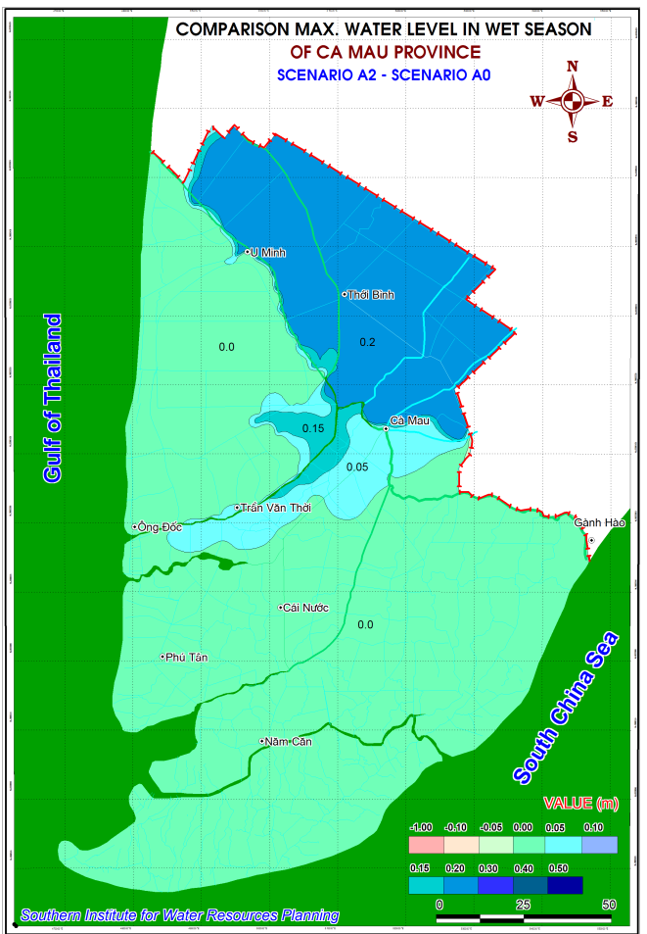  Comparison: A2 & A0

Figure 30: Changing of Max water level – Comparison: A2-A0, A1-A0
  - Assessment of the Sea level rise Scenarios

Impact of sea level rise to salinity intrusion
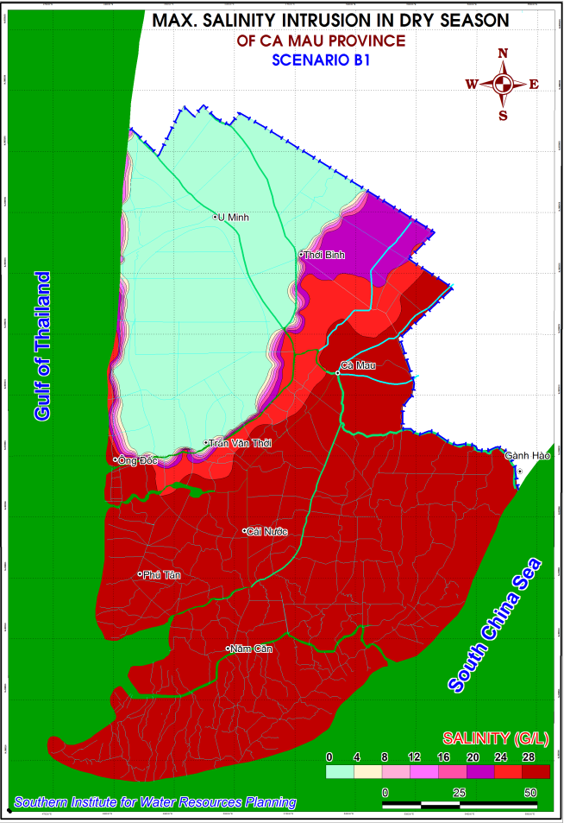 | 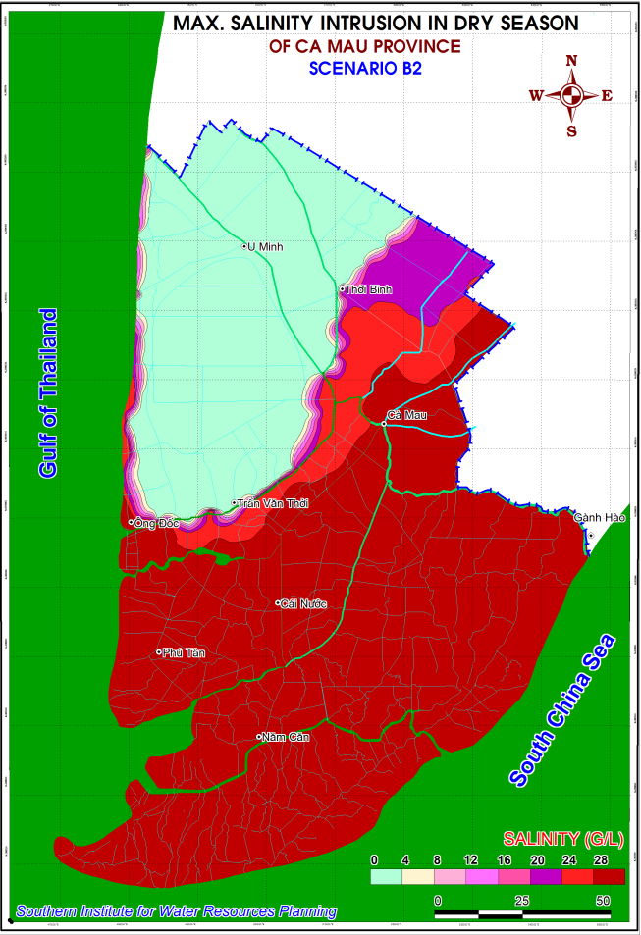

Figure 31: Max. Salinity intrusion – Scenario B1 & B2
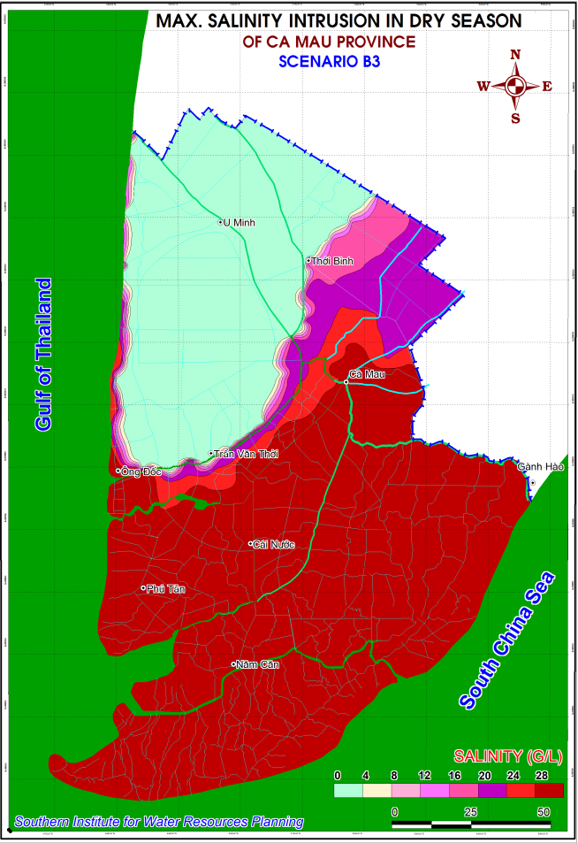 | 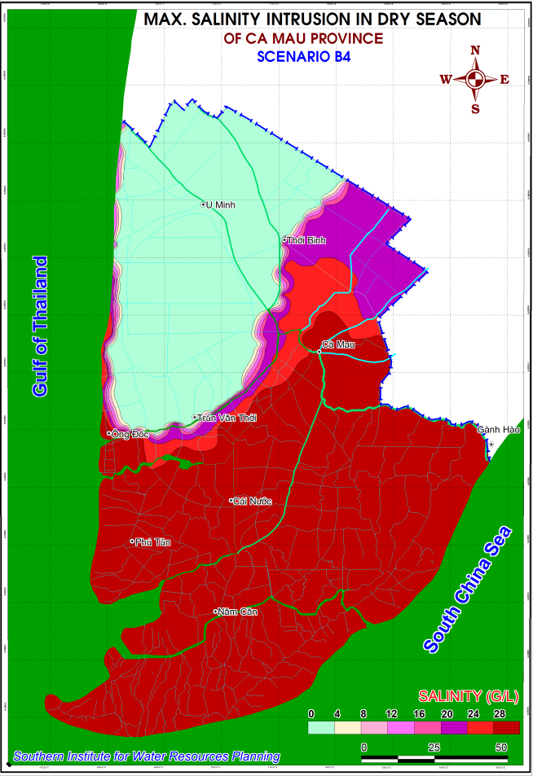

Figure 32: Max. Salinity intrusion – Scenario B3 & B4

Impact of sea level rise to water level
- In dry season:
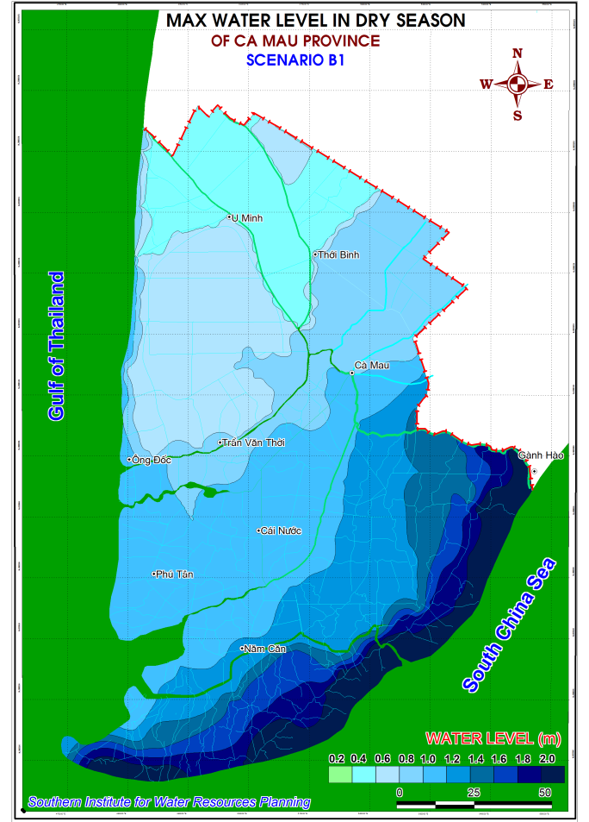  Max. Water level in Dry season – Sce. B1 | 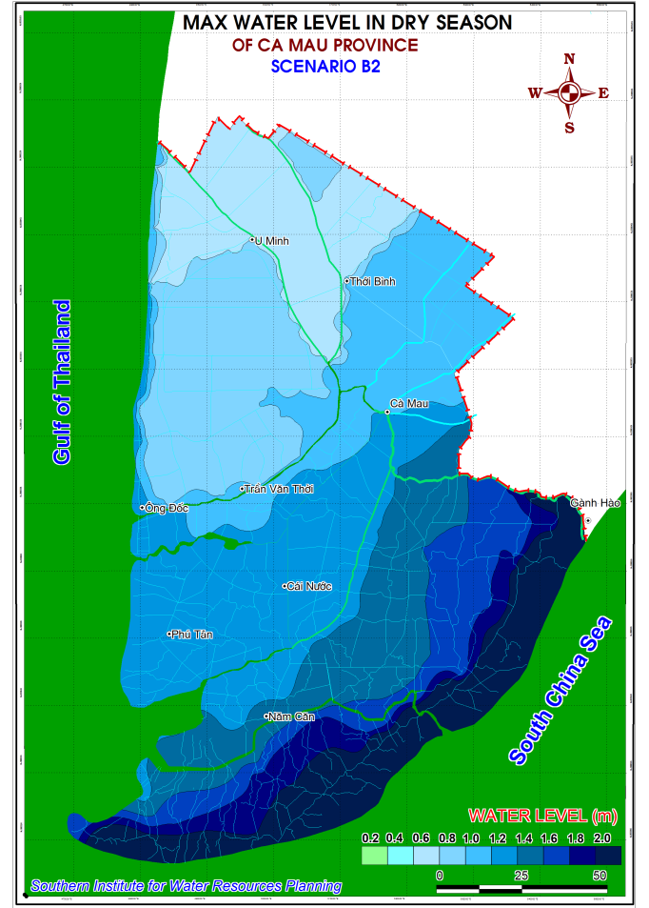  Max. Water level in Dry season – Sce. B2

Figure 33: Max. Water level in Dry season – Scenario B1, B2
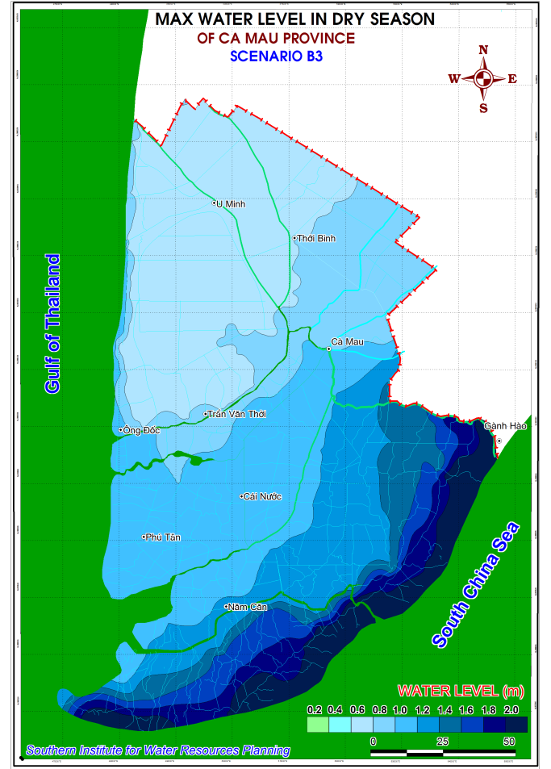  Max. Water level in Dry season – Sce. B3 | 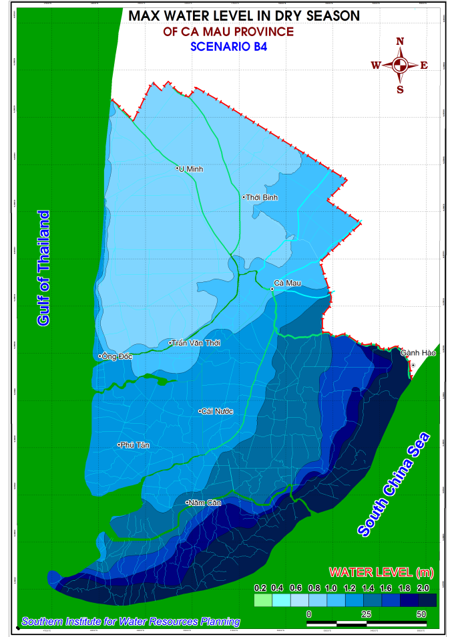  Max. Water level in Dryt season – Sce. B4

Figure 34: Max. Water level in Dry season – Scenario B3, B4
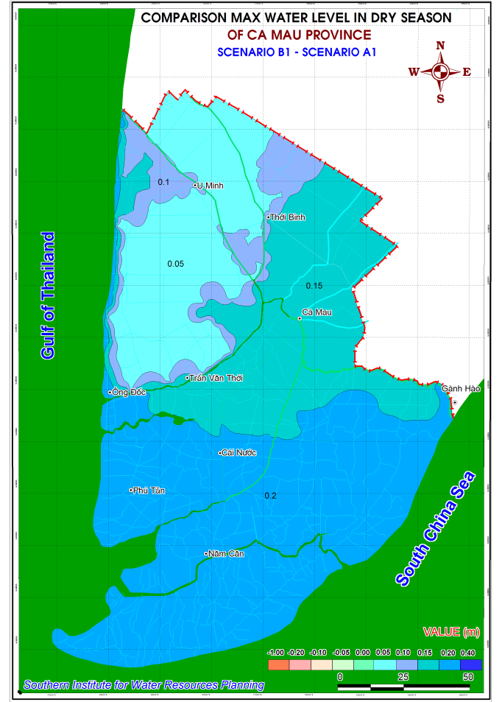  Comparison: B1 & A1 in dry season | 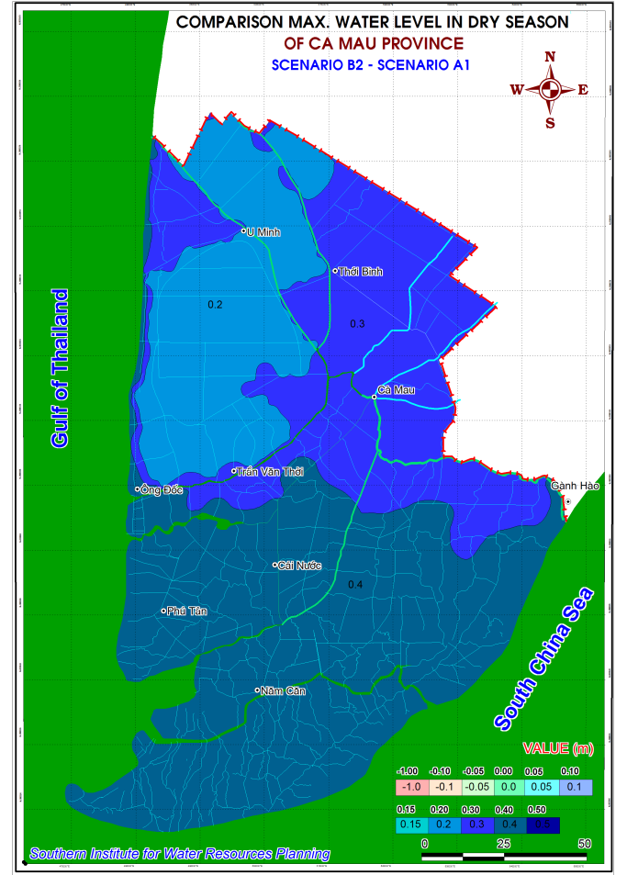  Comparison: B2 & A1 in dry season

Figure 35: Changing of Max water level – Comparison: B1-A1, B2-A1
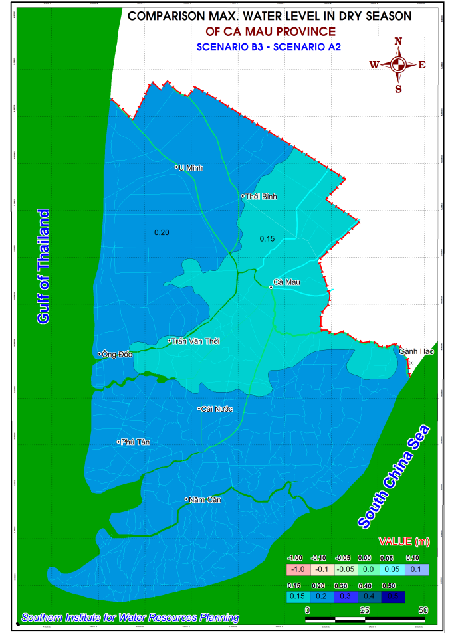  Comparison: B3 & A2 in dry season | 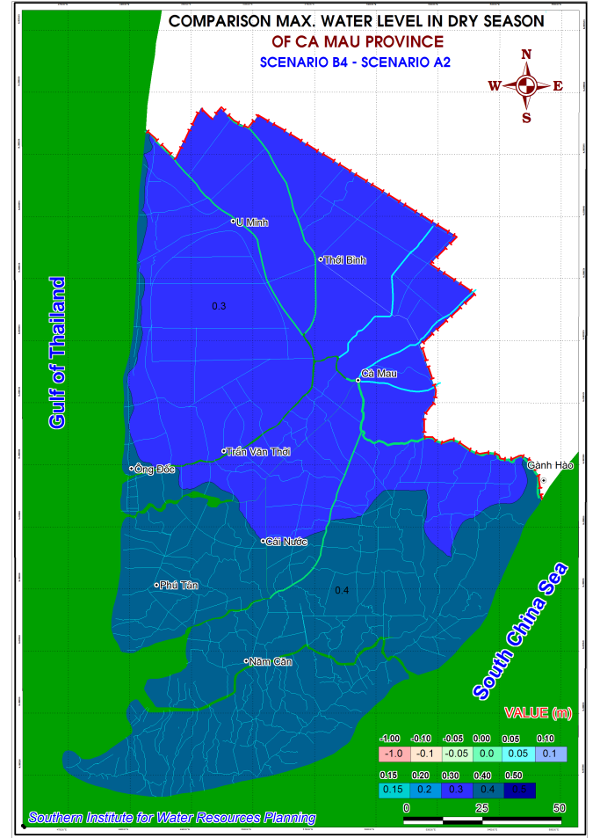  Comparison: B4 & A2 in dry season

Figure 36: Changing of Max water level – Comparison: B3-A2, B4-A2
- In wet season:
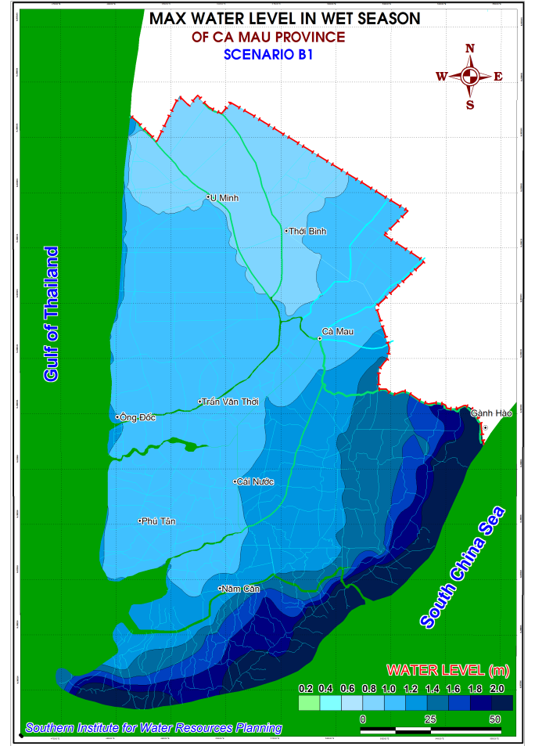  Max. Water level in Wet season – Sce. B1 | 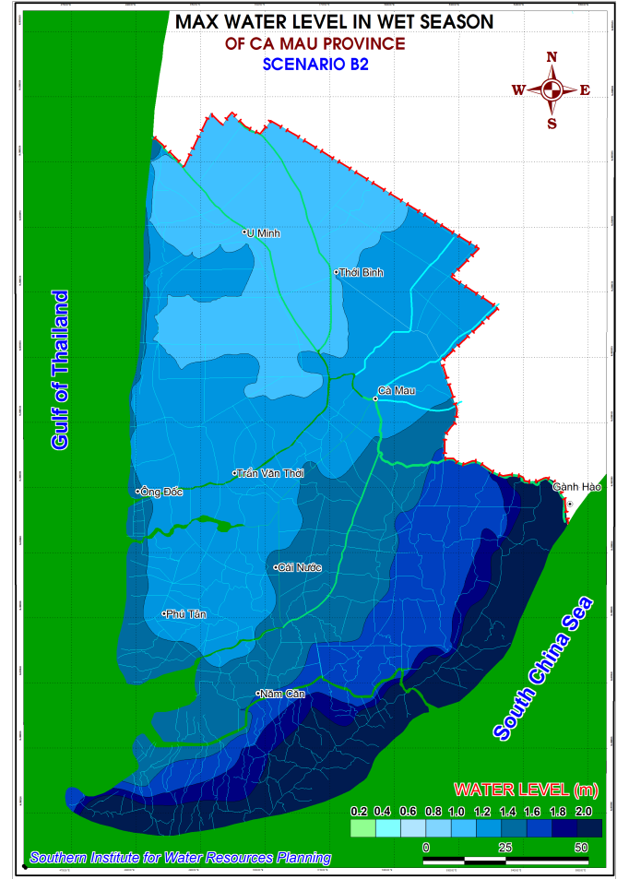  Max. Water level in Wet season – Sce. B2

Figure 37: Max. Water level in wet season – Scenario B1, B2
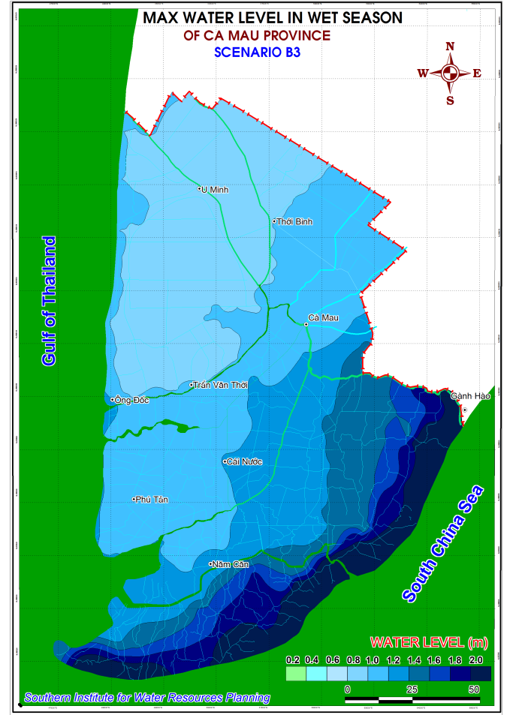  Max. Water level in Wet season – Sce. B3 | 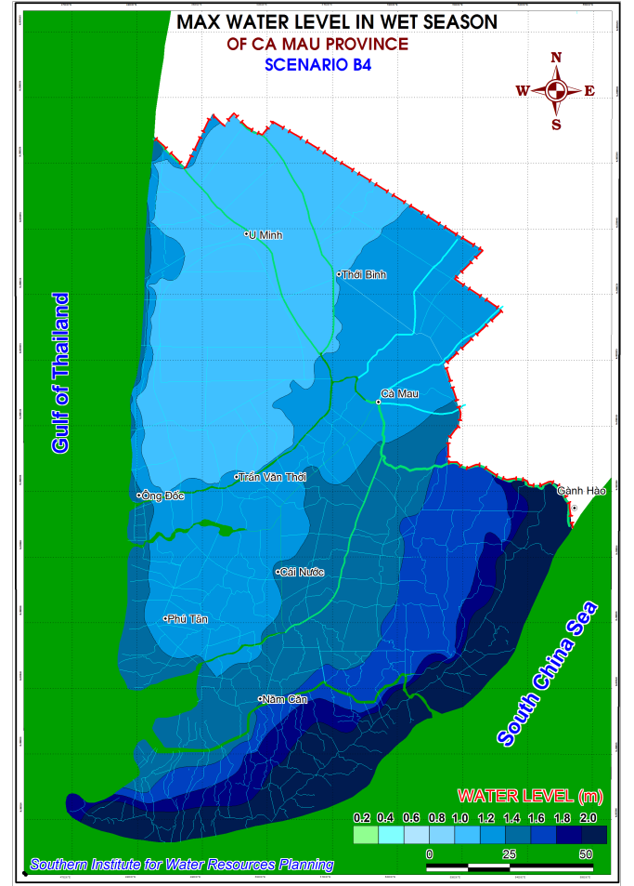  Max. Water level in Wet season – Sce. B4

Figure 38: Max. Water level in wet season – Scenario B3, B4
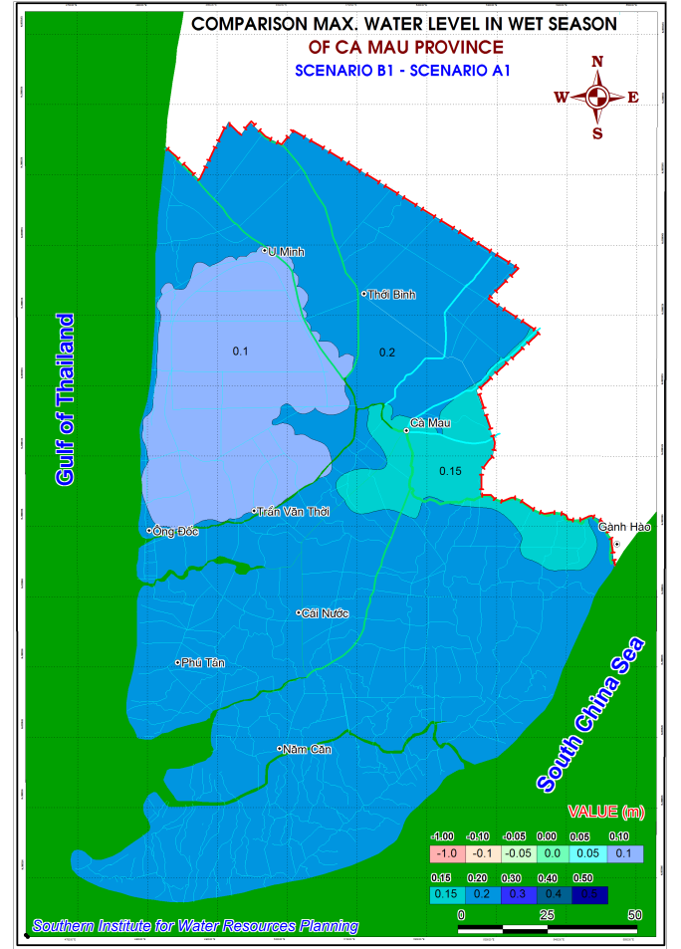  Comparison: B1 & A1 in wet season | 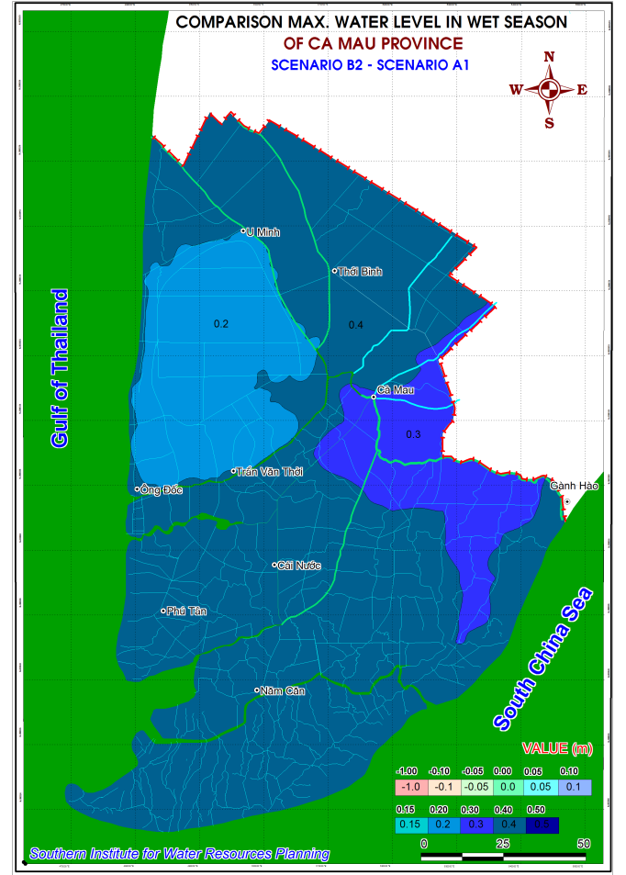  Comparison: B2 & A1 in wet season

Figure 39: Changing of Max water level – Comparison: B1-A1, B2-A1
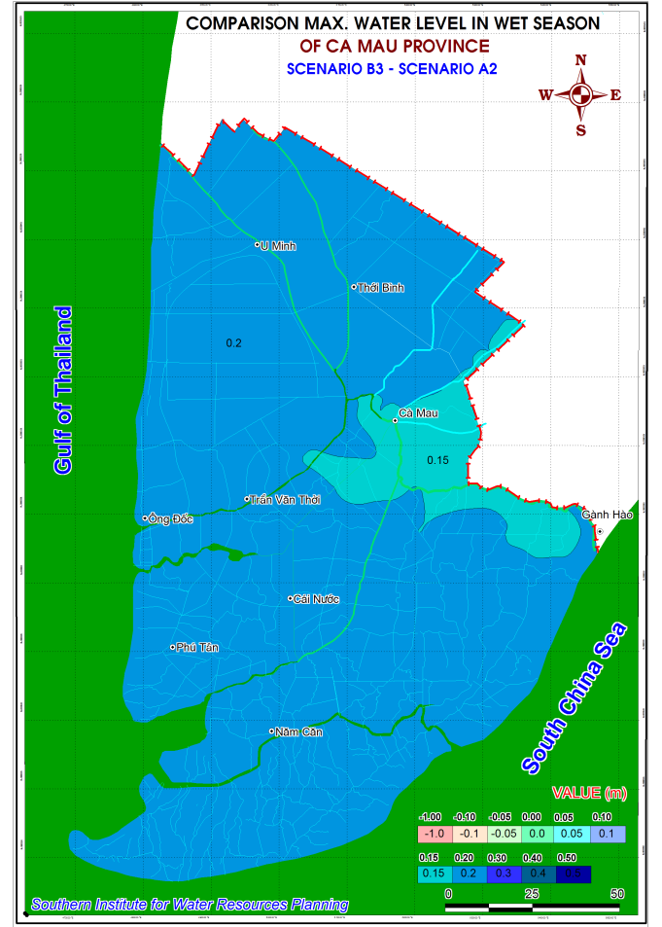  Comparison: B3 & A2 in wet season | 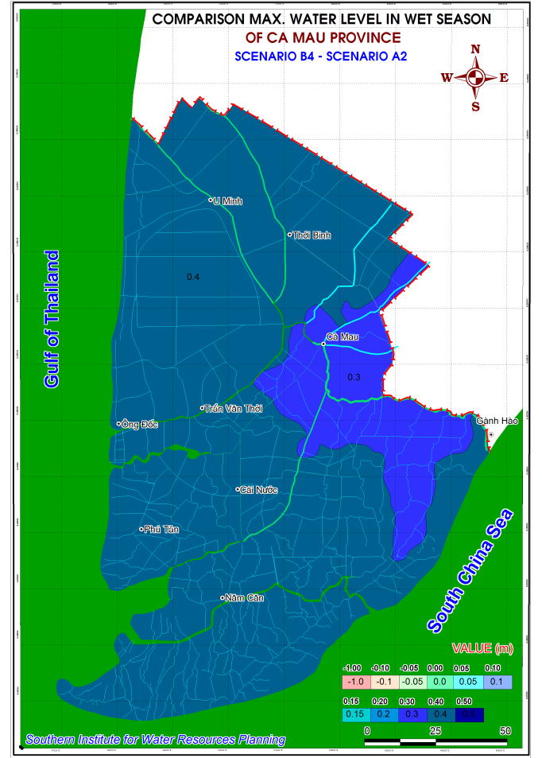  Comparison: B4 & A2 in wet season

Figure 40: Changing of Max water level – Comparison: B3-A2, B4-A2
  - Assessment of the Extreme climatic event Scenarios

Impact to salinity intrusion
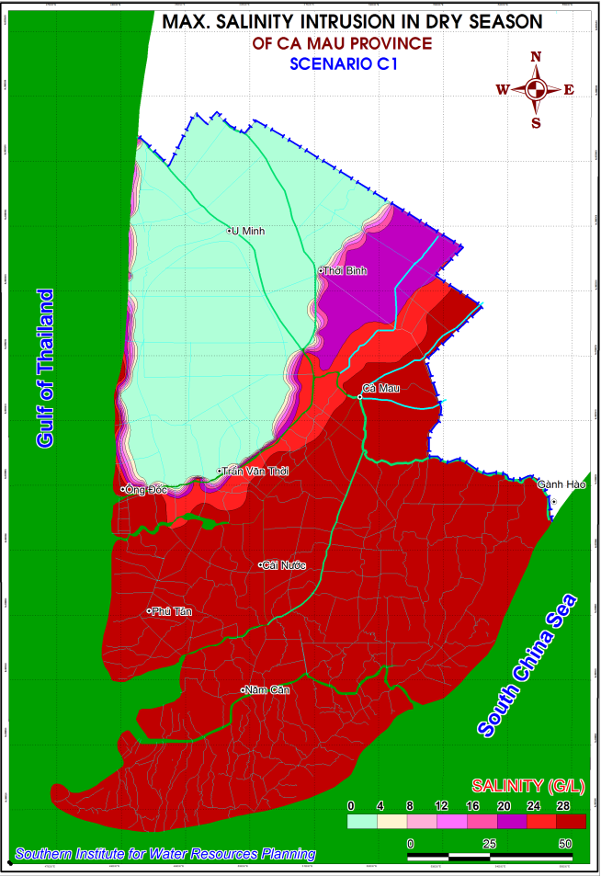  Max. Salinity intrusion in Dry season - Sce. C1 | 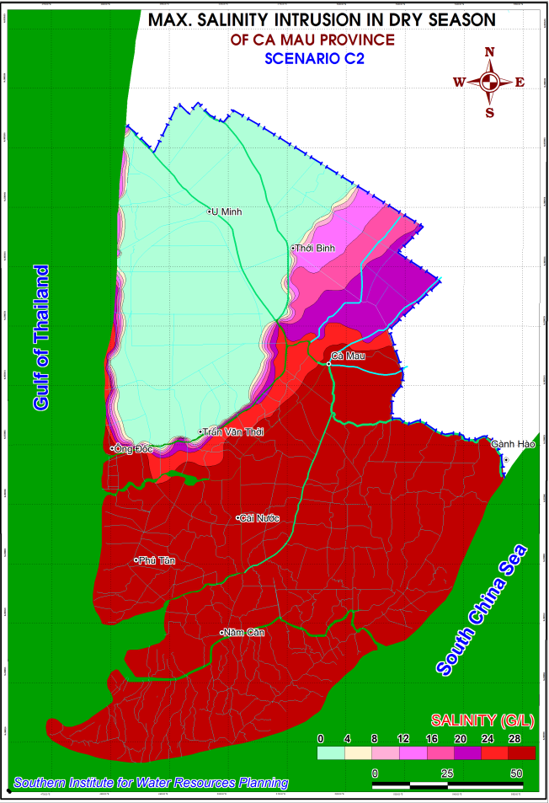  Max. Salinity intrusion in Dry season - Sce. C2

Figure 41: Max. Salinity intrusion – Scenario C1 & C2

Impact to water level
- In dry season:
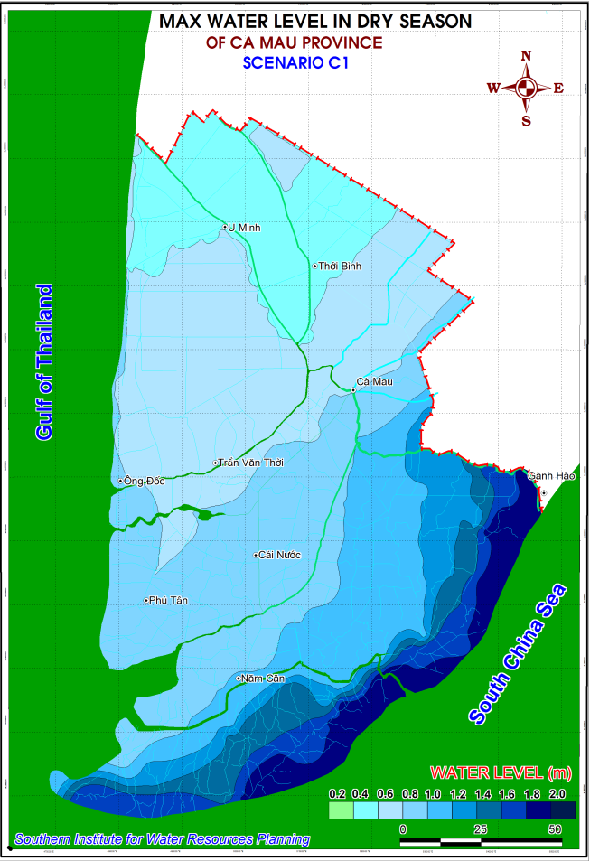  Max. Water level in Dry season – Sce. C1 | 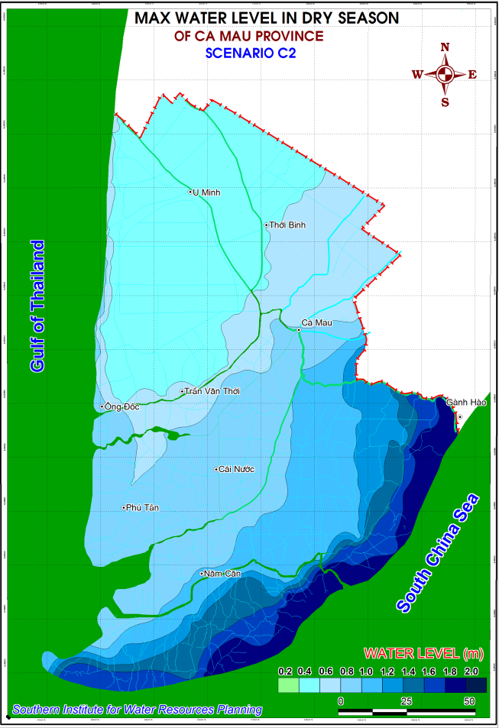  Max. Water level in Dry season – Sce. C2

Figure 42: Max. Water level in Dry season – Scenario C1, C2
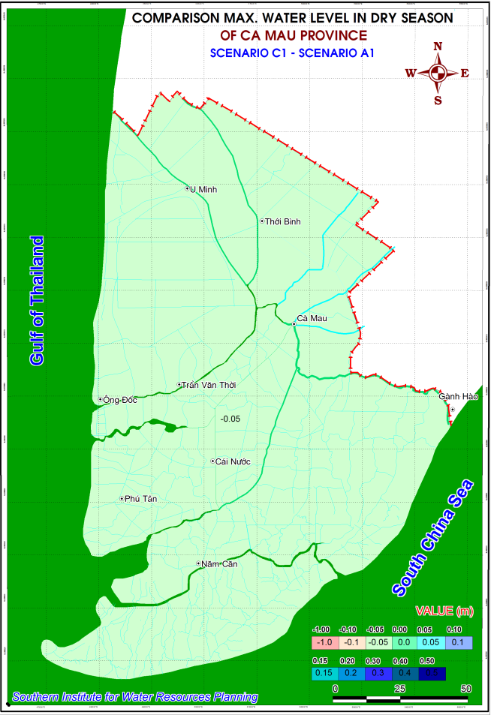  Comparison: C1 & A1 | 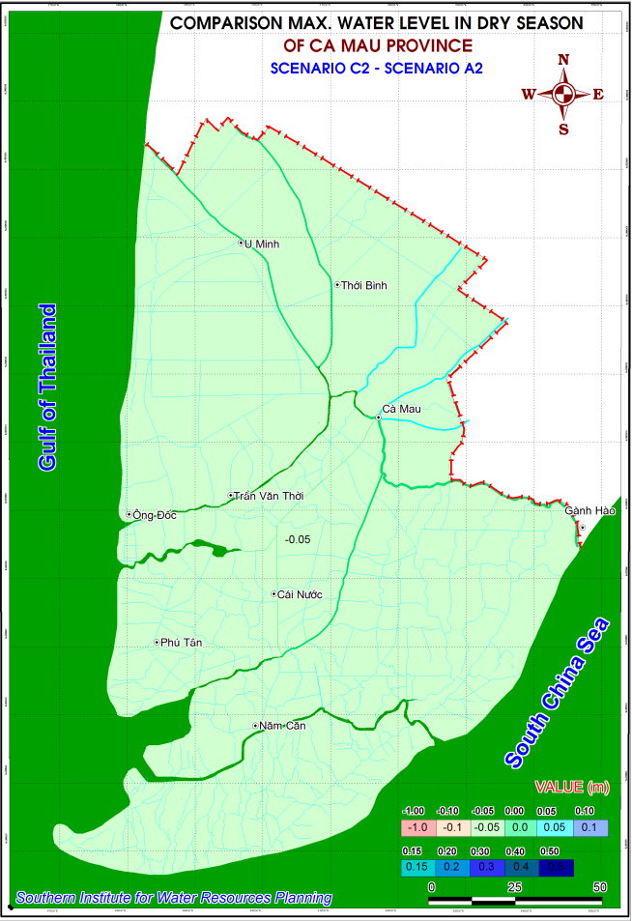  Comparison: C2 & A2

Figure 43: Changing of Max water level – Comparison: C1-A1, C2-A2
- In wet season:
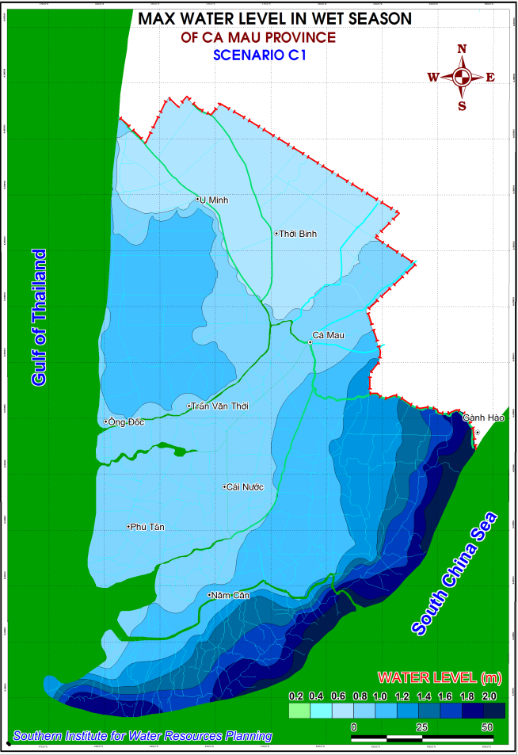  Max. Water level in Wet season – Sce. C1 | 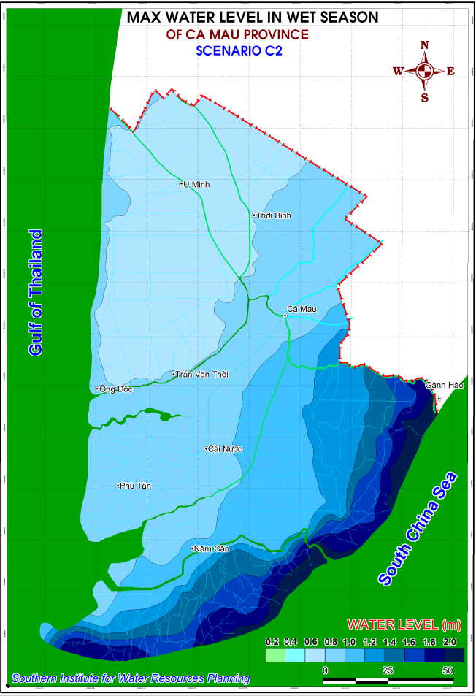  Max. Water level in Wet season – Sce. C2

Figure 44: Max. Water level in wet season – Scenario C1, C2
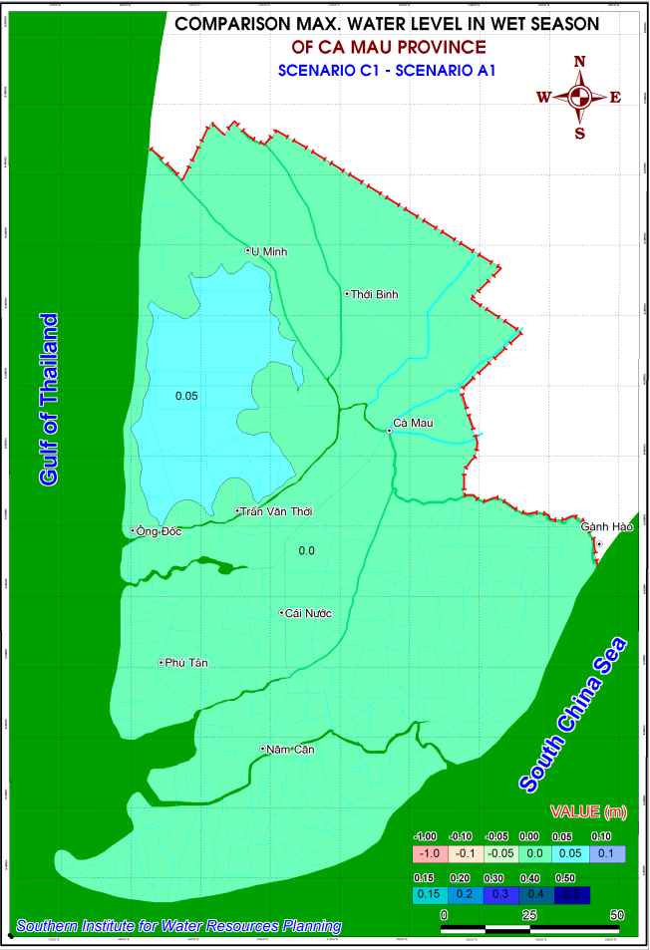  Comparison: C1 & A10 | 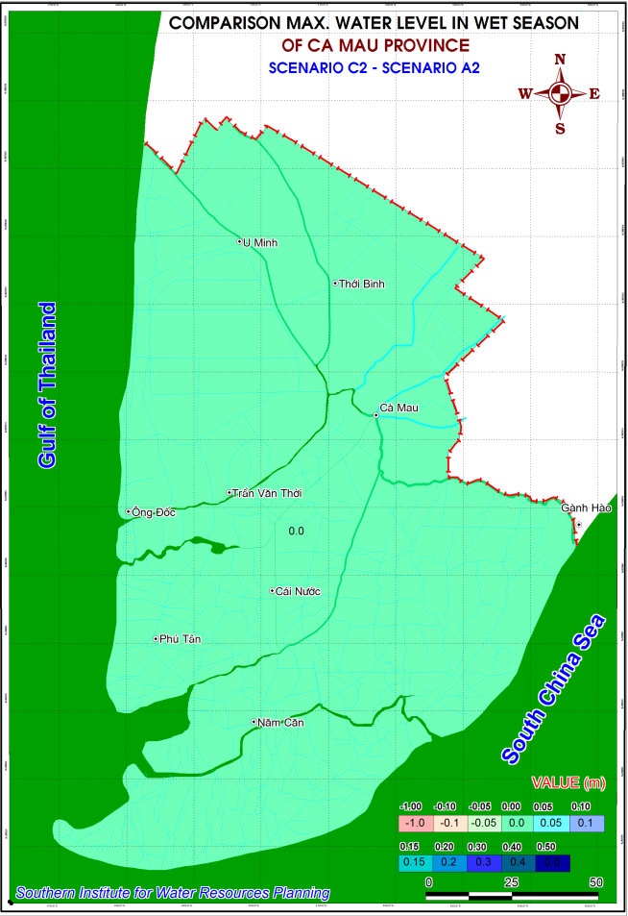  Comparison: C2 & A2

Figure 45: Changing of Max water level – Comparison: C1-A1, C2-A2
  - Assessment of the complex SLR, CLC and Storm Scenarios

Impact of sea level rise to salinity intrusion
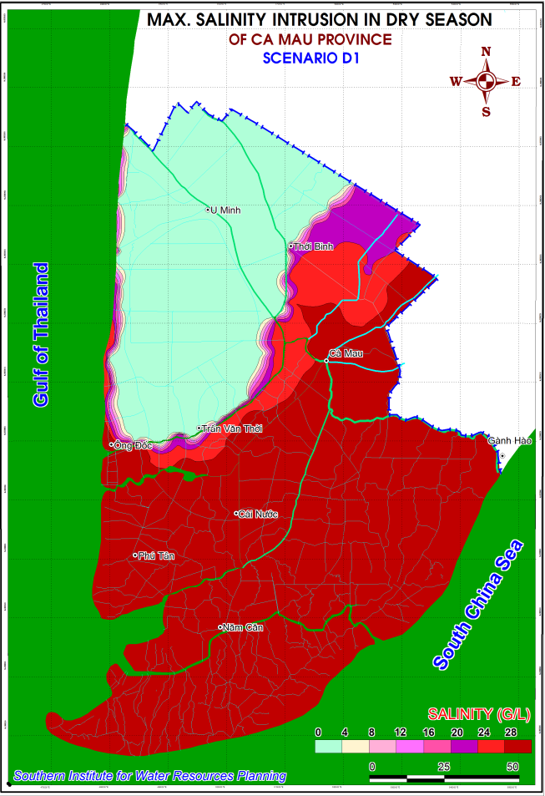 | 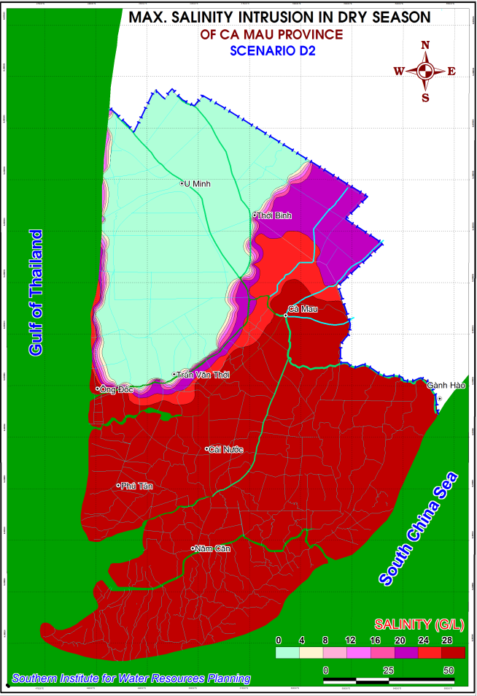

Figure 46: Max. Salinity intrusion – Scenario D1 & D2

Impact to water level
- In dry season:
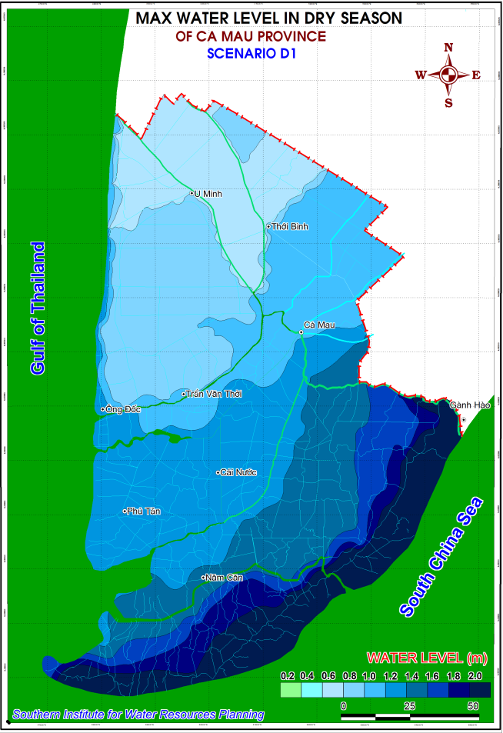  Max. Water level in Dry season – Sce. D1 | 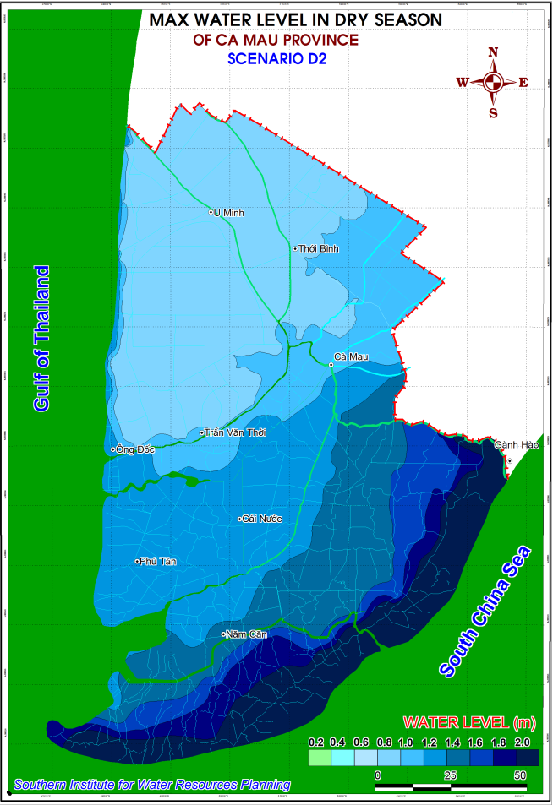  Max. Water level in Dry season – Sce. D2

Figure 47: Max. Water level in Dry season – Scenario D1, D2
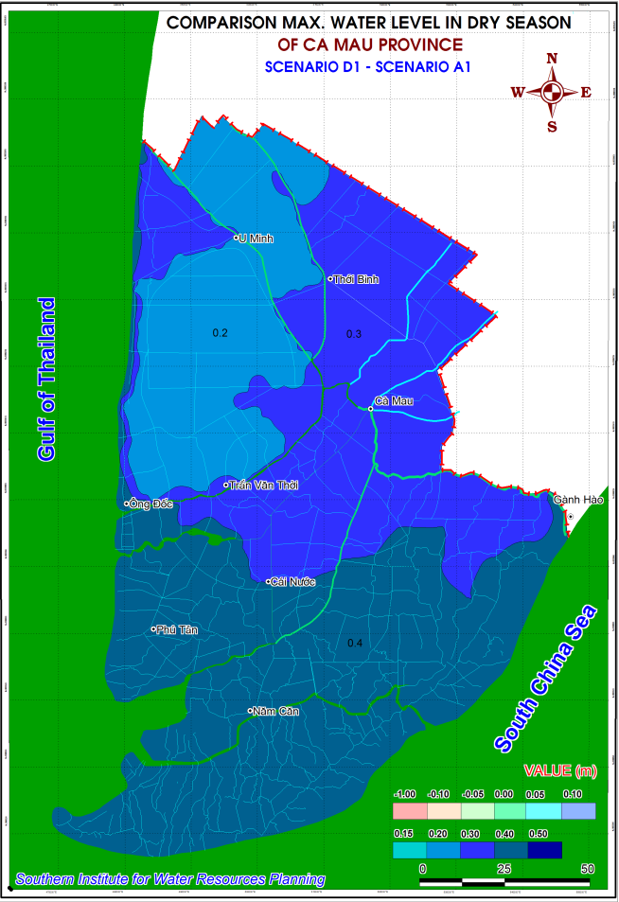  Comparison: D1 & A1 in dry season | 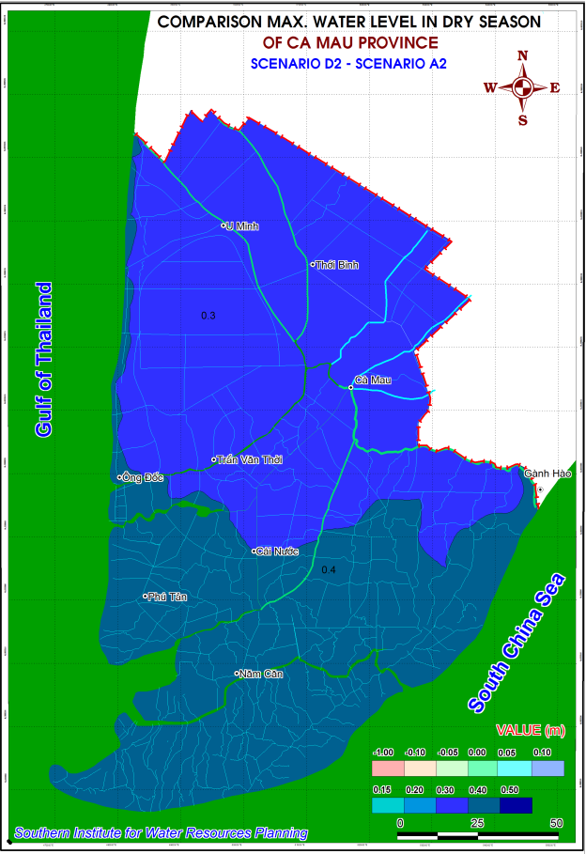  Comparison: D2 & A2 in dry season

Figure 48: Changing of Max water level – Comparison: D1-A1, D2-A2
- In wet season:
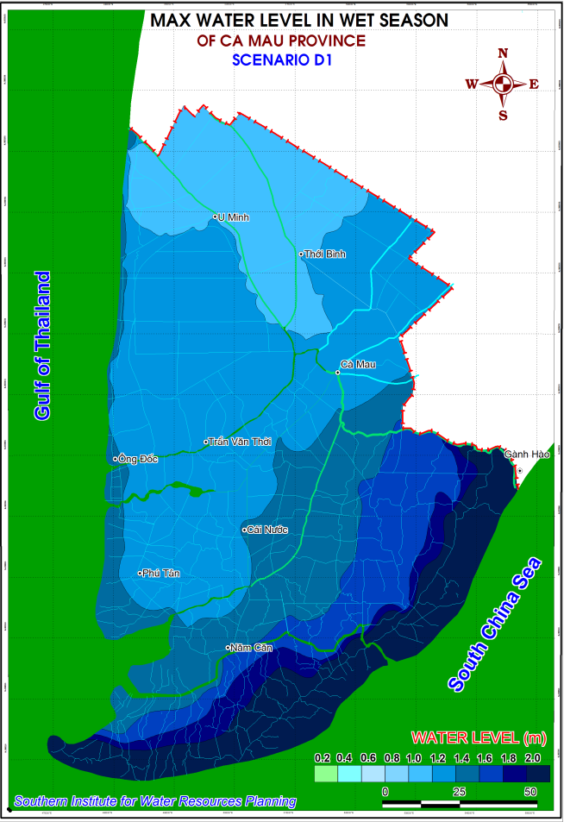  Max. Water level in Wet season – Sce. D1 | 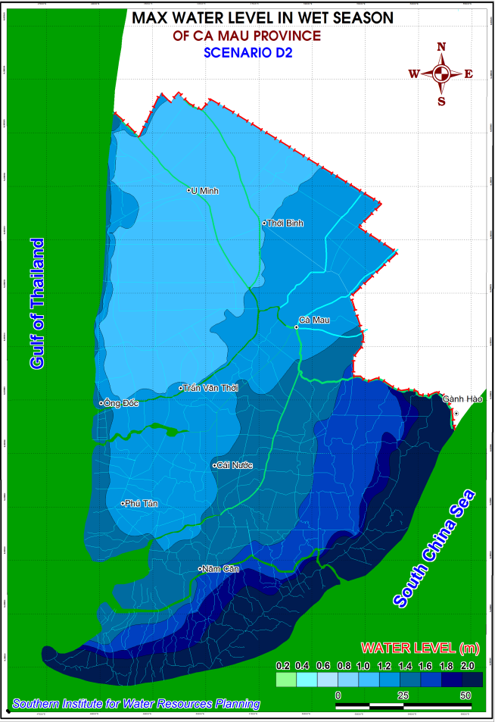  Max. Water level in Wet season – Sce. D2

Figure 49: Max. Water level in wet season – Scenario D1, D2
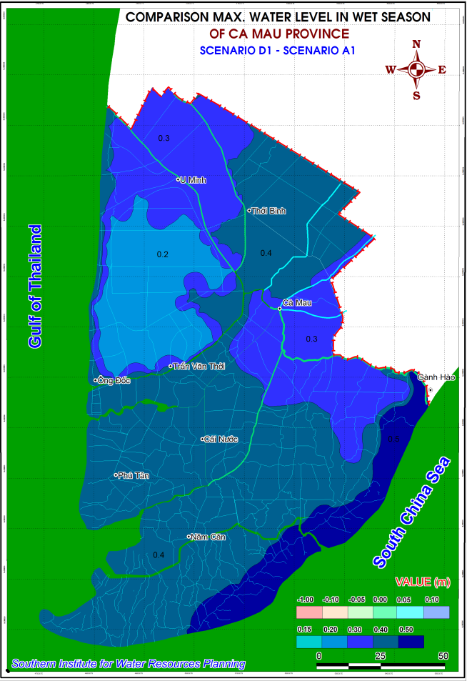  Comparison: D1& A1 in wet season | 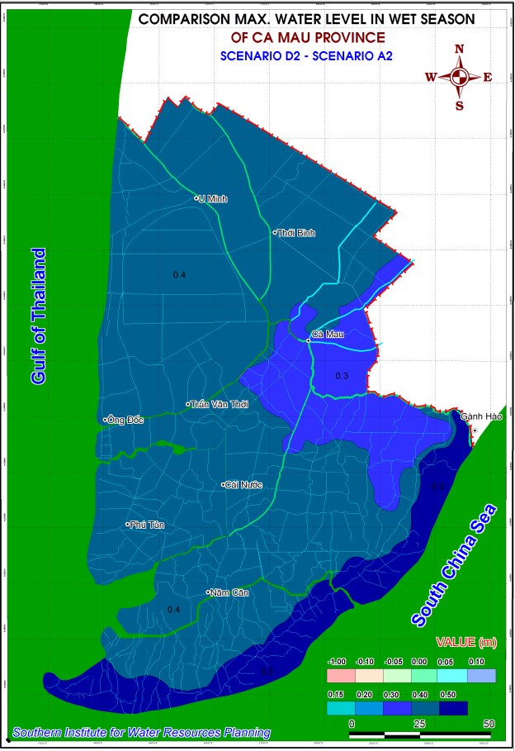  Comparison: D2 & A2 in wet season

Figure 50: Changing of Max water level – Comparison: D1-A1, D2-A2
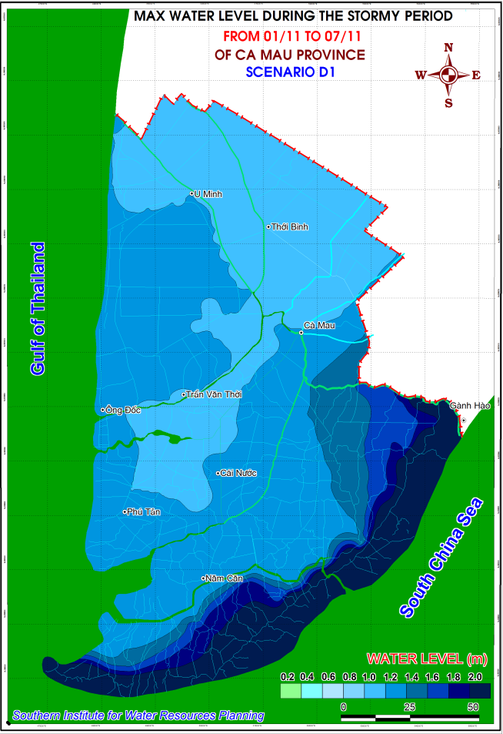 | 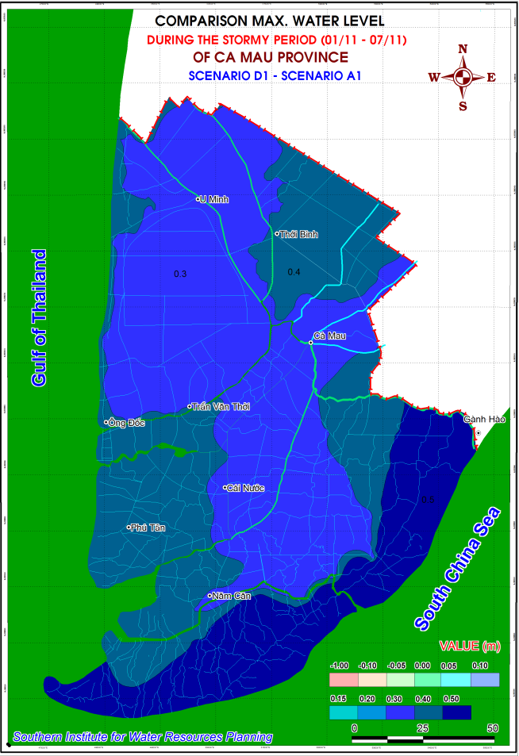

Figure 51: Changing of Max water level during the stormy period – D1 & A1

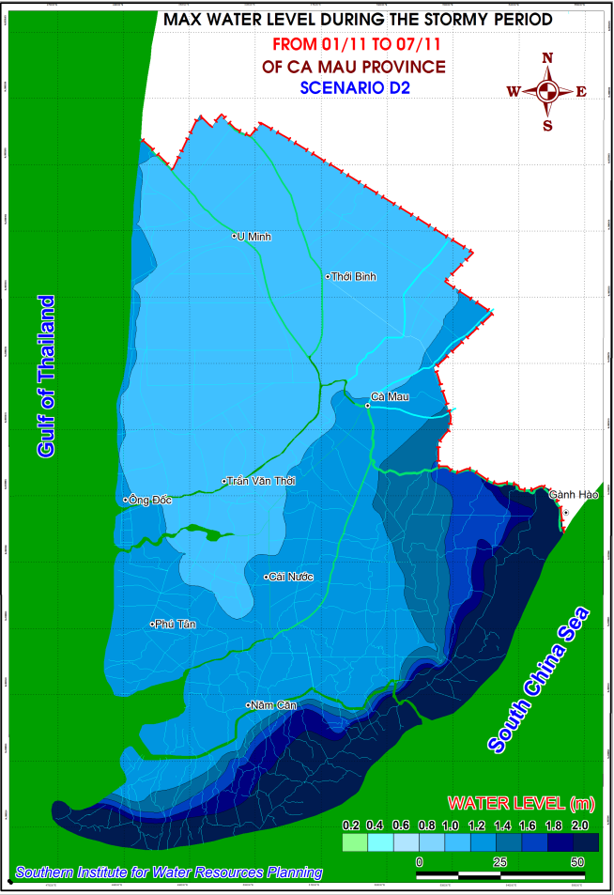 | 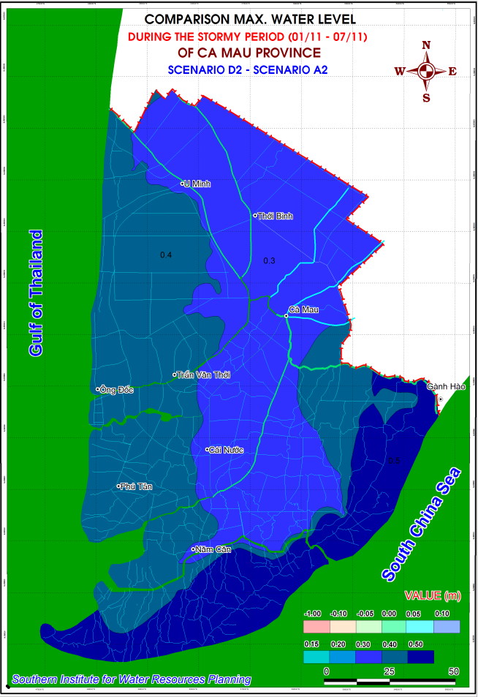

Figure 52: Changing of Max water level during the stormy period – D2 & A2
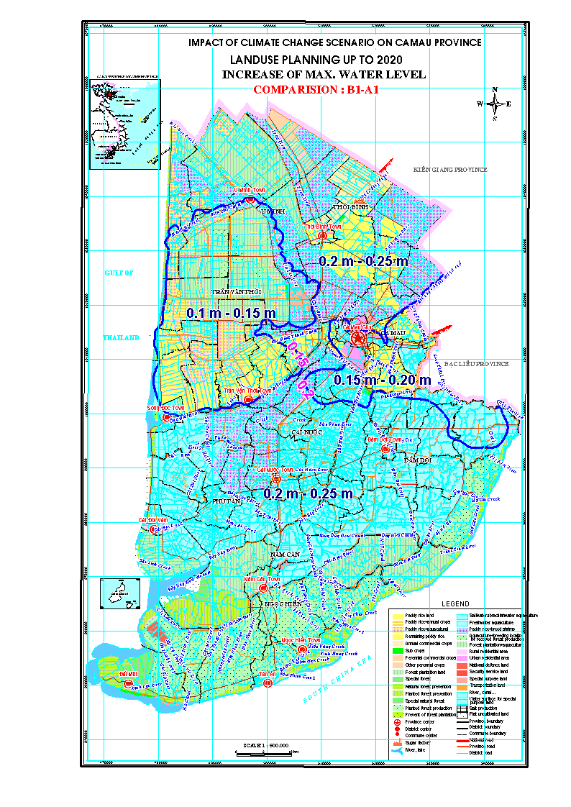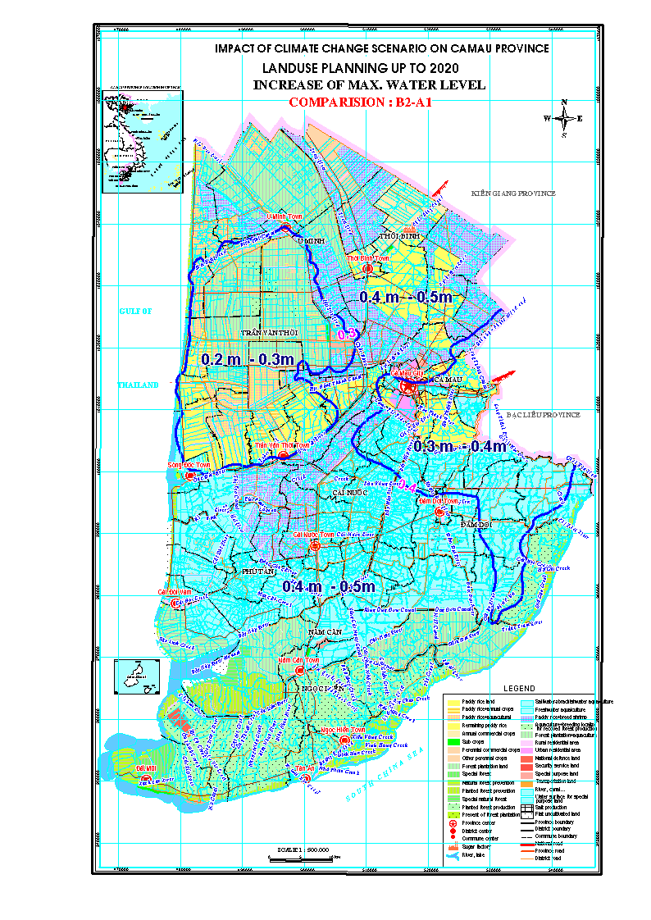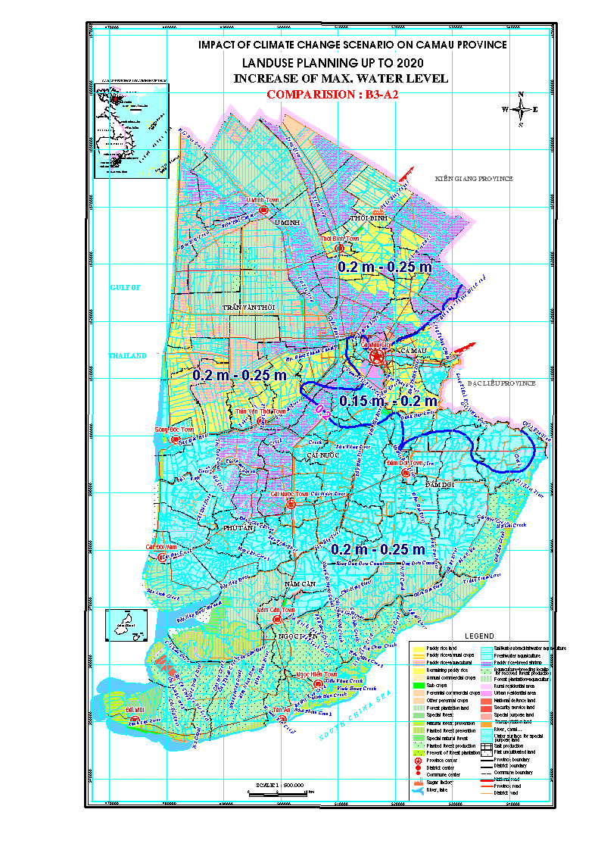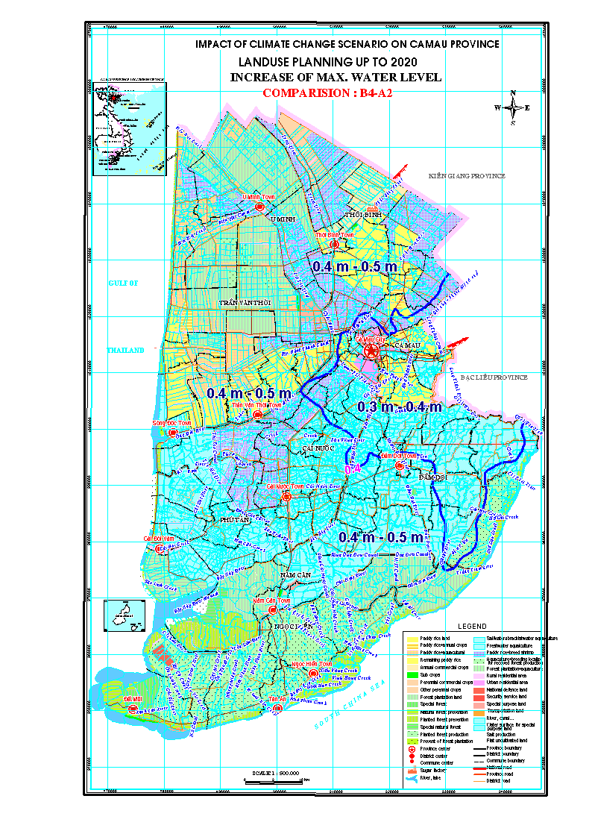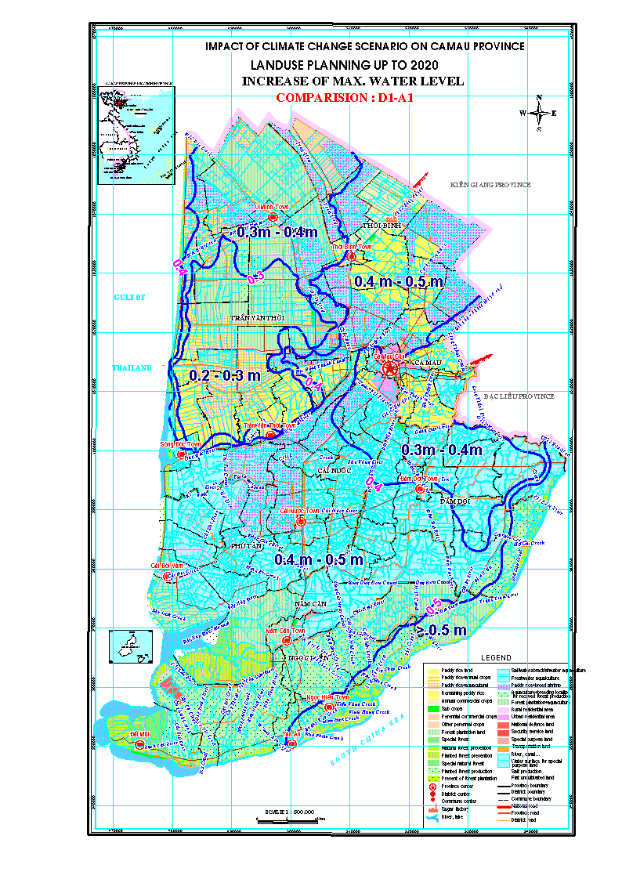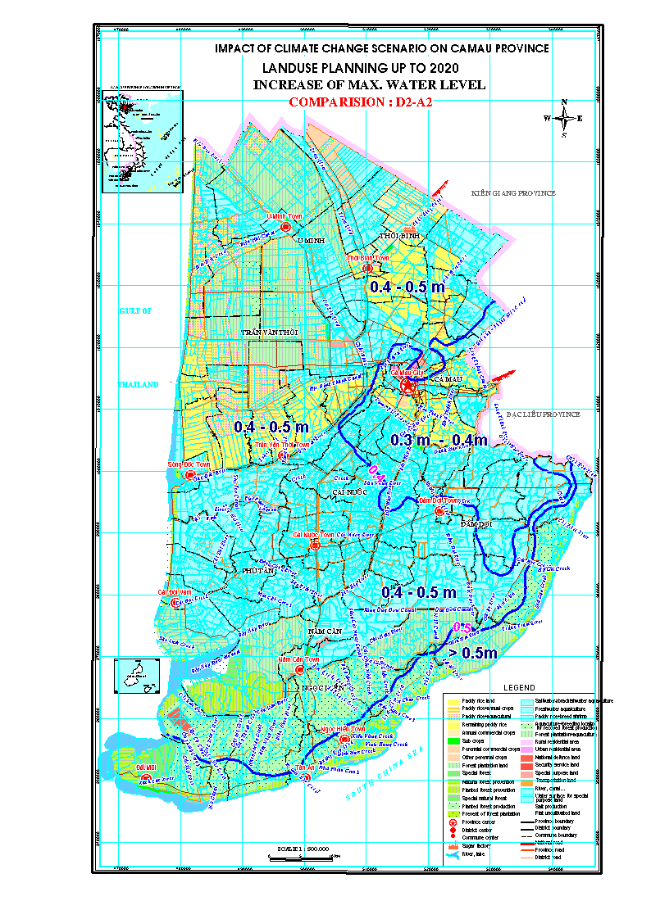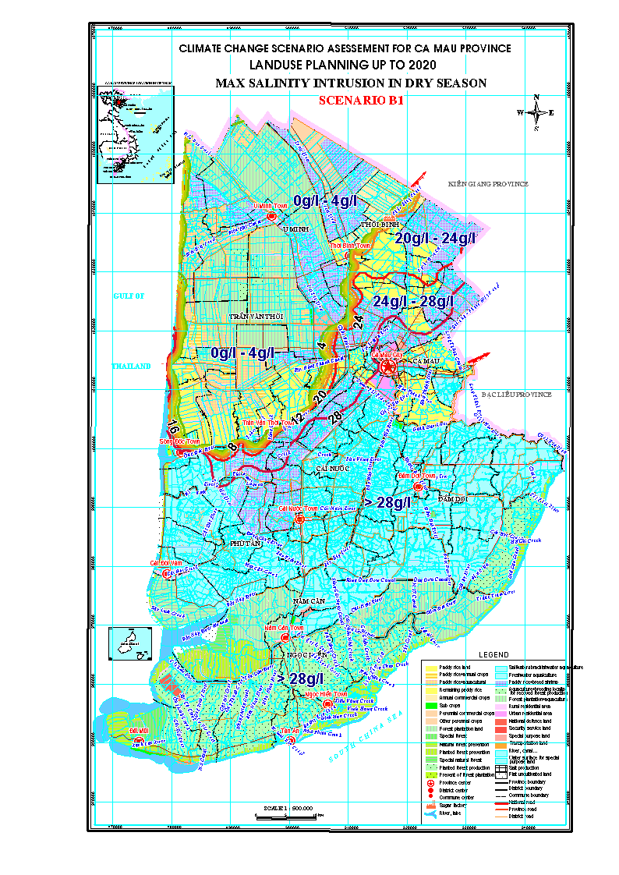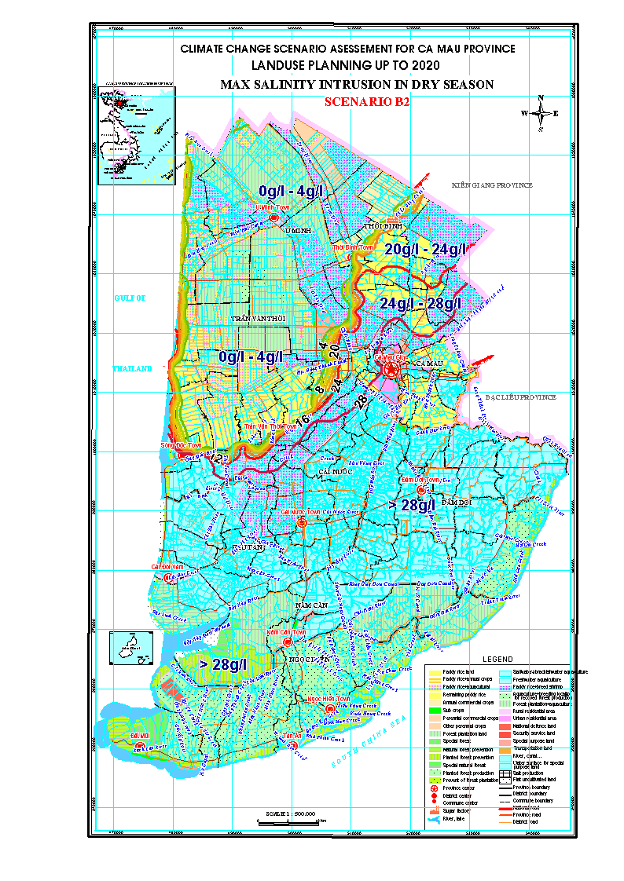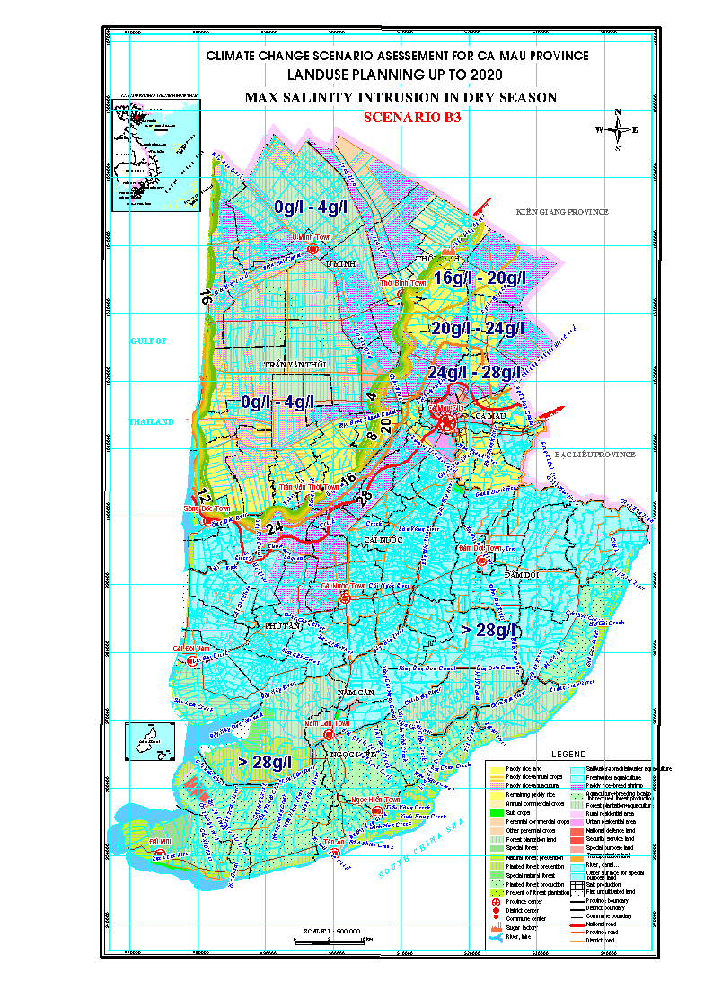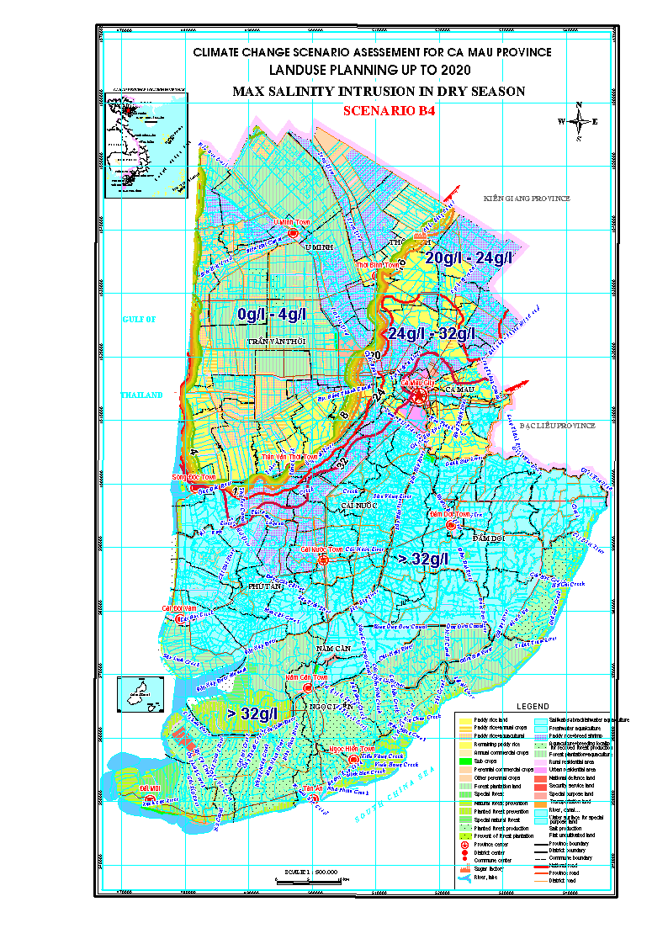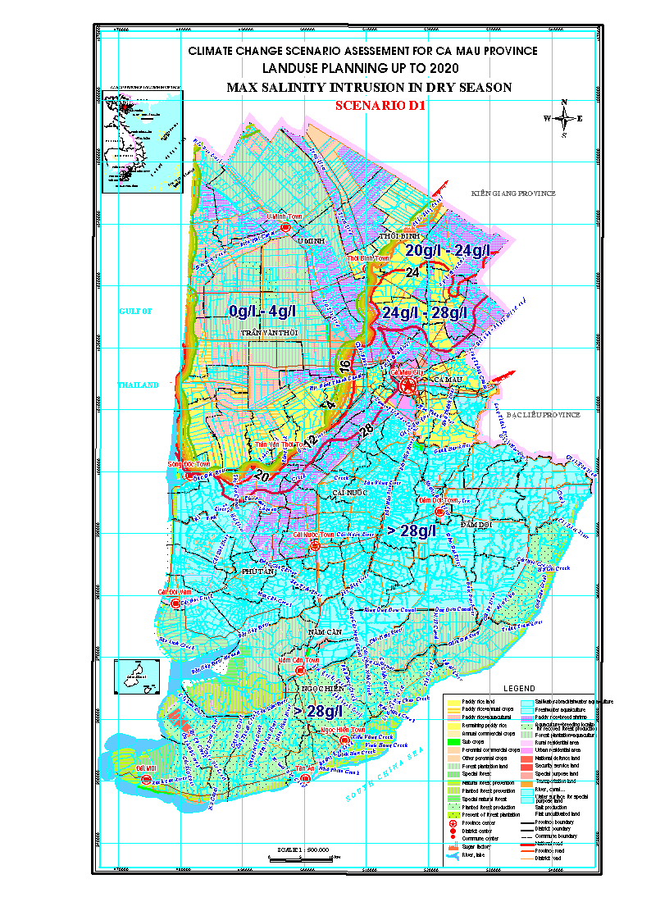
Figure 28:
Figure 29:
Figure 30:

Figure 31:
Figure 32:
Figure 33:
Figure 34:
Figure 35:
Figure 36:
Figure 37:
Figure 38:
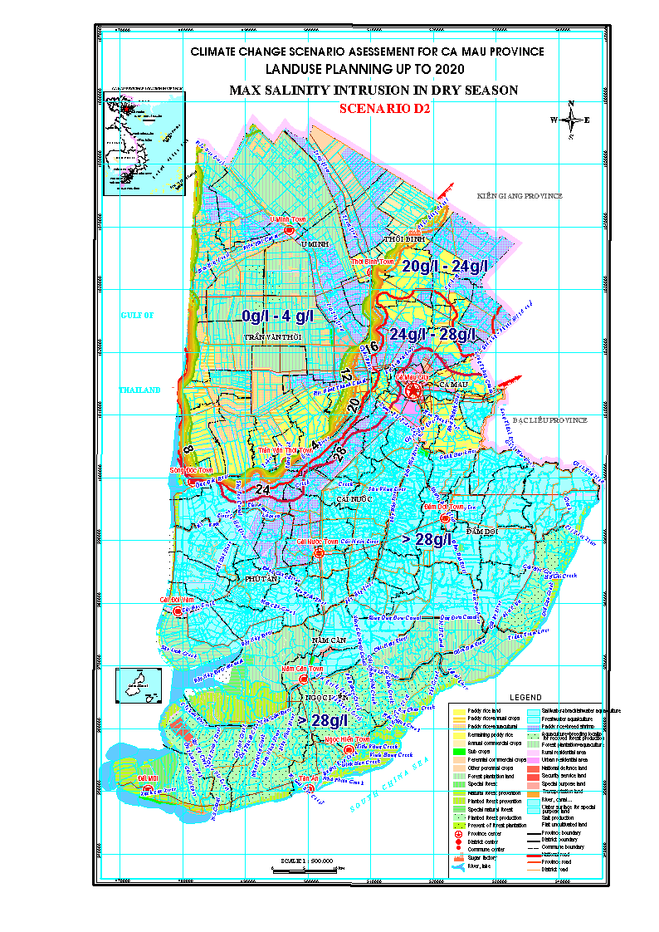
Figure 39:

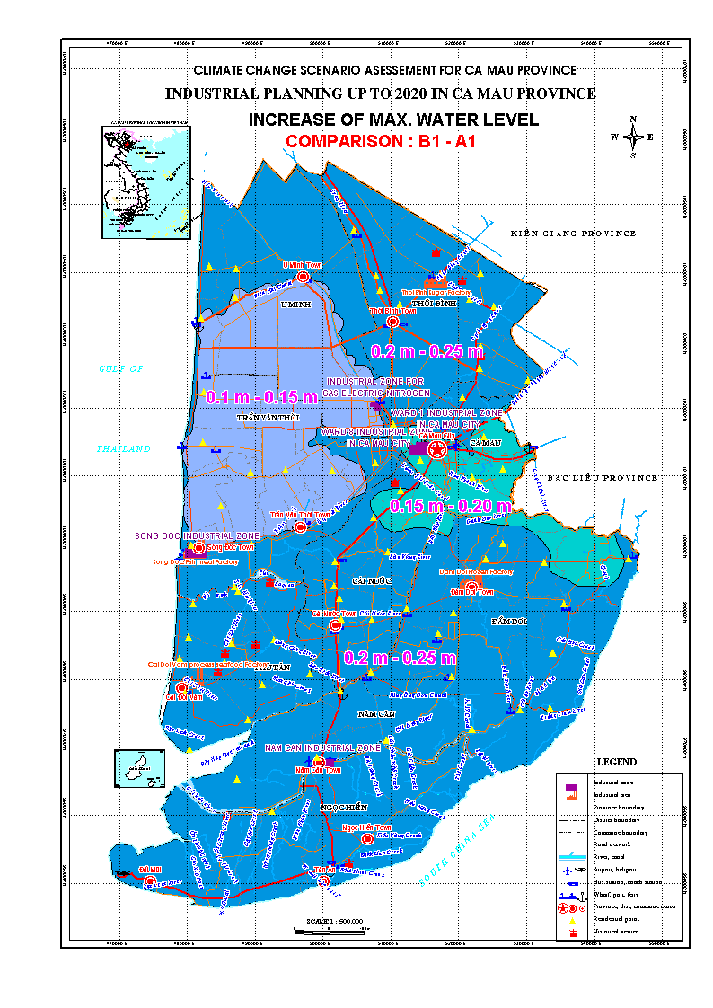
Figure 40:

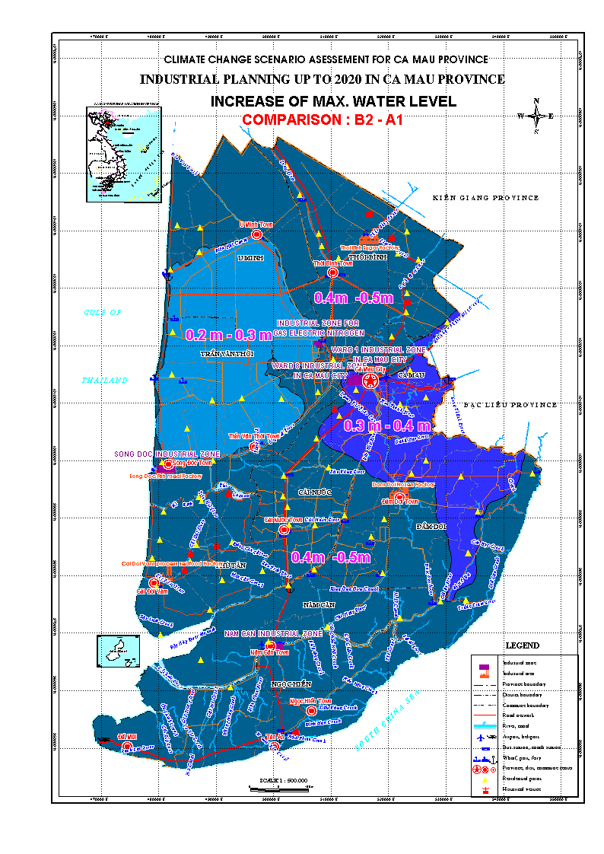
Figure 41:
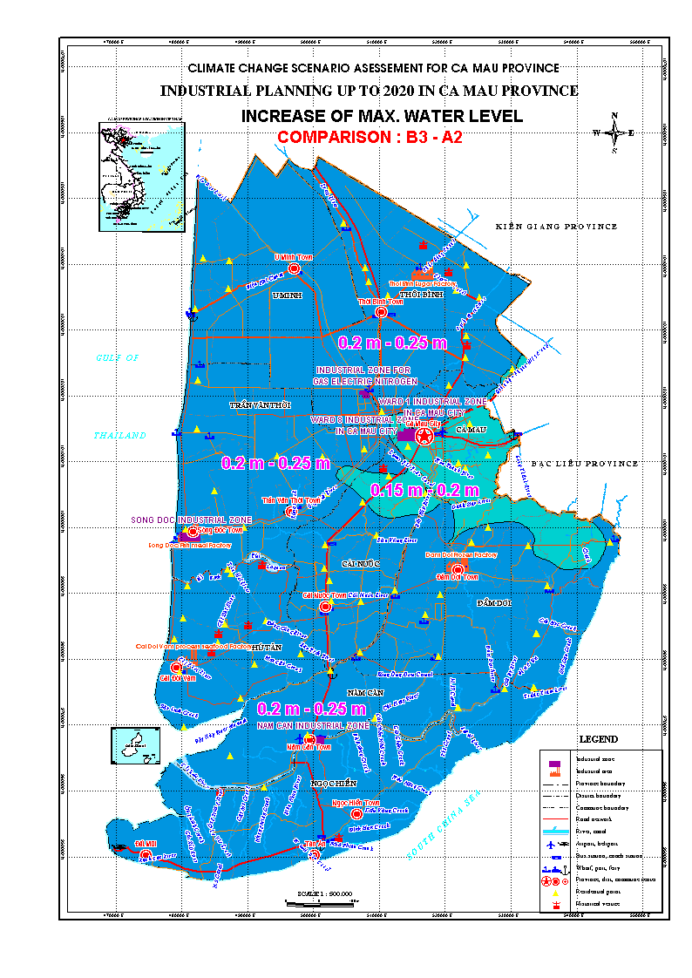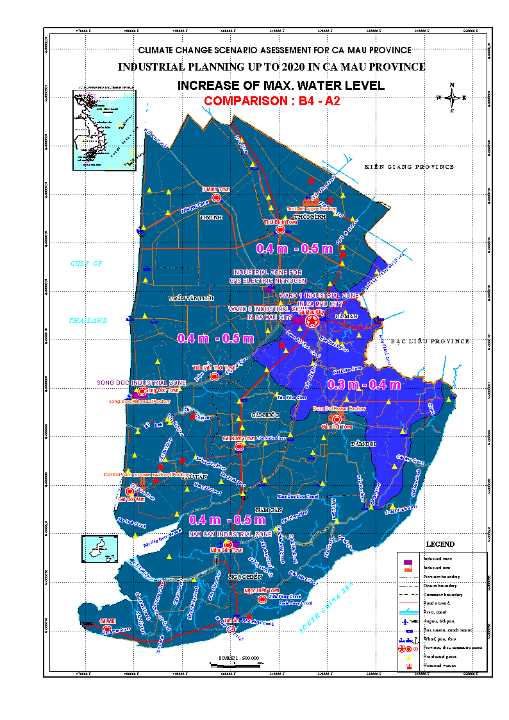
Figure 42:
Figure 43:
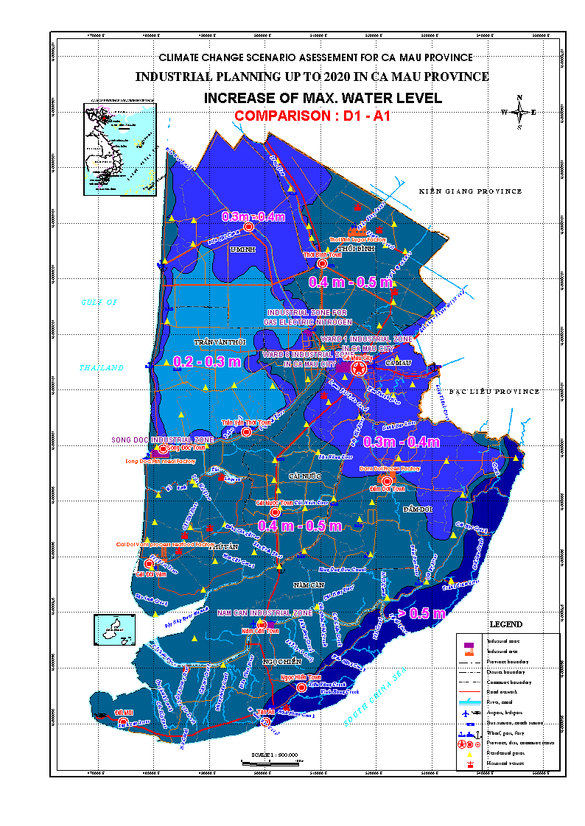
Figure 44:
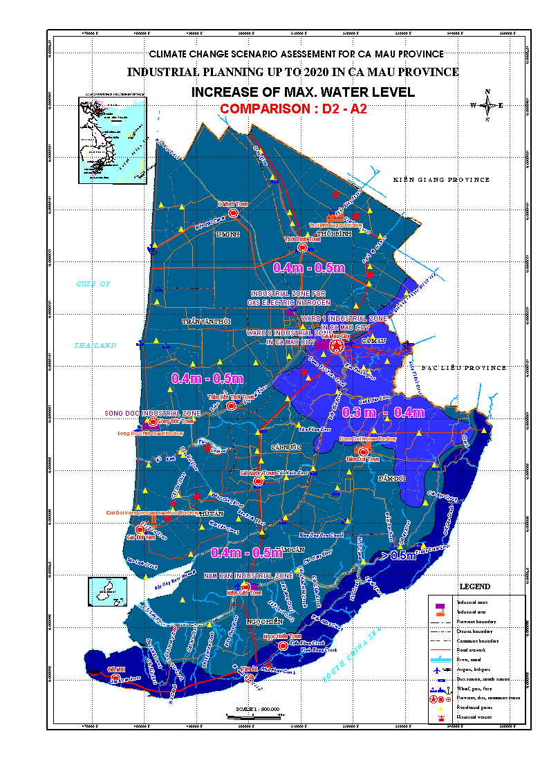
Figure 45:
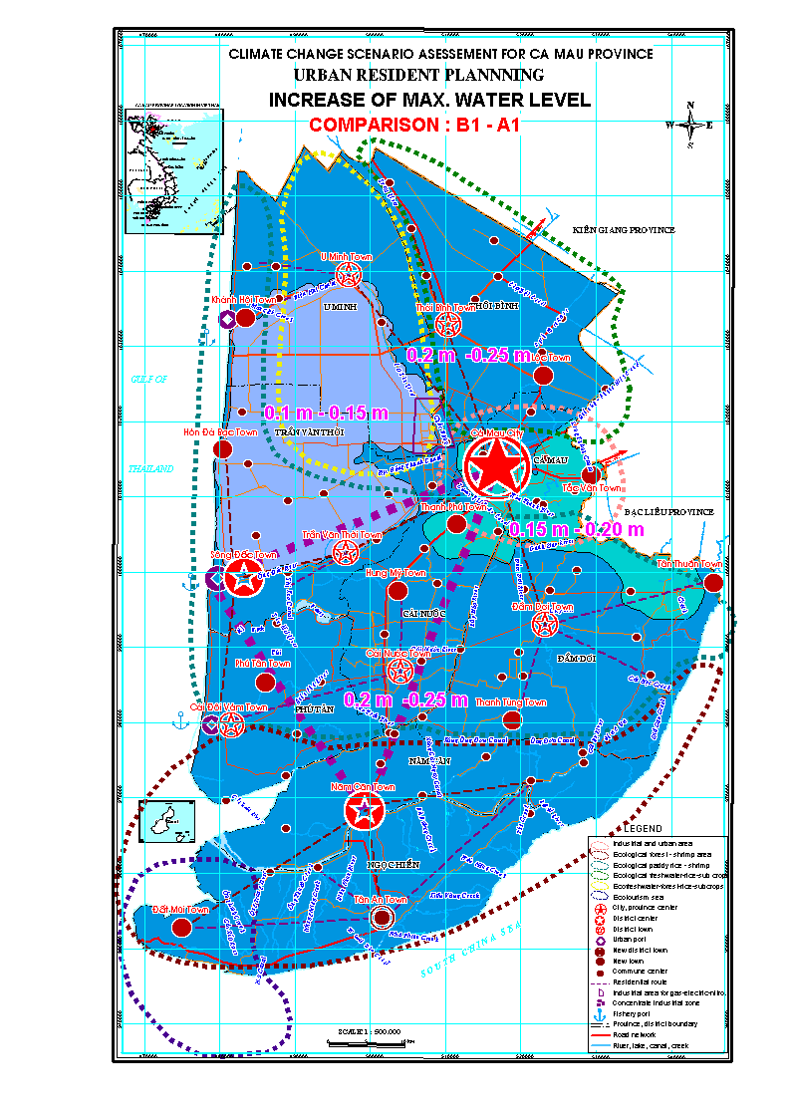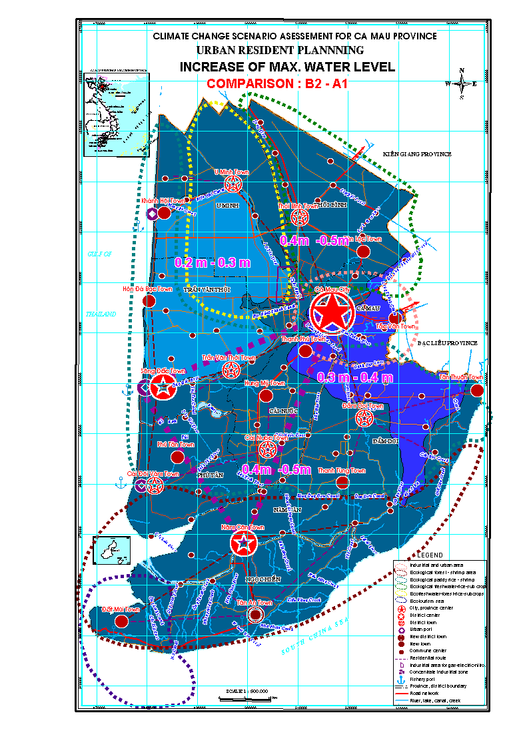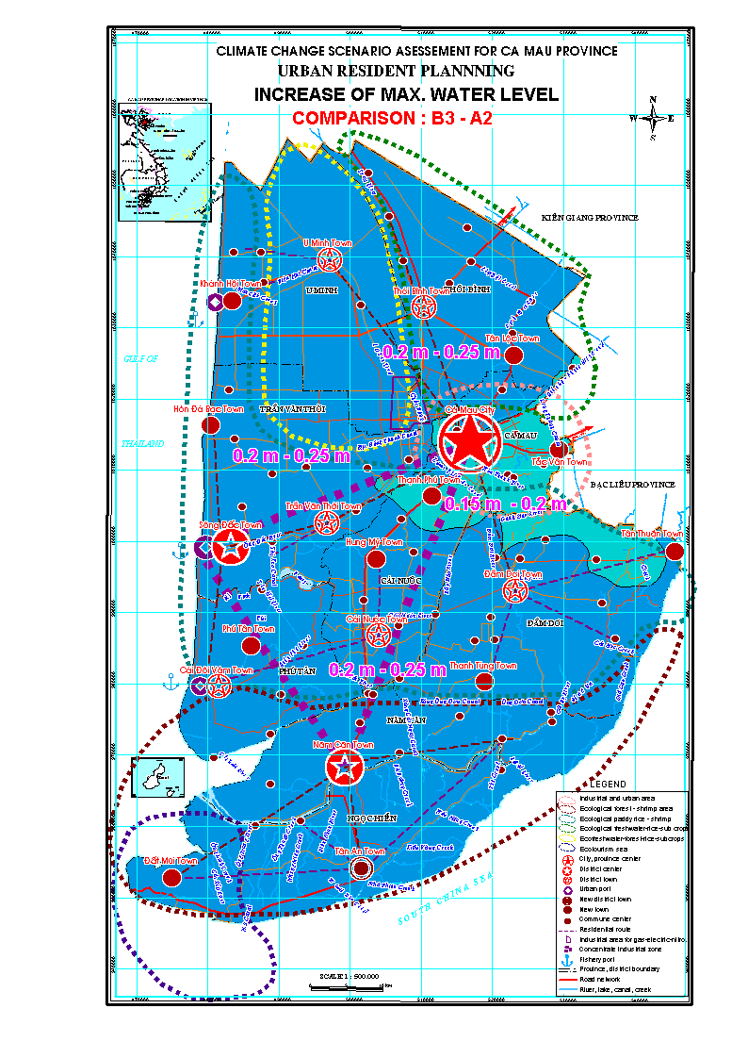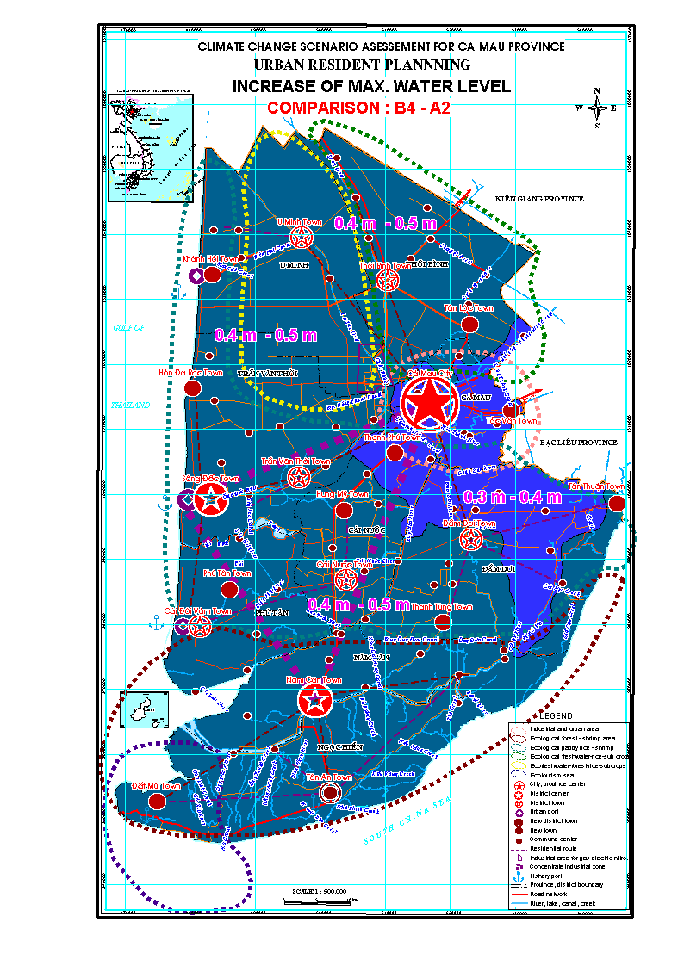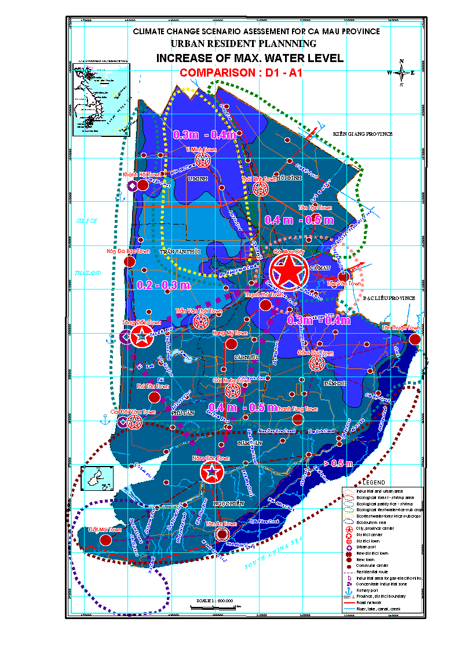
Figure 46:

Figure 47:
Figure 48:
Figure 49:
Figure 50:
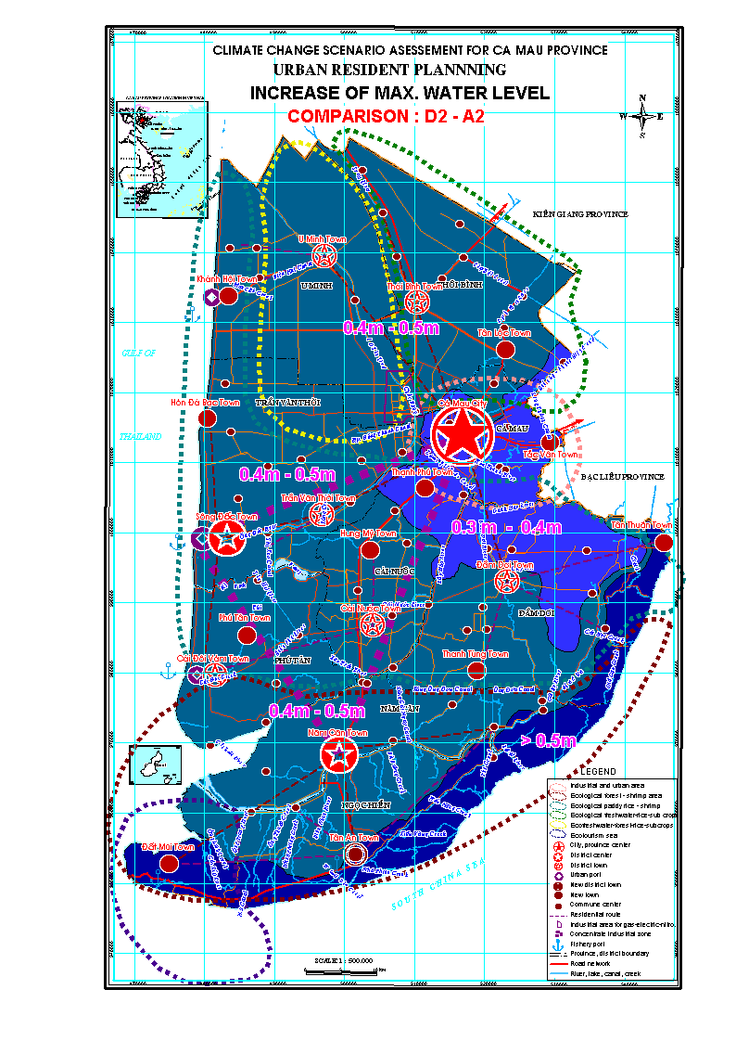
Figure 51:
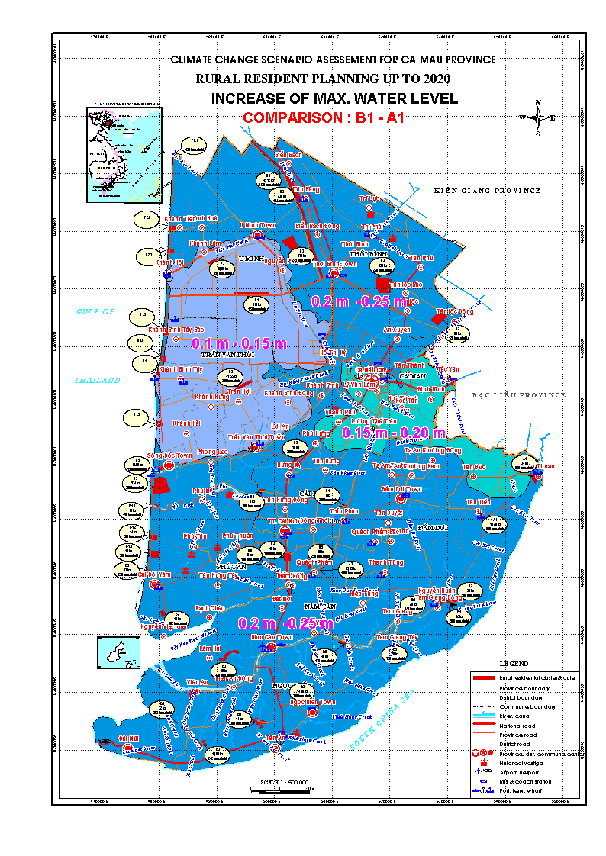
Figure 52:

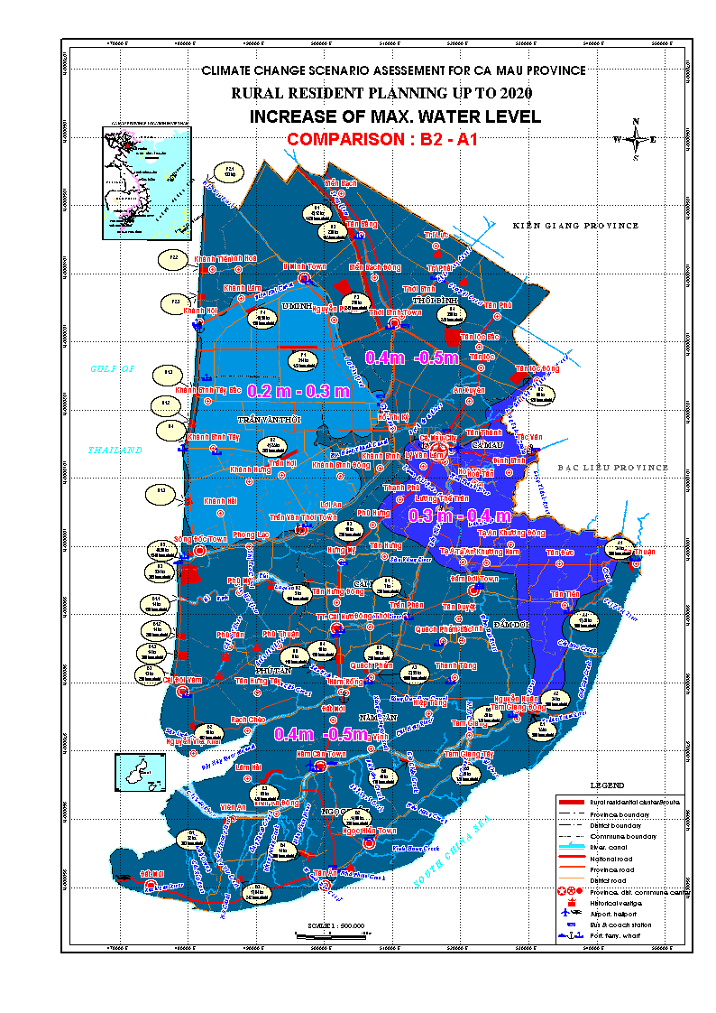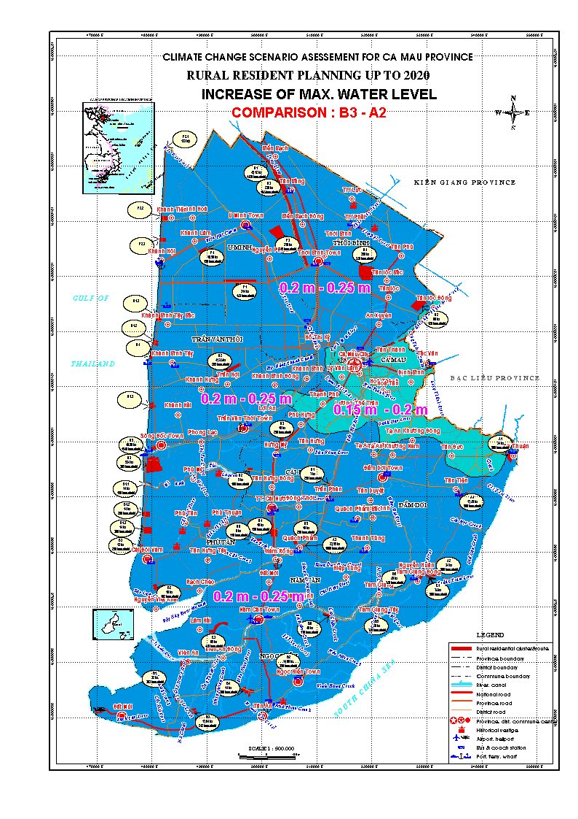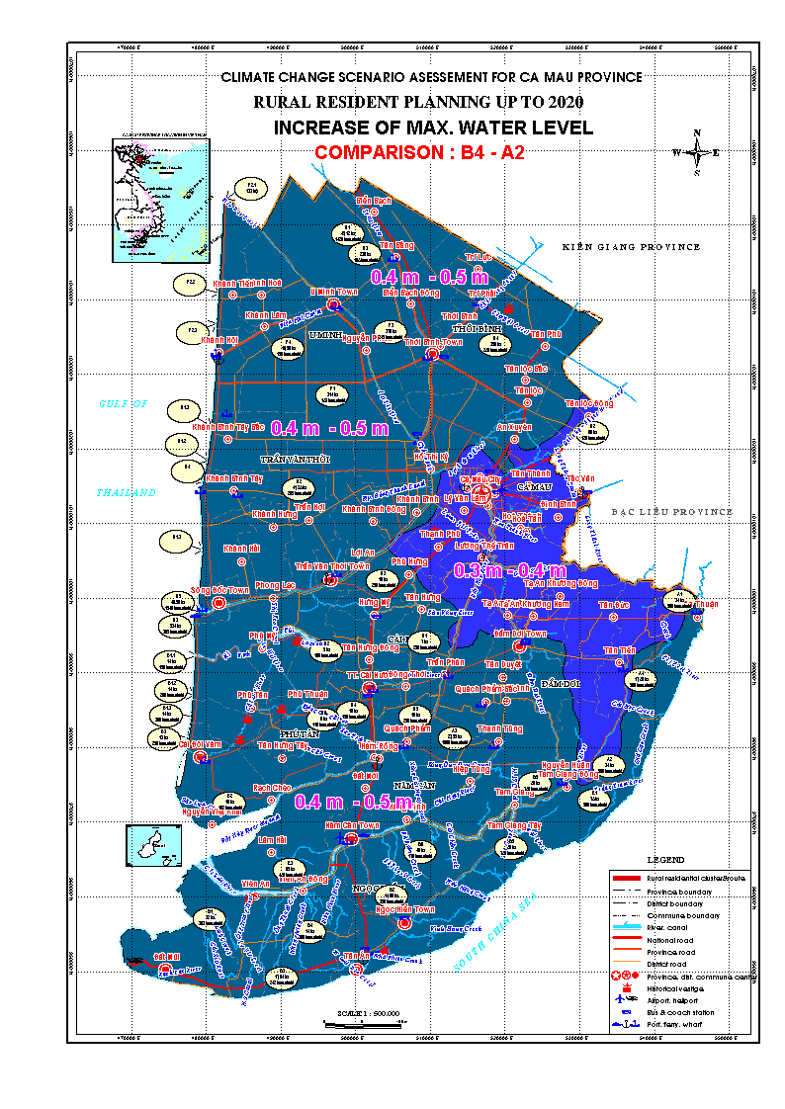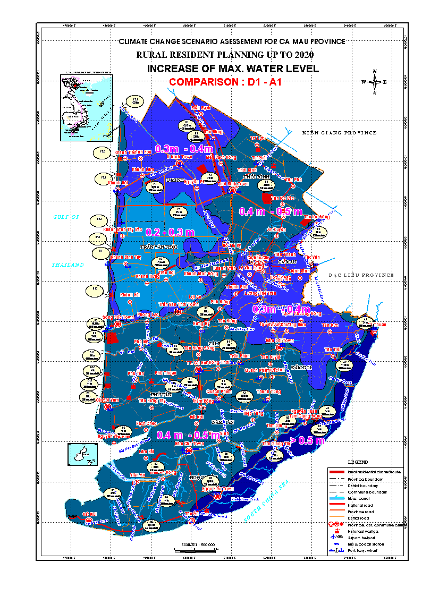
Figure 53:
Figure 54:
Figure 55:
Figure 56:
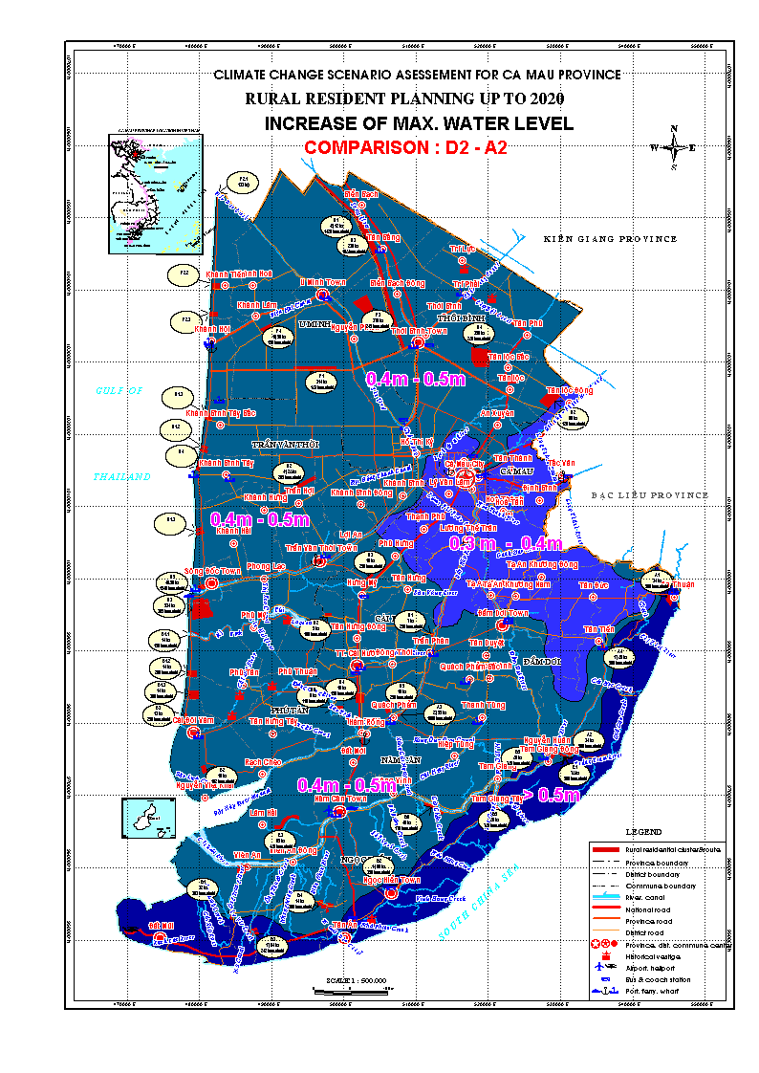
Figure 57:
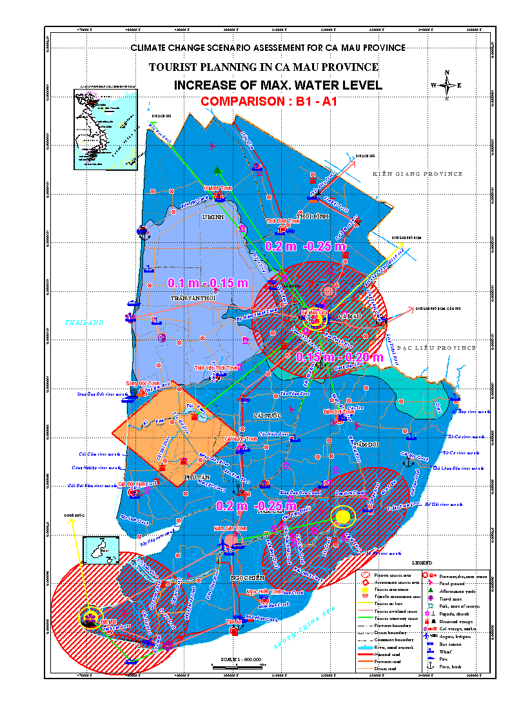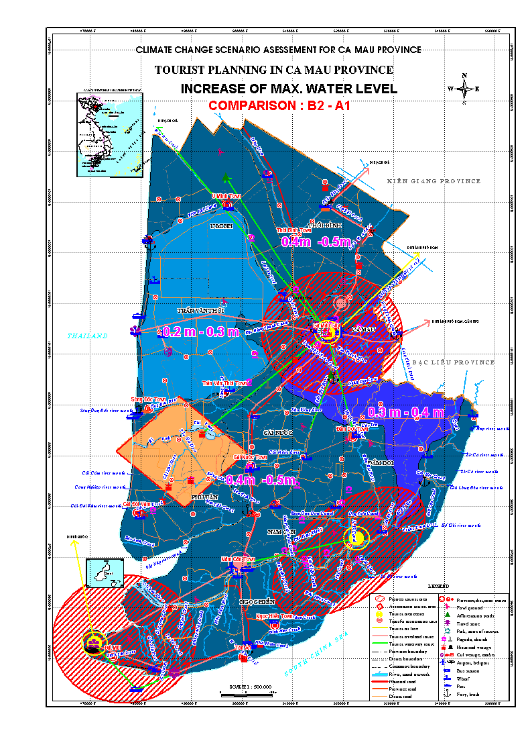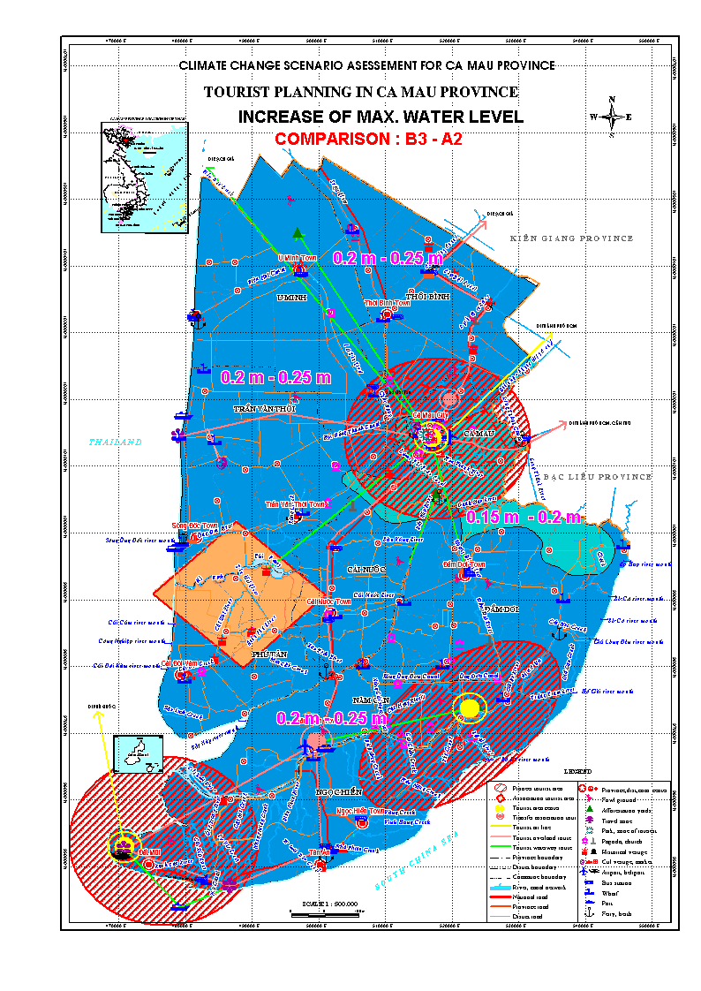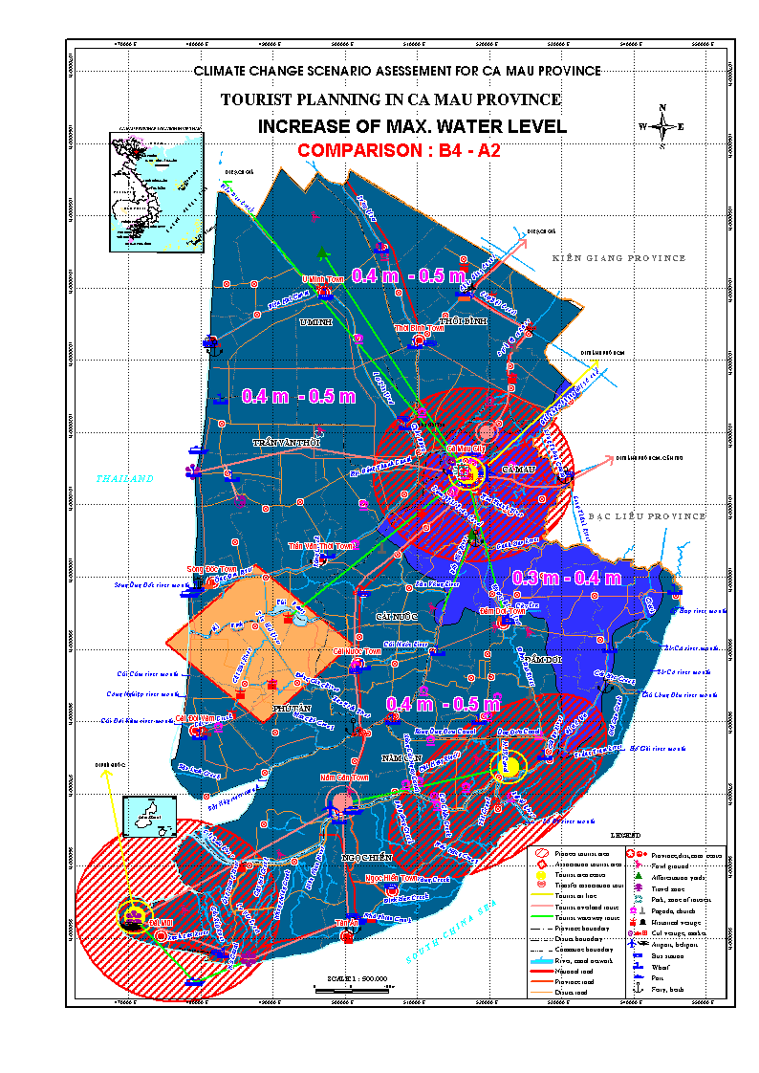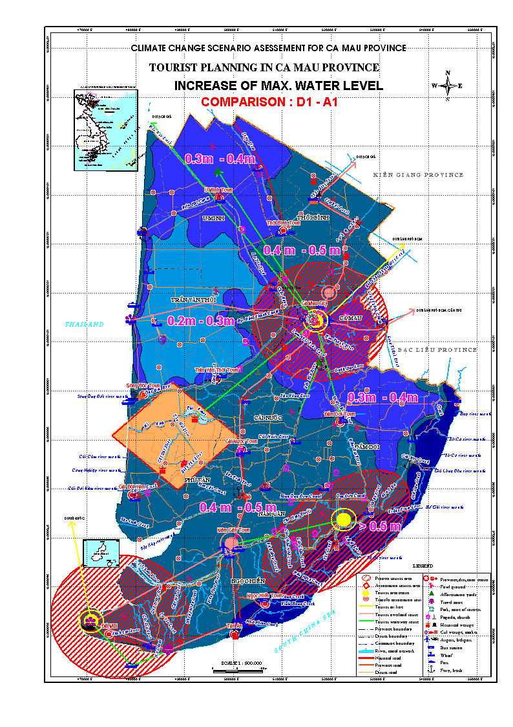
Figure 58:

Figure 59:
Figure 60:
Figure 61:
Figure 62:
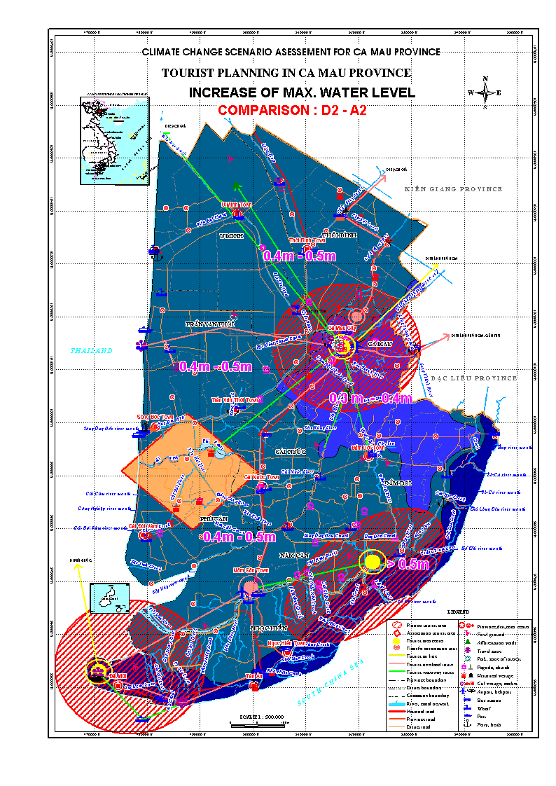
Figure 63:
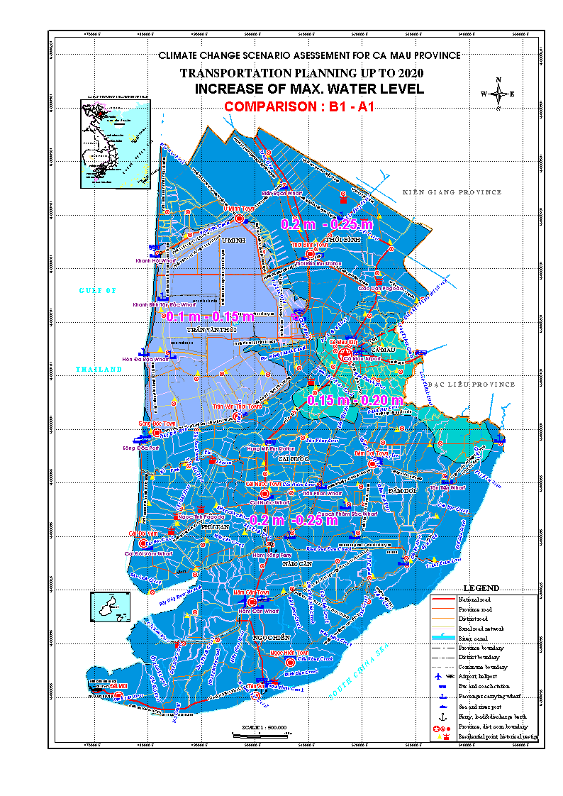
Figure 64:

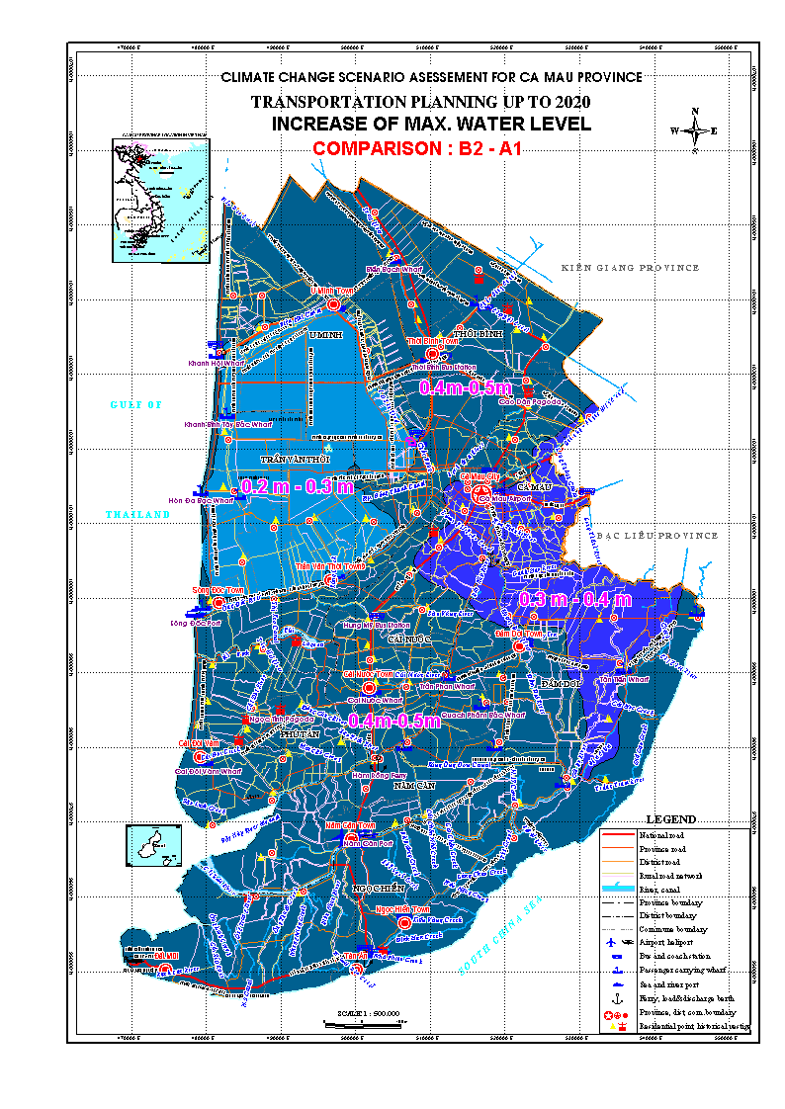
Figure 65:
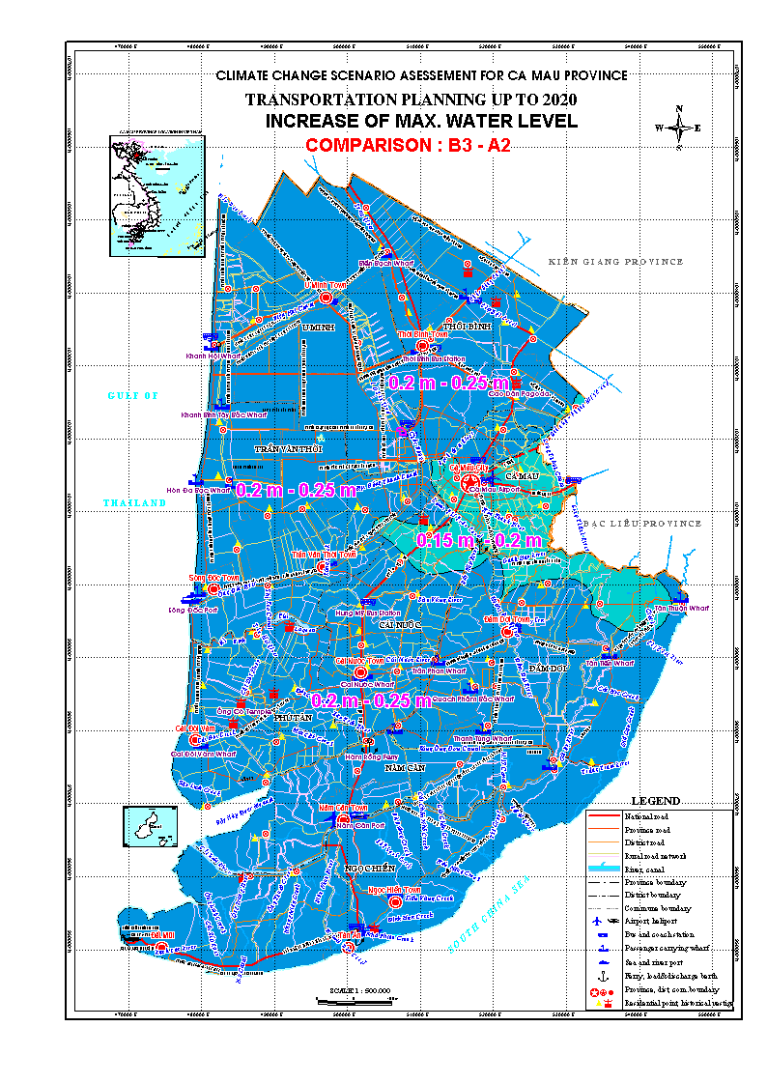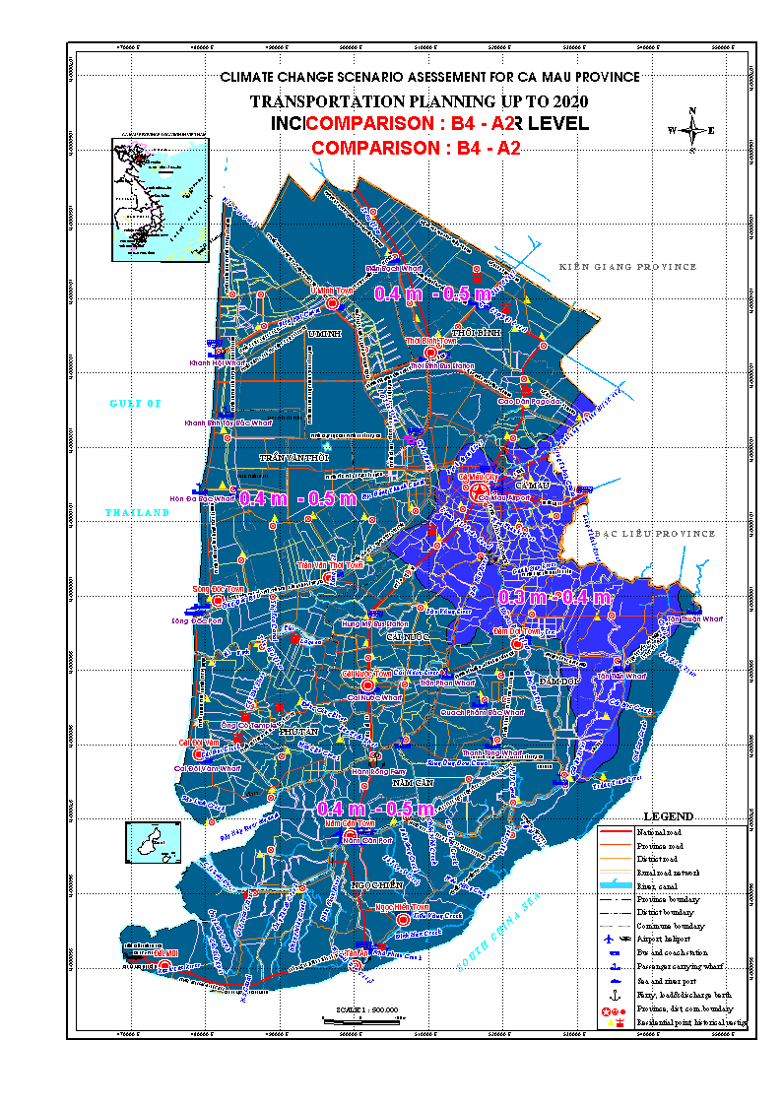
Figure 66:
Figure 67:
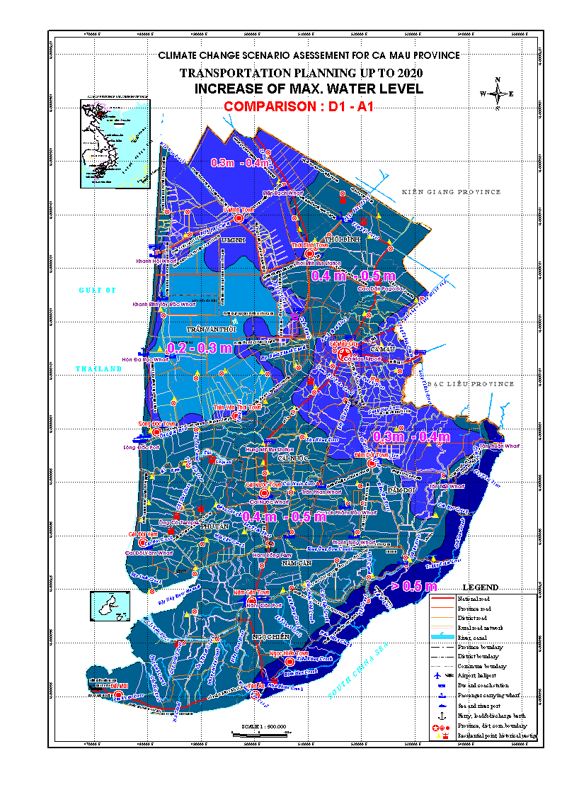
Figure 68:
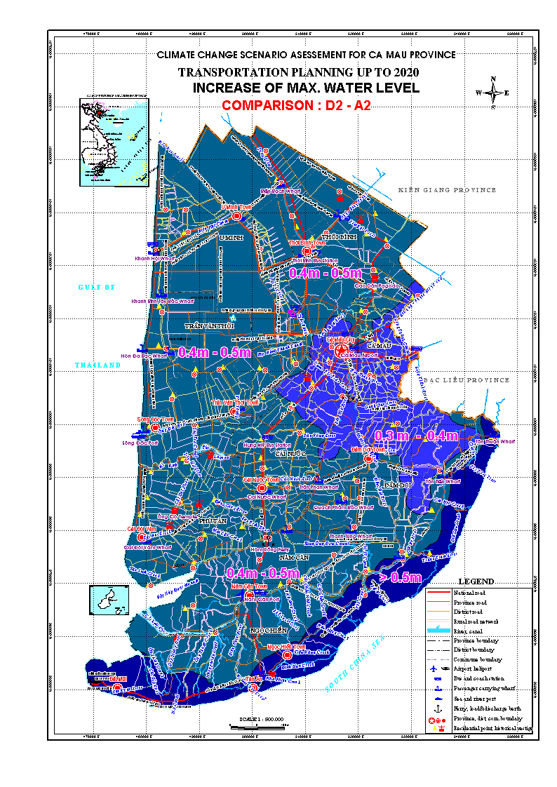
Figure 69:

